TILE - Total Integrated Laboratory Environment
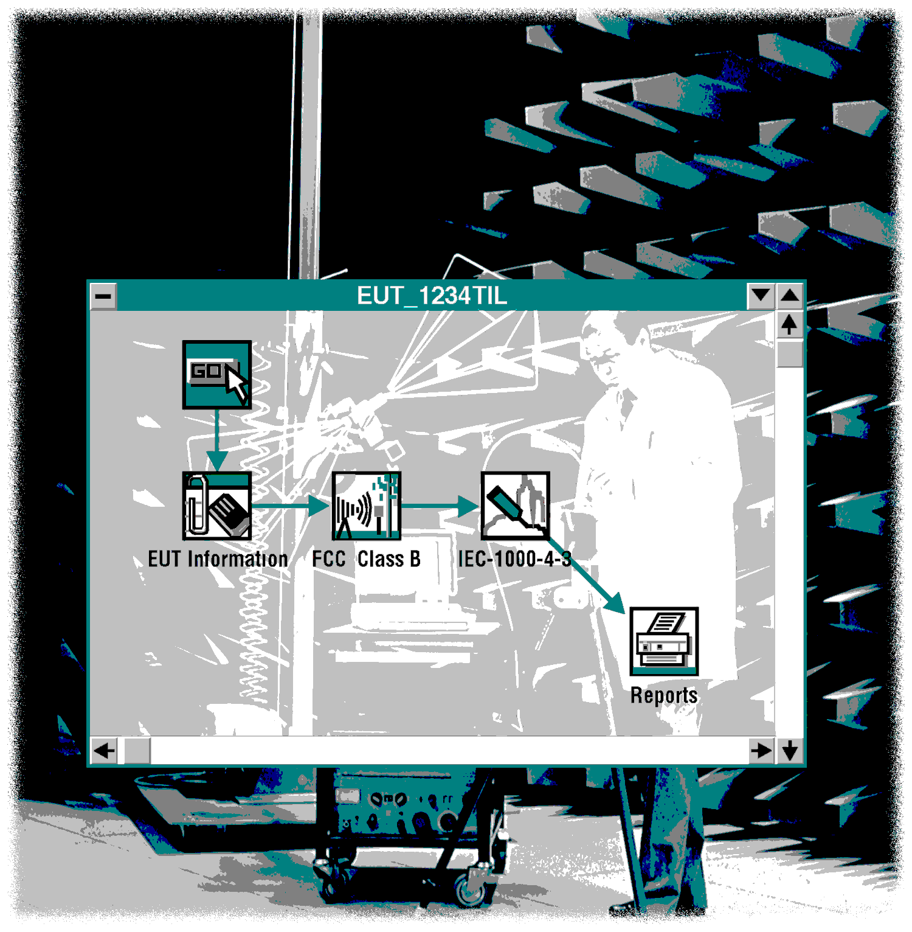TILE/ICS Instruction Manual
By Quantum Change, Inc.
Version 2.3.B
Copyright © 1996 - 2004

Quantum Change, Inc.
SOFTWARE USER LICENSE AGREEMENT
PRODUCT: TILE/INSTRUMENT CONTROL SYSTEM Software
Licensed To:______________________________________________________

QUANTUM CHANGE, Inc. (QUANTUM CHANGE) provides this Program and licenses it for use. You, the Software User (sub-licensee), assume responsibility for the selection of the Program to achieve your intended results, and for the installation, use, and results obtained from the Program.
This is a site license. The license may be assigned either to an individual department or group, or to a unique location. Installing this program on a network server is encouraged, but this does not extend the license beyond the limits previously stated in this license. The license is NOT transferable without the express written permission of Quantum Change, Inc.
UNDER THIS LICENSE YOU MAY:
Use the Program in a single department or group at any given time.
Copy the Program for backup purposes.
You may not use, copy, modify, or transfer the Program or any copy, modification or portion, in whole or in part, except as expressly provided for in this license.
LIMITED WARRANTY
QUANTUM CHANGE warrants that the Program will perform as described in the accompanying User's Manual. The entire risk as to the quality and performance of the Program is yours. QUANTUM CHANGE does not warrant that the functions contained in the Program will meet your requirements or that the operation of the Program will be uninterrupted or error free.
QUANTUM CHANGE MAKES NO OTHER WARRANTIES OR REPRESENTATION OF OR ABOUT THE SOFTWARE EXCEPT AS EXPRESSLY PROVIDED HEREIN. QUANTUM CHANGE. MAKES NO EXPRESS OR IMPLIED WARRANTIES OF MERCHANTABILITY OR FITNESS FOR A PARTICULAR PURPOSE.
If you believe that the Program does not meet the conditions of the above Limited Warranty, you must notify QUANTUM CHANGE in writing within ninety days of the date of shipment.
LIMITATION OF REMEDIES
QUANTUM CHANGE’s entire liability, and your only remedy is If we are notified within the warranty period of significant errors in the Program that fail to meet the conditions of the above Limited Warranty, QUANTUM CHANGE will, at its option (a) correct such errors within ninety days, or (b) authorize a refund of your license fee upon return of all Program materials to QUANTUM CHANGE, Inc..
IN NO EVENT WILL QUANTUM CHANGE BE LIABLE TO YOU FOR ANY DAMAGES, INCLUDING LOST PROFITS, LOST SAVINGS OR OTHER INCIDENTAL OR CONSEQUENTIAL DAMAGES ARISING FROM THE USE OR INABILITY TO USE SUCH PROGRAM EVEN IF QUANTUM CHANGE HAS BEEN ADVISED OF THE POSSIBILITY OF SUCH DAMAGES, OR FOR ANY CLAIM BY ANY OTHER PARTY.
By installing this software, you acknowledge that you have read this AGREEMENT, understand it and agree to be bound by its terms and conditions. You further agree that it is the complete and exclusive statement of the agreement between us which supersedes any proposal or prior agreement, oral or written, and any other prior communications between us relating to the subject matter of this Agreement.

Table of Contents
Chapter 1 TILE! Introduction 1-1
Introduction 1-1
Chapter 2 TILE! Installation Instructions 2-3
Items Required 2-3
Step 1 - Checking the Computer Setup 2-3
Step 2 - Installing TILE! 2-4
Step 3 - Ready to Run 2-5
Chapter 3 TILE/ICS Tutorial 3-6
Creating A Test Profile 3-6
Step 1 - Creating A New Test Profile 3-7
Step 2 - Defining Instruments 3-8
Step 3 - Defining Data Elements 3-9
Step 4 - The Log Function 3-11
Step 5 - Sequencing Your Test 3-12
Information Data 3-12
Step 6 Emissions Setup 3-13
Measure Range 3-14
Name 3-14
Frequency 3-15
Amplitude 3-15
Links 3-16
Parameters 3-16
- Creating A Graphical View of the Data 3-17
- Performing Math Functions 3-18
- Quasi-Peak Measurements 3-19
- Final Step 3-19
- Connecting the Actions 3-20
- Creating an Immunity Profile 3-20
- Our Goal - Performing an Immunity Test 3-20
- Define Data Elements 3-20
- The Immunity Test Profile 3-22
- Define Instruments 3-22
- Calibrating the Immunity Field 3-22
- Performing an Immunity Test 3-27
Chapter 4 TILE! System Overview 4-32
The TILE! Environment 4-32
Operational Overview 4-32
Tool Bars within TILE! 4-33
Windows Menu Bar 4-33
Windows Tool Bars 4-33
The Toolbar 4-33
The Status Bar 4-34
The Command Bar 4-34
The Popup Bar 4-34
The Windows Menu Bar 4-35
File 4-35
File/Options 4-35
GPIB 4-35
Database 4-35
Default Directories 4-36
Security Options 4-36
- Edit 4-37
- View 4-37
- Options 4-37
- Structure 4-37
- Graphics 4-37
- Display 4-37
- Run 4-37
- Window 4-38
- Help 4-38
Chapter 5 TILE! Data Window 5-39
Overview 5-39
Data Types 5-39
Measurement Elements 5-39
File Elements 5-40
Equation Elements 5-41
Preset Elements 5-41
Word Elements 5-41
Word From Equation Elements 5-41
Word From File Elements 5-42
Creating TILE! Data Elements 5-42
Data Window Structure 5-42
Element Names 5-42
Element Database in Use 5-43
Valid Points 5-43
Type 5-43
Intp (Interpolated) 5-43
Source 5-44
Adding Data Elements 5-44
Name 5-44
Source 5-44
Select Type 5-45
Continuous (Log and Linear) 5-45
Save to Database 5-45
Auto Sort 5-45
- File Page 5-45
File Name - Directory Path 5-45
File Format 5-46
Word Type Data 5-46
Value Initialization 5-46
Sorting Data Options 5-47
Valid 5-47
Units 5-47
- Equation Page 5-47
Triggered 5-51
Functions 5-51
- Preset Page 5-51
Amplitude 5-51
Frequency 5-52
- Editing TILE! Data Elements 5-53
- Deleting TILE! Data Element 5-53
Chapter 6 The TILE! Instrument Window 6-54
Instruments in the TILE! System 6-54
The Instrument Window 6-54
Defining an Instrument 6-55
Driver Page 6-55
File and Path 6-55
Do Not Use Driver Check Box 6-56
Desc (Description) 6-56
- Address Page 6-56
- Board 6-56
- Primary 6-57
- Secondary 6-57
- Setup Page 6-57
- Timeout 6-57
I/O 6-58
Serial Poll 6-58
Other GPIB Bus settings 6-58
- Serial Page 6-59
- Baud Rate 6-60
- Data Length 6-60
- Parity 6-60
- Stop Bits 6-60
- Accepting your choices 6-60
- Editing an Instrument 6-60
- Deleting an Instrument 6-61
Chapter 7 The TILE! Flowchart Window 7-62
Flowchart Overview 7-62
Working with Icons and the Palette 7-63
Placing Icons 7-63
Editing Icons 7-63
Linking Actions 7-63
Aligning Actions 7-64
Page Size 7-64
Working with the Flowchart 7-64
Edit Menu 7-65
View Menu 7-65
The Toolbar 7-65
The Status Bar 7-65
The Command Bar 7-66
The Popup Bar 7-66
Palette 7-66
Icons - Shortcuts and visual clues 7-66
Graphics Menu 7-67
Imbedding Text in the Flowchart 7-67
The Text Tool 7-68
The Drawing Tools 7-68
- Run Menu 7-69
- Windows Menu 7-69
Chapter 8 The TILE! Log Window 8-70
Log Window 8-70
Log Overview 8-70
Configuring the Log Options 8-70
Options 8-71
File 8-72
Sound 8-72
Chapter 9 TILE! Audit Trail 9-74
Audit Trail Window 9-74
Audit Trail Overview 9-74
Audit Trail Options 9-74
Chapter 10 TILE! Actions 10-75
How Actions Work 10-75
Palette 10-75
Common Action Commands 10-76
Enter Key 10-76
Tab Key 10-76
OK 10-76
Cancel 10-76
Apply 10-76
Help 10-76
Common Name Page 10-76
OK, Cancel, Apply and Help 10-77
Information Actions 10-77
Start 10-77
Name 10-77
OK, Cancel, Apply and Help 10-77
Prompt 10-77
Prompt Action Tab 10-78
Prompt Message Tab 10-78
Prompt Choice Tab 10-78
Accept/Reject 10-78
Auto Choose 10-79
- Prompt Sound Tab 10-79
Enable Sound Prompt 10-79
File Name 10-79
Path 10-80
Browse 10-80
- OK, Cancel, Apply and Help 10-80
- Client 10-80
- Client Action Tab 10-80
- Client Information 10-80
- OK, Cancel, Apply and Help 10-80
- EUT 10-81
- EUT Action Tab 10-81
- Equipment Under Test – Page 1 and 2 10-81
- Additional Equipment 10-81
- Floating EUT 10-81
- OK, Cancel, Apply and Help 10-82
- Operator/Laboratory Information 10-82
- Laboratory Information Action Tab 10-82
- Laboratory Information Tab 10-82
- OK, Cancel, Apply and Help 10-82
- Comment 10-82
- Comment Action Tab 10-83
- Comment 10-83
- OK, Cancel, Apply and Help 10-83
- Picture 10-83
- Picture Action Tab 10-83
- Picture 10-84
- OK, Cancel, Apply and Help 10-84
- Instrument Actions 10-85
- Instrument Initialization 10-85
- Instrument Initialization Action Tab 10-85
- Instrument Initialization Instruments Tab 10-85
- OK, Cancel, Apply and Help 10-85
- Measure Range 10-85
- Measure Range Action Tab 10-86
- Measure Range Frequency Tab 10-86
Start Frequency 10-86
Stop Frequency 10-86
Number of Ranges 10-86
Pause at each range 10-87
Scaling 10-87
From File 10-87
Harmonic 10-88
Start Frequency 10-88
Bandwidth 10-88
Harmonic Count 10-88
- Measure Range Amplitude Tab 10-88
Reference Level 10-89
Fixed Reference Level 10-89
Attenuation Level 10-89
- Measure Range Links Tab 10-89
Data 10-89
Instrument 10-90
QP Detector 10-90
Preselector 10-90
- Measure Range Parameters Tab 10-90
RF and Video Bandwidth 10-90
Number of Sweeps 10-91
Sweep Time 10-91
Detector 10-91
- Measure Range Dialog 10-92
- OK, Cancel, Apply and Help 10-92
- Measure Peaks 10-92
- Measure Peaks Action Tab 10-92
- Measure Peaks Frequency Tab 10-93
- Measure Peaks Amplitude Tab 10-93
Reference Level 10-94
Attenuation Level 10-94
TDMA Type Signal 10-94
- Measure Peaks Output Tab 10-94
- Measure Peaks Search Tab 10-95
Span 10-95
Use Percent 10-95
Sweep Time/Number of Sweeps 10-95
Min/Max Frequency 10-95
QP Across Band 10-96
- Measure Peaks Parameters Tab 10-96
RF and Video Bandwidth 10-96
Number of Sweeps 10-96
Sweep Time 10-96
- Measure Peaks Instruments Tab 10-97
- Measure Peaks Dialogs 10-97
- OK, Cancel, Apply and Help 10-98
- Scan Range Measurement 10-98
- Scan Range Action Tab 10-98
- Scan Range Frequency Tab 10-98
Start Frequency 10-98
Stop Frequency 10-98
Number of Ranges 10-99
Scaling 10-99
- Scan Range Amplitude Tab 10-99
Reference Level 10-99
Attenuation Level 10-100
- Scan Range Data Tab 10-100
Max Level 10-100
Max Position 10-100
- Scan Range Antenna/Turntable Position Tab 10-101
Tower/Turntable 10-101
Margin 10-101
Pos. Stop Timing 10-101
Polarity Settings 10-101
- Scan Range Links Tab 10-102
Spectrum Analyzer/Receiver 10-102
QP Adapter 10-102
Preselector 10-102
Tower/Turntable 10-102
- Scan Range Parameters Tab 10-102
RF Bandwidth 10-102
Video Bandwidth 10-103
Number of Sweeps 10-103
Sweep Time 10-103
Detector 10-103
- Scan Range Dialog 10-104
- OK, Cancel, Apply and Help 10-104
- Scan Peaks 10-104
- Scan Peaks Action Tab 10-104
- Scan Peaks Frequency Tab 10-105
Input Data 10-105
Tower/Turntable/Polarity Data 10-105
- Scan Peaks Frequency Steps Tab 10-105
- Scan Peaks Amplitude Tab 10-106
Reference Level 10-106
Attenuation Level 10-106
- Scan Peaks Instruments Tab 10-106
- Scan Peaks Output Tabs 10-107
- Scan Peaks Search Tab 10-107
Peak Search and Span 10-107
Span 10-108
Use Percent 10-108
Sweep Time and Number of Sweeps 10-108
- Scan Peaks Search BW 10-108
RF and Video Bandwidth 10-108
Max/Min Frequency 10-108
- Scan Peaks Compare Tab 10-109
Switch 10-109
Accept Criteria dB 10-109
- Scan Peaks Parameters Tab 10-109
RF Bandwidth 10-109
Video Bandwidth 10-109
Number of Sweeps 10-110
Sweep Time 10-110
QP/Avg Across Search Band 10-110
- Scan Peaks Optimization Process Tab 10-110
Re-Optimize 10-110
Partial Optimize 10-111
Tower/Turntable Stepped 10-111
- Scan Peaks Optimize Parameters 10-111
Optimize in QP 10-111
Optimize in Avg 10-111
MaxHold On 10-111
Fix Reference Level 10-112
Optimize Sweep Time 10-112
Optimize Span 10-112
RF and Video Bandwith 10-112
- Scan Peaks Antenna Polarity Tab 10-112
Check Single Polarity 10-112
Check Both Polarities 10-112
Check Input Polarity Only 10-112
- Scan Peaks Timing Tab 10-113
Polarization Timing 10-113
Tower/Turntable Stop Timing 10-113
Retry Count for Twr/Turn 10-113
- Scan Peaks Power Tab 10-113
Signal Active 10-114
TIA IA-102 Test 10-114
Leveling Amplitude 10-114
Output Data 10-114
Tolerance 10-114
- Scan Peaks Dialog 10-114
- OK, Cancel, Apply and Help 10-114
- Quick Scan 10-115
- Quick Scan Action Tab 10-115
- Quick Scan Frequency Tab 10-115
Start Frequency 10-115
Stop Frequency 10-115
Number of Ranges 10-115
Scaling 10-116
From File 10-116
- Quick Scan Amplitude Tab 10-116
Reference Level 10-116
Attenuation Level 10-116
- Quick Scan Data Tab 10-117
Peak Data 10-117
- Quick Scan Instruments Tab 10-117
- Quick Scan Timing Tab 10-118
Tower/Turntable Stop Timing 10-118
Polarity Timing 10-118
- Quick Scan Parameters Tab 10-118
RF Bandwidth 10-118
Video Bandwidth 10-119
Number of Sweeps 10-119
Sweep Time 10-119
Detector 10-119
- Quick Scan Tower/Turntable Tab 10-119
Tower/Turntable 10-120
Margin 10-120
Polarization 10-120
- Quick Scan Dialog 10-120
- OK, Cancel, Apply and Help 10-120
- Optimize Measurement 10-121
- Optimize Measurement Action Tab 10-121
- Optimize Measurement Frequency Tab 10-121
Start Frequency 10-121
Stop Frequency 10-121
Number of Ranges 10-121
Scaling 10-122
- Optimize Amplitude Tab 10-122
Reference Level 10-122
Attenuation Level 10-122
Dual Receiver 10-122
- Optimize Measurement Data Tab 10-123
Max Level 10-123
Max Positioner1 10-123
Max Positioner2 10-123
Check in Continuous Mode 10-123
- Optimize Measurement Tower/Turntable Tab 10-124
Margin 10-124
Polarization 10-124
- Optimize Measurement Instruments Tab 10-124
QP Adapter 10-125
Preselector 10-125
Positioner1/Positioner2 10-125
- Optimize Measurement Timing Tab 10-125
Tower/Turntable Start/Stop Timing 10-125
Polarity Timing 10-125
Try Count for Tw/Turn 10-126
- Optimize Measurement Parameters Tab 10-126
RF Bandwidth 10-126
Video Bandwidth 10-126
Number of Sweeps 10-126
Sweep Time 10-126
Detector 10-127
- Optimize Measurement Dialog 10-127
Stop 10-127
Pause 10-127
- Two Receiver Option 10-127
- OK, Cancel, Apply and Help 10-128
- Signal Discrimination (OATS) 10-128
- Signal Discrimination Measurement Action Tab 10-128
- Signal Discrimination Measurement Input Data Tab 10-129
Frequency-PK 10-129
Frequency-QP 10-129
Frequency-Avg 10-129
Tower Data 10-129
Turntable Data 10-129
- Signal Discrimination Measurement Output Data 1 Tab 10-130
Peaks 10-130
QP 10-130
Avg 10-130
Antenna Factor 10-130
Antenna Used 10-130
- Signal Discrimination Measurement Output 2 Tab 10-131
Tower 10-131
Turntable 10-131
Hor/Vert 10-131
Comments 10-131
- Signal Discrimination Measurement Instruments Tab 10-131
Receiver/Analyzer 10-131
Preselector 10-132
QP Adapter 10-132
Tower 10-132
Turntable 10-132
Manual 10-132
- Signal Discrimination Measurement Parameters Tab 10-132
RF Bandwidth 10-132
VBW/Step Size 10-133
Number of Sweeps 10-133
Sweep Time 10-133
Detector 10-133
Default Span 10-133
- Signal Discrimination Measurement Amplitude Tab 10-133
Reference Level 10-134
Attenuation 10-134
- Signal Discrimination Measurement Standards Tab 10-134
Limit 10-134
Default Ant Factor 10-134
Cable Loss 10-134
Preamplifier Gain 10-134
- Signal Discrimination Measurement Tower/Turn Position Tab 10-135
Start 10-135
Stop 10-135
Margin 10-135
Default Position 10-135
Automatically Set Twr/Turntable 10-135
- Signal Discrimination Measurement Timing Tab 10-136
Tower Start/Stop Timing 10-136
Turn Start/Stop Timing 10-136
Polarity Timing 10-136
Try Count 10-136
- Signal Discrimination OATS Dialog Box 10-136
Table of Frequencies 10-136
Instrument Read Buttons 10-137
Antenna 10-139
Read Freq 10-139
Direct Read QP 10-139
Set Before, Set After, and Delete Frequency Buttons 10-139
Table Settings View 10-140
- OK, Cancel, Apply and Help 10-140
- Site Attenuation 10-140
- Site Attenuation Action Tab 10-140
- Site Attenuation Frequency Tab 10-141
Start Frequency 10-141
Stop Frequency 10-141
Step 10-141
Search Span 10-141
- Site Attenuation Levels Tab 10-142
Signal Generator 10-142
Reference Level 10-142
Direct Mode 10-142
RF Bandwidth 10-142
Video Bandwidth 10-142
- Site Attenuation Data Tab 10-143
Attn Level 10-143
Ant Height 10-143
Calibration 10-143
- Site Attenuation Antenna Tab 10-143
Start 10-143
Stop 10-143
Step 10-144
Margin 10-144
Continuous 10-144
Prompt for Antenna Change 10-144
Polarization 10-144
Polarization Timing 10-144
- Site Attenuation Instruments Tab 10-144
- Site Attenuation Dialog 10-145
- OK, Cancel, Apply and Help 10-145
- Immunity Calibration 10-145
- Immunity Calibration Action Tab 10-145
- Immunity Calibration Frequency Tab 10-146
Start Frequency 10-146
Stop Frequency 10-146
# of Steps/Dec/% 10-146
Log 10-146
Percent 10-146
Set From Data 10-147
- Immunity Calibration Freq Steps Tab 10-147
Minimum Attenuation between steps 10-147
No Sig Gen On/Off between steps 10-147
Use Previous Amp for Best Guess 10-147
Power Off at Fail to Level 10-148
Update Sensors at each level 10-148
Start Delay 10-148
First Step Tries 10-148
- Immunity Calibration Amplitude Tab 10-148
Data 10-149
Data Units 10-149
Delay Time 10-149
- Immunity Calibration Leveling Tab 10-149
Leveling Source 10-150
Tolerance 10-150
Offset 10-150
Max Lvl Step 10-150
Max dBm 10-150
Max Count 10-150
Continue on Fail-to-Level 10-151
Best Guess Amp 10-151
- Immunity Calibration TEM Tab 10-151
Height 10-151
Impedance 10-151
Ref Out Data 10-151
- Immunity Calibration Calibration Tab 10-152
- Immunity Calibration Results Tab 10-152
Record 10-152
Data 10-153
Signal Generator 10-153
Power Meter1 10-153
Power Meter2 10-153
Net Power 10-153
Probe 10-154
- Immunity Calibration Instruments Tab 10-154
Use Net Power 10-154
Delay Time 10-154
- Pause 10-154
Pause Frequencies 10-155
Pause Message 10-155
- Immunity Calibration Dialog 10-155
- OK, Cancel, Apply and Help 10-155
- Immunity Test 10-155
- Immunity Test Action Tab 10-156
- Immunity Test Frequency Tab 10-156
Start Frequency 10-156
Stop Frequency 10-156
# of Steps/Dec/% 10-156
Log 10-157
Percent 10-157
Set From Data 10-157
- Immunity Test Freq Step 1 Tab 10-157
Modulation Always On 10-157
No Sig Gen On/Off between steps 10-158
Minimum Attenuation between steps 10-158
Auto Level on Change of Frequency (Manual Mode) 10-158
Use Previous Amp for Best Guess 10-158
Display VSWR (Net Power Only) 10-158
Step to Next Frequency on Fail (Auto Mode) 10-159
Power Off at Fail to Level 10-159
- Immunity Test Freq Step 2 Tab 10-159
Power on When Entering Manual Mode 10-159
Do Not Exceed Std Field 10-159
Use Previous Amp when Leveling Failed on Previous Freq 10-159
Read Sensors with Modulation On 10-160
First Frequency Delay 10-160
First Offset 10-160
First Step Tries 10-160
- Immunity Test Pause Tab 10-160
Pause Frequencies 10-160
Pause Message 10-161
- Immunity Test Primary Amplitude Tab 10-161
Data 10-161
Use Apparent Power (CS02) 10-162
- Immunity Test Secondary Amplitude Tab 10-162
Max Lvl 10-162
Max Level Inst 10-162
Level Units 10-162
Tolerance Plus/Minus 10-162
Count 10-162
Generator Step Size 10-163
Harmonic Test 10-163
Min Margin 10-163
Upper Freq Limit 10-163
- Immunity Test Leveling Tab 10-163
Leveling Source 10-163
Tolerance 10-164
Offset 10-164
Max dBm 10-164
From Table 10-164
Max Step 10-164
Min Step 10-165
Max Count 10-165
Continue on Fail-to-Level 10-165
Best Guess Data Element 10-165
- Immunity Test TEM Tab 10-165
Height 10-165
Impedance 10-166
- Immunity Test Check Tab 10-166
Power Meter Check 10-166
Door Check Active 10-166
- Immunity Test Reference Tab 10-167
Reference File 10-167
Ref Out File 10-167
Reference Type 10-168
- Immunity Test Thresholding 10-168
Lower/Upper Threshold Data Elements 10-168
Lower/Upper Effects 10-168
- Immunity Test Auto Threshold 1 10-168
Auto Thresholding 10-168
Tolerance 10-168
EUT Delay 10-169
Threshold Limit 10-169
Threshold Output 10-169
Threshold Instrument 10-169
- Immunity Test Auto Threshold 2 10-169
- Immunity Test Auto Threshold 3 10-169
- Immunity Test AM Modulation Tab 10-170
Enable 10-170
Depth 10-170
Frequency 10-170
External 10-171
Waveform 10-171
External Gating 10-171
- Immunity Test FM Modulation Tab 10-171
Enable 10-171
External 10-171
Deviation 10-171
Frequency 10-172
Waveform 10-172
External Gating 10-173
Enable 10-173
External 10-173
Pulse Rate 10-173
Pulse Width 10-173
External Gating 10-173
- Immunity Test PM-Key Test 10-174
Key Test 10-174
Key On 10-174
Key Off 10-174
Number of Cycles 10-174
Monitor 4 On/Off Data 10-174
- Immunity Test Calibration Tab 10-174
- Immunity Test Probe Cal Tab 10-175
- Immunity Test Results 1 Tab 10-175
Record 10-175
Data 10-176
Signal Generator 10-176
Power Meter1 10-176
Power Meter2 10-176
Net Power 10-177
Pass Fail 10-177
- Immunity Test Instruments Tab 10-177
Signal Generator 10-178
Amplifier 10-178
Power Meter 1 10-178
Power Meter 2 10-178
Measure Net Power 10-178
Delay Time 10-178
- Immunity Test Probe Tab 10-179
Probe 1-4 10-179
Delay Time 10-179
Leveling Method 10-179
- Immunity Test Monitor Tab 10-180
- Immunity Test Process Tab 10-180
Step Test Defined 10-181
Start Delta 10-181
Step Size 10-182
Std Delay 10-182
Soak Time Off 10-182
Delay Exceptions 10-182
Auto Start 10-182
- Immunity Test Pass/Fail Tab 10-182
Call Action 10-183
Prompt on Failure 10-183
Step Down on Failure 10-183
# of Steps 10-183
- Immunity Test Dialog 10-184
Frequency/Step Information 10-184
Leveling Loop Information 10-184
Amplitude Information 10-185
Sensor Information 10-185
Control Buttons 10-185
- OK, Cancel, Apply and Help 10-186
- Immunity Field Calibration (16 Point) Test 10-186
- Immunity Field Calibration Action Tab 10-187
- Immunity Field Calibration Input Tab 10-187
- Immunity Field Calibration Standard Tab 10-187
- Immunity Field Calibration Output Tab 10-188
Max Pwr (12 Pts) 10-188
Matching Sig Gen 10-188
Matching Probe 10-188
- OK, Cancel, Apply and Help 10-188
- Utility Actions 10-188
- Position Tower 10-188
- Position Tower Action Tab 10-189
- Position Tower Position Tab 10-189
Antenna Height 10-189
Polarity Only 10-189
Polarization 10-189
Margin 10-189
Pol. Timing (Polarization Timing) 10-189
- Position Tower Links Tab 10-190
- Position Tower Dialog 10-190
- OK, Cancel, Apply and Help 10-190
- Position Turntable 10-190
- Position Turntable Action Tab 10-191
- Position Turntable Position Tab 10-191
Margin 10-191
Retry Count 10-191
Start/Stop Delay 10-191
- Position Turntable Links Tab 10-191
- Position Turntable Dialog 10-192
- OK, Cancel, Apply and Help 10-192
- Position EUT (GTEM Manipulator) 10-192
- Position EUT Action Tab 10-192
- Position EUT Position Tab 10-193
Azimuth/X-Axis 10-193
Orthogonal/Y-Axis 10-193
Preset 10-193
- Position EUT Links Tab 10-193
Ortho/X-Y Positioner 10-193
- Position EUT Dialog 10-194
- OK, Cancel, Apply and Help 10-194
- Calibrate Cables/Amplifiers 10-194
- Calibrate Cables/Amplifiers Action Tab 10-194
- Calibrate Cables/Amplifiers Setup Tab 10-194
From Table 10-195
Start Frequency 10-195
Stop Frequency 10-195
Step 10-195
Level 10-195
Delay 10-196
- Calibrate Cables/Amplifiers Data Tab 10-196
Attenuation 10-196
Calibration 10-196
- Calibrate Cables/Amplifiers Frequency Steps Tab 10-196
Reference Level 10-196
Stop at each Step 10-196
First Frequency Delay 10-197
- Calibrate Cables/Amplifiers Links Tab 10-197
Signal Generator 10-197
Amplifier 10-197
Power Meter/Spec. Anal. 10-197
Preselector 10-197
- Calibrate Cables/Amplifiers Dialog 10-197
Step 10-197
Frequency 10-198
Generator Level 10-198
Power Meter Level 10-198
Attenuation 10-198
- OK, Cancel, Apply and Help 10-198
- Switch 10-198
- Switch Setup Action Tab 10-198
- Switch Setup Switches Tab 10-198
- Switch Setup Instrument Tab 10-199
Instrument 10-199
Number of Tries 10-199
Delay between Tries 10-199
- OK, Cancel, Apply and Help 10-199
- GPIB Control 10-199
- GPIB Control Action Tab 10-199
- GPIB Control Instrument Commands 10-200
Delay Time 10-200
Command Format 10-200
Variable Delay Timing 10-200
- OK, Cancel, Apply and Help 10-200
- Serial Interface 10-201
- Serial Interface Action Tab 10-201
- Serial Interface Information Tab 10-201
- Serial Interface File Setup 10-201
- Serial Interface Serial Setup 10-202
Serial Encoder 10-202
VCR/Data Recorder 10-202
Monitor Instrument 10-202
Display Date/Time Stamp 10-202
- Serial Interface Action 10-202
- OK, Cancel, Apply and Help 10-202
- Data and File Commands 10-203
- Math 10-203
- Math Action Tab 10-203
- Math Data Tab 10-203
Add 10-203
Remove 10-203
- Math Dialog 10-204
- OK, Cancel, Apply and Help 10-204
- Clear Data 10-204
- Clear Data Action Tab 10-204
- Clear Data Tab 10-204
Add 10-205
Remove 10-205
- OK, Cancel, Apply and Help 10-205
- Transfer Data 10-205
- Transfer Data Action Tab 10-205
- Transfer Data to File Tab 10-205
Data 10-206
To/From File 10-206
Prompt for Name 10-206
Append Data 10-206
Word Type 10-206
Name 10-206
Path 10-206
Browse 10-207
- OK, Cancel, Apply and Help 10-207
- Print 10-207
- Print Action Tab 10-207
- Print Display Tab 10-207
Add 10-207
Remove 10-208
- OK, Cancel, Apply and Help 10-208
- Launch Application 10-208
- Launch Application Action Tab 10-208
- Launch Application Commands Tab 10-208
Executable 10-208
Parameters 10-208
Working Directory 10-209
- OK, Cancel, Apply and Help 10-209
- Auto Save 10-209
- Auto Save Action tab 10-209
- Auto Save Save As Tab 10-209
Prompt for Name 10-209
Use Current Name 10-209
Auto Incr. 10-209
Save to Database 10-209
- OK, Cancel, Apply and Help 10-210
- Direct Entry 10-210
- Direct Entry Action tab 10-210
- Direct Entry Data Element Tab 10-210
Data Element 10-210
Append to Existing Data 10-210
- Direct Entry Dialog 10-210
Element Name 10-210
Insert Before 10-211
Insert 10-211
Insert After 10-211
Delete 10-211
<< >> 10-211
- OK, Cancel, Apply and Help 10-211
- GTEM/OATS 3 Position Correlation 10-211
- GTEM/OATS 3 Position Correlation Action Tab 10-211
- GTEM/OATS 3 Position Correlation Correlation Tab 10-211
X: 10-212
Y: 10-213
Septum (Z:) 10-213
- GTEM/OATS 3 Position Correlation OATS Tab 10-213
Height Min 10-213
Height Max 10-213
Separation 10-214
EUT Height 10-214
Free Space 10-214
- GTEM/OATS 3 Position Correlation Inputs Tab 10-214
Vx 10-214
Vy 10-214
Vz 10-214
Frequency BW 10-215
- GTEM/OATS 3 Position Correlation Results Tab 10-215
Maximum 10-215
Vertical 10-215
Horizontal 10-215
- GTEM/OATS 3 Position Correlation Dialog 10-215
- OK, Cancel, Apply and Help 10-216
- GTEM/OATS 9-Position Correlation 10-216
- GTEM/OATS 9-Position Action Tab 10-216
- GTEM/OATS 9-Position GTEM Tab 10-216
X: 10-217
Y: 10-218
Septum (Z:) 10-218
- GTEM/OATS 9-Position OATS Tab 10-218
Height Min 10-218
Height Max 10-218
Separation 10-219
Height Step 10-219
EUT Height 10-219
- GTEM/OATS 9-Position Alignment Tab 10-219
- GTEM/OATS 9-Position Input Tab 10-220
- GTEM/OATS 9-Position Results Tab 10-221
- GTEM/OATS 9-Position Dialog 10-221
- OK, Cancel, Apply and Help 10-222
Chapter 11 TILE! Graphs and Tables 11-223
Graphs 11-223
Creating a Graph 11-223
Mouse Position 11-224
Data Options 11-224
Selecting Data 11-224
Add 11-225
Remove 11-225
- Controlling Display Conditions 11-225
Line 11-225
Marker 11-226
Column Width 11-227
Decimal Places 11-227
Column Description 11-227
2nd Description 11-227
- Display Options 11-227
- Titles Tab 11-227
Justify Titles 11-228
- X Labels Tab 11-228
Title 11-228
Frequency Range 11-228
Data for Freq 11-228
Format 11-228
- X-Axis Tab 11-229
Axis Ticks 11-229
Grids 11-230
- Y Labels Tab 11-230
Title 11-230
Amplitude Range 11-230
Format 11-230
- Y-Axis Tab 11-231
Step 11-231
Axis Ticks 11-231
Grids 11-232
- Fonts Tab 11-232
Title-Line 1 11-232
Title-Line 2 11-232
Graph Title 11-233
X-Axis 11-233
Y-Axis 11-233
Legend 11-233
- Graph Tab 11-233
Graph 11-233
Plotting Area 11-234
Border 11-235
- Legend Tab 11-235
Display Legend 11-235
Auto Size 11-235
Legend 11-235
Border 11-236
- Additional Information Tab 11-237
- EUT Tab 11-238
Display 11-238
EUT (Action) 11-238
Position 11-238
Border 11-238
Show Titles 11-239
- Comments Tab 11-239
Display 11-239
Comment (Action) 11-239
Comment (Position) 11-239
Border 11-240
- Bitmap Tab 11-240
Display 11-240
Browse (Bitmap) 11-240
Position 11-241
- Page Default Tab 11-241
Landscape 11-241
Portrait 11-241
- Zoom Graph 11-241
- Vertical 11-242
- Horizontal 11-242
- Copy Graph 11-242
- Keeping a Graph After Creation 11-242
- Editing an Existing Graph 11-242
- Temporary Zoom 11-243
- Zoom In 11-243
- Zoom Out 11-243
- Tables 11-244
- Creating a Table 11-244
- Data 11-244
Add 11-244
Remove 11-245
- Options 11-245
- Controlling Display Conditions 11-245
Line 11-245
Column Width 11-245
Decimal Places 11-246
Column Description 11-246
2nd Description 11-246
- Display Options 11-246
- Titles Tab 11-246
Title 11-246
Line 1 11-246
Line 2 11-246
Justify Titles 11-246
Reverse Sort Order 11-247
Column 1 Heading 11-247
Column 1 Title 11-247
Freq Decimal Places 11-247
Column Width 11-247
- Additional Information 11-247
- Comment Tab 11-248
Display 11-248
Comment 11-248
- EUT Tab 11-248
Display 11-248
Include Titles 11-249
- Page Defaults 11-249
Printer Page Orientation 11-249
Page Width 11-249
Tab Spacing 11-249
Skip Headers on Copy/Export 11-249
Use Text for Frequency on Copy/Export 11-249
Exclude Units 11-249
Use Space for NAN on Copy/Export 11-250
- Keeping a Table after Creation 11-250
- Editing an Existing Table 11-250
Chapter 12 TILE! Options 12-251
Voltage Monitoring 12-251
Database 12-251
Index i

TILE! Introduction
Welcome to the TILE! Software. TILE! is a dynamic software package that undergoes constant enhancements and improvements. Inputs from you - the user - as well as those of our developers, as we strive to streamline the software, are implemented to support these evolving needs. Corrections and additions are welcome to help make TILE! Help informative as possible.

Introduction
TILE is an integrated approach to designing, performing, reporting and archiving complex Electromagnetic Compatibility (EMC) tests. TILE/ICS (Instrument Control System) is the portion of the TILE system that provides simple, direct control of EMC measurement instruments. It has a unique, visual interface. The TILE concept provides a common user interface for all testing, coupled with tight integration into various standard report writing software (such as Microsoft Word or Lotus AmiPro) as well as spreadsheets (such as Novel’s Quattro Pro or Microsoft’s Excel). It provides the ability to perform EMC tests as well as manipulate the data generated during these measurements.
By using the latest software techniques, such as OLE 2.0 (Object Linking and Embedding) and ODBC (Open Database Connectivity), TILE allows for rapid design and testing within the laboratory environment. The use of 32-bit code is of particular significance within the EMC community given the large data sizes inherent in EMC testing.
TILE/ICS uses a flowchart to simplify the user interface. Each step in the process is represented on the flowchart with an icon, which are referred to as actions. The icons are each a unique test, information step or prompt. The flowchart provides a powerful tool for symbolizing communications with the instruments and data manipulation/correction.
Instrument control is based on the General Purpose Instrument Bus (GPIB or IEEE-488-2), Serial Communications (IEEE-232) or other standards. The TILE system is hardware independent within these constraints and the abilities of the hardware used. Most EMC instrumentation is supported by TILE. The emphasis on hardware independence allows for quick introduction of new instrumentation into the laboratory environment. No new ‘code’ has to be written by the user, only a new instrument driver by Quantum Change. These instrument drivers are provided free of charge to registered users.
This manual provides the appropriate instructions for installing the software, building test profiles, debugging their design and running these on a day to day basis. A tutorial will help to provide a short guide to getting up and running.

Contact Us

You can contact Quantum Change by phone, fax, mail or email. Please use the following:

Quantum Change, Inc.
105 Green Tree Tavern Road
North Wales, PA 19454-1238

Telephone 1-215-540-8850
Facsimile 1-215-540-8851

Email: support@quantumchange.com

TILE! Installation Instructions
Chapter 2 is a detailed description of installing the TILE! software on your PC. It will list the system requirements, checking for the correct GPIB driver, and a short tutorial on the loading of the software.

Items Required
- National Instruments (or other supported GPIB Card) Installation Disks (CD, or 2/3 disks)
- TILE! Installation Disks (9 disks, CD or Network installation file)
- Computer - Intel 486DX with 8 MB RAM minimum, 8 MB available disk space, a GPIB Card, and Windows 95 or higher Windows operating system (Windows NT must be Version 3.51 or higher).
- Note: due to 16 bit limitations, Windows 3.x is not supported by TILE!.

Step 1 - Checking the Computer Setup
The GPIB software must be installed in a 32 bit configuration before installing the TILE! software. This will preclude the use of certain brands of GPIB cards. Quantum Change has a long history of support and use of the National Instrument (NI) brand of GPIB Cards and these are the recommended brand. For the remainder of this chapter any reference to NI can be applied to any GPIB card that is supported by TILE. Be aware that the National Instrument card may be installed and operating and still not be configured for 32 bit operation. There are two ways to determine the correct setup. From ‘Start’ go to the NI-488.2 GPIB Software folder. Check and verify that an icon called ‘Win32s Interactive Control’ or ‘Measurement and Automation Explorer’ is present. If either one of these two conditions are met the software is properly loaded. If either one of these conditions are not met, the NI software must be reinstalled for the correct configuration. If you do not have a version of the NI software dated after 1993, please contact NI or Quantum Change for a current version of the NI software. This is available electronically through NI’s Internet Support.
Appropriate Internet addresses are:
Quantum Change - //www.quantumchange.com
National Instruments - //www.ni.com
If your installed version meets these requirements go to Step 2.

Step 2 - Installing TILE!
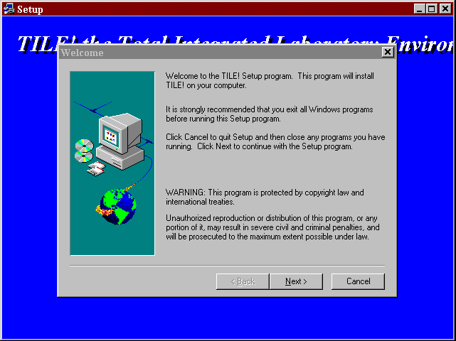
Installing TILE! is easy! Just insert the appropriate disks when prompted and step through the installation wizard.
Installation:
- Install ‘TILE! Disk 1 of 9’ in your drive a: or b: or an appropriate CD drive. If installing from an downloaded file, go to the appropriate temporary directory.
- From the Control Panel, choose ‘Add/Remove Programs’ and follow the wizard. If you are more comfortable, from the Windows Start Bar select ‘Run’. Type ‘x:setup.exe’ (x represents your disk drive with the installation diskettes/disks.
- If you are installing this in place of an existing TILE! installation, we recommend that you install it to a unique directory. This will insure your ability to access previous versions since the new version might have unique characteristics not found in prior versions.
- The installation wizard will now walk you through the installation process.
- If a different destination location or if a different Program Folder is desired, make the appropriate selections as the wizard step you through the installation process.
- When the setup is complete, click Finish to complete the setup.
If you receive a warning message with regards to ‘byte count errors’ during the installation, chose “ignore” and continue with the installation process. After the installation is complete a shortcut labeled ‘TILE’ will be created on the desktop. A new folder, with the appropriate name, will exist in the identified drive. From the ‘Start/Programs’ is an icon labeled “TILE!”. Click on this icon to launch ‘TILE!’ for the first time. The first time you install the software you will receive an error stating that the ‘GPIB DLL failed’. The program will continue to load to a blank program screen with an ‘Open File’ dialog. Click ‘Cancel’ on the dialog box. From the Windows bar select ‘File\Options’. This will bring up a window called Global Options. The first option shown will be GPIB driver. Using browse, find the file called ‘NIGPIB.DLL’ (if using NI, otherwise choose the appropriate driver for you card). Highlight this selection and click on ‘OK’. Close the program. This will store your GPIB setting for future sessions. When you reopen the program it will correctly load the GPIB.DLL (program) file. On versions which support HP or other GPIB cards (Win95 and Windows NT), select the appropriate ‘xxGPIB.DLL’ file.

Step 3 - Ready to Run
You are now ready to run the program. For those who have not had training on the use of the TILE! program, Chapter 3 is a short tutorial which will help you understand the basic principle and operation of the system.

TILE/ICS Tutorial
This tutorial has been generated to help the user become familiar with routine tests. Our intent is to familiarize individuals with general test setup, windows, and test execution.

Creating A Test Profile
The TILE/ICS program is designed as an instrument independent, software based testing environment for the EMC laboratory. It is a Windows based application with the concurrent use of windows and dialog boxes to control communication with the program.
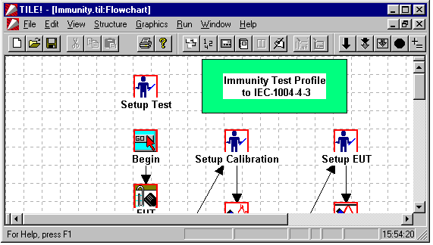

There are five major windows within TILE/ICS:
- Flowchart- The sequence of actions to perform a specific test. The flowchart is a visual representation where each icon represents a completely independent step in the test. Each icon represents a miniature program that can be completely configured as a stand-alone step.
- Data - Defined data elements are used to store information obtained during the testing, whether for storage of measurement values, specification limits, correction factors or the results of mathematics upon other data elements.
- Instrument - The definition of instruments which will be controlled during this test. This includes both the instrument driver as well as the GPIB or Serial port information necessary to address the instrument properly.
- Log – Used for debugging purposes, the logging function allows the user to track the completion/status of each step of the test. The log can show a complete history of the commands sent to the various instruments in the test.
- Audit Trail – A record, in text format, of the configurations of each action present on the flowchart.
These windows are considered permanent and cannot be closed by the user (they can only be minimized). The ability to define multiple views of the data, through graphs and tables, is an additional feature of the program. Multiple graphs and tables can be created with there own unique view of the data elements. Graphs and Tables are considered temporary views of the data since the user can close them - and thus eliminate this view of the data.
As a way of acclimatizing the user to the TILE/ICS environment, this tutorial is designed to step the new user through the creation of a test profile. A test profile is defined as the sequence of actions necessary to perform a specific test as well as the data to be used/generated and the instruments involved in the test. An action is an information step, a measurement step, or an output step. The goal of this tutorial is to create a simple test profile that will identify the EUT, perform a simple radiated emission scan, pause for instrumentation change and then perform a simple radiated immunity test. This will then familiarize the reader with basic concepts behind a TILE/ICS test.

Step 1 - Creating A New Test Profile
To create a new test profile it is essential to sketch out the overall goals of the test profile. This will allow the designer to identify appropriate data elements, instrument linkages, and sequences needed for this profile. For this tutorial, we are going to perform two basic tests: an emission scan and an immunity scan. The flowchart can be used to ‘sketch out’ the framework of the test profile including very complex tests. But even the simplest can be configured quickly and easily. For our purposes the following is a reasonable estimation of our steps:
- Identify the EUT, Client and Operator
- Setup the test equipment
- Perform an emission scan
- Correct the data with Antenna and Pre-Amplifier Correction Factors
- Find the peaks signals above the specification limit
- Perform a Quasi-Peak measurement
- Pause the test to change instrumentation
- Start an immunity test by running a calibration of the field with a probe/power meter for leveling
- Display the results in both graphical and tabular form
First, start the TILE/ICS program from the Desktop Icon or through ‘Start/Programs/Tile’. The first time TILE/ICS is started you will have a skeleton window with an ‘open’ dialog box listing all ‘*.til’ files. Since we need to create a ‘new’ blank test profile, cancel this dialog box. Now we need to create a blank, fresh profile. There are two ways for this to be accomplished. First, select ‘File/New’ from the top bar. Or, just click on the icon, which will launch a new profile. The profile will consist of the five standard windows: the Flowchart, Data, Instrument, Log, and Audit Trail windows.
The flowchart window has a related palette of tools that is visible when the flowchart is in the foreground. If this palette is NOT visible, go to ‘View/Palette’ and check this choice to view the palette. If the palette has only drawing tools, and no icons, then you are missing the palette and need to contact Quantum Change for assistance. For a further example of the appearance of the palette, look at the first page of Chapter 10.
Across the top of the window you will see a sequence of icons which are more general windows icons. To the left are the ‘New’, ‘Open’, ‘Save’ and ‘Print’ icons. Towards the center are a set of icons that are shortcuts for maneuvering around the TILE profile.
In order, these icons access the Flowchart, Data Window, Instrument Window, Log Window, Audit Trail, Graphs/Tables and the GPIB Direct dialog.
Actions are selected from the palette tools with the mouse and ‘dropped’ on the flowchart in the sequence in which the test is to be performed. Each action on the palette has a unique function. The Flowchart is the default window, but to create our test profile we also identify the instruments to be used and the data elements that will be used in this test.

Step 2 - Defining Instruments
Open the instrument window by clicking on the instrument 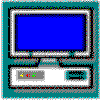 icon in the shortcut toolbar. The instrument window allows for identification of each instrument, either by bus address or COM port, which will be present during a test. The use of a unique instrument driver allows the test profile to be independent from the characteristics of specific instruments. For example, when you define ‘Spectrum Analyzer’ in the instrument window and you are presently using an HP8591E. Now lets suppose that this instrument is being sent out for repairs and an R&S ESB1 is used in place of the HP8591E. Opening the instrument window and associating the R&S instrument driver in place of the HP instrument driver, still under the name ‘Spectrum Analyzer’, is all that is needed to continue operating. All your defined test profiles, reflecting the generic name, are still valid.
First, lets begin by creating a new instrument. With the instrument window in the foreground, select ‘Edit/Add’ from the toolbar or use the shortcut icon. Once the instrument definition window is open, you will notice a dialog box with four tabs. Tab A is Name, Tab B is Driver, Tab C is Address, and Tab D is Setup. Each instrument and data element requires a unique name. There is no strict convention for naming (except for data elements used in math functions), so feel free to use a descriptive name. Generally, we recommend using generic names since identification by hardware names will imply a specific instrument. The overall design allows you to substitute instruments anytime and generic names make this easier. For our purposes, name the instrument ‘SpecAnal’. Type the name in the block shown, but DO NOT hit the ‘ENTER’ key. Hitting ‘ENTER’ causes the dialog box to close and, without a driver identified, you will generate an error.
Now click on the tab marked ‘Driver’. On this page we need to put the specific instrument driver which will be associated with the name. For convenience you can hit ‘Browse’ and see the complete library of available instruments. Select the instrument you have available.
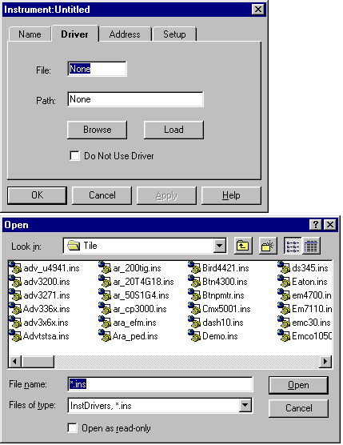
Once we have selected an instrument, DO NOT hit the ‘ENTER’ key. Instead Click on the tab marked ‘Address’. Choose the appropriate GPIB card and unique address indicator. Generally you should be using GPIB0 for the card. TILE/ICS supports up to four GPIB cards with 32 address on each card. Most spectrum analyzers use bus address 18 (default). If you have an older instrument which does not meet the IEEE-488-2 standard, you may need to make changes. Use the ‘Setup’ tab to accomplish this. Contact Quantum Change for specific help with these settings.
You may also use a pre-amplifier with your analyzer. These generally do not have GPIB interfaces and are treated as passive devices. Only identify instruments that are controlled by the bus. We will handle cases such as the pre-amp in the data section. We will also be using a signal generator, probe and/or power meter for the immunity test. Configure each of these instruments as described above.

Step 3 - Defining Data Elements
The Data window  is designed to identify the elements that are to be used in the flowchart. Some examples of different data elements are: the results of an instrument scan, a data file containing transducer correction factors, or data created from default information, such as a flat 10 V/M spec limit for immunity.
With the Data window in the foreground, select ‘Edit/Add’ from the toolbar or use the shortcut icon. Once the data definition window is open, you will notice a dialog box with three tabs. Tab A is ‘Name’ (as is the first tab of all actions in the TILE/ICS system), Tab B is ‘Source’ and Tab C is ‘Values’. Name this data element ‘raw’ since it will represent, or hold, the raw data from the spectrum analyzer scan. Now click on the Tab marked ‘Source’.
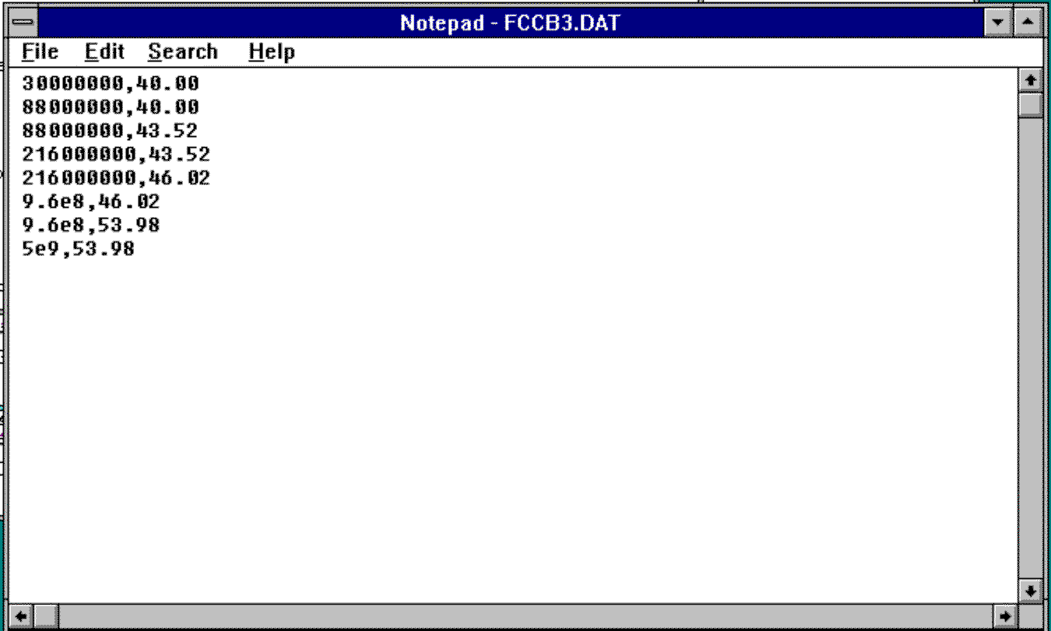
You will see a page with four choices and a default selection marked ‘Continuous’. These are the four types of data elements: Measurements, File, Equation and PreSet. The dialog box changes its state depending upon what type of data element it represents. The default setting is a measurement.
A measurement in the TILE/ICS system is defined as any result from an action. Most results will be actual data obtained from an instrument during a test procedure. This, however, is not always true. Certain specialized actions do not address an instrument but, by definition, their result is an action. A good example of this is the GTEM correlation routine. A unique action exists to perform this mathematical modeling. The output of this action (the correlated data) is considered a measurement data element. Go ahead and click ‘OK’ to accept the default settings for our ‘raw’ data.
Next consider the case of a specification limit. Normally within the TILE/ICS system various standard items, such as specification limits or transducer factors, are stored as ASCII text files. The general format is a table with two columns. The first column is frequency. The second column is a number. For convenience we use the standard ending ‘*.dat’ to represent our data files, but TILE/ICS will support ‘.txt’ and ‘.csv’ files as long as the format is frequency and value separated by a comma.
The following illustrates creation of the FCC specification limit for Part 15, Class B, using the Windows Notepad text editor. The frequency column can be stated in raw number (i.e., 1 MHz is 1000000) or in scientific notation (i.e., 1 MHz is 1e6). The related number, separated by a comma, is just a number. Its units and meaning are strictly related to how and where it is used. In this case, the number represents a reading in dBuV. A similar table could be created for a custom immunity specification limit and the number would represent V/M. In TILE/ICS, units are relative to their use. Keep this in mind when we get to immunity testing.
We need to create a new data element. Name it ‘FCC’, for it will represent the FCC specification limit. Select ‘File’ under ‘Source’. A new tab appears called ‘File’. Click on this tab. Using browse, find the appropriate file and highlight this choice. Click ‘Apply’. This links the data element name to this file and, upon acceptance, loads the values. If you want to check the values before leaving the dialog box, click on ‘Values’. Then click ‘Initialize’. This will load and display the values from the file. At this point, if you created a new file, it is good practice to check that your frequency numbers are correct. The Values page will display the data in engineering notation, which makes checking a little easier. Once you are satisfied with the data, press ‘OK’ to register the data element.
Next consider the case of a preamplifier or antenna factor. You could have a correction factor file with the appropriate information stored. We have discussed using a file earlier. But there are often times when we need a quick reference line or limit. If we were using a preamplifier to temporarily test some function, we might want to add a 26dB correction factor to the spectrum analyzer display. To accomplish this, define a new data element (following the procedures outlined above) called ‘preamp’. Move to the ‘Source’ tab and select ‘Preset’. At this point two additional tabs appear; ‘Amplitude’ and ‘Frequency’. Choose ‘Amplitude’. We can enter a fixed value (such as a fixed 26 to represent our correction factor), a sliding number scale (either up or down) or a Multiplicative scale. These last two are interesting to use when we want to create a reference number that is indicative of frequency.
For this example, set the value at +26, representing 26dB. It is not necessary to enter a number since the use of the data element controls its units. Move to the ‘Frequency’ tab and set the frequency to an appropriate value for your instrument. Keep in mind that all equations which reference this value will be limited in use to the frequency range entered. If you set a frequency range to 30 MHz-600 MHz for the preamp, then run a 30 MHz-1000 MHz scan and finally add these elements together. The resultant data will only cover the frequency range 30 MHz-600 MHz. When you have completed this step, click ‘OK’ to save this element.
Now we need to define an element to correct the raw data for the effects of the preamplifier. Create a new data element called ‘corrected’. At ‘Source’ choose ‘Equation’. This will activate the ‘Equation’ tab. Click on this tab. You are now in the equation writer; a blank block in which you can enter an appropriate equation. The equation writer is quite robust with a number of functions available. The mathematics is binary; every unique pair of functions must be fully parenthesized. In the current example we want to correct the raw data for the preamp gain. The following is an example of the function.
After entering the formula, click ‘OK’ to accept and continue.
The last step is to find our peaks and perform a Quasi-Peak measurement. Create a data element called ‘peaks’, source type-equation and enter an equation ‘corrected>(FCC-6). This will create a list of data elements that are 6 dB below the FCC specification limit or higher. Select ‘OK’ to complete entering this data element. Next create a data element called ‘qp’ as a measurement type. Although we have only defined the data necessary for the emissions test, stop at this point. Close the data window and bring the log window to the foreground. We will define the immunity test and its data elements later.

Step 4 - The Log Function
Before moving on to designing the actual test profile, there is one element of our test that we need to discuss - the Log. The Log allows you to create a history of the design and/or execution of the test profile. By default the Log is turned OFF. If logging is desired, open the Log window by clicking on the Log icon. Click on ‘Options/Select’ on the Windows toolbar.
Select the elements you wish to track. To track the GPIB commands, select ‘View/Status’.
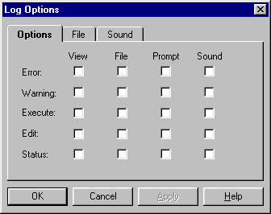
You will also have a tab labeled ‘File’. Click here and enter a file name if you want a permanent record of the log and have selected a choice under ‘File’. If ‘File’ is not specified, the log will only record the steps of this run. If you choose to create a log file, make sure that you turn it off after you have captured enough information. The log will continue to grow every time this profile is executed and can, eventually, reach a large enough size to affect operation of the program. After completing your selections, minimize the log window.

Step 5 - Sequencing Your Test
Open the Flowchart window by clicking on the Flowchart Icon. The flowchart is where the actual testing takes place, but it is more than a test. It is a complete sequence of actions necessary to perform a number of tests, all within the same profile. Think of this as looking at an EUT (Equipment under test) profile where all the tests required are outlined to fully certify this EUT. You may need to perform an emissions test (both conducted and radiated) as well as a 3 V/m immunity test. Within TILE/ICS are all the components needed to perform the required testing. One of the greatest advantages of this approach is that all the data generated by the various tests is available in a common location (this saved file) in a common format - accessible to your standard word processors and spreadsheets. Think of a TILE/ICS saved file as a file drawer with all pertinent data to the EUT stored together.
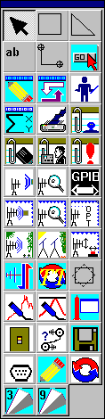
We call the sequence of actions a ‘test profile’. To create this sequence we have a palette of tools which can be pasted onto the flowchart in the order desired. Many of these actions are informational, some are actual tests and some are special functions related to hardware interfaces. The accompanying figure shows a typical palette. Some palettes have additional actions, or fewer actions, depending on the optional modules installed by the user. For this tutorial we will assume the basic requirements of emission and immunity testing and steer clear of the more complex requirements of Open Area Testing (with the related positional information) and Optimized Tower/Turntable motions.

Information Data
From the palette select the ‘GO’  action and place it at the upper left hand corner of the flowchart. Remember the flowchart is a drawing paper. You can scroll down the page for additional space or work sideways. There is no magic to the organization on the page. You could drop actions randomly and link them together into a reasonable test, but it might be more understandable to organize them either vertically or horizontally. In this example we will actually have two parts of the test, emissions and immunity, in addition to a set of information steps to identify the EUT other pertinent data. Working from left to right, across the top of the Flowchart window, drop the ‘EUT’, ‘Client’, and ‘Operator’ icons.
Double-click on the ‘GO’ icon. This will present the ‘Edit/Execute/Go’ options. Click on ‘Edit’, opening up this action’s options. This is the same process used to access all actions. Some will yield only a few options (such as this ‘GO’ action) and some will be quite complex (the ‘Immunity’ action is the most complex). The first page of every action is a prompt for a name. Every action used should be given a unique name. There are no fixed naming conventions although long complex names are difficult to work with in the graphical layout. It is important to use a unique name for each icon. At places within TILE/ICS you are given drop down boxes listing all the icons on the flowchart. If you use the same names, or no name, it is virtually impossible to insure you have selected the correct action. The name also allows you to start a test profile automatically when the program is opened by displaying the name of the first action to execute. This will be demonstrated later. For now give the ‘GO’ action the name ‘Start’. Next highlight each of the ‘EUT’, ‘Client’, and ‘Operator’ icons and name each. A unique name is important since any action can be used multiple times within a test, but these three are rarely used more than once, so name them ‘EUT’, ‘Client’, and ‘Operator’ respectively.
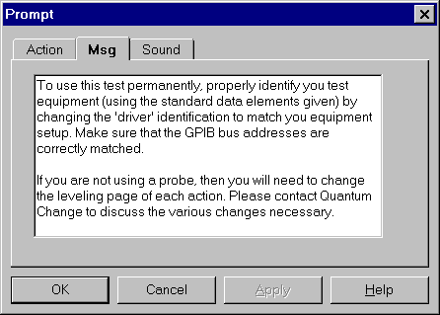

Step 6 Emissions Setup
Next we will begin to layout the emissions test. On the left and about three squares below the ‘GO’ action, place the ‘Prompt’  action icon. Double click and ‘Edit’ this action. The first tab is for Name, as is the first tab of all actions. Name this action ‘Prompt for Setup’. Click on the Tab marked ‘Message’. This gives you a place to enter a text message that will be displayed at this point during the test profile execution. Enter the following message in the block:
This is only a sample message but it illustrates some of the possibilities for its use. Test profiles can be constructed with as many prompts as wanted. This allows the designer to construct a test which can be performed by individuals unfamiliar with EMC testing.
Next drop the ‘Initialize Instruments’ icon on the flowchart to the left of the prompt. Initialize is used to send an initialization string to the instrumentation. Many instruments do not require a specific initialization, but some do. It is strongly recommended that any spectrum analyzer or receiver be initialized prior to use, since the complex states these can be left in vary dramatically.
Edit this action and name it ‘Initialize Instr’. Next click on the tab labeled ‘Instruments’. This will open a page with two columns. Column one is the list of defined instruments. Column two is reserved for the selected instruments. At this point click on the ‘SpecAnal’, highlighting it, and press the ‘Add’ button. This will put the spectrum analyzer on the list of instruments to be initialized. Add any other instruments that are necessary to column two.
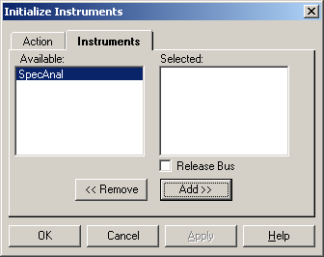

Measure Range
The Measure Range action is used to configure a measurement of a range of frequencies using a receiver or spectrum analyzer. The results of the measurement will be stored in the defined data element.
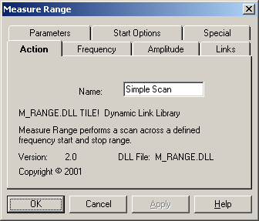

Name
Drag and Drop the ‘Measure Range’ 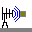 Icon to the right of the ‘Initialize’. When you edit this action you will see five tabs: ‘Action’, ‘Frequency’, ‘Amplitude’, ‘Links’, ‘Parameters’, ‘Start Options’ and ‘Special’. These tabs give you access to the characteristics of this step and allow you to customize them to your specifications. You can place multiple actions on a test profile, customizing each differently. For now, name this action ‘Simple Scan’.

Frequency
Click on the ‘Frequency’ tab.
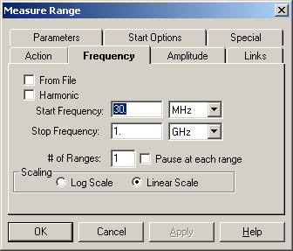
You have three items that are set here. Start and Stop Frequency control the width of the scan. Number of Ranges is used to split the scan into smaller pieces to allow for higher resolution. A more detailed explanation of this action is found in Chapter 10. When you address a spectrum analyzer, the information that is passed down the GPIB is the actual dpi screen resolution of the analyzer (this is not true of most receivers). Resolutions vary from 400 dpi to 1300 dpi. For that reason, TILE/ICS offers a convenient way to insure adequate frequency coverage while still minimizing your setup requirements. Simply specify how may ranges to break the frequency scans into and TILE/ICS will automatically take these small screen shots and sum them together into a common output. For example, if you are using a 120 KHz bandwidth for a 970 MHz scan (30 MHz - 1000 MHz). Then 970,000,000/120000 yields 8083 points. If you are using a 1000 point resolution analyzer (such as the HP8566/8), you would need 8-9 ranges. If you are using a 400 point resolution (such as the HP8591), you will need 20-21 ranges. Keep in mind that TILE/ICS is a platform which allows you to control your instrumentation. In designing your test profiles you must have a good fundamental understanding of the capabilities of your equipment.
For this example, leave the default start/stop frequencies at 30MHz - 1GHz. Set the number of ranges to an appropriate number given your spectrum analyzer or receiver.

Amplitude
The amplitude setting controls the upper scaling factor for your analyzer/receiver.
Setting this too high will give you an unacceptable noise floor. Setting it too low will cause your signals to be in saturation. Certain commercial specifications use 80 dBuV. Set the amplitude to a value of 80. This setting is primarily used with Spectrum Analyzers. If you are using an EMI Receiver, you may leave this on the default; since it has no significant meaning with a receiver. The ‘Attenuation Level’ settings allow you to control the noise floor and saturation level of your analyzer. Set this number to an appropriate value (or leave the default in place).
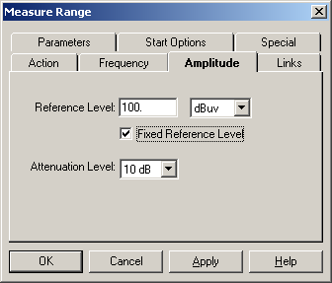

Links
The phrase ‘Links’ is used throughout TILE/ICS to refer to the data elements and instruments which will be effected by each action. In the case of this emission scan, the data element ‘raw’ was created to hold the results of this action. Click in the ‘data’ field. The down arrow will display all the available data elements. Click and select ‘raw’.
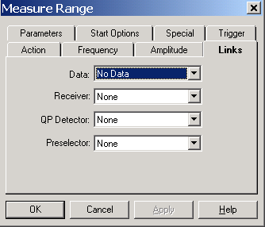
Next click on the ‘instruments’ field. The down arrow will display all the available instruments. Select the ‘SpecAnal’. In certain cases, a Preselector is also used. In those cases you will have created an instrument for the Preselector and identified it in this drop down. If you receiver/analyzer has a built-in Preselector it is not necessary to identify it separately

Parameters
The parameter fields allow you to specify the exact bandwidths, sweep time, and number of sweeps for this action. The use of multiple actions within the same test profile allows you to perform various wide band and narrow band scans within the same test.
The two resolutions, RF and Video bandwidth, need to be set to an appropriate measurement. For this example, select either 1 MHz or 120 KHz for each resolution. Depending upon the standard that you are attempting to meet, you may need to select a wider video bandwidth resolution. TILE/ICS allows you to control the exact condition of your test. Nothing is mandatory. Certain instruments do not support large video bandwidths. In these circumstances, the system will step to the largest available resolution for the instrument.
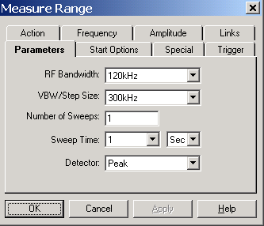
Sweep time is defaulted to 1 sweep at 1 second. If you set the number of sweeps to more than 1, the analyzer is automatically set to Max-Hold and the number of sweeps designated are performed. One unique feature of TILE/ICS is the ability of the test to be performed exactly as the engineer wants it. This includes the ability to set the analyzer in a condition that is incorrect. There are not internal limits to the parameters that can be set. For instance, if you set a 1KHz bandwidth with a 1 second sweep time on most analyzers, you will generate an ‘Out of Cal’ condition. It is up to the user to test emission parameters to determine the appropriateness of any combination.
This completes the design of the emission scan. Click ‘OK’ to accept this action. At this point, it would be a good idea to test the settings of the action. Double click on the action and select ‘Execute’ to begin a scan. Observe the analyzer to insure that the parameters and scan are acceptable. If the action was set for more than one range, the display will only show the last range. If you want to see the complete range it is only necessary to open a graph window to see the complete scan.

Creating A Graphical View of the Data
The data elements that have been created earlier are permanent elements of the test (unless they are consciously deleted). Each is a repository for information. Once the ‘Simple Scan’ has been executed, the data element ‘raw is filled with the information generated. There are two ways to verify this.
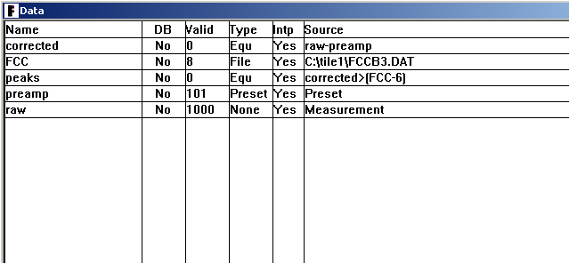
First, switch to the Data window. On the row for the ‘raw’ element, the third column is labeled ‘Valid’. This column contains the number of valid data points stored in this element.
The second method involves creating a graph or table view of the data. Graphs and Tables are temporary views of the data elements. The word temporary is used here to illustrate one distinct point. When you create a graph or table, they are present only as long as the window is open or minimized. If the window is closed, the graph or table disappears. This is important to keep in mind when opening and closing windows. Choose ‘Minimize’ unless you really want them to close the particular table or graph.
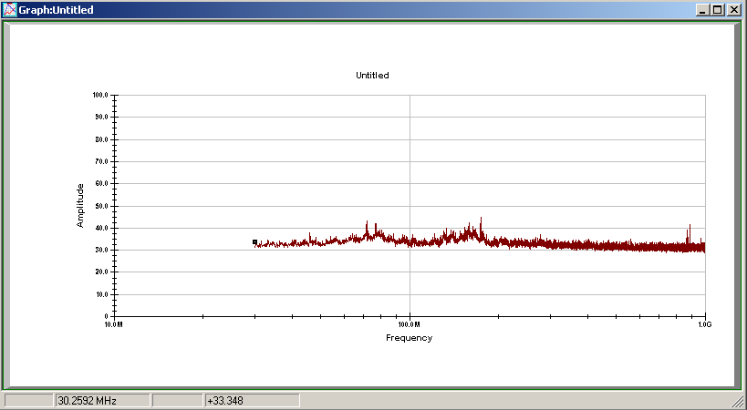
To create a graphical view of the data, first click on ‘Window’ on the upper tool bar. The fourth item down is ‘Add’. Click on ‘Add’. You have the choice of creating a graph or table. Click on graph. This opens a blank graph window. Now select ‘Display/Data’.
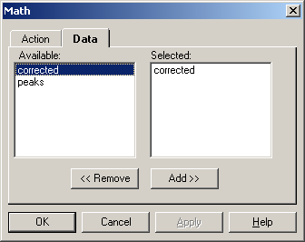
This will display a two-column selection window. The first column shows the available data elements. The second column indicates the selected data elements. Highlight ‘raw’ in column one and click ‘Add’. Now click ‘OK’ to display this element on the graph. This will display the complete range of values stored in ‘scan’.
If you are satisfied with the results of this scan, we are ready to continue designing our test profile. If the scan is not complete, if the analyzer indicated saturation, or any other setup problem exists, check the settings again. Minimize (do not close) the graph window and bring the flowchart to the foreground. Double click on the Emission action and edit the parameters. Re-execute this action after changing parameters until you achieve the scan results that are anticipated.

Performing Math Functions
After the scan, it is necessary to correct the scan data to reflect the correction factors for the preamp (or cables and antennas). Drag the Math  icon to the flowchart and line it up next to the scan action. Double click and edit the action. First name the action - ‘Correct Scan’. The second tab is labeled ‘data’. Click on this tab and a two column selection window is presented. The math data element ‘corrected’ was defined as the equation that would correct the scanned information. Select this element and click ‘add’. This will cause the math equation to be executed when this action is executed. Accept these parameters and return to the flowchart.
Execute this action. Change to the Data window and check that the element ‘corrected’ now shows valid data. Open the data element, select the ‘values’ tab and look at the information. If you open the data element ‘scan’ and look at these values the difference should be exactly 26 dB. Another method to check this would be to open the Graph window and add this element to the graph. It should display a line identical to the ‘raw data but reduced by 26 dB.
Drop another Math action on the screen. Edit this to select the element ‘peaks’. You can identify more than one equation in one action. They will be executed in the order they are selected. Since ‘peaks’ includes the results of ‘corrected’, it should be executed in sequence after the ‘corrected’.

Quasi-Peak Measurements
The values of the math function ‘peaks’ should yield those points requiring quasi-peak measurement. Select the Measure Peaks  icon from the palette and place it next in sequence. Edit the action. The tabs are ‘Action’, ’Frequency’, ‘Amplitude’, 'Output', 'Search', 'Parameters', and 'Instruments'. Name the Action ‘Perform QP’. Next select the ‘Frequency’ tab. The only choice on this page is to select the data element from which the quasi-peak frequency points will come. We defined ‘peaks’ as this function and performed it earlier. This will have filled this data element with the valid number of points. The other choices on this page are described in Chapter 10 and are not important at this point. Do NOT check any boxes on this page. Select ‘peaks’ on this page and then move to the ‘Instrument’ tab.
The ‘Instrument’ tab is similar to the emission action with the exception of the addition of ‘Quasi-Peak’ in the instrument definition. Since many analyzers use a separate QP adapter, this should be identified separately both in the instrument definition and on this page. Many analyzers and receivers have the QP function internally. In these cases you do not need to name a separate QP instrument. Select the appropriate instruments for this test. If you select an instrument that does not have a QP function without naming a Quasi-Peak instrument, the software will perform an emulation of the QP measurement. This WILL NOT meet the requirements of the IEC regulations. This will be similar to a prescan.
The ‘Amplitude’ tab allows you to set the reference level and RF attenuation level for your instruments.
This action can also be used to measure a unique set of frequencies for peak, quasi-peak and average, but in this example we are going to measure Quasi-Peak only. The ‘Output’ tab seeks a name for the results of this action. We defined a data element called ‘qp’. Select this for the 'Quasi-Peak' section of 'Output' and check the box in front of it. If you are using this action to measure average or peak, select these also and link an appropriate data element. You can only make one type of measurement in an action, so choose carefully.
The 'Search' tab provides some control of the search algorithm, especially in conjunction with 'Parameters'. When performing a Quasi-Peak measurement, in particular, you may need to limit the search band when large signals are relatively close together. Furthermore, you may wish to force a reading only at the specified frequency. In this case DO NOT check the 'Peak Search' box. ‘Parameters’ is identical to the 'Measure Range' icon. Select the appropriate settings for your test.

Final Step
We have now created a complete test profile for an emissions measurement. We could have included tower movements , turntable position , manual capture and optimization using the OATS  actions, Scanned for peak readings with tower/turntable maximization using Scan Range 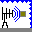, or Scan Peaks  icons. To provide for a reasonable ending, insert the Comment 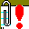 icon which will prompt the operator to included any comments concerning the test These comments are saved as part of the overall profile when run and provide additional information for reference purposes.

Connecting the Actions
Once all the actions are laid out on the flowchart and appropriately identified (and named), it is time to sequence the test. We have laid out the actions in a reasonable graphical fashion. The linkage of the actions determines the sequence of execution. Select the Linkage 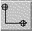 icon. Click on the Start icon one time. This sets the first anchor. Now move to the EUT icon and click twice. This sets the final anchor. You will see the following.
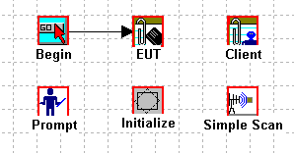
Now connect the remaining actions in the desired sequence. Occasionally you will see a connection that does not have an arrow. This was caused by the second placement, which occurred when you double clicked. If you double clicked slowly, it sets an ‘anchor’ under the action with the pointer head underneath. You can highlight the line, delete it and reconnect; or just leave it alone, the action will execute correctly. The test profile is now ready for a complete execution. Go to the ‘Start’ action, double click and then select ‘Execute’. This will start the chain executing in sequence. Observe the emission scans and QP scans in particular to insure they sequence as you defined them.

Creating an Immunity Profile
Immunity tests are designed to check the operation of electronic equipment under the influence of electromagnetic disturbances. During the course of immunity testing, the equipment is powered on and operating.

Our Goal - Performing an Immunity Test
In creating an Immunity profile you can add these steps to an existing profile, creating a requirements profile (i.e., including both emissions and immunity tests under one profile), or you can ‘File/Close’ the current profile and create a ‘New’ profile. The general method of creating an immunity test is the same as creating an emissions test. Define your data elements, define the instruments, and layout the sequence of the test. For demonstration purposes, we are going to create a test based upon the EN50082 test requirement. This is a staggered immunity test with 3 V/M across most of the band and 10 V/M in certain designated ranges (such as the FM channels).
There are two parts to this test. The first part entails creating a leveled field using the Immunity Calibration Icon. The Second part comprises the Immunity test itself. The immunity test will use the output of the immunity cal to perform the leveling steps.

Define Data Elements
To begin we will need to make sure that data elements exist for the following items:
- Calibration of Amplifier (even if amplifier is not GPIB controlled)
- Calibration of Power Meter (if used)
- Calibration of Probe (if used)
- Specification Limit Data
- Signal Output (from Immunity Calibration)
- Probe Output (from Immunity Calibration) - (if used)
- Power Meter Output (from Immunity Calibration) - (if used)
- Probe Output (from Immunity Test) - (if used)
- Power Meter Output (from Immunity Test) - (if used)
- Pass/Fail
- Signal Output (from Immunity Test) – (if leveling is being used)
The calibration data elements will be linked to data files. Go to the Data Window 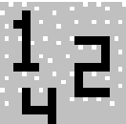. Select ‘Edit/Add’ or use the Add Data icon. Name the Data Elements (call the first one ‘CalAmp’). Next move to the tab labeled ‘Source’. Select ‘file’ and browse for the appropriate data table. If you are not sure, choose the ‘Amp.Dat’ file. This data file illustrates a 50dB amplifier cal table. If your amplifier is stronger, it will increase the number of steps needed to level properly and possibly overshoot on the first step. If you amplifier is smaller it will only increase the number of steps.
Create Data elements for the Probe and Power Meter calibrations in the same manner.
Next load the specification limits. In this case create a new data element called ‘speclmt’. Select the ‘Source’ tab, select ‘file’, and browse until you find a file called ‘EN50088.dat’. Select this file. Move to the ‘Values’ tab and hit initialize. This will load the file and show you the values for this data element.
The rest of the data elements are all ‘Measurements’ and need to be defined. Essentially you will create a new data element, give it an appropriate name (for example ‘sigout’ for the Signal Generator Level from the Immunity Calibration) and than select ‘OK’. All the defaults are fine for these data elements. Use the list above to create data elements. At a minimum create the following:
- CalAmp (Source - File)
- CalProbe or CalPmtr (Source - File)
- SpecLmt (Source - File)
- SigOut (Source - Measurement)
- ProbeOutCal or PmtrOutCal (Source - Measurement)
- ProbeOutFinal or PmtrOutFinal (Source - Measurement)
- Pass/Fail (Source - Measurement)

The Immunity Test Profile
We are now ready to create an immunity test profile. If you are adding immunity to an existing profile, just start at the completion of the last step and start sequencing the immunity test. If you are creating a separate profile, you might want to add the ‘EUT’, ‘Operator’ 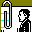 and/or ‘Client’ icons. Look at the ‘Information Data’ in the emissions section of this tutorial to see an illustration of these steps.
Next drop a ‘Prompt’ Action in the sequence. It is good practice to prompt for hardware setup prior to beginning the immunity calibration. Start by editing the action (double-click on the icon), select ‘Edit’. Name the action, for example ‘Immunity Cal. Setup’. Move to the ‘Msg’ tab. Enter an appropriate message, for example:
Press ‘OK’ upon completion of your message. You may wish to execute this action (only this action will execute when you double-click and choose ‘Execute’) to insure that it looks and displays information the way you intended.
Setup the Instrumentation to perform an immunity calibration. Connect the Signal Generator to the Amplifier, and connect the Amplifier to the Antenna in the Chamber. Make sure the Probe is positioned where the EUT will be placed during the final test.
Next we need to start configuring the Immunity Calibration. Immunity and Immunity Calibrations are the two most complex actions in the TILE/ICS system. There are a number of unique settings which control exactly how you want to perform your test. In addition, the Immunity Calibration can be used to dramatically shorten your testing time by optimizing the test to your instrumentation and site setups.

Define Instruments
It is necessary to identify the instruments that will be addressed by the GPIB during the test. Move to the Instrument Window using the shortcut icon 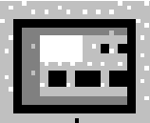. A minimum requirement to perform the immunity test is that you have a signal generator. Create an instrument using either ‘Edit/Add’ or the Add Instrument icon. Name the instrument ‘SigGen’. Move to the ‘Driver’ tab and ‘browse’ to find the instrument driver for the signal generator model you are using. Select this instrument driver. Move to the ‘Address’ tab. On this page you will select the GPIB address for the instrument. Set the appropriate address for your signal generator and then select ‘OK’ to complete the definition.
Create the Probe, Power Meter and Amplifier instruments (as required).

Calibrating the Immunity Field
Drop the Immunity Calibration icon  on the flowchart after the ‘Prompt’. Double-click and edit this action.
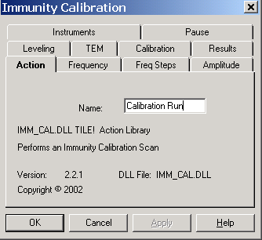
There are ten (10) tabs in the immunity calibration.
- Action - Action Name (used to identify unique actions during quick starts or OLE links).
- Frequency - Controls the frequency range for this test.
- Frequency Steps – Sets the behavior of certain conditions during the test.
- Amplitude - Determines the amplitudes to be used during this test.
- Leveling - Method of leveling. Choices are ‘No Leveling’, ‘Power Meter’, ‘Probe’.
- TEM – Identifies whether or not a TEM cell is to be used along with the TEM cell height and impedance characteristics.
- Results - Stores the results (instrument settings) of this test
- Calibration - Links instruments to their respective calibration files.
- Instruments - Selects instruments used in this action.
- Pause – Allows the user to specify frequencies to pause the test to change instrumentation.
The first tab is ‘Action’. Enter an appropriate name for this action - ‘Calibration Run - EN50088’ for example. This should be a unique name for the action. If you were to configure a test that ran one calibration at 3 v/m and one at 10 v/m, do not call them both ‘Calibrate’.
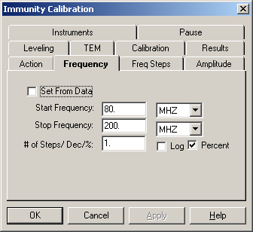
Select the ‘Frequency’ tab. On this tab you have two major choices. To run from a predefined frequency table (data element) or to select a set of stepped frequencies. There is a small box labeled ‘Set from Data’. If this box is checked a box appears that allows you to select an identified data element.
If you were performing an IEC test, you may have a data element defined that is the 1% stepped frequency points required by the standard. If this is how you need to run this test, go to a spreadsheet and create a table of values (column 1) that is the stepped frequency steps that you want. Fill in column 2 with the number ‘3’ (a default spec limit). Save this into a Comma Separated Variable (CSV) format in the TILE/ICS directory. Call this data file ‘IECPoint.dat’ or ‘IECPoint.csv’. Create a data element called ‘SpecPnts’ and link it to this data file (you can type in the ‘IECPoint.csv’ name into the file link even though it does not appear in the file list). You can now call this data element from this tab to run those specific values.
The other choice is to select a start and stop frequency, the number of steps (the total actually tested will be one more than the number of steps specified) and whether it needs to be logged stepped or not. Make sure that the start and stop frequency agree with the range of values allowed in the Calibration tables for the instrument being used (the CalAmp, CalProbe and CalPmtr elements). If the ranges are inconsistent, the action will not perform properly.
The next tab ‘Frequency Steps’ controls certain special conditions. For instance, certain signal generators have internal mechanical relays that switch on/off when RF is turned on/off. When stepping from one frequency to the next we normally set the RF to a minimum attenuation and then turn off the RF, step frequency, turn on RF, set the attenuation to the desired level. This will cause relay clattering in some signal generators. If you want to restrict this type of sequence, just check the box labeled “No Sig Gen On/Off between Frequencies”. The ‘Use Previous Amp for Best Guess’ allows you to dramatically speed up your calibration sequence. These are all discussed in Chapter 10.
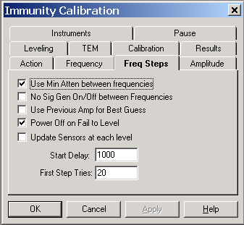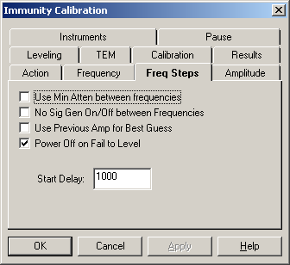
Next select the tab labeled ‘Amplitude’. There are three choices for data units on this tab. What is the name of the data element that controls your amplitude
level? This is a critical definition in the TILE/ICS system. Data elements and data files do not have an automatic value conversion. If your specification limit is in V/M and you are using a power meter for leveling, the amplitude table must be in dBm to match the power meter. This may require you to create a separate data element as an equation and transform the specification limit into the relevant. If you are using a Probe for monitoring, the specification limit is directly usable. You can continue on. If you are only using a power meter or no leveling at all, call Quantum Change for assistance in setting this up fully. In this example, we named an element ‘speclmt’. Set this as the data element for this tab and move to the next tab.
The next step is ‘Leveling’. This tab has a number of choices that relate to the leveling criteria. The first choice (and default) is to use ‘No Leveling’. This feature is handy for calibration of cables or power meter setups. In this mode, your amplitude (the previous tab) is a table of dBm values, for example a fixed -10 dBm. By injecting a known signal into a test setup with the power meter in line and a 50 ohm termination on the coupler, the measured output of the power meter less the input power level will equate to it’s calibration table (a common table covering both the power meter itself, the cables involved and the losses of the coupler). ‘No Leveling’ is also usable in TEM Cell or GTEM Cells where the impedance is known and you can calculate the field.
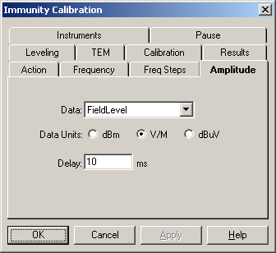
If ‘No Leveling’ is chosen, no other field on this page is used in the calibration.
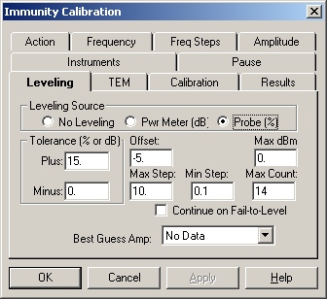
The tolerance level should be set to an appropriate value for you method. If leveling to a ‘Pwr Meter’ these values represent +/- dB values. If leveling to a ‘Probe’ these are percent tolerances (i.e., 10%). Select the type of leveling appropriate for your setup. The other settings can be left alone for now, using the defaults, but are discussed in greater detail in Chapter 10.
We will be ignoring the ‘TEM’ tab but it is discussed in greater detail later.
Select the 'Calibration' tab. In performing immunity measurements, it is necessary to calculate the error margins in each of the instruments used. In this way, the probe error is automatically adjusted and all readings are corrected numbers. The amplifier correction is used in the estimations of the needed signal generator levels If an incorrect amplifier correction number is shown, it will be difficult for the system to automatically level.
Enter ‘CalAmp’ for the amplifier. If you are using the probe or power meter enter ‘CalProbe’ and ‘CalPmtr’ in the appropriate sections. We are not defining a complex power meter test, so the ‘Power Meter2’ setting can be ignored. The data elements should have been defined earlier. If not, click OK; go to the ‘Data’ Window and define them; enter edit mode again and resume editing this action.
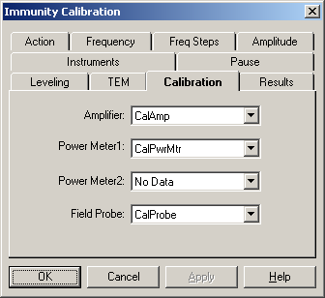
Select the 'Instruments'. tab. On this page we need to identify which instruments will be present during the test. In immunity testing the signal generator is mandatory. The drop down arrow will give you access to the named instruments. Select the signal generator.
The remaining choices are determined by your test setup. If you are using a field probe, select this instrument. If you are using a power meter, select this instrument. Regardless of which leveling method you are using, you can record the levels of any of the optional instruments. This is convenient when we want to level with the probe, determine the signal generator level needed and than remove the probe for the final immunity test. Under these circumstances, recording the power meter levels in both cases will allow us to determine how accurately we are replicating our expected field level.
You should enter the amplifier only if it is equipped with a GPIB interface. Again, drop down the arrow and select the named instrument.
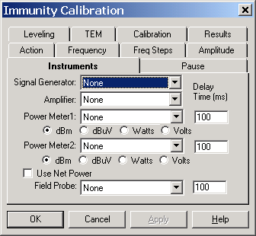
The ‘Delay Time’ settings, for the power meters and probes, allow the user to control the amount of leveling time between the trigger and the reading. Probes and power meters as a class are usually designed to always talk. Whenever you request a current reading they will immediately return the current valid reading. Unfortunately, most of them will not tell you they have not leveled since they were triggered and will send the LAST valid reading, not the current one. To prevent this TILE! gives you the ability to insert a delay between the trigger and the reading to make sure the instrument has leveled properly. This is discussed in greater detail later, in Chapter 10.
Select the 'Results' tab. In this section we need to identify those data elements that we wish to record during the immunity calibration. If we are leveling, for instance, we might want to record the signal generator level present when the field level is achieved. Then, during the immunity test we can quickly achieve the level desired by injecting this signal into the EUT, without leveling. Select the Signal Generator box and enter the ‘Sigout’ data element. If you desire Power Meter or Probe information saved, check the appropriate boxes and use either ‘ProbeCalOut’ or ‘PmtrCalOut’ (which were defined earlier).
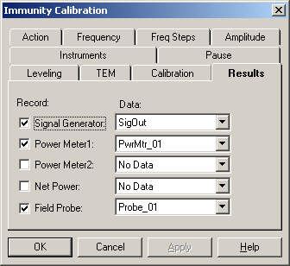
Recording power meter or probe levels can be used to graph your results after your test is done. Check the appropriate results you want and select the data elements to save the information to.
Now that we have defined the calibration that we need to establish, we are ready to define the Immunity Test.

Performing an Immunity Test
The immunity action is similar in structure to the Immunity Calibration, but it includes specific control of the modulation, test dwell time and pass/fail monitoring/recording. Structurally, you could configure the immunity test to run a fully leveled test. This would only require that your EUT and probe not interact. A more common test would entail running the calibration first, determining the signal generator level necessary to create the desire field, then running the immunity test with the signal generator level being directly set to those recorded during the calibration step.
To begin the immunity test, drag and drop the immunity test icon onto the test profile after the Immunity Calibration icon. Double click and select 'Edit'. You will immediately notice that the tabs are identical to the Immunity Calibration with six additional tabs - AM Modulation, FM Modulation, Monitor, Threshold, Check, Process, and Pass/Fail. These allow the user to establish defined characteristics of the desired test per the relevant specifications (for example IEC-1000-4-3's requirements for 80% modulation).
If we have run the Immunity Calibration, then the conceptual setup of this action is slightly different. In the Immunity Calibration we determined the necessary signal generator level needed (in CW) to establish a desired field. We now use this input in the Immunity Test to establish a known field, with modulation on if required. On the 'Frequency' tab and 'Amplitude' tab enter the data elements containing the signal generator output information measured during the Immunity Calibration. You might want to review the settings on the ‘Frequency Steps’ tab. On the 'Leveling' tab, leave the default setting of 'No Leveling'.
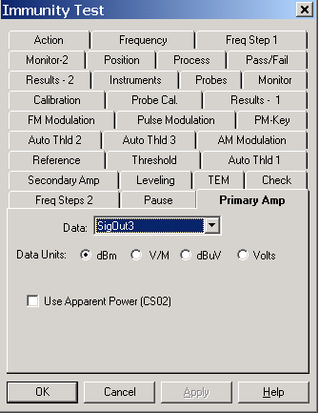
Next set the 'Instruments', 'Results' and 'Calibration' as were shown under Immunity Calibration. In the Results field, remember that we should have a separate set of data elements for the output of the final test that were used for the output of the calibration step. Also, you have the option to record the levels for multiple probes, but this is discussed later. If you forgot to define all your data elements, say 'OK' to this action, window to the 'Data' Window, define additional measurement data elements, window back to the 'Flowchart', double-click on this action and return to the edit function. There is absolutely no reason not to add elements or instruments when you determine the need. The only risk is forgetting to return to the incomplete action and make the corrections/additions.
The ‘TEM’,‘Check’, ‘Reference’, ‘Threshold’ and ‘Auto Thld’ tabs are used in special circumstances. They are explained in Chapter 10, but are not necessary in this example.
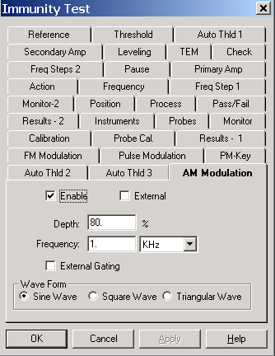
The first tab of interest in the Immunity Test is 'AM Modulation’. You can select 'Enable' or 'External'. If you do not want any AM Modulation, leave the 'Enable' boxed blank. If you check this box, you need to add or change the 'Depth' and 'Frequency' settings. If you are using an external modulation generator (set manually) then check 'External'.
'Depth' is the range of AM modulation at this frequency. A typical value is 80%, which means that the signal will vary between 20% and 180% of the reference level. The 'Frequency' relates to the repetition rate at which the modulation will be cycled. It basically relates to the sound that will be produced by the signal. The human voice operates from the high Hertz to 12-15 KHz. This signal is used to imitate the radio transmission of a human voice.
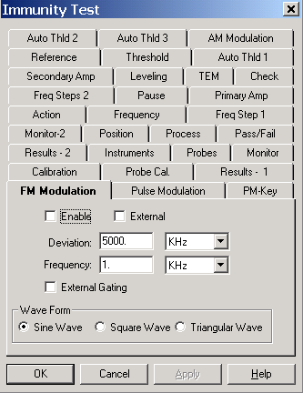
The next page is 'FM Modulation'. The first two items are the same as on the previous page- 'Enable' and 'External'. Set them appropriately.
If you are enabling FM Modulation, you need to also set the 'Deviation' and 'Frequency'. Deviation relates to the bandwidth of the FM modulation. Frequency is the repetition rate.
With both AM and FM modulation pages, you can set them active at the same time. Make sure this is what you want. Although some generators will support this, most will not. If your generator will not support both at the same time, it could cause unpredictable results.
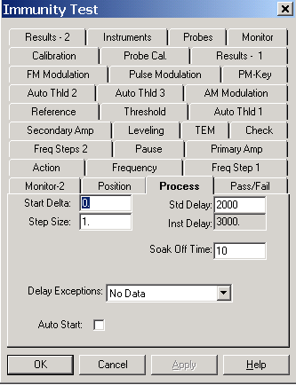
You can also set Pulse Modulation, but remember these modulations are generally incompatible with each other. Also, on the ‘Process’ tab is a choice for a keyed test which emulates a pulse modulated signal for certain specifications. See Chapter 10 for a further discussion.
There is a special Pulse Modulation method called the Keyed Test which allows you to perform a specialized pulse as required by the certain medical and automotive standards. The key test basically turns on and off the signal generator in a defined cycle of on times and off times for the number of cycles set in the action. This generates a pulse response curve without the requirement for a separate modulator.

The final stages are related to defining what to do during the test. The ‘Process’ tab controls the sequencing of events at each frequency point AFTER the appropriate field has been established and the modulation turned on. Most standards establish a norm for how long an EUT must be immersed in an immunity field. This is called ‘Std Delay’. For example, the IEC 1000-4-3 requires a 3 second dwell time. The dwell time is counted from the time the field level is confirmed. For this reason the dwell discussed here is completely different from the delay found on the ‘Leveling’ page. Once you apply signal to the amplifier, ‘Std Delay” relates to the time it takes the measuring instrumentation to return valid numbers. Dwell relates to the period after valid level has been established until the completion of the test.
The ‘Soak Off Time’ is the amount of time that the signal generator will be off between each frequency.
The ‘Pass/Fail’ page controls when and how the system records a failure. The standard system assumes manual interruption for failure reporting. There are options in TILE! that support automatic failure analysis.
In the previous paragraph we discussed steps within a frequency point. Within the Pass/Fail analysis, the system will prompt for failure at each step, at the completion of each step but prior to moving to the next frequency point, or at the completion of the complete test. Select an appropriate setting. When the action is running the operator always has the opportunity to override the automatic run and record a failure.
The ‘Call Action’ tab relates to Voltage Monitoring and other automatic failure analysis methods available in the TILE! system. There are not appropriate for our example and are discussed in greater detail in Chapter 10 and 12.
Now that we have defined the Immunity Calibration and the Immunity Test actions, we can run them to test our set-ups. Double-click on the Immunity Calibration action and select ‘Execute’. This action will display a dialog box during the run. The dialog box displays current frequency, step number, and target amplitude in the upper box. The lower box displays information relating to the leveling loop itself. Current amplitude, leveling attempt number and delta %. Delta % refers to how much the last step changed the signal generator level stated in percent. The stop button will abort the current run (after reading and clearing the GPIB).
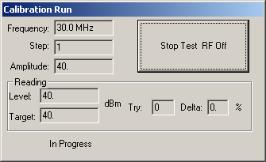
After completion of this execution, check the ‘Data’ Window to insure that valid numbers were written to the ‘SigOut’ data element. Once these have been confirmed, we can begin testing the Immunity Test. Double-click on the Immunity Test and ‘Execute’. The dialog box presented is more complex than the Immunity Calibration and provides the user with great flexibility.
The first box displays the first frequency point in our test set (SigOut). The adjacent box indicates target amplitude and step information. The third box indicates current readings and is normally blank until we start the test. In the lower left corner, the current leveling loop information is displayed. Again, this is blank until we begin the test.
The default behavior of this dialog is to start in automatic mode. This can be changed on the ‘Process’ tab. Since we defined this test to use ‘No Leveling’ it will set the signal generator to the designated signal level, read the probe and/or power meter and determine when to go to the next step.
If we marked the ‘Run complete test’ box on the ‘Pass/Fail’ page, the system will level each step, pause the preset dwell time and move to the next frequency point. The ‘Start Auto’ button will change to ‘Halt’. At any time the operator can ‘Halt’ the test, manually step backwards or forwards, change the levels and pass or fail the EUT at the current frequency.
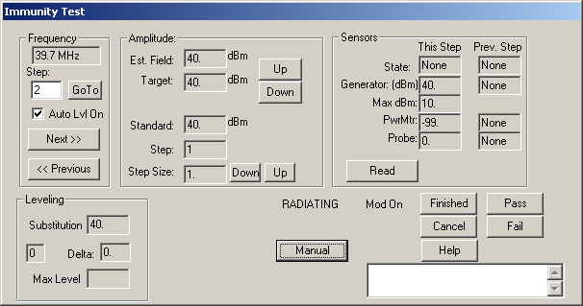
While in manual mode the button returns to ‘Start Auto’ mode. After making manual selections, you can re-start the auto mode from the current frequency by clicking ‘Start Auto’.
At this stage, you can run through the complete frequency range or ‘Cancel’ the test. We have finished building the profile and testing our definitions.
The last step to building this profile would be to insert a Comment icon . This will prompt the operator at the end the test to enter relevant comments. Double click and edit this action, name it ‘Final comments’. Now link all the actions together and you are ready to run this profile.

TILE! System Overview
TILE! Operates in a standard 32-bit Windows environment with standard windows controls and it is optimized for Win95, Win98, Win2000 and WinNT, which are true 32-bit operating systems.

The TILE! Environment
There are five standard windows that are always present when any TILE! profile is opened. These are called Flowchart, Data, Instrument, Log, and Audit Trail. Each of these windows represents a logical division in the system’s structure of procedures and definitions required to run a test. This configuration allows the user to control the setup and flow of the test by moving freely between functional windows.
The standard TILE! Windows have the following purpose:
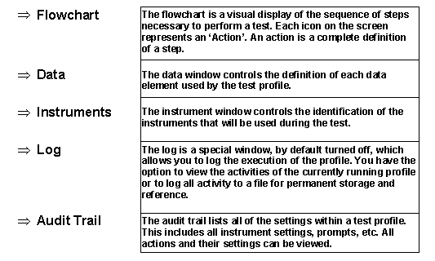
The control and manipulation of these functional windows are described in further detail in the succeeding chapters of this manual.

Operational Overview
There are three necessary steps to create a test profile.
- Define the Data Elements to be used
- Identify the Instruments used.
- Setup the sequence of the test using the Flowchart.
A step-by-step discussion of how to build a test profile is in Chapter 3 TILE/ICS Tutorial.

Tool Bars within TILE!

Windows Menu Bar
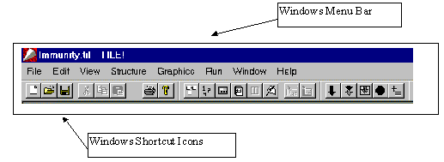The TILE! software uses standard Windows pull down menus. The menu options will change according to which functional window has the focus. The most common items are the ‘File’ and ‘Window’ drop downs.

Windows Tool Bars
The Windows Tool Bar is the more traditional Windows control method. The shortcuts are icons that allow you to quickly perform a selected action without the tedium of stepping through different drop down menus.
This use of icons to shortcut execution of certain steps is intrinsic in the design of the TILE! system. The Palette of actions, used in designing a test profile, is completely based upon icons. The Windows Shortcut Icons are a powerful tool for quickly maneuvering between different windows on your screen.
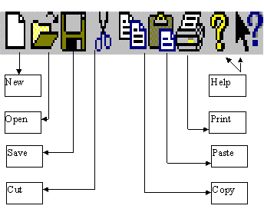

The Toolbar
The Toolbar contains a group of standard windows tools; New, Open and Save relate to file shortcuts. Cut, Copy and Paste relate to object and text manipulation. Print causes the currently highlighted window to print. The printer defaults are set in the ‘File/Printer Setup’ menu. Help uses the standards window help structure to access TILE! on-line help files.

The Status Bar
The status bar displays information on the status of the window. Items such as current action, time, elapsed time are displayed. The only control the user has is to display the line or to turn it off. There are no options for configuring this information.

The Command Bar
The Command Bar provides shortcuts that allow control of the execution of the TILE! program.
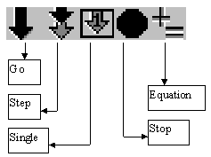
The Go, Step and Single buttons bring down a dialog box which will display all the defined steps of the flowchart.
Go starts the test running from the selected step. The Step mode starts the test running but pauses after each steps operation. The Single only performs the indicated step. Stop halts execution of the test. It may not stop an action that is already in communication with the GPIB, but it will cause a break at the next available step of the test.
The Equation shortcut causes all defined equations to be updated. This is especially helpful when you have imported a secondary data set and want to update equations defined in the test profile. The Stop button currently does not perform any significant function since other ‘Stop’ buttons are present in the individual dialog boxes.
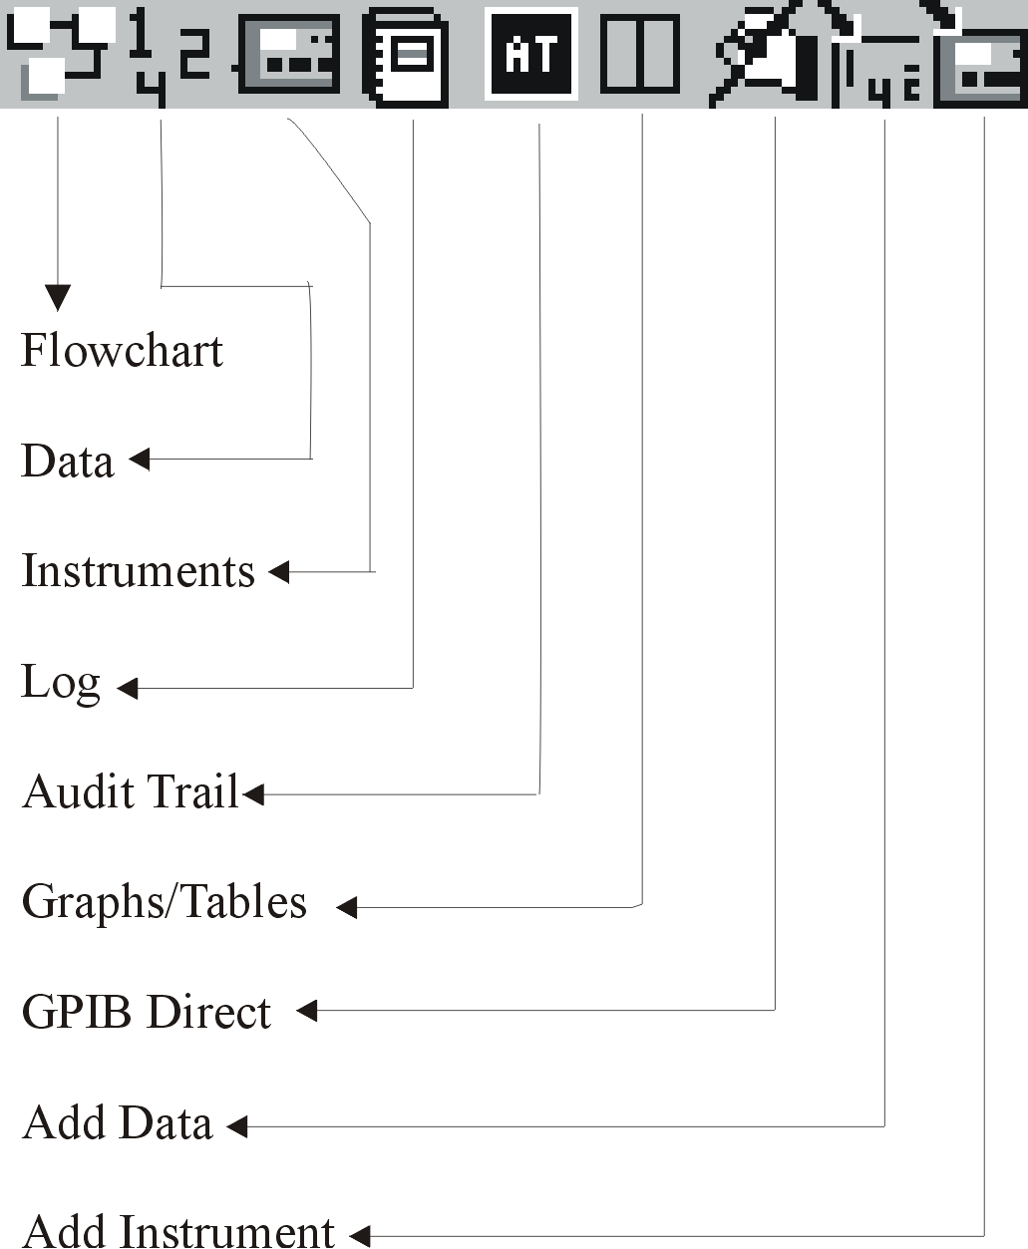

The Popup Bar
The Popup Bar contains shortcuts which allow you to quickly move from one window in the system to another.
Clicking on the Flowchart, Data, Instrument or Log icons will bring that window to the front.
The GPIB Direct symbol gives you access to the GPIB bus. This allows you to send direct commands to instruments (to test the bus, to clear the bus or to debug instrument instructions). This is roughly comparable to the National Instruments IBIC (or Measurement and Automation Explorer), but uses the TILE! defined instrument names and addresses

The Windows Menu Bar
The Windows menu bar options available within TILE! are defined as follows:

File
The File option is common to all menus. See the Windows manual for details on common options. ‘Options’ is one of the selections available in the File menu. Use this selection to set the GPIB driver you will use with the TILE! software. The only drop down menu which is not a standard Windows selection is ‘Options’.
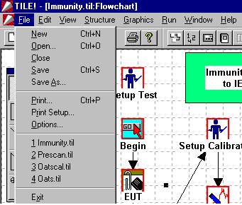

File/Options
‘Options’ is the menu used to define the GPIB interface, the Database output, the File options, and the Security settings.

GPIB
Quantum Change provides a unique ‘.DLL’ file which handles communications between our program and the physical card. For example, with National Instrument cards we use a file called ‘NIGPIB.DLL’ which is found in the main TILE! directory. There is only one choice on this menu.
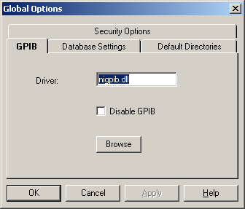

Database
The Database Options require the use of a separate Database module that is sold separately. If the database is present, the user needs to link the TILE! information to the appropriate database (ODBC) files. Defining ODBC linkages is not a simple process. The user is cautioned to make sure these are appropriate setup and properly identified within the TILE! system. Failure to setup the ODBC links may cause strange and unusual problems during execution. If this is active, there are a number of places where the user has control of data transfers. In the data definition, you choose whether to ‘expose’ each data element to the ODBC database. In the ‘Auto Save’ icon you can choose whether to make a database save or whether to just save to the local disk (this is extremely important to limit garbage being written to the database. No transfer takes place to the database without an affirmative selection by the user.
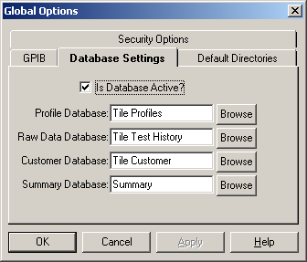

Default Directories
When TILE! opens the default directory for all file opens (whether instrument drivers or data elements), is the current directory, unless a separate default directory is identified. Using a separate ‘Profiles’ and ‘Data’ directory makes identifying users files much easier. The default location puts all customer data in the same directory with the samples, which increases the risk of losing data since the samples are overwritten whenever a new version is installed on the computer.
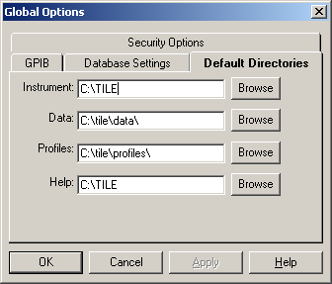

Security Options
The ‘Security Options’ tab is used to enable file security for the test profile. By default security is disabled when a new profile is invoked. There are two types of security, ‘File Level’ and ‘System Level’. Do not confuse the TILE! security with the tighter security possible under certain network control systems (such as Windows NT or other UNIX systems). Within TILE! you can control the users ability to edit certain features while retaining their ability to execute and save the profile. When security is active, the user cannot ‘edit’ any icon on the flowchart. The user can access data elements, but not change their ‘source’ type. But the user can make any changes necessary to the instrument definitions. Experience has demonstrated that it would not be unusual for the user to need to change the instrument driver of a pre-configured test (due to maintenance or troubleshooting).
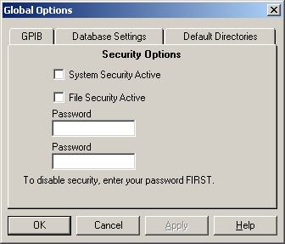

Edit
The Edit menu contains standard Windows options and changes to match the requirements of the Window that has the current focus. See the Windows manual for details on the standard features. See individual chapters for specific instructions.

View
The View menu changes to match the requirements of the window that has the current focus. See the Windows manual for details on the standard features. See individual chapters for specific information.

Options
The Options menu contains a file that controls the functions of the Log Window. See Chapter 8 - Log Window for more details.

Structure
The Structure menu is available when the current focus is the Flowchart Window. This menu option allows you to control the structure of the test flowchart. This menu option is explained in detail in Chapter 7 - Flowchart Window, Aligning Actions.

Graphics
The Graphics menu is also available when the current focus is the Flowchart Window. This menu option allows you to control how the graphics of the test flowchart are displayed. This menu option is explained in detail in Chapter 7 - Flowchart Window, Graphics Menu.

Display
The Display menu is available when the current focus is either the Graph Window or the Table Window. The Display menu changes to match the requirements of the window that has the current focus. This menu option allows you to control how the data sets are displayed. This menu option is explained in detail in Chapter 10 - Graphs & Tables.

Run
The Run menu allows for different options to start execution of a test profile. It is rarely used since you can access the same features from within the Flowchart. The primary use for this menu is to start a test running while keeping a graph or table in the foreground.
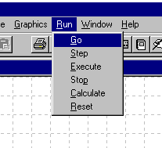
Go - Begin execution from the designated step.
Step - Begin execution from the designated step, but pause between each steps operation.
Execute - Execute this action only.
Stop - Stop execution of the current action.
Calculate - Re-calculate all data elements defined as equations.
Reset - Resets the Flowchart Progress Indicators.

Window
The Window menu contains standard Windows options and also contains an option to add Graph, Table, and Page windows. See the Windows manual for details on the standard features. See Chapter 10 - Graphs & Tables, for a description of the ‘Add’ Function.
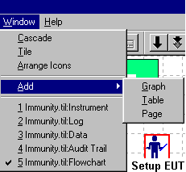

Help
The Help option is common to all windows programs. TILE! Help is a useful tool that hopes to answer all the questions that this manual covers in an on-line scenario.
The help file is an electronic copy of the manual.
The ISO 9000 Help is a special feature that allows the user to add user-generated help pages to the help system. Its primary aim was to allow the user to access work instructions from within TILE!.

TILE! Data Window
This chapter describes the procedures for defining, building, selecting, and managing data elements used in the test.

Overview
Each data element is an array of amplitude vs. frequency values. Each data element may be filled from an instrument measurement, a file, an equation or a preset value. The only practical limit to the number of data elements is your need and the available memory of your system.

Data Types
There are four types of data elements in the TILE! structure: measurements, file, equation, and preset. Each of these represents a unique capability over competing software. Within the TILE! system you can take a measurement, add an antenna correction factor, compare it to a specification limit and create arbitrary criteria with a few simples clicks of the mouse.
These data elements, when combined in a test profile, can provide a wide range of information on the EUT. This information is saved with the test profile and can be retrieved for future tests. This ability to track not only the final number, but each of the intermediate corrections, provides a powerful archiving tool for the test laboratory.
To take advantage of the flexibility of this system, you must understand the different element types and how to intermix them for maximum efficiency.

Measurement Elements
The most common element, and the default element type, is that most often seen in an EMC test - the results of an instrument reading. A measurement, by definition, is the result of an instrument reading. There are some exceptions - notably the GTEM Correlation algorithm but generally if the action involves a response from an instrument - it is a measurement.
Typical examples would be a spectrum scan, the power meter level in an immunity test, the quasi-peak reading off a QP meter and the field level from a probe system.
When defining a test, especially an emission test, start with the raw numbers (the measurements from the analyzer) and add or correct the readings going forward. One of the advantages of the TILE! system is that measurements cannot be changed by the user. You can create a correction factor and add them together to form a third data element, but the original information will always be present.
This is especially useful in documenting the test process, after the test or three months later. You can always look at the raw numbers and trace the corrections and adjustments that have made to reach your final output numbers. ISO 9000 and ISO 25 both have references to ‘proving’ the numbers are real. Once it is proven that the actual readings are the source of the numbers on the final report, this provides the path required to your instrument calibration. TILE! was designed to solve this problem.
The creation of these data elements is discussed in Adding Data Elements on page 44.

File Elements
There are many types of information that are used in an EMC test that are not related to the actual measurement but to the standard or the instrumentation. Correction factors, specification limits and gain tables are all samples of data that is needed in an EMC test, but which are normally maintained separately. File Elements allow you to import this information into the TILE! system and use them in a test profile.
The default file format is an ASCII text file. The general format for all data elements is a two-column table of information. The table should be comma delimited variables with column one a frequency component and column two a value. All white spaces are ignored. You must use commas (,) or semi-colons (;) as your delimiters. The size of the file is only restricted by your system parameters. You can create these table quite easily in the Windows Notepad or most spreadsheets. As the above illustrates, the frequency can either be in raw numerical values or in engineering terminology. The value (the second number) has no specific unit of measure. Its unit of measure is a function of how it is used in the test profile.
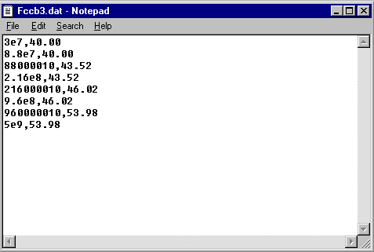
In the above example the table represents the FCC Class B specification limit at 3 meters separation. To create a stair step in the levels, there is a transition frequency point at 88 MHz, 216 MHz and 960 MHz. When creating a stair-step effect there should be at least a 1 Hz difference in the frequencies.
Importing this data into a data element allows us to use this information for graphing purposes, mathematical comparisons and peak searches. Correction factors take the same form, a table of frequency and value points. Correction tables include antenna correction factor, amplifier gain tables, cable loss tables, etc. When used in concert with the other data elements in the TILE! system, these elements add a high degree of flexibility to the users ability to configure and control testing. Creating these elements is discussed in File Page on page 45.

Equation Elements
In performing EMC tests, mathematically manipulating data is an everyday occurrence. The use of an equation as a data element allows you to create a new data element by mathematical reference to two or more other elements. Whether this is simply adding an antenna factor to a raw reading or performing obtuse mathematics to determine waveform performance, the equation writer has the flexibility to perform some fairly complex mathematics.
The equation writer is the tool for defining an equation element. It is discussed in greater detail in Equation Page on page 47. In the equation writer you define values using a wide range of mathematical functions. Some are as simple as adding or subtracting elements, but the complexity is only limited by your imagination.
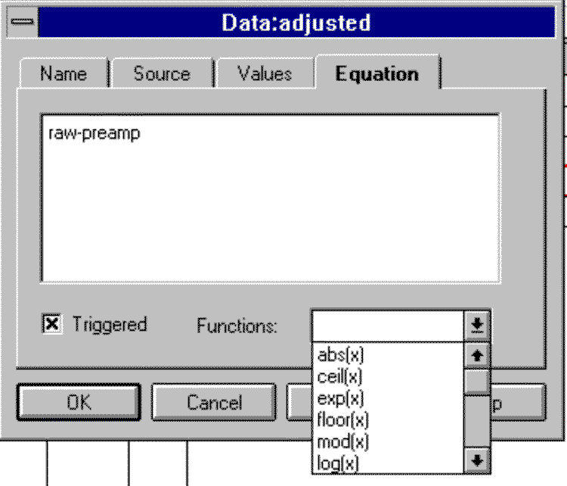

Preset Elements
The preset data element is a simple value generator used to create simple data sets. For instance, you may have a 26dB preamplifier that you need for only a simple, non-certified scan. Instead of going through the elaborate calibration routine, creating a data file for the calibration and loading it through the file elements, preset allows you to quickly create a set of values across the frequency range. Once created, preset data elements are treated just like any other data element in the system. A discussion on creating these elements is found in Creating Data Elements on page 42.

Word Elements
There are certain places within the TILE! System where it is necessary, or possible, to track an alphanumeric comment keyed to a specific frequency. For instance, in immunity testing if you go to manual mode you have an option, at each frequency, to enter a comment about this step in the test. Whether this comment is a performance characteristic or a comment about power state of the EUT is strictly up to the user. From the TILE! standpoint, it is an alphanumeric comment. The word type data element is a two column format, just like all other TILE! data. The first column is frequency. The second column is your alphanumeric text. This text is limited to 256 characters in length.

Word From Equation Elements
You can perform two math functions using Word-type data elements. The ‘min’ and ‘max’ functions compare the data, starting at the first character, and determine the ‘greater’ or ‘lesser’ based upon the ASCII text number for the character. As soon as a digit is less/greater than the one being compared the equation conditions are met and the result is written. These functions are primarily used in automotive testing where you have a single alpha code for performance.

Word From File Elements
It is possible to import a Word-type data element from file (using the same CSV format used in regular data elements). This allows you to move Word-type data from one profile to another easily.

Creating TILE! Data Elements
To define a data element you must first bring the Data window into the foreground (or focus). This can be accomplished by using the Windows Menu Bar or clicking on the Data icon Popup Bar. For more information on the Popup Bar, see The Popup Bar on page 34.
Click on the Data Icon to move to the Data Window, or Select 'Windows/Data' from the Menu Bar.

Data Window Structure
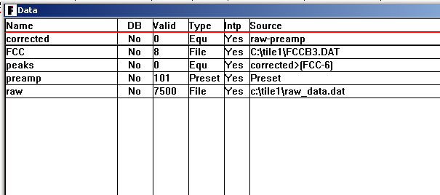
When brought to the front focus, the data window displays all the currently defined data elements. The first column indicates name. The second column identifies whether the database option is selected for this data element. The third column displays the number of valid points in the data element. The fourth column indicates the type of data element. The fifth indicates whether this is an interpolated data element. And the sixth column displays relevant information for the data type.

Element Names
Each data element must be given a unique name. The name can contain upper and lower case characters as well as most other keys. Although you can enter spaces, i.e. “Antenna Factor”, it is highly recommended that you do not use spaces. A space in the name will make it impossible to use this element in an equation. You will find when creating test profiles that using a name that gives reference to its source is very convenient. Calling a reading from an analyzer ‘raw’ will convey the essence of this element as well as its use.
As a matter of convenience, all the TILE! samples use a few standard nomenclatures. ‘af_’ precedes all Antenna Factors. ‘c_’ precedes all corrected data (‘c_raw’ would be the corrected value for the data element ‘raw’). Most drop down selection boxes that utilize data elements will automatically sort them alphabetically. Keep this in mind when creating data element names.

Element Database in Use
This column is only meaningful if the TILE/DB database option is installed. If this option is installed (see Chapter 11 for greater detail) you can specify on the source tab whether to update the database for this data element when doing a save. If it is marked for saving, the data element is copied to the database table of results.

Valid Points
This column displays the current number of valid points in a data element. When first created, measurement elements are empty and display a value of zero. All other data elements are filled with data upon their creation (or file opening) and this number indicates the number of valid points in the table.
You can see the data points when editing the data element. This is discussed in Adding Data Elements on page 44. The 'Measurement' type, ‘Equation’ type and ‘Word’ type will not display any valid points until the measurement/equation has executed. The 'File' type and 'Preset' type will display valid points as soon as they are defined.

Type
This column identifies each element’s type. The displayed values will be:
None - Measurement Type (Default)
File - File Type (either a regular data element or a ‘Word’ type)
Equ - Equation Type (either a regular equation or a ‘Word’ type equation)
Preset - Preset Type
Word - Word Type

Intp (Interpolated)
When EMC measurements are performed we generally have large data arrays of information. When applying specification limits, correction factors and other offsets, we need to insure a valid point exists at each frequency. Interpolated refers to a switch set during the definition of the data element. This switch tells the system whether to interpolate the data element during math and graphing functions. If the switch is ‘Yes’ then interpolation will take place.
The default for all data element creation has this switch set on. All your file elements will generally be defined with this switch on when you are going to be displaying large quantities of data on graphs. This is normally turned off for peak information or results in which you only expect a few data elements (such as your final qp data). This is most obvious under graphing. If you choose to graph a set of peak signals they will appear as a line if the 'Interpolate’ is turned on. With the switch off, they would see discrete points which would require a marker to see on the graph.
Creating a table using an interpolated data element can have strange results. See Chapter 10 -TILE! Graphs and Tables

Source
The source text will vary depending upon the data type. A ‘File’ data element (whether regular or ‘Word’ type) would display the absolute path to the file. An ‘Equation’ type (whether regular or ‘Word’ type) data will display the mathematical equation that has been defined for this element. A ‘Preset’ type display's the word "Preset". A ‘Measurement’ type displays the word “Measurement”.

Adding Data Elements
With the Data window in the foreground you have a view of the defined data elements. Select the Add option under the Edit drop down menu or click on the Add Element shortcut icon. This will open the New Data Element Dialog Box.

Name
The first page for a data element has two features. The first is a ‘Name’. Type a unique data identification name for this data element. There are no specific requirements for data element names except that they cannot contain math symbols (which includes the ‘-‘ dash which the math parser sees as a minus sign).
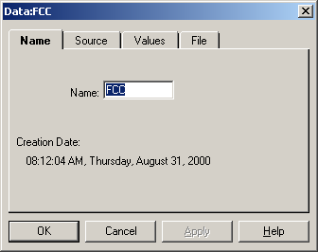
The second feature is the date/time stamp for the data element. This time will reflect the date that the data was last changed or updated. For ‘File’ type data elements it will reflect the date/time stamp for the file when this data element was created or last updated. If your date/time stamp changes on the disk it will not reflect here unless the data element is specifically updated. This is accomplished by either using the ‘Transfer Data’ icon on the flowchart as part of a test or by opening the data element on this page and clicking the ‘OK’ button.
When on this page you must use the mouse to maneuver between the tabs. DO NOT type a <Return> or click on the OK button unless you are through with this dialog. Go to the Source page by clicking on the tab marked ‘Source’.

Source
This tab page is the definition page for data elements. There are four choices that need to be made on this page – Selecting the data type, determining the interpolation methodology, the sorting method and whether to do a database save for this data element, if the TILE/DB product is installed also.
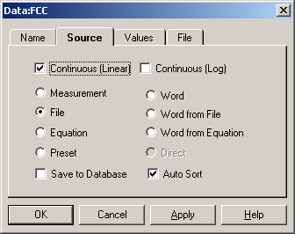

Select Type
The default setting for a new data element is a 'Measurement' type. When this is checked, the only option (tab) available is ‘values’. Measurement data elements only show a 'Values' tab. When first configured, the values are blank since no measurement has been performed. Click on the check box to select a type. For instance, ‘File’ as shown on this figure. Whenever you select a data type other than measurement, additional tab pages are made available.

Continuous (Log and Linear)
By default, the 'Continuous (Linear)' box is checked. This box will direct the system to interpolate data points when drawing graphs or performing mathematics in a linear fashion. If ‘Continuous (Log)’ is checked, then all interpolation will be in log format. If you are creating data elements that by nature should be discrete (peaks, over limit points, etc.), then uncheck these boxes to turn off the 'Continuous' option. In effect there are three choices, either turned on or both turned off.

Save to Database
This check box only has meaning if the TILE/DB product is installed. If this box is checked and the TILE/DB is present, then the software will transfer the contents of this data element to the database whenever a save is performed.

Auto Sort
This check box determines whether data is automatically sorted when it is loaded for the first time. This only has meaning for the ‘File’ type data elements when they are read from file the first time. You can change the sorting routine from the ‘Values’ tab with a slight difference. With ‘Auto Sort’ off, data from file will be read in the sequence it is in the file. The ‘Values’ tab allows you to sort the data either low-to-hi or hi-to-low (by frequency). This is potentially a different sequence than was read from file.

File Page
When the File type is selected on the 'Source' page, the 'File' tab will appear.
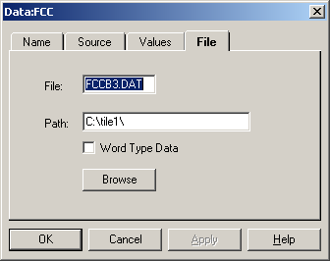

File Name - Directory Path
Use the Tab key to move to the 'File' or click on the text box with the mouse pointer. Type in the file name for the file. Make sure you append a file descriptor – such as .dat or .txt – to properly identify a file. The same applies to the 'Directory' text box. When you enter the directory path it is extremely important that it be identical to the physical location on disk. If using a network drive it is best to map the network driver to a local drive letter before setting the path.

You may click the ‘Browse’ button and use the Windows browse facilities to assist you in finding your data file. Once selected through the Browse function, the 'File' and 'Directory' will be filled in automatically.

File Format
To make creating files as easy as possible we use 'ASCII' type files for loading or saving data information. Specifically, TILE! uses the ‘comma separated variable’ or ‘CSV’ data type. This format is a two-column format. For our uses the first value is Frequency. The second value is the number of interest. When looking at the file with a text editor (such as Notepad), these two values would be separated by a comma. Within a spreadsheet program make sure that you set the file type to ‘CSV- text’ when doing a ‘save’ or ‘save as’. If the file is in the
wrong format the data will not be read.

Word Type Data
There are times when you might need to load ‘Word’ type data into a TILE! profile. Since the CSV file type includes no definitional information, we need to ‘warn’ the program when we are importing text data, as opposed to numbers. The ‘Word Type’ check box serves this function. The first time you are importing data, check this tab to insure it is imported as text. Be very careful not to use this check box on data that is numerical. In this case you will end up with text that cannot be used in normal mathematics.

Value Initialization
The data from the file is read in one of two ways. First, when you accept the settings (press 'OK') the data file is automatically read into the data element. The second method requires moving to the 'Values' tab and pressing the 'Initialize' button. On the Data window this element will now show the number of valid data elements. This gives you the ability to look at the contents of a data file prior to accepting it. There are two display boxes on this page - 'Units' and 'Valid'. The 'Units' field is not active under the current version of TILE!. The 'Valid' field displays the total number of points in this data element.
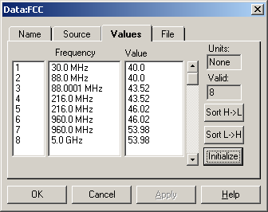

Sorting Data Options
On the ‘Values’ tab you also have two choices for sorting the data. Normally, data within TILE! is sorted from low frequency to high frequency. It is important that the data be in one of these two structures. Data that is not sorted will cause strange results during math operations since the interpolation functions looks to the frequency before and after for a valid range. Clicking on the ‘Sort H->L’ will cause the data list to be sorted starting at the highest frequency and sequencing down to the lowest frequency. The ‘Sort L->H’ tab does the opposite. It sorts data starting at the lowest frequency and sequencing to the highest frequency.

Valid
The valid indicator shows the number of valid frequency points in the named data element. This is also demonstrated by scrolling down the list, using the right hand scroll bar, to look at the list of values.

Units
This field is not active. It will always show ‘None’. Within TILE!, the appropriate unit of a data element value is completely a function of where you use it. A number used as a antenna correction factor is technically a dB until it is added to the reading in dBuV. The result is dBuV/M. It is important to carefully measure that appropriateness of any data element as it is used.

Equation Page
On the equation tab is an equation writer in which you can enter a formula to define a data element. You can enter a fairly complex equation, but you are limited to 9 imbedded parenthesis. Each parenthesis must delineate a binary equation. The example here demonstrates taking a reading, adding the cable losses and subtracting preamp gain. To keep a binary operand, the cable loss and preamp gain are enclosed in parenthesis. The raw data element is then added to this element.
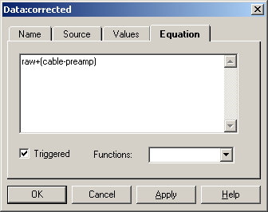
The equation may consist of operations, conditions, and functions. The operators and conditionals allow either matrix or constant operands. All math functions are in lower case and the math parser is case sensitive. You must enter functions in lower case. Also, avoid naming a data element the same as a math function.
The results of any math operation are stored into the named data element. Until the equation has been executed, no values are present. The 'Values' tab will serve no purpose at this point. After execution, you can use the 'Values' tab to view the data element values.
It is important to keep track of they interpolation settings for any data element. If data element (x) is continuous, then all of data element (y) that is bounded by the frequency values of data element (x) will be evaluated. The same is true for data element (y) if it is continuous. If both data elements are continuous all values, bounded in one data element by the other data element, will be evaluated. If both elements are discrete only those values with identical frequencies will be evaluated. The above statements are true for conditionals and two parameter functions.
The operators available to you are:
Add {x+y} | Simple addition function
Subtract {x-y} | Simple substraction function
Multiply {x*y} | Simple multiplication function
Divide {x/y} | Simple division function
Modulus {x%y} | A function that returns the remainder of a division equation. This is the same result as the function x - (x/ y) * y.

There are conditionals available to you such as the ‘Greater than’ shown in the above example. The results of the conditionals are dependent upon the interpolation settings for the data element.
The conditionals available to you are:
Equal  {x = y} | Determines those frequencies of the two data elements in which the values are equal (exactly equal). The resultant data element will only have frequencies where this condition is true. If either of the data elements is interpolated, you might see strange results so make sure the definition of each data element is clear.
Not Equal  {x != y} | Determines those frequencies of the two data elements in which the values are NOT equal. The resultant data element will only have frequencies where this condition is true. If either of the data elements is interpolated, you might see strange results so make sure the definition of each data element is clear.
Greater than  {x>y} | Determines those frequencies where the x value is greater than the y value. This is the same as the ‘max’ function, except the ‘max’ function will also work with ‘Word’ type data elements.
Less than  {x<y} | Determines those frequencies where the x value is less than the y value. This is the same as the ‘min’ function, except the ‘min’ function will also work with ‘Word’ type data elements.
Greater than or equal  {x>=y} | Determines those frequencies where the x value is greater than or equal to the y value.
Less than or equal  {x<=y} | Determines those frequencies where the x value is less than or equal to the y value.
Special Math Functions are:
abs(x) | Absolute value of each value in the data element x.
acos(x) | Arccosine of each value in the data element x.
acosh(x) | Arccosine (hyperbolic) of each value of the data element x.
alog(x) | Anti-Log of each value of the data element x. This is the value e raised to the value of x.
alog10(x) | Anti-Log of each value of the data element x. This is the value 10 raised to the value of x.
asin(x) | Anti-Sine of each value of the data element x.
asinh(x) | Anti-Sine (hyperbolic) of each value of the data element x.
atan(x) | Anti-Tangent of each value of the data element x.
atanh(x) | Anti-Tanget (hyperbolic) of each value of the data element x.
ceil(x) | The smallest integer, at each frequency, that is greater than or equal to x.
cos(x) | Cosine of each value in the data element x.
cosh(x) | Anti-Cosine of each value in the data element x.
dbp(x) | Converts each value in the data element x from a db to Power in Watts. The basic equation is 10^(x/10). It is equivalent to dbw. To convert from dbm first divide the dbm number by 1,000.
dbv(x) | Converts each value in the data element x from a db to Voltage. The basic equation is 10^(x/20). For dBuV multiply the voltage by 1,000,000 first.
dbw(x) | Converts each value in the data element x from a db to Power in Watts. The basic equation is 10^(x/10). It is equivalent to dbp.
diff(x,y,c) | Compares the frequencies in data element x to those in data element y. If the difference between the frequencies is greater then the constant c (which you might consider the bandwidth in Hertz), the frequency from element x is added to the resultant data element with the value of x.
equal(x,y,c) | Compares the frequencies in data element x to those in data element y. If the difference between the frequencies is less then the constant c (which you might consider the bandwidth in Hertz), the frequency from element x is added to the resultant data element with the value of x.
excl(x,y,c) | Compares the frequencies in data element x to those in data element y. Those frequencies in y that are also in x (within the bandwidth c in Hertz) are excluded from resultant data element.
exp(x) | Returns the exponential value of x in log base e.
floor(x) | Determines the largest integer that is less than or equal to x for each frequency.
gmc(x) | Calculates a bin function for emissions data to the General Motors specification. This may not be used in the new world specification.
impulse(x,c) | This function strips impulsive signals from a data stream. Impulse is defined as a single signal that exceeds the signal before and after by more than c (in Hertz). CAUTION – use this function carefully. If the c value is defined too broadly or your frequency steps are too large, you may be stripping out real data.
j0(x) | Bessel function of each value in the data element x.
j1(x) | Bessel function of each value in the data element x.
log(x) | Log of each value in the data element x to the base e (natural base).
log10(x) | Log of each value in the data element x to the base 10.
max(x,y) | Compares the x and y values and writes the maximum of the two to the resultant data element.
maxhv(h,v,x) | This functions was created to determine the whether the horizontal or vertical data had the maximum value and to create a related ‘Word’ type data element, in this case x, with the text ‘H’ or ‘V’. The resultant data element has the maximum value of the two (exactly like the max function). The x data element will have the H/V to designate the polarity.
maxhvtt(h,v,x) | This function compares the polarity (from data element x) and matches the appropriate horizontal and vertical data element.
min(x,y) | Compares the x and y values and writes the minimum of the two to the resultant data element.
mod(x) | Modulus command (same as the symbol %). A function that returns the remainder of a division equation. This is the same result as the function x - (x/ y) * y.
pdb(x) | Converts a value in Watts to db. Same as 10*log10(x). This is identical to ‘wdb’.
peak(x,c) | The resultant data element is all values that are greater than a constant c.
pow(x,c) | The value of x raised to the c. For example x² is pow(x,2).
reduce(x,c) | This function compresses the number of in the data element ignoring any points that are within c dB of the points on either side. To be ignored the point must be point before > current point > point after and the difference between the point before and the current point must be less then c. Also, the difference between the point after and the current point must be less then c.
scfm(x,y) | Standard Correlation for Ford Motor. Does a correlation analysis on the data in elements x and y to the Ford specification.
sin(x) | Determines sine of each value in the data element x.
sinh(x) | Determines sine (hyperbolic) of each value in the data element x.
speaks(x,c) | This function was designed to ‘walk’ the data and determine when you had strong signals by comparing the previous and next signals looking for excursions from the lowest to highest signal of c. For instance, the equation speaks(x,8) would look for all signals that were at least 8 db from low to high amplitude.
sqrt(x) | Determines the square root of each value in the data element x.
tan(x) | Determines the tangent of each value in the data element x.
tanh(x) | Determines the tangent (hyperpolic) of each value in the data element x.
top(x,c) | Determines the top ‘c’ number of points in the data array. The default is 10 if c is not stated.
top10(x) | Determines the top 10 values in the array x.
toy(x) | Calculates a bin function for emissions data to Toyota specification. This may not be used in the new world specification.
vdb(x) | Calculates the dB value of a Voltage using the equation 20*log(x).
vswr(f,r) | Calculates the VSWR ratio from a forward and reverse power. The first data element must be the forward power and the values must be higher than the reverse data element.
wdb(x) | Converts a value in Watts to db. Same as 10*log10(x). This is identical to ‘pdb’.

Triggered
The 'Triggered' check box determines when math equations are executed. By default the box is checked. Triggered data elements are executed when the Math action is processed in the test profile. If triggered is not checked, the system will attempt to update the equation whenever the data element is changed. This can dramatically slow down the overall system performance. Use this option with great caution.

Functions
The 'Functions' drop down text box displays the available mathematical functions. These are displayed for reference purposes, but when selected the appropriate function will be entered in the equation box ready for completion.

Preset Page
The preset values are defined by two conditions - frequency and amplitude. These are combined in the same fashion as the standard file format.

Amplitude
Enter the value that is appropriate for your data element. For instance, to create a 26dB preamplifier gain table you would enter a 26 (the units are assumed in its use).
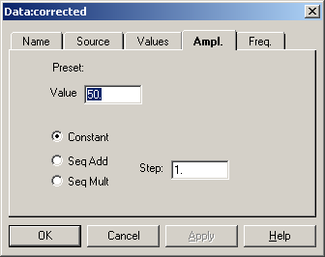

Constant
Constant is the default setting for preset values. When constant is checked the value in the text table is filled into a table across the frequency range defined on the 'Frequency' page.

Seq Add
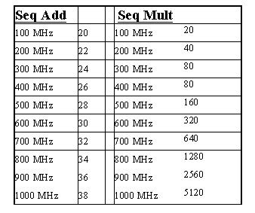
Sequential add takes the starting value in the text box labeled 'Value' and sequentially adds the value shown in 'Step'. The number of steps is set on the 'Frequency' page. If the starting value was 20, the step was a value of 2 and there were 10 steps from 100 MHz to 1000 MHz, the following table would be defined. Click on the check box to select this option.

Seq Mult
Multiplicative sequencing takes the starting value from the 'Value' text box and multiplies the value by the 'Step' at each frequency. With a starting value of 20, a step value of 2 and 10 steps between 100 MHz and 1000 MHz we would see the values on the adjacent table. Click the check box to select this option.
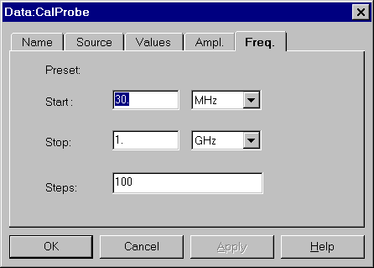

Frequency
The Frequency page displays the start frequency, stop frequency and number of steps. The frequency information works in concert with the amplitude information to define the data element. This is all the information needed to create the element values.
Enter an appropriate value in the text box and click the drop down arrow to select the units. You can also move between the text box and the units by using Tab key and entering the first letter of the units (K-KHz, M-MHz and G-GHz).
You can view the preset values by clicking on the 'Values' tab and ‘Initialize’.

Editing TILE! Data Elements
There are two methods to edit data elements after their creation. Bring the Data window to the front focus. With either the Mouse or the Arrow keys select a data element. Clicking on the “Edit” command on the Windows Menu Bar provides the options to Add, Delete, Edit, or Initialize a selected data element.
Double clicking on the selected data element with the Mouse will open the dialog box for editing purposes.

Deleting TILE! Data Element
There are two methods to delete data elements after their creation. Bring the Data window to the front focus. With either the Mouse or the Arrow keys select a data element. Using the Mouse, click one time on a data element to highlight it. Hitting the 'Delete' key will delete the selected data element or chose "Edit/Delete" from the Windows Menu Bar. Delete will permanently remove an existing data element.
Caution - Do not delete a data element that is used in a test profile. This may cause a catastrophic failure of the software. For safety sake, it is advisable to rename a data element to ‘unused’. This will serve as a place holder for future uses. If the data element had been referenced in an action or on a table or graph, it will still work.

The TILE! Instrument Window

Instruments in the TILE! System
One of the biggest advantages of the TILE! system is its hardware independence. This is achieved by using small, modular programs called instrument drivers. These are recognizable in TILE! by the three digit extension "*.ins". The instrument driver contains the unique programming code to allow the software to talk to the instrument. In reality these are dynamically linked libraries (DLL’s), but we use the ‘.ins’ nomenclature to make it more readable when creating drop down lists of instruments.
Instrument drivers are used in the system to provide communications between the main program, the test profile, and the instrument on the GPIB (or serial) port. An instrument in a test profile needs to be identified by a unique name and then 'linked' to an appropriate instrument driver. The use of a separate name link allows the user to quickly substitute different instruments into a test without having to modify any actions in the test profile.

The Instrument Window
The Instrument window provides visual access to the currently defined instruments. The displayed elements are the instrument name, type, board, address, instrument library name (instrument driver link), version number, instrument serial number and calibration date. The serial number and calibration date default to ‘Unknown’ unless the user/designer has specifically entered this information. See the definition of the ‘Operator’ icon in Chapter 10. The name given to an instrument should be a unique reference to a type of instrument. Calling the spectrum analyzer 'SpecAnal' instead of HP8568B gives much greater flexibility in designing test profiles. If you name an instrument with the hardware name, the implication will be that this is the only instrument that is acceptable for this setup. This is not true in the TILE! system. Wherever the name is used in the test profile, you expect to see a receiver or analyzer, not necessarily a specific receiver or analyzer. This is sometimes a subtle difference, but it is very important in properly designing a test profile.
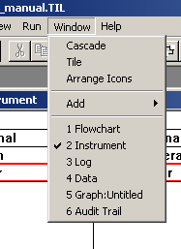
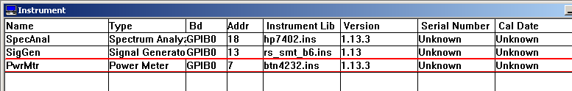
There are two ways to bring the Instrument window to the foreground (current focus). The easiest way is to click on the Instrument Window Icon of the Command Bar. This will bring the window to the front. You can also select "Window" from the Menu Bar and select the numbered line that is your instrument window. On this drop down box, the check mark indicates the current focus. To change this just click on the window desired, in this case "2 Instrument". The Instrument window will come to the front.

Defining an Instrument
To define a new instrument, move the Instrument window to the front. You can then click on 'Edit/Add' from the Menu Bar or use the New Instrument Icon to quickly open the new instrument dialog. All instruments and actions in the TILE! system have a common name page. Enter a unique name on this page and then select the 'Driver' Page. DO NOT press the Enter key. This will attempt to save the instrument without proper definitions of the instrument driver and GPIB information. This will generate an error.

Driver Page
The Driver page has two test boxes - File and Path, a 'Browse' button, a 'Load' button and a 'Do Not Use' check box.
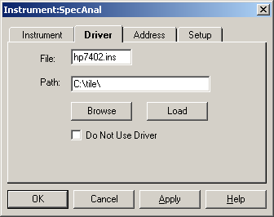

File and Path
Although it is possible to enter the 'File' and 'Path' directly, the best method is to use the 'Browse' button. Using 'Browse' will insure the correct path for the instrument driver files.
Click on 'Browse' to open a windows open file dialog box. The "*.ins" files will be pre-selected. If the directory is not correct, move to the correct directory. Generally, instrument drivers exist for each manufacturer’s model number. Some manufacturers maintain a stable instrument command set cross their product line and in these instances there may be a generic driver for that manufacturer. Find the driver for the model instrument you are defining. Select this driver by double clicking with the mouse on this selection. From the keyboard, use the Arrow keys to highlight the desired file and press the 'Enter' key.
If you see no ‘.ins’ files in the browse box, check your settings for viewing registered files in the Windows Explorer or My Computer.
Once you have selected an instrument driver, the 'File' and 'Path' text boxes will be filled in. If you are going to be moving the test profile between different programs with slightly different hard drive arrangements it is extremely important to click on the 'Path' and remove the drive letter and semi-colon from the path. By removing these, windows will look on the current hard drive. If you use the same directory name on different machines, the files will now be transportable.

Do Not Use Driver Check Box
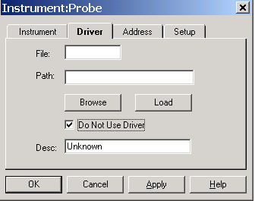
The 'Do Not Use Driver' check box is used to define an instrument which does not have an instrument driver. These types of instruments can be controlled with the GPIB Control action described on page 203. The convention in the 'GPIB Control' requires an instrument name. Using the 'Do Not Use Driver' box allows you to assign a name and board address to an instrument when a specific driver is not available.
DO NOT PRESS ENTER. Enter will save the current settings and exit the dialog box. Click on the next tab to continue the instrument definition.

Desc (Description)
When using the ‘Do Not Use Driver’ option, you can enter a description of the item. This will be displayed on the instrument window under ‘Type’.

Address Page
Each instrument must have a unique bus address. If there are two instruments on the same bus, you will get a failure. The default settings for the 'Address' page are GPIB Board '0' and address '18'. Change these settings to insure the instrument does not conflict with other instrument settings.

Board
The drop down arrow on the 'Board' text box will display the available settings. The TILE! system supports multiple GPIB boards, serial, VXi and custom PC Card interfaces. The GPIB standard supports up to 96 addresses. Typically a GPIB card can support 32 different devices, so multiple board configurations are unusual. Select the setting appropriate for your instrument by using the Arrow key to highlight the selection and the Tab key to select an item or by double clicking on the selection.
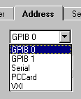

Primary
The specific hardware address of the instrument relative to the board selected needs to be entered in the 'Primary' text box. Click on the drop down arrow and select the appropriate number. From the keyboard, Tab to the text box and use the Up/Down Arrows to select the correct setting. The primary address is a number in the range of 0 to 30 decimal. Defining addresses above 30 is possible with the secondary address but is recommended only for the most sophisticated users.
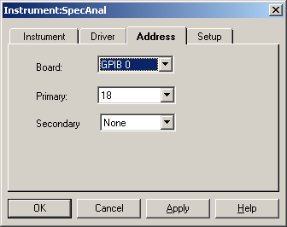

Secondary
The secondary address is sometimes used on older test instruments, and is a number in the range of 96 to 126 decimal. The secondary address is a GPIB standard convention which is rarely used in the TILE! system.

Setup Page
The setup page is the active tab if a GPIB or VXi board is chosen on the Address Page. On this page there are settings which control the communications between the computer and the instrument. The default settings are appropriate for all instruments meeting the IEEE-488-2 standard. If your instrument is an older model, you may need to adjust some of these settings to match the instrument. Refer to your hardware manual for more information on these settings or contact Quantum Change.
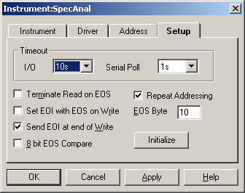

Timeout
The two timeout settings, I/O and Serial Poll, refer to how the system responds to timing differences between different instruments and their communications on the bus.

I/O
The I/O timing determines how long the GPIB bus will wait for a response from an instrument before reporting an error. This default setting is set to 10 sec, and this covers most requirements. When you are running long sweep times in emission scans, depending upon your analyzer, the bus may timeout before the instrument is through the measurement if your sweep time is longer than the I/O setting. If you need to run 20 second sweeps, the I/O setting may need to be set at more than 20 seconds.
A strong indication of I/O incompatibility is when your scan stops in the middle and traces the floor thereafter. In this case usually the GPIB has aborted and reported an error. Change the I/O time to agree, or exceed, with the instrument sweep time.

Serial Poll
The Serial Poll settings refer to a GPIB standard for SRQ errors. The Serial Poll Timeout list box is used to set the wait time for poll responses from the instrument. The default wait time is 1s. This setting is almost never changed. Please refer to the GPIB card manuals for information on this setting. If you have problems with serial polls, try using a longer timeout value.

Other GPIB Bus settings
The following settings are specific to differences between the IEEE-488-1 and IEEE-488-2 standards. Proper establishment is described in the instrumentation manual. If you have specific problems with an instrument, contact Quantum Change for more assistance.
Terminate Read on EOS (End of String)
The Terminate Read on EOS check box allows the software to terminate a read operation when it receives the EOS byte. The default setting for this option is disabled.
Set EOI (End of Instruction) with EOS (End of String) on Write
The Set EOI with EOS on Write check box allows the software to assert the GPIB EOI line whenever it sends the EOS byte. The default setting for this option is disabled.
Send EOI (End of Instruction) at end of Write
The Send EOI at end of Write check box allows the software to assert the EOI line at the end of each data transfer. The default setting for this option is enabled.
8 bit EOS (End of String) Compare
The 8 bit EOS Compare check box allows the software to use all eight bits of the EOS byte when checking a match. Only seven bits are used if this option is not selected. The default setting for this option is disabled..
Repeat Addressing
The EOS Byte list box has a range of 0 to 255 and is used by the software for all EOS operations. The default setting is to turn this ON. There are no known times when this should NOT be ON.
EOS (End of String) Byte (Binary)
The Repeat Addressing check box allows the software to address the instrument before every read or write operation. Some older instruments require this to be set. The default setting for this option is disabled.

Serial Page
When the 'Serial' Option is selected on the Address page, the tab references change to the Serial page. These text boxes control the 4 general conditions of the serial bus - Baud Rate, Data Length, Parity and Stop Bits.

Baud Rate
The 'Baud Rate' has 9 available settings ranging from 300 to 115,200. Refer to the instrument manual to determine the correct settings. Click on the drop down box to display the list. Double click to accept. From the keyboard, use the Up/Down Arrows to display the correct choice. Use the Tab button to set the reading and move the next test page.
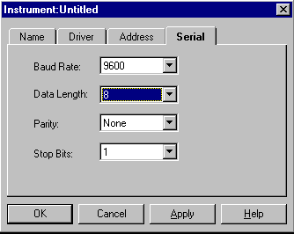

Data Length
There are four 'Data Length' settings - 5, 6, 7 and 8. Refer to the instrument manual to determine the correct settings. Click on the drop down box to display the list. Double click to accept these settings. From the keyboard, use the Up/Down Arrows to display the correct choice. Use the Tab button to set the reading and move the next test page.

Parity
There are 5 'Parity' levels - None, Odd, Even, Space and Mark. Refer to the instrument manual to determine the correct settings. Click on the drop down box to display the list. Double click to accept. From the keyboard, use the Up/Down Arrows to display the correct choice. Use the Tab button to set the reading and move the next test page.

Stop Bits
The 'Stop Bits' can be set to either 1 or 2. Refer to the instrument manual to determine the correct settings. Click on the drop down box to display the list. Double click to accept. From the keyboard, use the Up/Down Arrows to display the correct choice. Use the Tab button to set the reading and move to the next test page.

Accepting your choices
Once you have made the appropriate choices on each of the 4 pages, click on the 'OK' button or press Enter to accept. 'Cancel' will cancel the definition and exit the dialog box.
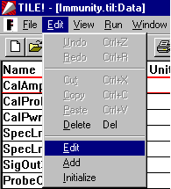

Editing an Instrument
You can edit an existing instrument by bringing the Instrument window to the current focus. Click to highlight the instrument in question and double click to begin editing. You also can use the Arrow keys to highlight the instrument and using the "Edit/Edit" functions from the Windows Menu Bar.
All settings and pages are the same as described in Defining an Instrument on page 55.

Deleting an Instrument
Deleting an instrument requires selecting the instrument, either with the Mouse pointer or by using the Arrow keys and using the Delete key. To delete an instrument, choose "Edit/Delete" from the Windows Menu Bar. Delete will remove an existing instrument.
Caution - Do not delete an instrument that is used in a test profile. This may cause a catastrophic failure of the software.
Using the Mouse, click one time on an instrument to highlight it. Hitting the 'Delete' key will delete the selected instrument.

The TILE! Flowchart Window
The Flowchart Window displays and defines the actions included in the test and depicts the sequence of their execution. The flowchart, with its associated data elements and instruments, is the central component in creating a unique test profile.
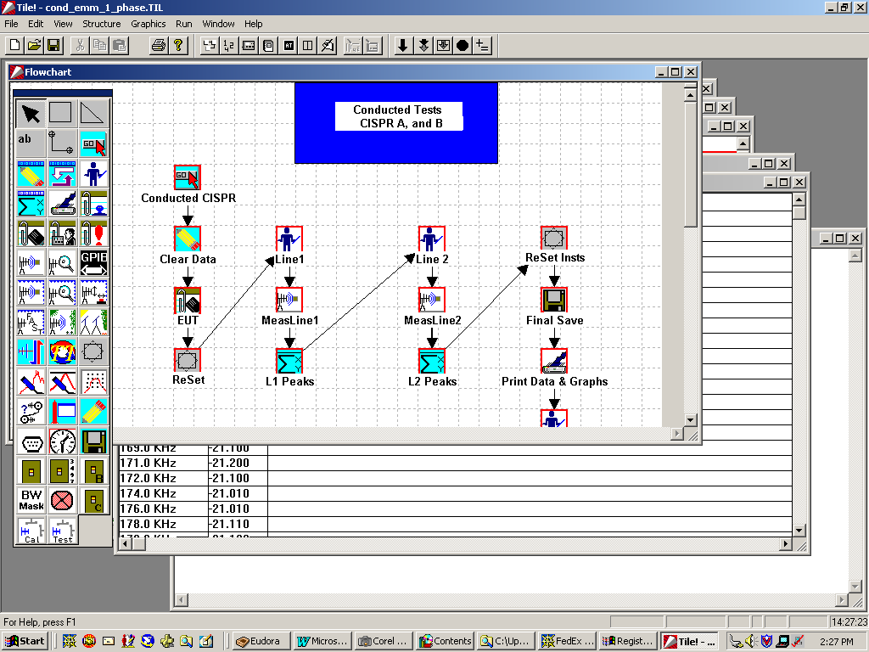

Flowchart Overview
The flowchart has two functions. First, each action defines a specific set of information gathering or instrumentation controlling steps. For instance, in the flowchart figure there is a prompt action that gives the operator instructions on the necessary manual steps required at this point in the test. There is a measurement action that specifies the frequency range, bandwidth and instrument for a frequency measurement. Second, it specifies the order of execution for this test. A flowchart defines a complete test program. This can be a simple test, such as one which performs an emission scan for a specific international standard. But the real power of the TILE! concept is the ability to define a test profile that is a requirements test. It can include emission as well as immunity and acts as the repository for the final certification test data for a new product.
By consolidating a wide range of ‘requirements’ into one test profile, the user can automatically store related information in a common file for future reference. This also dramatically simplifies the ability to quickly generate test reports for submissions or internal reporting.

Working with Icons and the Palette
The Palette provides access to the range of available actions. The palette found in your version of this software may have additional icons, or fewer, depending upon the system ordered. The palette controls which features of TILE! An operator can access. Specific details on each action are in Chapter 10 – Actions.

Placing Icons
Each icon can be ‘dragged-and-dropped’ on to the flowchart during the design stage. Click one time on the appropriate icon on the Palette. When you move to the flowchart a small box indicates the icon is ready to be dropped. Click one time at the desired position to drop the icon. It is not important to have absolute position on the drop since the icon can be moved and aligned after placing.

Editing Icons
The standard windows pointer is the arrow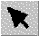. In TILE!, we refer to this as the Pick Tool. If the arrow is not active (if you have started to drop an icon and changed your mind), click on this icon to reassert the arrow pointed. Position the arrow over an action to be edited and ‘Double clicking’ on the action gives the designer access to the specific characteristics of each action.
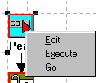
When you ‘Double Click’ you will activate the editing or executing options for this action. At this stage, ‘Edit’ gives you access to the action’s definitions, i.e., the ability to customize the performance of this step. The ‘Execute’ option will cause this icon to execute ONLY this step. To cause a chain of actions to execute requires using either the ‘Go’ action or the ‘Execute’ shortcut’s.
Each action’s definition can be found in Chapter 10 - Actions.

Linking Actions
Once you have defined a group of actions on the flowchart, you next ‘link’ them together to form a common chain of test steps. The Connect Tool (from the palette) is used to connect one action to the next. Select this tool, position the cursor over the first action and click once. The single click is defined as an anchor. It is used to attach the first anchor at the starting position. Moving the cursor across to the next action will drag a connecting line between the two actions. Double Clicking will attach the endpoint to the second action.
You can only attach two actions together in one operation. To attach multiple actions, you must attached pairs together and then duplicate the steps for the remaining actions. An action can have multiple incoming attachments, but only one outgoing attachment (with the exception of the ‘Prompt’ action – see Prompt in Chapter 10).

Aligning Actions
The tools available to align and structure the icons positioned on the flowchart exemplify the graphical nature of the flowchart. When the flowchart is the active window, the Windows Menu Bar displays the ‘Structure’ option.
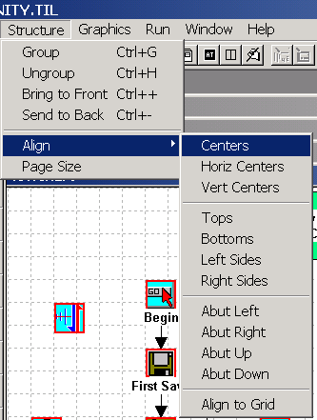
Two components are available under ‘Structure’ - Grouping and Aligning. Grouping involves establishing precedence for bitmaps placed on the flowchart. Aligning applies to selected items on the flowchart.
To select multiple actions for alignment purposes, click on the first action. Hold down the ‘Shift’ key and click all remaining icons to be aligned. Choose the option desired and the icons will be aligned as selected.

Page Size
The default page size for the flowchart is an 8.5 inch by 11 inch page. You can make the flowchart large by changing the page size. The height of the page will automatically scale to the width. When printing it will automatically be scaled to fit on a standard page.

Working with the Flowchart
The flowchart allows you to work with graphical tools to enhance the appearance or efficiency of the test profile. The imbedding of graphics on the flowchart is a powerful method of clarifying a test requirement or setup. Labeling can be added to personalize the flowchart, imprint instructions in an obvious manner, or clarify attached graphics.
A good example of this is labeling. Creating a sequence of icons to perform an emissions test is the heart of the TILE! system. But adding a title to the flowchart makes it obvious to the user what is being accomplished in the test profile. Imbedding a bitmap picture of your test setup could be even more descriptive.

Edit Menu
The Undo/Redo options are classic Windows tools. If you accidentally erase an icon, immediately ‘undo’ the mistake. ‘Redo’ allows for repeating a step (and is probably used much less often). ‘Delete’ and ‘Select All’ allow you to quickly clear large areas of the flowchart. For single deletions and selections, it is easier to use the mouse.
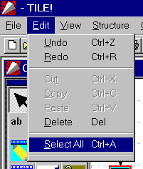

View Menu
The ‘View’ Command off the Windows Menu Bar provides a number of tools for controlling the screen of the program. You also have some shortcut keys that allow you to move around the program if your mouse is not operating properly.
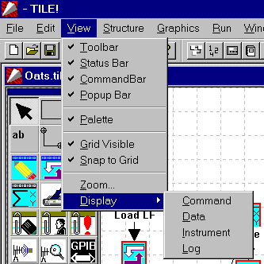
The first four choices concern the active areas around the window. The Toolbar, Status Bar, Command Bar and Popup Bar are all shortcut keys or status indicators for the window frame.

The Toolbar
The Toolbar contains a group of standard Window’s tools. New, Open and Save relate to file shortcuts. Cut, Copy and Paste relate to object and text manipulation. Print causes the currently highlight window to print. The printer defaults are set in the ‘File/Printer Setup’ menu. Help uses the standard Window’s help structure to access on-line help files.
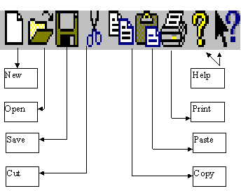

The Status Bar
The status bar displays information on the status of the window. Items such as current action, time, elapsed time are displayed. The only control the user has is to display the line or to turn it off. There are not options for configuring this information. This information, with the exception of the current time, only appears when the program is executing.

The Command Bar
The Command Bar provides shortcuts that allow control of the execution of the TILE! program.
The Go, Step and Single buttons bring up a dialog box which displays all the defined steps of the flowchart.
Go starts the test running from the selected step. The Step mode starts the test running but pauses after each step’s operation. Single only performs the indicated step. Stop halts execution of the test. It may not stop an action that is already in communication with the GPIB, but it will cause a break at the next available step of the test.
The Equation shortcut causes all defined equations to be updated. This is especially helpful when you have imported a secondary data set and want to update equations defined in the test profile.

The Popup Bar
The Popup Bar contains shortcuts, which allow you to quickly move from one window in the system to another.
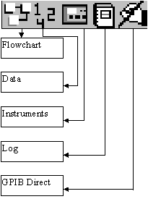
Clicking on the Flowchart, Data, Instrument or Log icons will bring that window to the front.
The GPIB Direct symbol gives you access to the GPIB bus. This allows you to send direct commands to instruments (to test the bus, to clear the bus or to debug instrument instructions). This is roughly comparable to the National Instruments WIBIC or Measurement Automation Explorer, but uses the TILE! defined instrument names and addresses.

Palette
The ‘Palette’ is visible by default but it is commonly turned off to clear the screen during operation of the profiles. Click on time to turn it off (the check will disappear) and click again to turn it back on (the check will appear).

Icons - Shortcuts and visual clues
The icon based structure of TILE! may seem confusing at first. Certain icons may not be obvious (a violation of the basic theory of icons) or helpful, but once you become familiar with this structure it provides an extremely fast and flexible user interface. Given a serious look, you will be surprised at the performance and results. Also, not all icons referenced in this manual are visible on all palettes. The palette is modified to display only the actions available for the version of the software you are running.

Graphics Menu
When considering the structure of the flowchart, sometimes it may be appropriate to imbed pictures for reference or esthetics. The ‘Graphics/Bitmap’ option allows you to insert bitmaps onto the flowchart. When you select ‘Bitmap’ the standard Window’s browse dialog opens to select the file. Once the file is selected, the cursor is used to position the bitmap on the flowchart. The bitmap is NOT visible until you place it the first time. Once it is visible it can be selected and moved just like the icons on the flowchart.
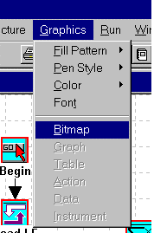
Depending upon the bitmap, it can be scaled and sized. First select the icon (click when the cursor is position over the icon). When the bitmap is selected it is highlighted with 8 small black boxes. These are the ‘handles’. To size the bitmap, grab either of the four corners and pull the box size larger or push the box size smaller. Grabbing either of the side boxes will change only one orientation of the bitmap’s size (i.e., squeezing or flattening the bitmap).
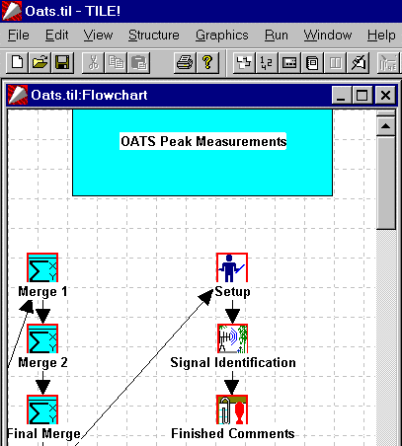

Imbedding Text in the Flowchart
As the attached picture demonstrates, using text can dramatically improve the appearance and ease of operation for test profiles. Each action is given a unique name during the construction of the test profile. These names can identify what is being accomplished at this step. The title across the top is user defined. In this case, it is the name of the test profile. This reminds the user what the purpose of this test is (we all have loaded the wrong program at different times).

The Text Tool
The text icon 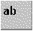 is located on the palette. Click on this icon and move the cursor onto the Flowchart, in the approximate position that you would like to place your text. When you click on the flowchart, the text editor will open. Do not be concerned if it does not start at the precise point that you want the text. You can move it later.
Enter the desired text into the text editor. If you want to change the font or style, highlight the text with cursor and choose ‘Graphics’ on the Windows Menu Bar.
Choose ‘Font’ to modify the font and font characteristics.
To move the text box, select the Pick Tool from the palette and grab the text box handle.
If you want to change colors you need to choose the ‘Pen’ Tool. Click on ‘Graphics/Pen Style’. This tool is used for both text and other drawing tools (discussed in the next section). It would be easier to encourage the user to experiment with these selections than it would be to explain all the options.

The Drawing Tools
Two tools are for drawing squares and multi-line structures. These can be used to add color and background to your flowchart. Again, the purpose of this is to improve the appearance of your test profile. This is especially true if you are supporting customers. Adding your company logo or a highlighted box can add depth and color to the flowchart.
When you click on either of these actions, you place the first point by clicking a starting location on the flowchart. Move to the next position.
For a square, a box will open as you stretch the second point across the flowchart. At anytime that you double click, you will set the opposite end of the box and create the final box.
For the multi-line tool, the first click places the starting point, each additional clicked position sets an anchor. Move and single click as many times as appropriate. At the endpoint double click to complete drawing the object.
Once either structure has been created, clicking on any part of the object will select the object.
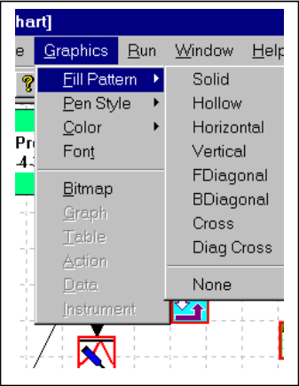
Once selected, the ‘Graphs’ tools all apply to this object. Use ‘Graph/Fill Pattern’ to select a background shade in conjunction with colors provided using ‘Graph/Color’. You can change the color of the lines or color of the background with this tool, it applies to both selected text objects and shapes.

Run Menu
The ‘Run’ Menu gives you access, via the keyboard, to the same features as explained in ‘Run’ on page 37

Windows Menu
The Menu Bar gives you keyboard access to the different windows. Maneuvering with the keyboard is not as elegant as using the Mouse, but option is especially helpful when you have multiple graphs and tables open. Moving between windows becomes very awkward as the number of window’s increase.
‘Add/Graph’ and ‘Add/Table’ allows the user to create new graphs and tables with data elements from the profile. Each graph/table is a unique view of the data present in the profile. A more detailed discussion of this topic is found in Chapter 10 Graphs & Tables.

The TILE! Log Window

Log Window
The Log window provides a tracking and debugging service to the overall TILE! system. It allows the user to track errors, executions, warnings, edits and status during the test profile execution and design. The default settings for the Log are all OFF. Once the log is turned on it does affect performance and timing of the test. Logging to File in particular slows down the overall execution of the test.

Log Overview
Logging can generate a large amount of information during a test, most of which is not useful except for debugging. However, the user will find two particular cases where logging is extremely helpful.
First, when debugging the design of a test profile, logging can assist is determine the reasons for failures. By trapping GPIB error information and internal error reporting, the Log conveniently lists the history to date.
Second, if you have a lab environment where technicians are being asked to perform testing in the absence of needed supervision. The Log can provide the history of events that will allow the supervisor to quickly scan results with confidence. If the test profile was built and tested properly, the Log will track how the operator ran the test, and which steps were modified or aborted. The supervisor, by reviewing the log, can quickly spot unusual activity, by action name, which allows them to inspect only those questionable parts of the test.

Configuring the Log Options
To configure the Log options you first bring the Log Window to the foreground (or focus). There are two ways to accomplish this - by using the Windows Menu Bar or by using the Popup Bar Icons.
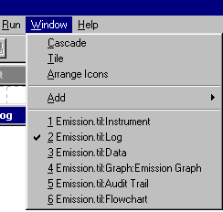
From the keyboard use the Alt key to access the Windows Menu Bar. Select Windows. This drop down box will list the open windows. Use the Arrow keys to move to Log and hitting Enter to select.
With the mouse, click on the Log Window  Icon.

With the Log window in the foreground you will see a visual list of the logged activity to date. If the test profile was just opened this should be blank.
If the test profile has been executed, it will have listings of log entries. Each of these entries will display the time stamp, the action or activity and the result. A result is either a completed action or a message with error/warning information. You can configure the log to control which items are logged and how the information is stored and transmitted.
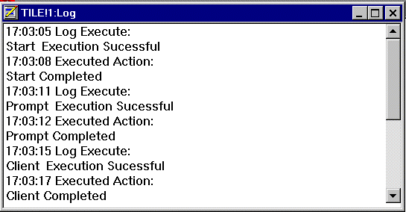
When the Log window is in the foreground, the Windows Menu Bar changes to display the 'Options' menu. The drop down list for this menu item has two choices available 'Select' and ‘Empty Log’. Clicking ‘Select’ will display the Options Dialog for the Log Window. This dialog controls all the settings for the Log. ‘Empty Log’ will clear the Log for subsequent test runs.
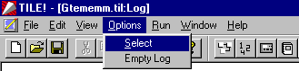

Options
On the 'Options' page you have a matrix of choices for logging. The columns control View, File, Prompt and Sound. The rows control the different events - Error, Warning, Execute, Edit and Status.
There are two forms of logging. Logging to the Log window and logging to file. The Log window only retains information while the program is open. When it is closed, the log is cleared. The log file is a permanent record with each event (and different days activities) appended at the end of the file.
The Options have the following meaning:
View - Determines whether an event is recorded on the Log Window display.
File - Writes the log to a log file. All information is appended to the end of the file, so a permanent log record is possible.
Prompt - Opens a popup message box at each event. The operator must interact with the message before the test profile will continue.
Sound - Assigns a sound effect to the event.
Error - Error messages indicate that the execution of the program has generated a condition which cannot be continued without loss of data or program continuity.
Warning - Warning messages indicate that the execution of the program has generated an unexpected condition. The operator is advised of the condition, but the program assumes operation can continue.
Execute - Execution messages are generated as each action icon in the flowchart is executed. These track the normal flow of execution along the flowchart.
Edit - An action has been edited (the edit function invoked, it does not mean any changes were made).
Status - The status of each action is recorded as they execute. If this is not checked, only errors and warnings will display during an execution. Status messages are also generated for each call made to the IEEE 488 bus. The status messages track the condition of the IEEE 488 bus and the status of instruments attached to the bus. The amount of detail included is based on the specific instrument drivers installed

File
If you have selected 'File' options for any of the rows on the 'Options' page, you must specify a log file. Open the Notepad and save a file with the "*.log" ending. This file will then be available to write logging information. If a log file is not specified, the information will not be saved.
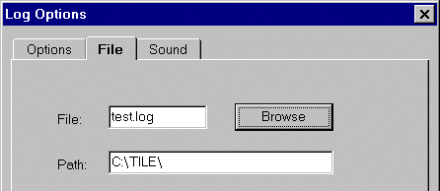

Sound
The 'Sound' page links Window’s sound files to specific events in the TILE! system. Each event has a text box and a check box. The text box is used to identify the sound file. The check box indicates which event is being defined so that the 'Browse' function can operate.
'Browse' opens the Windows Open File dialog box. Use this method to find the sound file (*.wav identify windows sound files) desired. You must highlight each check box for each event prior to using 'Browse.
Once you have selected a file with the 'Browse' button, the text box will be filled in with the appropriate file name.
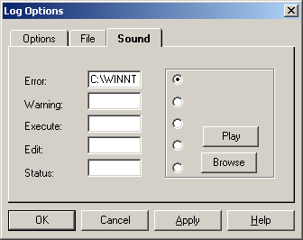

TILE! Audit Trail

Audit Trail Window
The audit trail is designed to provide a textual view of the settings in each icon on the flowchart.
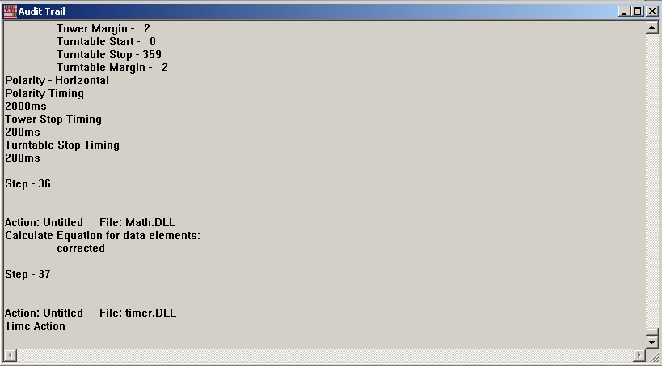
Each icon is summarized to give the details of each icon’s setting. Each icon has a separate listing. The step numbers refer to the sequence the icon were added to the flowchart. This is because you can have multiple starting points to the flowchart. There is no easy way to determine which is next or first.

Audit Trail Overview
The Audit Trail was created to allow the user to easily create a record of the settings in the flowchart, either for documentation or for debugging purposes. After you design and test a profile, you might want to print a copy of the Audit Trail to save as a record of the original design. This makes it easier to answer questions about the design of the test – from accreditation auditors, for instance.
The printed copy can also be used during the design mode to insure that the settings in related icons are the same. For instance, in the GTEM testing you need to perform 3 identical emissions test. It is critical that the Resolution Bandwidth, Video Bandwidth, Sweep Times and Number of Sweeps are consistent. It is easier to see this on the Audit Trail then to double click each icon and check the settings of two or three different tabs.

Audit Trail Options
The only option on the Audit Trail is to print. There are no other options that can be selected.

TILE! Actions
Actions are the heart of the TILE! System. All of the operator interface which describes the test parameters, functionally how the test will progress, and the linkages for data and instrument interface are characterized here. Actions are generic in scope, which allows for flexibility and versatility when designing a test, and for this reason alone demonstrates the true power of the TILE! System. The structure allows the design a test in which many similar steps are linked together into a cohesive whole.

How Actions Work
When designing an EMC test, there is more required than just the instrumentation setup. The designers must ask themselves, “What are the conditions that we need for this test?” Typically you need to know what EUT is being tested, who is performing the test, for whom the test is being done, and possibly a set of comments on the unique circumstances of this test. All of these are individual steps that need to be done in sequence to perform a complete test. TILE! provides a structure in which you can sequence a test, gather the information, display it and store it all in one convenient storage receptacle (the profile). In the TILE! system, each of these steps is defined as an ‘Action’. In Chapter 7, The TILE! Flowchart Window, is a discussion of how actions are placed, edited, sequenced and linked. Chapter 3, TILE/ICS Tutorial, gives examples of how to build a test.
This chapter is dedicated to describing the actions in detail.

Palette
The palette displays the actions that can be added to the flowchart. Each action is represented by an icon, which can be selected with the mouse and dropped into a flowchart. This display shows the flowchart palette. The user can select an action from the palette and add it to the flowchart using the mouse. The icons shown on the palette besides this text do not represent all the actions available within TILE!. These are the most common ones.

Common Action Commands
The Windows environment offers many common tools for dealing with a graphical environment. For ease of use, TILE! use’s as many common features as possible. This simplifies the learning environment. The most common features are the ‘Buttons’ that appear in most windows. Whenever the following terminology is used the meaning is the same throughout the program.

Enter Key
The ‘Enter’ key (sometimes referred to as the Carriage Return for those who are old touch typists) accepts the entered information. This may not have the desired effect when you are inside a Window’s dialog box. Enter has the same meaning as ‘OK’ when inside a dialog box. When a box has more than one area of the screen requiring information, you must use the Tab key or your Mouse to maneuver around the dialog box.

Tab Key
The ‘Tab’ key is the primary method of maneuvering between different fields in a dialog box when using the keyboard. You can always use the Mouse to move between entry points, but when touch typing use the Tab key.

OK
The ‘OK’ button accepts the input for the current, open, dialog box and continues with the appropriate modification or operation specified in the flowchart.

Cancel
The ‘Cancel’ button discards all changes made to the dialog box inputs. The flowchart is left as it was before the dialog box was opened. If you are in the middle of an action’s execution, all execution is halted and the program returns to the flowchart.

Apply
The ‘Apply’ button is used in certain Window’s program applications and is present in many standard dialog sequences. This button has specific uses in the TILE! program but generally causes the same action as the ‘OK’ button.

Help
The ‘Help’ button starts the Window’s Help Application with the TILE! Help File and opens to the topic that describes the particular dialog box or function.

Common Name Page
Most actions use a common name page. The name is used to add a unique title to the flowchart refers to this object when using shortcut icons or macro lookups.
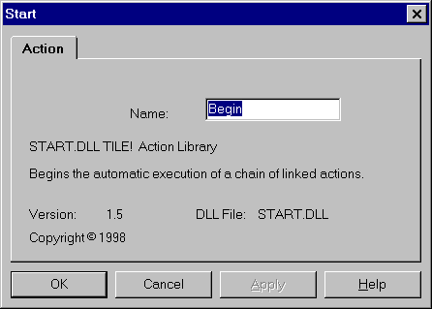
Although names can be quite long (the limitation is 128 characters) you should avoid long names since they crowd the flowchart dramatically. It is very helpful to make the titles descriptive of what this step is meant to do. These shortcut names will aid in quickly moving between different sections of a test profile.

OK, Cancel, Apply and Help
A description of the OK, Cancel, Apply, and Help buttons is found in Common Action Commands on page 77.

Information Actions
The information actions allow you to attach information to your test file for reference. This information can be transferred to the database when using the TILE! database option. This option is available when the database utility is available. This is described in Chapter 11 - Options.

Start

The start action provides a logical starting point to a test profile. This is the only action that allows the execution of a string of actions. When you double click on this action and select ‘Execute’, the complete string of linked actions will begin to sequence. This is the unique feature of this action.
To edit the action, double click and select ‘Edit’.

Name
The Name text box is used to add a title that is displayed on the flowchart and is used to refer to this object. Naming each action with a unique name is critical to using the shortcut’s offered through the Command Bar and Menu Bar.
The information displayed on this page includes information on the version of this action and it’s creation dates. This information, and this page, is common to all actions.

OK, Cancel, Apply and Help
A description of the OK, Cancel, Apply, and Help buttons is found in Common Action Commands on page 77.

Prompt

The Prompt action displays a message box on the screen and waits for a response from the user before executing the next action in the flowchart. This action is also the only action that will support dual outputs. Once option for ‘Prompt’ is to specify an accept and reject path for execution.
An optional sound prompt can be played as part of this action. The sound prompt plays a standard Windows WAV sound file which requires that the computer have a Windows compatible sound board properly installed.

Prompt Action Tab
The Name text box is used to add a title that is displayed on the flowchart and is used to refer to this icon. See Common Name Page on page 77 for a detailed description.

Prompt Message Tab
The Message text box allows the user to enter a message that will be displayed in the Message Box during the execution of this action. A carriage return can be entered to space text. For this reason, the ‘Enter’ button will NOT act as the ‘OK’. You must use the Mouse or Tab buttons. The Message text box includes an OK and Cancel Option. During operation, if the operator selects OK, execution of the next action in the Flowchart continues. If the operator selects the Cancel button execution is halted and the flowchart remains as it was before the dialog box was opened.
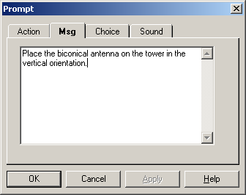
When using the Prompt action we recommend that you put multiple paragraphs of information instead of a single large paragraph. The visual impact of long paragraphs of information can be confusing to the operator. When the amount of data exceeds the simple view, you will automatically scroll to add more. This has a very clumsy appearance when it is executing. We recommend that you put long comments into separate prompt actions so that the amount of information can be easily digested as the operator executes the test.

Prompt Choice Tab
The ‘Prompt’ action has a unique characteristic. It is the only action that allows two outward arrows (directions) to exist. All other actions execute in a serial fashion. The ‘Prompt’ action has an option that allows you to ‘automatically’ determine the direction that this action will take based upon a ‘greater than’, ‘less than’ or ‘equal’ relationship.

Accept/Reject
The first choice on this page reflects the attachment of actions out of this action. The first arrow is automatically determined to be the accept path. The second arrow is the reject path.

Title
You can control the titled displayed on the dialog box for the Accept and Reject buttons. The default are the words ‘Accept’ and ‘Reject’.

Action
The actions displayed here reflect the sequence in which the arrows were attached to the two actions. You can reverse them by dropping down the selection box and choosing the opposite action. You must change both of them or the change will not be accepted.

Auto Choose
Once these are identified, you can display, on the prompt, a data element and the number of data elements that are valid for that data element. If you click on ‘Auto Choose’, then the action will automatically choose the path to take based upon the appropriate mathematical relationship indicated. A common use, for instance, would be to specify that you want to perform a peaks/qp measurement on the specified data element if there are less than 11 data elements. If there are more data elements, the unit has too many failures to justify the additional measurement time.
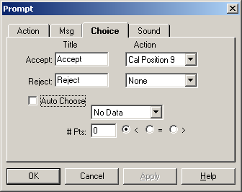

Prompt Sound Tab
An optional sound prompt can be included which plays a Windows .WAV file. This option requires that the computer have a Windows compatible soundboard installed. Checking the ‘No Sound’ box will disable this option. This is the default.

Enable Sound Prompt
There are two options for sound. Play a sound file once or play until interrupted. Check the ‘Single’ or ‘Continuous’ box, as desired. The sound prompt is played during the execution of the Prompt action in the test profile.
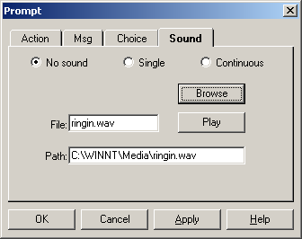

File Name
The File text box is used to specify the name of a .WAV file. The browse option is available for this step.

Path
This text box contains the path to the .WAV file. If the .WAV file is in the default directory, no entry is required. This box is filled automatically when the Browse option is used

Browse
The ‘Browse’ button opens the standard Windows File Open dialog box that is used to select the .WAV file that will be used when this action executes. When a file is selected, the File and Path text boxes are automatically updated.

OK, Cancel, Apply and Help
A description of the OK, Cancel, Apply, and Help buttons is found in Common Action Commands on page 77.

Client
The Client Information action is used to record specific information concerning a client. There are nine generic fields with related titles. These can be modified by the user, during editing, to match any requirements for labels. When executing, only the value field is changeable.

Client Action Tab
The Name text box is used to add a title that is displayed on the flowchart and is used to refer to this icon. See Common Name Page on page 77 for a detailed description.

Client Information
The first two items of the client information, referred to as Contact and Company in the generic titles, are the only items that appear on Tables and Graphs when using the ‘Additional Information’ options. All other fields, including the four editable fields on the ‘Additional Information’ tab, are for reference purposes only.
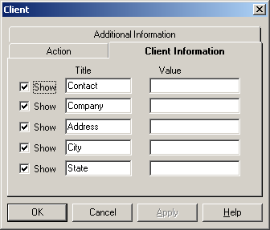

OK, Cancel, Apply and Help
A description of the OK, Cancel, Apply, and Help buttons is found in Common Action Commands on page 77.

EUT

The EUT Information action provides a method to record information unique to the Equipment Under Test (EUT), sometimes referred to as the UUT (Unit under Test). The first field can be displayed on the bottom of Graphs and top of Tables when utilizing the ‘Options/Additional Information’ features of Graphs/Tables.

EUT Action Tab
The Name text box is used to add a title that is displayed on the flowchart and is used to refer to this icon. See Common Name Page on page 77 for a detailed description.

Equipment Under Test – Page 1 and 2
There are seven fields that can be used to describe the EUT. The titles can be modified by the user when editing the action. Only the values can be changed when executing the action.
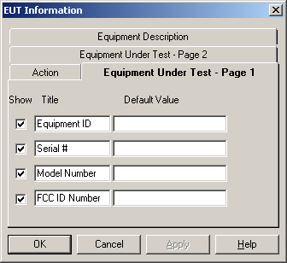
The first field, labeled ‘Equipment ID’, can be display on Graphs and Tables using the ‘Options/Additional Information’ features.

Additional Equipment
Additional Equipment is a general text block that can be used to provide up to 256 characters of descriptive text. This is commonly used to illustrate setups for the EUT or any peripheral equipment that was present during the test. This is very helpful when re-testing equipment.
The ‘Show’ fields on each tab are used to allow the user to turn off display of certain fields during execution. If you decide you only want the first field, turning off the show option for the remaining fields will simplify the entry requirements for the operator during execution.
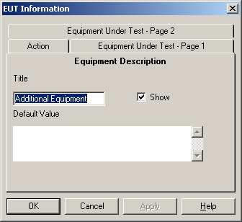

Floating EUT
The EUT action is has a special feature allowing all information and titles to be displayed on Graphs. See Chapter 10 -TILE! Graphs and Tables for a further discussion of this feature.

OK, Cancel, Apply and Help
A description of the OK, Cancel, Apply, and Help buttons is found in Common Action Commands on page 77.

Operator/Laboratory Information
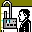
The Operator information action is used to provide two different items to the profile. The first, and most obvious, is the name of the engineer/technician performing the test. The ‘Operator’ field is a single line of text, up to 128 characters long. The operator field can be displayed on Graphs/Tables using the ‘Option/Additional Information’ features. These are described in greater detail in Chapter 10 - TILE! Graphs and Tables.

Laboratory Information Action Tab
The Name text box is used to add a title that is displayed on the flowchart and is used to refer to this icon. See Common Name Page on page 77 for a detailed description.

Laboratory Information Tab
The display matrix in the box also the operator to verify, and change, the Serial Number and Calibration Date for the various instruments defined in the profile. This information is not mandatory and can be skipped by the operator, but it does provide a convenient methodology for verifying that the correct instrument has been used and to allow storage of the correct Calibration Date for each instrument in the stack. See Chapter 6 - The TILE! Instrument Window for a greater explanation of this information.
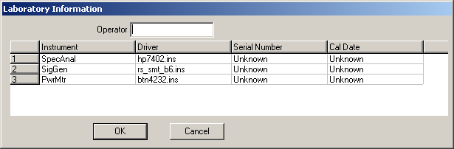

OK, Cancel, Apply and Help
A description of the OK, Cancel, Apply, and Help buttons is found in Common Action Commands on page 77.

Comment
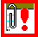
The Comment action allows the operator to insert comments that relate to the test process. This action can be used liberally where operator input on various stages of the test process is desired.

Comment Action Tab
The Name text box is used to add a title that is displayed on the flowchart and is used to refer to this icon. See Common Name Page on page 77 for a detailed description.

Comment
The Comment text box provides space to record comments specific to this profile or step. You can define multiple comments within the same profile, but only one can be displayed on an individual Graph or Table. Generally, you are limited to a total of 234 characters. We strongly recommend that you enter separate lines of text to insure a consistent view when placed on a Graph. Text will automatically wrap down the screen.
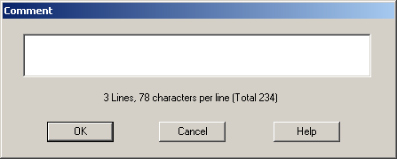

OK, Cancel, Apply and Help
A description of the OK, Cancel, Apply, and Help buttons is found in Common Action Commands on page 77.

Picture
The Picture action allows the display of a bitmap picture that relates to the test process or setup. The operator, once they have inspected the picture, can continue or quit.

Picture Action Tab
The Name text box is used to add a title that is displayed on the flowchart and is used to refer to this icon. See Common Name Page on page 77 for a detailed description.

Picture
The Picture tab allows selection of the bitmap to be displayed as well as entry of text to record a comment specific to this step.
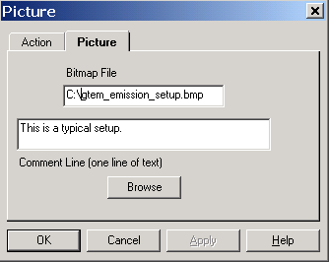

OK, Cancel, Apply and Help
A description of the OK, Cancel, Apply, and Help buttons is found in Common Action Commands on page 77.

Instrument Actions

Instrument Initialization
Instrument initialization provides a method of sending instrument reset/preset commands to designated instrumentation. This is especially important at the start of long sequences of different types of tests. It is important to insure the instruments are in a defined starting setup since there is no automatic initialization in any specific instrument commands.

Instrument Initialization Action Tab
The action tab is a common name page. A complete description is found in Common Name Page on page 77.

Instrument Initialization Instruments Tab
This page displays a two-column screen. The first column shows the instruments defined in this test profile. The second column displays those instruments that need to be initialized at this step. You can highlight the instrument and click ‘Add’ or ‘Remove’. Instruments can also be selected and moved by double clicking on the instrument. This will move it to the opposite column (either to add or to remove, as appropriate).
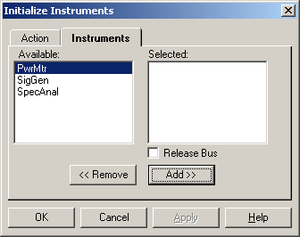

OK, Cancel, Apply and Help
A description of the OK, Cancel, Apply, and Help buttons is found in Common Action Commands on page 77.

Measure Range
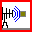
The Measure Range action is used to configure the measurement of a range of frequencies used by a receiver or spectrum analyzer. The measured data is stored in the specified data element. The operating conditions for the receiver or spectrum analyzer are set in the Measure Range Parameters page. The Measure Range action requires one data element for storage of the results and at least a receiver or spectrum analyzer. These parameters are set with the Links tab.

Measure Range Action Tab
The action tab is a common name page. A complete description is found in Common Name Page on page 77.

Measure Range Frequency Tab
The ‘Frequency’ tab allows the operator to select the range parameters over which measurements will be taken.
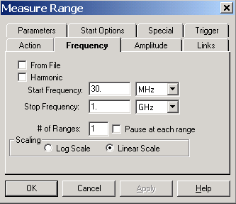

Start Frequency
The start frequency is set using the text box and units list box. The frequency set is the product of the value in the text box and the multiplier selected in the units list box. The list of available multipliers can be viewed by clicking on the down arrow to the right of the units list box. Enter a value in the text box and select the appropriate units. The Tab key will move between these boxes. In the unit’s box, entering the first letter will highlight the appropriate value.

Stop Frequency
The stop frequency is set using the text box and units list box. The frequency set is the product of the value in the text box and the multiplier selected in the units list box. The list of available multipliers can be viewed by clicking on the down arrow to the right of the units list box. Enter a value in the text box and select the appropriate units. The Tab key will move between these boxes. In the unit’s box, entering the first letter will highlight the appropriate value.

Number of Ranges
Entering a value into the text box sets the number of ranges. When this action is executed, the frequency span between the start and stop frequencies is divided into the number of ranges specified. This is true for spectrum analyzers only. This item is ignored for true receivers.
Unique scans are made of each frequency range with the results collected into a single data element. The number of points in the data file is the product of the number of ranges and the number of measurement points per scan for the instrument connected to this action.
In designing the measurement, knowledge of the capabilities of the analyzer/receiver is critical. If your spectrum analyzer has a 401 dot resolution to its display (a common setting), then when you do a scan the instrument will only send 401 points, regardless of the bandwidth you specified in the parameters. If you are making a measurement from 30 MHz to 1000 MHz with a 120 kHz bandwidth, you need 8,083 points ({1,000,000,000-30,000,000}/120,000). If you analyzer only reports 401 points, you need to break this frequency range into at least 20 ranges to obtain a reasonable accuracy. For this reason, you might want to design a scan with broad bandwidths, calculate the peaks and run a measurement of the peaks only with the narrow bandwidth. Experimentation by the user is recommended.

Pause at each range
If there is more than one range, turning this on will cause the software to pause between each range and let the user choose to retry the range, store the value or cancel the test.

Scaling
The ‘Log Scale’ and ‘Linear Scale’ radio buttons are used to select the appropriate frequency range scaling. If the range is 30MHz to 1GHz with log scaling selected, the frequency range will be adjusted to measure the ‘Number of Ranges’ per decade across the stated frequency range. For example, if you entered 30 MHz – 1 GHz for your frequency range and set the ranges to 2 in log scale, you would get a decade from 30 MHz – 300 MHz broken into 2 ranges and then another sequence from 300 MHz – 3 GHz broken into two ranges. Since our ending frequency is only 1 GHz, actual number of ranges in the last decade would vary depending upon the logarithmic steps. The default is ‘Linear Scale’.

From File
Select the ‘From File’ check box if you wish to read in the frequency data from an external file. This data must first be imported into a ‘File’ type data element. The data should be comma separated variables with column one identifying the frequency and column two identifying the value. For this feature to work, the frequency list (from the data file) should represent pairs of Start and Stop frequencies. If the number of data elements is not even, this feature will return an error. For more information on file creation, see Chapter 5, File Elements on page 40 for more details.
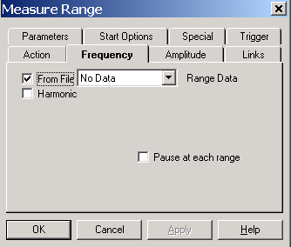
You can still utilize the ‘Pause at each range’ option when using ‘From File’.

Harmonic
The Harmonic option allows this action to be used to measure a Primary frequency (called ‘Start Frequency’) and then take measurements at a specific number of harmonics. At each frequency, a span for the range measurement will be established using the ‘Bandwidth’ parameter. On the example shown here the software would scan from 29.5 MHz – 30.5 MHz, 59.5 MHz – 60.5 MHz, …299.5 MHz – 300.05 MHz. These 10 scans (primary plus 9 harmonics) are combined into one data array.
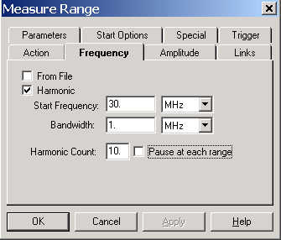

Start Frequency
Enter the desired primary frequency. This will be the first frequency measured. All harmonics are calculated from the frequency.

Bandwidth
Chose an appropriate bandwidth for the analyzer to take a sweep. This is the same as a span.

Harmonic Count
This value determines the number of harmonics measured. The primary frequency is the first harmonic.

Measure Range Amplitude Tab
The Amplitude tab allows the operator to select the reference level and attenuation levels to be used with the spectrum analyzer during each scan. These values may be ignored for some EMC Receivers, especially the Reference Level.
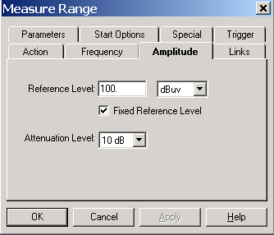

Reference Level
The ‘Reference Level’ is a function of both the noise floor of your instrument and the maximum expected signal. If you are working in an anechoic chamber, you could set this to 60-80 dB and take valid readings. But on an OATS, this would very quickly put your analyzer/receiver in saturation.
The ‘Reference Level’ for the measurement is set using the text box and units list box. The frequency set is the product of the value in the edit box and the multiplier selected in the units list box. The list of available multipliers can be viewed by clicking on the down arrow to the right of the units list box.

Fixed Reference Level
During scans the default behavior is to set the Reference Level specified and is not changed during the various scans. If this field is unchecked the behavior changes slightly. The specified reference level is set at the start of each scan, but after the information for the analyzer is downloaded, it is checked to determine if there are any values within 10 dB of the reference level. If there are, then the reference level is stepped up 10 dB and rescanned. This procedure continues until the maximum signal is within the current range of the analyzer display or we have reached the maximum. This will insure that report accurately the total signal strength. Some analyzers will report a signal that is off the screen, but others report numbers that are not accurate. For this reason, this option will allow accurate measurements under these conditions. This procedure does have one side effect that concerns most users. When we combine the multiple scans together, the apparent noise floor will shift depending upon the changes made to the reference level.

Attenuation Level
Use this field to select the attenuation level to be used for the scans. This allows you to adjust the attenuation to match your environment or EUT. You can choose values from 0 – 60 dB or AUTO. We do not generally recommend AUTO. Some spectrum analyzers change other settings within the analyzer when the attenuation is set to AUTO. If you test this to insure the performance is what you expect it can be a very easy method of controlling the analyzer’s response to high ambient fields.

Measure Range Links Tab
The Links tab allows the operator to specify data and instrument links. This is the point of coordination between the instrument window, the data window and the flowchart.

Data
The Data list box is used to identify the data storage element to be used by this action. When the action is executed, the data element is resized to the product of the number of ranges and the number of measurement points per scan for the instrument connected to this action. If no errors are detected during the execution, the data is marked as valid and the frequency and amplitude data are set for each point measured.
You select the data element by clicking on the down arrow next to this line. This will display all the defined data elements. Select the appropriate data elements.
CAUTION - picking a data element that is used somewhere else will erase your previous information.

Instrument
The Instrument list box is used to identify the instrument from which measurements will be taken. Press the drop down arrow to display the defined instruments. One advantage of the TILE! system is its ability to quickly change test instruments. If you design the parameters and frequency ranges to match all your instruments, then you can change instruments during a test by simply changing the linkage in the Instrument Window. The names used on the Instrument linkage in each action will automatically adjust to the newly defined instrument.

QP Detector
The ‘QP Detector’ list box is used to select the QP Detector that will be used for the measurement. Only select an instrument if you have a physically separate box for QP measurements. This is true of both the Hewlett Packard 85650 QP Adapter and the Anritsu MN1602a. If you analyzer/receiver has a built-in QP function DO NOT specify an instrument in this box.
If an QP Adapter is selected, the performance of the test will change slightly. When using an HP8566/8 with the HP85650 QP adapter, the manufacturer specifies a set of matching RF and Video Bandwidths to math the RF bandwidths of the QP adapter. The TILE! software will set the analyzer to these matching bandwidths when using the ‘Parameters’ settings on the QP Adapter. If you want a specific bandwidth on the analyzer, do NOT specify the QP Adapter in this box and the software will only setup the analyzer.

Preselector
The ‘Preselector’ list box is used to select the Preselector that will be used for the measurement. You only need to select an instrument if you have a physically separate box acting as a Preselector. If you analyzer has this function built-in DO NOT specify an instrument in this box.

Measure Range Parameters Tab
The Parameters tab is used to specify the instrument setup for this measurement.

RF and Video Bandwidth
Click on the drop down arrow to display the available RF and video bandwidth settings. Not all instruments will be able to use each of these settings, but the instrument driver will pick the closest setting that is valid for the specified receiver. For instance, most older EMC Receivers will only do 9kHz and 120kHz RF bandwidths. For all bandwidths at or above these settings, the driver will automatically pick the appropriate setting. Video settings are not valid for most EMC Receivers.
When you have specified a QP Adapter on the ‘Links’ tab, the RF Bandwidth will be set for the QP Adapter. The Analyzer will be set to a matching set of RF and Video Bandwidths determined by the manufacturer.

Number of Sweeps
A setting greater than one will cause the analyzer to be put in ‘MaxHold’ and the specified number of sweeps will be made. For EMC Receivers, the software will sweep the receiver the number of specified times and hold the peak value internally.

Sweep Time
The ‘Sweep Time’ setting is how long the receiver/analyzer will take to sweep across the frequency band. This setting will determine the dwell time at each frequency point. The value is entered by clicking on the drop down arrow for both the text box and the units box. Set these to the required values. Be aware that this value in receivers determines the dwell time PER READING. Since receivers sweep by stepping and measuring each frequency you need a much faster value for a reasonable sweep.

CAUTION - Setting this value greater than 10 seconds can cause the instrumentation to time out. If this happens change the GPIB/Setup/Timeout settings in the instrument definition to a value higher than the sweep time. See page 57, ‘Timeout Settings’ for more detail on sweep times over the GPIB bus.

Detector
Allows selection of the measurement detector desired for this scan. The available options are PEAK, QUASI-PEAK, and AVERAGE. Click on the drop down arrow to select the appropriate type.

CAUTION - Selection of QUASI-PEAK (QP) during a range scan is not recommended. Most analyzers will not perform the test or take an excessively long time. QP is only recommended using the Measure Peaks and Scan Peaks functions. This is a perfectly acceptable setting for Receivers.

Measure Range Dialog
When executed the Measure Range Dialog box will open. This gives the user visual information on the current step, start and stop frequencies as well as a ‘Stop’ button to halt execution of the action. If the ‘Stop’ button is pushed the action will terminate at the end of the current GPIB operation (this range scan). The Pause button will pause execution after the current analyzer scan, but prior to the next scan. With this option you can manually check a reading and then ‘Retry’ the scan, ‘Capture’ the current scan and Cancel execution.
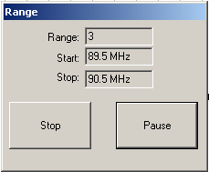

OK, Cancel, Apply and Help
A description of the OK, Cancel, Apply, and Help buttons is found in Common Action Commands on page 77.

Measure Peaks

Measure Peaks provides the ability to perform measurements on a selected set of frequency points. These points are usually derived by performing peak selections off a range of measurement values, but can include fixed frequency points from a table. This is particularly helpful when measuring known harmonics or other fixed point considerations.

Measure Peaks Action Tab
The action tab is a common name page. A complete description is found in Common Name Page on page 77.

Measure Peaks Frequency Tab
This action takes a set of peaks from a data element and performs a Peak, QP and/or Average reading for each data point. The choice of performing Peak/QP/Average measurements depends upon the settings in the Output tab. Press the drop down arrow and select the data element that contains the points of interest.
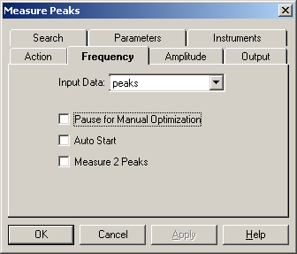

Pause for manual optimization
During the measurement process, it may be required to optimize the signal level at the specified data points. This selection allows the operator to accomplish this. This is helpful when doing a Mil-Std CE-101 type test or when you want to manual search (for instance when using a small probe on a circuit board) for a signal. You might call this the appropriate setting is you want to ‘shake the cables’.

Auto Start
‘Auto Start’ will automatically step the measurement through the desired frequency points. Selecting ‘Auto Start’ overrides the ‘Pause for manual optimization’ selection’, but the Measure Peaks dialog box gives the operator the ability to halt the test and then step through frequency points through manual selections on the dialog box. See the Measure Peaks Dialogs for a view of this dialog box.

Measure 2 Peaks
The ‘Measure 2 Peaks’ selection allows the operator to record peak levels at different antenna locations. This is a specific requirement of CE-101 which requires a measurement at 7 cm spacing and a second reading at 50 cm spacing. The operator will be prompted to move the antenna to the second position once the peak data is recorded. Two data elements are required on the ‘Output’ page. Peak2 data element must be selected to store the results of this second reading.

Measure Peaks Amplitude Tab
The Amplitude tab allows the operator to select the reference level and attenuation levels to be used with the spectrum analyzer during each scan. These values may be ignored for some EMC Receivers, especially the Reference Level.

Reference Level
The ‘Reference Level’ is a function of both the noise floor of your instrument and the maximum expected signal. If you are working in an anechoic chamber, you could set this to 60-80 dB and take valid readings. But on an OATS, this would very quickly put your analyzer/receiver in saturation.
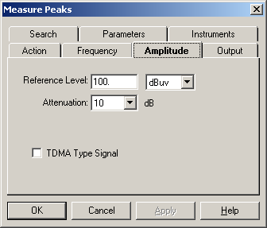
The ‘Reference Level’ for the measurement is set using the text box and units list box. The frequency set is the product of the value in the edit box and the multiplier selected in the units list box. The list of available multipliers can be viewed by clicking on the down arrow to the right of the units list box.

Attenuation Level
Use this field to select the attenuation level to be used for the scans. This allows you to adjust the attenuation to match your environment or EUT. You can choose values from 0 – 60 dB or AUTO. We do not generally recommend AUTO. Some spectrum analyzers change other settings within the analyzer when the attenuation is set to AUTO. If you test this to insure the performance is what you expect it can be a very easy method of controlling the analyzer’s response to high ambient fields.

TDMA Type Signal
When this check box is set, the software will set the marker to follow the peak during each sweep. TDMA signals are pulse type signals which appear to change frequency each time we take a scan. Another method to handle this would be to set the number of sweeps large enough to insure that you capture the signal.

Measure Peaks Output Tab
On the Output page you choose the type of location to store your results. The selection on this page determines the detector for this measurement.
The data element must be defined as a measurement type in the data window. TILE! Version 1.1F and earlier did not allow you to select more than one option at a time. Later versions will allow you to perform any or all three measurements in one action.
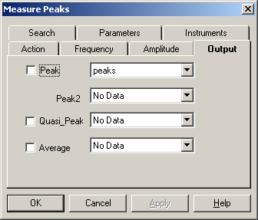

Measure Peaks Search Tab
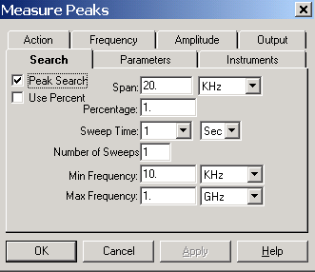
When performing peak measurements one problem determining if we are on the signal of interest. Often, you will take a measurement scan across of range of frequencies (using Measure Range or one of the other emission actions). These readings are fairly wide band scans. Most spectrum analyzers have significant frequency drift when comparing wide-band measurements to vary narrow band measurements (and by this we mean the bandwidth of the scan). When you are searching for peak signals you can determine whether to search for a closer peak. If the box labeled 'Peak Search' is checked, then the software will perform a peak search routine prior to taking final measurements.
When this box is checked, you then specify the band around which you want to search. For instance, if you are taking measurements that will typically see two signals within 2 MHz of each other you might specify a band search of less than 1 MHz. This will insure that you do not identify the wrong signal when measuring these points. At the same time this will insure that the peak signal is properly centered on the screen prior to measurement.

Span
Specify a frequency span for the analyzer during peak searching. This is a fixed span that does not vary with frequency. Use the ‘Percent’ method if you want the span to vary with frequency.

Use Percent
Check this box and select a percent value to utilize a frequency dependent span. This is an alternative method to setting a fixed span.

Sweep Time/Number of Sweeps
You can select an appropriate sweep time and number of sweeps for the search mode. These settings are different than those used during the final readings (which are set on the Parameters Tab). If more than one sweep is specified than the analyzer will be put in MaxHold and the number of sweeps executed.

Min/Max Frequency
These settings allow you to insure that the analyzer settings do not exceed a minimum or maximum frequency. For instance, let us assume that you are measuring conducted emissions from 150 KHz – 30 MHz and have a suspect at 151 KHz. With the search span set to 20 KHz, it would normally open a search span of 141 KHz – 161 KHz. Given the noise floor of some analyzers it would be possible for ‘walk’ the noise floor down below 150 KHz. Setting the minimum frequency to 150 KHz would limit the search span to 150 KHz – 161 KHz. This would insure that the peak was found in this span. A second consideration you are faced with is doing testing outside the range that the standards are written. In this case setting the minimum and/or maximum frequency will insure that your searches stay within the frequencies of interest.

QP Across Band
The default behavior is to perform a QP measurement at Zero (0) span. If ‘QP Across Band’ is selected, a QP measurement will be performed at the frequency span selected in the ‘Span’ box.

Measure Peaks Parameters Tab
The Parameters tab is used to specify the instrument setup for this measurement.
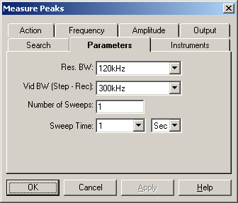

RF and Video Bandwidth
Click on the drop down arrow to display the available RF and video bandwidth settings. Not all instruments will be able to use each of these settings, but the instrument driver will pick the closest setting that is valid for the specified receiver. For instance, some of the older EMC Receivers will only do 9 KHz and 120 KHz RF bandwidths. For all bandwidths selected at or above these settings, the driver will automatically pick the nearest appropriate setting.
The video BW parameter is used slightly differently with a receiver. When using a true EMC receiver, the Video BW is treated as the step size for measurements.

Number of Sweeps
A setting greater than one will cause the analyzers to be put in ‘MaxHold’ and the specified number of sweeps will be made. For EMC Receivers, the software will sweep the receiver the number of specified times and hold the peak value internally.

Sweep Time
The ‘Sweep Time’ setting is how long the receiver/analyzer will take to sweep across the frequency band. This setting will determine the dwell time at each frequency point. The value is entered by clicking on the drop down arrow for both the text box and the unit’s box. Set these to the required values.
Keep in mind that receivers treat the sweep time as a dwell time PER STEP. Analyzers use sweep time as the time to perform a single sweep across the whole frequency. This is very important when configuring a test. Setting a receiver to 1 second sweep time could result in sweeps taking minutes, or even hours.
CAUTION - Setting this value greater than 10 seconds can cause the instrumentation to time out. If this happens change the GPIB/Setup/Timeout settings in the instrument definition to a value higher than the sweep time. See page 57, ‘Timeout Settings’ for more detail on sweep times over the GPIB bus.

Measure Peaks Instruments Tab
The ‘Instruments’ page identifies which instruments will be addressed by this action. At a minimum you must specify the Analyzer. Click the drop down button and select the appropriate named instrument.
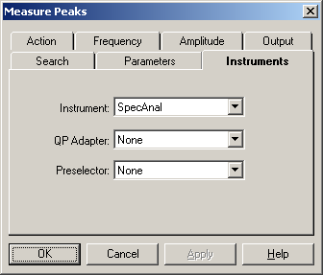
If you are making QP measurements you will need to specify the QP Adapter only if a completely separate instrument performs the QP function.
The Preselector needs to be specified if a separate instrument is present.

Measure Peaks Dialogs
The Measure Peaks dialog box gives a visual display of the current step number, the current target frequency, the current instrument frequency, the current amplitude, and the measurement type. Depending upon the choices on the Frequency tab, the actual appearance of the dialog box changes slightly.
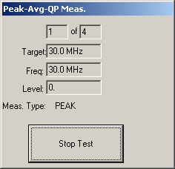
There is a ‘Stop Test’ button that allows the user to terminate execution of this action. When you click ‘Stop Test’ the system will complete the current GPIB read/write sequence to insure a clean exit of the GPIB bus. Immediate cancellation of the process could leave the GPIB in a non-working condition. This is true of most stop or halt buttons in the TILE system.
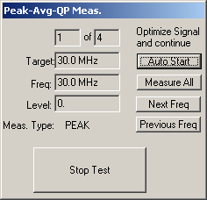
If the ‘Pause for Manual’ option is checked on the Frequency Tab then you will have an additional set of buttons that allow you to ‘step’ through each frequency.

OK, Cancel, Apply and Help
A description of the OK, Cancel, Apply, and Help buttons is found in Common Action Commands on page 77.

Scan Range Measurement
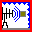
The Scan Range Measurement action is used to perform a measurement of a range of frequencies, using either a receiver or a spectrum analyzer for the primary instrument with these measurements optimized for either tower or turntable maximums. This action only optimizes one orientation (either tower or turntable). To optimize both tower and turntable readings, use the Optimize Action on Page 122.

Scan Range Action Tab
The action tab is a common name page. A complete description is found in Common Name Page on page 77.

Scan Range Frequency Tab
The Frequency tab allows the operator to select the range parameters across which measurements will be taken.
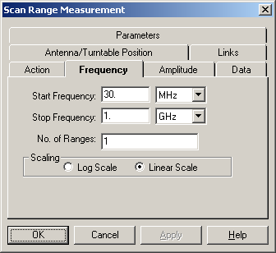

Start Frequency
The start frequency is set using the text box and units list box. The frequency set is the product of the value in the text box and the multiplier selected in the units list box. The list of available multipliers can be viewed by clicking on the down arrow to the right of the units list box. Enter a value in the text box and select the appropriate units. The Tab key will move between these boxes. In the unit’s box, entering the first letter will highlight the appropriate value.

Stop Frequency
The stop frequency is set using the text box and units list box. The frequency set is the product of the value in the text box and the multiplier selected in the units list box. The list of available multipliers can be viewed by clicking on the down arrow to the right of the units list box. Enter a value in the text box and select the appropriate units. The Tab key will move between these boxes. In the unit’s box, entering the first letter will highlight the appropriate value.

Number of Ranges
Entering a value into the text box sets the number of ranges. When this action is executed, the frequency span between the start and stop frequencies is divided into the number of ranges specified. This is true for spectrum analyzers only. This item is ignored for true receivers.
Unique scans are made of each frequency range with the results collected into a single data element. The number of points in the data file is the product of the number of ranges and the number of measurement points per scan for the instrument connected to this action.
In designing the measurement, knowledge of the capabilities of the analyzer/receiver is critical. If your spectrum analyzer has a 401 dot resolution to its display (a common setting), then when you do a scan the instrument will only send 401 points, regardless of the bandwidth you specified in the parameters. If you are making a measurement from 30 MHz to 1000 MHz with a 120 kHz bandwidth, you need 8,083 points ({1,000,000,000-30,000,000}/120,000). If you analyzer only reports 401 points, you need to break this frequency range into at least 20 ranges to obtain a reasonable accuracy. For this reason, you might want to design a scan with broad bandwidths, calculate the peaks and run a measurement of the peaks only with the narrow bandwidth. Experimentation by the user is recommended.

Scaling
The ‘Log Scale’ and ‘Linear Scale’ radio buttons are used to select the appropriate frequency range scaling. If the range is 30MHz to 1GHz with log scaling selected, the frequency range will be adjusted to measure the ‘Number of Ranges’ per decade across the stated frequency range. For example, if you entered 30 MHz – 1 GHz for your frequency range and set the ranges to 2 in log scale, you would get a decade from 30 MHz – 300 MHz broken into 2 ranges and then another sequence from 300 MHz – 3 GHz broken into two ranges. Since our ending frequency is only 1 GHz, actual number of ranges in the last decade would vary depending upon the logarithmic steps. The default is ‘Linear Scale’.

Scan Range Amplitude Tab

Reference Level
The ‘Reference Level’ is a function of both the noise floor of your instrument and the maximum expected signal. If you are working in an anechoic chamber, you could set this to 60-80 dB and take valid readings. But on an OATS, this would very quickly put your analyzer/receiver in saturation.
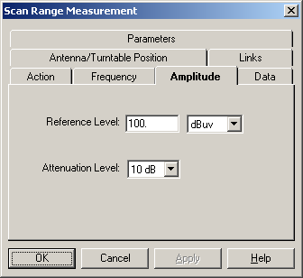
The ‘Reference Level’ for the measurement is set using the text box and units list box. The frequency set is the product of the value in the edit box and the multiplier selected in the units list box. The list of available multipliers can be viewed by clicking on the down arrow to the right of the units list box.

Attenuation Level
Use this field to select the attenuation level to be used for the scans. This allows you to adjust the attenuation to match your environment or EUT. You can choose values from 0 – 60 dB or AUTO. We do not generally recommend AUTO. Some spectrum analyzers change other settings within the analyzer when the attenuation is set to AUTO. If you test this to insure the performance is what you expect it can be a very easy method of controlling the analyzer’s response to high ambient fields.

Scan Range Data Tab
The Data tab allows the operator to identify the data storage elements to be used by this action.
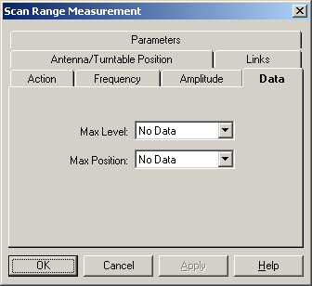

Max Level
This Data list box is used to identify the data storage element where the maximum value will be stored. When the action is executed, the data element is resized. For Spectrum Analyzers this is the product of the number of ranges and the number of measurement points per scan for the instrument connected to this action. For receivers it is the total frequency range divided by the step size (set with the Video BW on the Parameters Tab). If no errors are detected during the execution, the data is marked as valid and the frequency and amplitude data are set for each point measured.
You select the data element by clicking on the down arrow next to this line. This will display all the defined data elements. Select the appropriate data element.

Max Position
This Data list box is used to select the data storage element in which the height or angle of the maximum value will be stored. This is dependent upon whether you are using a tower or turntable controller.
You select the data element by clicking on the down arrow next to this line. This will display all the defined data elements. Select the appropriate data element.
CAUTION - Picking a data element that is used somewhere else will cause this action to overwrite previous data.

Scan Range Antenna/Turntable Position Tab
The Antenna/Turntable tab controls the settings for the positioner and what type of positioner will be used in this action.
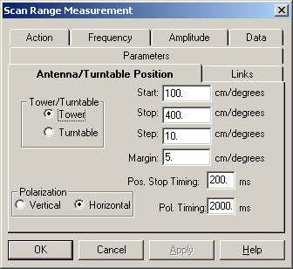

Tower/Turntable
These action buttons determine the character of the positioner. Your choice is either Tower or Turntable. The Start, Stop and Step settings are relative to the type of instrument selected. If a Tower is chosen (the default setting), then these reflect the height in cm’s. When a turntable is chosen, they determine angular degrees.

Margin
The margin allows the user to set an ‘error’ margin for the instrument. The software will use this value to determine when to send a stop command while the positioner is in motion. If the stop position is 400 and the margin is set to 5, the stop command will be issued when the software detects passing 395. This setting will be site and test specific because of the differences between positioners and the equipment placed upon them.

Pos. Stop Timing
Once a stop command is issued, this value is checked to determine a wait time before any other commands are sent to the positioner. If your braking system responds slowly, or has no braking system, this parameter will let you insure that a command to change direction is not issued before stopping has completed. On some older positioners if you send a stop command and immediately send a change of direction command, the second instruction will be ignored if the positioner is still in motion.

Polarity Settings
If you have configured this action to be a Tower then there are two additional control elements.

Polarization
Determines whether to put the tower in the vertical or horizontal orientation. Choose the appropriate setting.

Polarity Timing
This setting determines how long the software will wait after issuing the polarization command before any motion is started. Most towers have no feedback to determine whether polarization has executed, or what polarity they are in, so this command lets the user set a delay time prior to any further motion of the tower.

Scan Range Links Tab
The Links tab is used to identify the instruments which will be used during execution of this action. One advantage of the TILE! system is its ability to quickly change test instruments. If you design the parameters and frequency ranges properly, then you can change instruments during a test by simply changing the linkage in the Instrument Window. The names used on the Instrument linkage in each action will automatically adjust to the newly defined instrument.
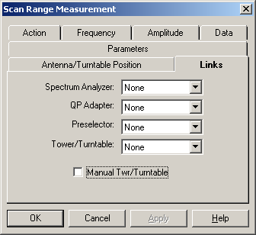

Spectrum Analyzer/Receiver
This drop down box identifies the instrument on which the voltage readings will be taken. Press the drop down arrow adjacent to each instrument to display the available instruments.

QP Adapter
This drop down box identifies which ‘QP Adapter’ will be used during the measurement process. Press the drop down arrow adjacent to the instrument to display the available instruments. Do NOT select an QP instrument unless you have a completely separate instrument, such as the Hewlett Packard 85685A or Anritsu MN1602A.

Preselector
This drop down box identifies which ‘Preselector’ will be used during the measurement process. Press the drop down arrow adjacent to the instrument to display the available instruments. Do NOT select an Preselector instrument unless you have a completely separate instrument, such as the Hewlett Packard 85650A.

Tower/Turntable
The choice of positioner determines whether angular or height information is captured while executing this action. Press the drop down arrow adjacent to each instrument to display the available instruments. If no tower or turntable is available, or it is not GPIB controlled, select the ‘Manual Twr/Turntable’ check box to configure an operator interrupt. This will allow you to manually set the tower position during the test. It is recommend that you identify the instrument in the instrument window and here even if it is manually operate.
If the ‘Manual Twr/Turntable’ check box is checked, whenever motion is called in the software a dialog box will open instructing the user to move to a specific position.

Scan Range Parameters Tab
The Parameters tab is used to specify the instrument setup for this measurement.

RF Bandwidth
Click on the drop down arrow to display the available RF bandwidth settings. Not all instruments will be able to use each of these settings, but the instrument driver will pick the closest setting that is valid for the specified receiver. For instance, many older EMC Receivers will only do 9 kHz and 120 kHz RF bandwidths. For all bandwidths at or above these settings, the driver will automatically pick the appropriate setting.
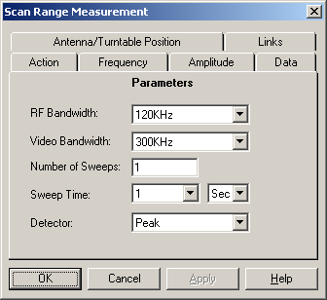

Video Bandwidth
Click on the drop down arrow to display the available Video bandwidth settings. Not all instruments will be able to use each of these settings, but the instrument driver will pick the closest setting that is valid for the specified analyzer.
For Receivers, this setting determines the step size for readings. Generally speaking this parameter should be the same or smaller than the RF bandwidth for receivers.

Number of Sweeps
A setting greater than one will cause the analyzer to be put in ‘MaxHold’ and the specified number of sweeps will be made. For EMC Receivers, the software will sweep the receiver the number of specified times and hold the peak value internally.

Sweep Time
The ‘Sweep Time’ setting is how long the receiver/analyzer will take to sweep across the frequency band. This setting will determine the dwell time at each frequency point when using a Receiver. The value is entered by clicking on the drop down arrow for both the text box and the unit’s box. Set these to the required values.
CAUTION - Setting this value greater than 10 seconds can cause the instrumentation to time out. If this happens change the GPIB/Setup/Timeout settings in the instrument definition to a value higher than the sweep time. See page 57, ‘Timeout Settings’ for more detail on sweep times over the GPIB bus.

Detector
Allows selection of the measurement detector desired for this scan. The available options are PEAK, QUASI-PEAK, and AVERAGE. Click on the drop down arrow to select the appropriate type.
CAUTION - Selection of QUASI-PEAK (QP) during a range scan is not recommended. Most analyzers will either not perform the test, or take an excessively long time. QP is only recommended when using a Receiver. For analyzers we recommend using the Measure Peak and Scan Peaks functions.

Scan Range Dialog
The Scan Range Measurement dialog box gives the user visual information on the current range that is being performed. The start and stop frequencies for this range are displayed along with the Tower or Turntable current and target position information.
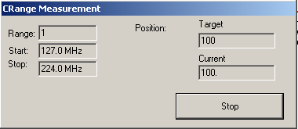
A ‘Stop’ button gives the user the ability to halt execution of the test at this point. When pressed, the system will complete the current sequence of GPIB commands and then halt execution. This is to insure the GPIB is not left in an inoperable condition.

OK, Cancel, Apply and Help
A description of the OK, Cancel, Apply, and Help buttons is found in Common Action Commands on page 77.

Scan Peaks

The Scan Peaks action provides the ability to perform measurements on a selected set of frequency points. These points are usually derived by performing peak selections on a range of measurement values, but can include fixed frequency points from a table. This is particularly helpful when measuring known harmonics or other fixed point considerations. This action has three distinct modes. The first mode is called ‘Search’. During this mode the software, if this choice is selected in the ‘Search’ tab, will open a search span, find the highest signal in this range and center the analyzer to this frequency. This is an important step when you have frequency inaccuracies which needed to be accounted for during the test. After the ‘search’ mode, the software will optimize the tower the turntable to insure we are locked on the highest signal. After searching both tower and turntables, using the selected choices on the “Optimize Parameters’ tab, the software will return these positioners to the position consistent with the highest signal. Then the ‘measurement’ mode will take final readings of peak/qp/average as specified on the ‘Output’ tab.

Scan Peaks Action Tab
The action tab is a common name page. A complete description is found in Common Name Page on page 77.

Scan Peaks Frequency Tab
This action takes a set of peaks from a data element along with the related positioning information and performs designated Peak, Quasi-Peak and Average readings on these frequency points.
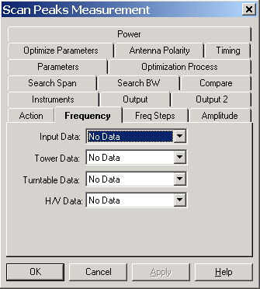

Input Data
Determines the frequency points of interest. This data table can be derived from an existing range measurement through an equation function, by loading a set of data points using a spreadsheet or ASCI text editor or by using the Direct action – see 214.

Tower/Turntable/Polarity Data
The Tower, Turntable and Polarity data elements contain position information related to the ‘Input Data’ element. Any of these may be ignored except the ‘Input Data’. If the position information is available here, then the ‘Optimization Process’ can include the ‘Partial Optimize’ feature.
Press the drop down arrow and select the data element that contains the points of interest.

Scan Peaks Frequency Steps Tab

Pause for manual Optimization
The ‘Pause for Manual Optimization’ selection will cause the measurement to stop at every frequency and optimize the reading. This is particularly useful when performing measurement to FCC compliance where the operator is required to optimize the signal by moving the cables, etc.
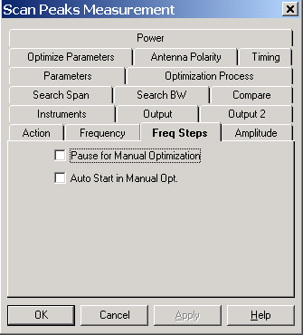

Auto Start
When selected, this option will step the operator through the measurement process, taking the readings automatically at each frequency point.

Scan Peaks Amplitude Tab

Reference Level
The ‘Reference Level’ is a function of both the noise floor of your instrument and the maximum expected signal. If you are working in an anechoic chamber, you could set this to 60-80 dB and take valid readings. But on an OATS, this would very quickly put your analyzer/receiver in saturation.
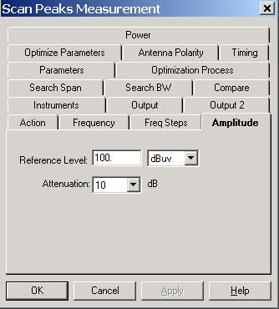
The ‘Reference Level’ for the measurement is set using the text box and units list box. The frequency set is the product of the value in the edit box and the multiplier selected in the units list box. The list of available multipliers can be viewed by clicking on the down arrow to the right of the units list box.

Attenuation Level
Use this field to select the attenuation level to be used for the scans. This allows you to adjust the attenuation to match your environment or EUT. You can choose values from 0 – 60 dB or AUTO. We do not generally recommend AUTO. Some spectrum analyzers change other settings within the analyzer when the attenuation is set to AUTO. If you test this to insure the performance is what you expect it can be a very easy method of controlling the analyzer’s response to high ambient fields.

Scan Peaks Instruments Tab
The instruments page identifies which instruments will be addressed by this action. At a minimum you must specify the Analyzer. Click the drop down button and select the appropriate named instrument.
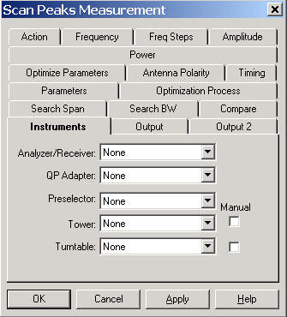
If you are making QP measurements you will need to specify the QP Adapter if you a completely separate instrument to measure QP. If your analyzer/receiver has this feature built-in you do NOT list it in this box.
The Preselector is specified if there is a separate instrument for this function.
Identify Tower and Turntable controllers as needed or when available. If no tower is available, or it is not GPIB controlled, select the manual tower check box to configure an operator interrupt. This will allow you to manually set the tower position during the test. We recommend that you create an instrument in the instrument window even if you are using a manual tower/turntable. This will allow you to upgrade the action in the future with the minimum of changes.

Scan Peaks Output Tabs
On the Output page you chose the type of test and location to store your results. The selection on this page determines the combination of detectors for each frequency measurement.
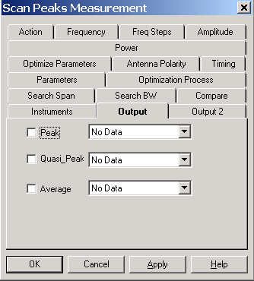
The data element must be defined as a measurement-type in the data window. You can select any or all of these detector types. If selected, a data element must also be selected. If more than one detector is chosen, the tests are always performed in the sequence shown on this tab.
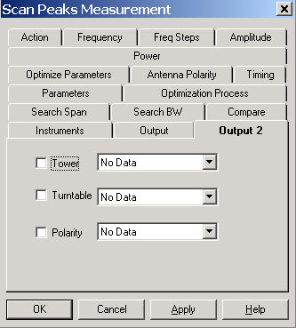
The second page – Output 2 – allows for identification of the Tower position, Turntable position and a text data element that will identify the polarity (either ‘H’ or ‘V’) of the final measurement. Check the items wanted and select an appropriate data element with the drop down arrow and selection box. The Tower and Turntable will identify all ‘Measurement’ type data elements. The Polarity data element must be a ‘Word’ type and only this type will be identified in the drop down box.

Scan Peaks Search Tab
When performing peak measurements, one problem is the need to insure the exact peak is found when repeating prior readings. This is especially true if your bandwidth is different than that used with the original measurements.

Peak Search and Span
The box marked 'Peak Search' determines whether the system will attempt to verify the peak by searching around the original point. If you check this box, you then need to specify the band around which you want to search. For instance, if you have two signals within 2 MHz of each other you might specify a band search of less than 1 MHz. This will insure that you do not identify the wrong signal when measuring these points. Other options include setting the span to 10 times the bandwidth. Choose a span consistent with your expected signal types and ambients.

Span
Specify a frequency span for the analyzer during peak searching. This is a fixed span that does not vary with frequency. Use the ‘Percent’ method if you want the span to vary with frequency.

Use Percent
Check this box and select a percent value to utilize a frequency dependent span. This is an alternative method to setting a fixed span.

Sweep Time and Number of Sweeps
These selections allow you to control the sweep time and number of sweeps to be taken while searching for the peak. These settings are only used during the search mode. Choosing a value greater than one for the number of sweeps will put the analyzer in ‘MaxHold’ mode during the measurement sweeps. There are at least two separate sweeps taken to find the maximum signal and move it to the center of the screen.
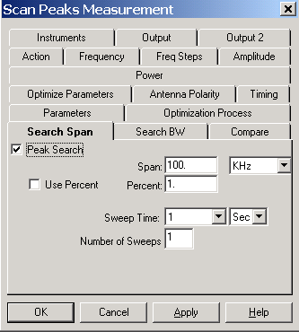

Scan Peaks Search BW

RF and Video Bandwidth
You can select the appropriate RF bandwidth and Video bandwidth. These settings are only used during the ‘search’ mode. You have a completely different set of bandwidth’s during the ‘optimize’ mode and the final measurement mode.
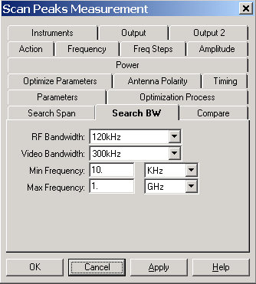

Max/Min Frequency
The values allow you to limit the search span to a defined minimum and maximum frequency. If you requirements do not include any testing above or below a certain frequency, these settings will insure the software never measures outside the frequency range of interest.

Scan Peaks Compare Tab

Comparison Check
The ‘Comparison Check’ is a special feature of the TILE! system which is used on sites with remote, in-line reference antennas. When a remote, reference antenna along with a RF Switch is available, the software will take measurements from both antennas, at each frequency, and compare them. If the difference is less than the amount shown in ‘Acceptance Criteria’, the signal will be ignored as an ambient.
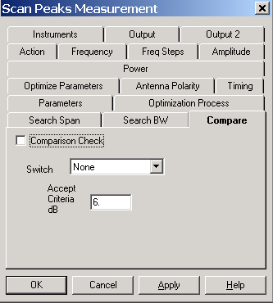

Switch
Select an instrument to control the switch.

Accept Criteria dB
This value, in dB is compared to the difference between the two antennas. If the difference is LESS then this value then this frequency is skipped (an ambient signal is assumed). If it is greater then this value, the frequency is measured in full.

Scan Peaks Parameters Tab
The Parameters tab is used to specify the instrument setup for this measurement.

RF Bandwidth
Click on the drop down arrow to display the available RF bandwidth settings. Not all instruments will be able to use each of these settings, but the instrument driver will pick the closest setting that is valid for the specified receiver. For instance, many older EMC Receivers will only do 9 kHz and 120 kHz RF bandwidths. For all bandwidths at or above these settings, the driver will automatically pick the appropriate setting.

Video Bandwidth
Click on the drop down arrow to display the available Video bandwidth settings. Not all instruments will be able to use each of these settings, but the instrument driver will pick the closest setting that is valid for the specified analyzer.
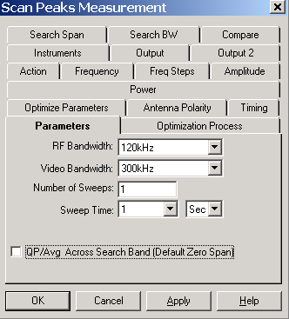
For Receivers, this setting determines the step size for readings. Generally speaking this parameter should be the same or smaller than the RF bandwidth for receivers.

Number of Sweeps
A setting greater than one will cause the analyzer to be put in ‘MaxHold’ and the specified number of sweeps will be made. For EMC Receivers, the software will sweep the receiver the number of specified times and hold the peak value internally.

Sweep Time
The ‘Sweep Time’ setting is how long the receiver/analyzer will take to sweep across the frequency band. This setting will determine the dwell time at each frequency point when using a Receiver. The value is entered by clicking on the drop down arrow for both the text box and the unit’s box. Set these to the required values.
CAUTION - Setting this value greater than 10 seconds can cause the instrumentation to time out. If this happens change the GPIB/Setup/Timeout settings in the instrument definition to a value higher than the sweep time. See page 57, ‘Timeout Settings’ for more detail on sweep times over the GPIB bus.

QP/Avg Across Search Band
The default behavior of the QP and Average measurements is to go into a zero span mode and measure the returned value. Sometimes, especially if your signal is frequency varying, you will miss the maximum. If you turn on this option, then the QP and Average measurements will be done across the defined search span. This takes a little longer, but will capture a moving target better.

Scan Peaks Optimization Process Tab
The Optimization Process determines how the software will react to height and angle information for each data point. Range measurements are often taken with the tower and turntable rotated through stepped positions. This yields the position at which the maximum was found. Since we do not measure all positions in the range measurements, the Scan Peaks action allows you scan a much higher positional accuracy. The ‘Optimization’ process takes place after the ‘Search’ mode is performed.
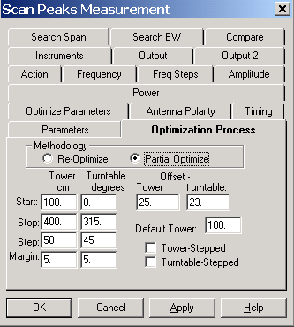
There are two methodologies available to solve perform this optimization.

Re-Optimize
Re-Optimize assumes that the earlier readings were not taken with enough tower height, or turntable movement, to adequately predict relative position. In this case, the tower and turntable need to be scanned through their full range of motion to determine the peak signal. This method starts by positioning the tower at the default position. The turntable is then scanned from the ‘Start’ position to the ‘Stop’ position and the peak signal and angle is recorded. The turntable is then moved to the position at which the maximum was recorded. The tower is then moved from the ‘Start’ Position to the ‘Stop’ position and the peak signal and height are recorded. The is then moved to this maximum position. The ‘Step’ value is ignored. The ‘Margin’ gives the user control of slippage on the tower and turntable. The stop command is given when motion reaches the limit – margin.

Partial Optimize
This method assumes that the range measurements included the necessary range of motion for the tower and turntable and that these are in the appropriate data elements on the ‘Frequency’ tab. This may not be position for the maximum signal due to limited motions, or steps, in the range measurements. With this method, the tower and turntable are scanned for the maximum signal over the range of starting positions +/- the offset value. The starting position is read from the ‘Input’ tables for the respective controller.

Tower/Turntable Stepped
When selected, the tower or turntable will move across the selected range at the defined ‘Step’ interval. In this mode, no continuous readings are taken.

Scan Peaks Optimize Parameters
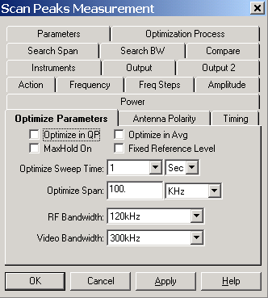
During the optimize process the tower is scanned to find the maximum signal. This tab gives your control of certain parameters during this process that will improve the measurement accuracy.

Optimize in QP
Normally the optimization is done in peak detector mode. This choice will turn on the Quasi-Peak detector.

Optimize in Avg
Normally the optimization is done in peak detector mode. This choice will use an average peak method instead.

MaxHold On
In normal mode, the screen is cleared between each sweep and a value is read for comparison purposes. With this option on, the analyzer is put in MaxHold and the readings will record the maximum. If you EUT is definitely the strongest signal, this will work well, but if there are strong ambients, there is a possibility of an ambient saturating your MaxHold readings. This will cause an error in the height evaluation.

Fix Reference Level
When this option is selected the reference level will remain fixed. If this is off, the default, then the reference level will be reset whenever a strong signal is within 10 dB of the reference level.

Optimize Sweep Time
Select an appropriate sweep time for the analyzer. The faster the sweep the better it will capture the maximum as the tower moves.

Optimize Span
The span can be set separately from the search and final measurement spans. This allows you to better exclude ambients when the tower is in motion.

RF and Video Bandwith
Click on the drop down arrow to display the available RF and Video bandwidth settings. Not all instruments will be able to use each of these settings, but the instrument driver will pick the closest setting that is valid for the specified receiver. For instance, many older EMC Receivers will only do 9 kHz and 120 kHz RF bandwidths. For all bandwidths at or above these settings, the driver will automatically pick the appropriate setting.

Scan Peaks Antenna Polarity Tab
This tab is used to set the respective polarity for the antenna during execution of this action
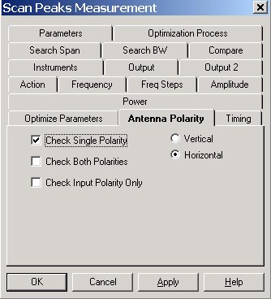
There are three options.
- Check Single Polarity
- Check Both Polarities
- Check Input Polarity Only

Check Single Polarity
With this option check, you also specify the Vertical or Horizontal orientation that is desired for this action. The antenna will be set to this polarity at the beginning of the execution and left there for the complete sequence.

Check Both Polarities
This option will perform a complete sequence, including tower and turntable positioning, and store the maximum value. The polarity will then be rotated and a complete sequence again executed. When this is complete the maximum values will be compared. The highest reading and it’s tower position, turntable position and polarity will be saved.

Check Input Polarity Only
If this option is checked, and there is an input antenna polarity data element on the ‘Frequency’ tab, then the antenna will be set to this polarity at the setup of each frequency step. The polarity can be different for each frequency.

Scan Peaks Timing Tab
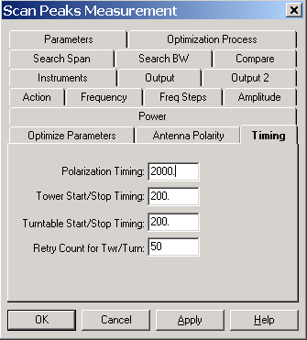
Use these settings to improve control of large turntables and older towers.

Polarization Timing
Different towers execute polarity movements at different speeds. To insure accurate testing, it is essential that the polarization movement be complete prior to any movement of the tower or turntable. This timing allows the user to match the execution to the characteristics of their tower.

Tower/Turntable Stop Timing
These setting allow the user to specify a minimum timing interval between the stop motion and any other movement command. This will insure accurate direction and motion. On some positioner’s (both towers and turntables), if they are issued the stop command and then immediately issued a change of direction command they will ignore the second command until the motion has completed. The software will report an error because the motion commanded did not take place. Setting this value to a higher number will insure that motion has stopped prior to sending any other command to the tower or turntable.

Retry Count for Twr/Turn
When the start command is issued to a tower or turntable, the software then begins reading the current position to determine when the limit is reached. This parameter controls how many times the positioner will be read, if the position does not change, before an error message is displayed.

Scan Peaks Power Tab
When measuring peak signals there are time when the user might need to inject a matching frequency signal from a signal generator. There is also a specific TIA specification, number 1A-102, which performs a signal substitution test. This tab allows configuration of either of these options.
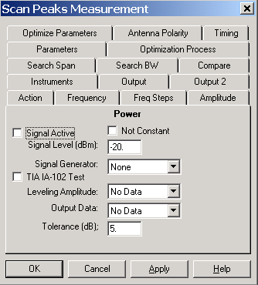

Signal Active
Setting this option on will cause the software to address the signal generator, specified in the Signal Generator selection box, setting the amplitude and frequency. The amplitude is usually a constant value, as shown here, but if the ‘Not Constant’ box is checked, then you can enter the name of a data element that will contain the desired amplitudes and frequencies.

TIA IA-102 Test
When actived, this feature will compare the reading to the amplitude from the ‘Leveling Amplutde’ and step the signal generator up or down to achieve a matching level. The signal generator level is stored in the ‘Output Data’ data element.

Leveling Amplitude
Select a date element that has the desired RF level.

Output Data
Select a data element to store the signal generator level during this test.

Tolerance
The margin of error between the actual reading and the desired level (from the ‘Leveling Amplitude’ data element).

Scan Peaks Dialog
The Scan Peaks dialog box gives the user visual information on the point that is currently being measured. The target and current frequencies are displayed as well as the amplitude at the current frequency. Tower or Turntable ‘Target’ and ‘Current’ position information are displayed in the appropriate boxes.
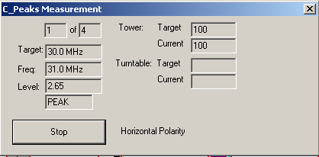
A ‘Stop’ button gives the user the ability to halt execution of the test at this point. When pressed, the system will complete the current sequence of GPIB commands and then halt execution. This is to insure the GPIB is not left in an inoperable condition. The current polarity is noted on the dialog, for reference purposes.

OK, Cancel, Apply and Help
A description of the OK, Cancel, Apply, and Help buttons is found in Common Action Commands on page 77.

Quick Scan
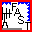
The Quick Scan Measurement action is used to measure a range of frequencies, using a receiver or spectrum analyzer instrument, optimized for tower and turntable maximums. The analyzer or receiver is constantly, in MaxHold, for each frequency range while the Tower and Turntable are rotated through a complete sequence.

Quick Scan Action Tab
The action tab is a common name page. A complete description is found in Common Name Page on page 77.

Quick Scan Frequency Tab
The Frequency tab allows the operator to select the range parameters over which measurements will be taken.
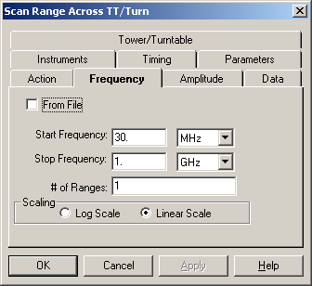

Start Frequency
The start frequency is set using the text box and units list box. The frequency set is the product of the value in the text box and the multiplier selected in the units list box. The list of available multipliers can be viewed by clicking on the down arrow to the right of the units list box. Enter a value in the text box and select the appropriate units. The Tab key will move between these boxes. In the unit’s box, entering the first letter will highlight the appropriate value.

Stop Frequency
The stop frequency is set using the text box and units list box. The frequency set is the product of the value in the text box and the multiplier selected in the units list box. The list of available multipliers can be viewed by clicking on the down arrow to the right of the units list box. Enter a value in the text box and select the appropriate units. The Tab key will move between these boxes. In the unit’s box, entering the first letter will highlight the appropriate value.

Number of Ranges
Entering a value into this text box sets the number of ranges. When this action is executed, the frequency span between the start and stop frequencies is divided into the number of ranges specified, for spectrum analyzers only. Unique scans are made of each frequency range with the results collected into a single data element. The number of points in the data file is the product of the number of ranges and the number of measurement points per scan for the instrument connected to this action. This parameter is ignored when using a receiver.
When designing the measurement, knowledge of the capabilities of the analyzer/receiver is critical. If your spectrum analyzer has a 401 dot resolution to its display (a common setting), then when you do a scan the instrument will only send 401 points, regardless of the bandwidth you specified in the parameters. If you are making a measurement from 30 MHz to 1000MHz with a 120kHz bandwidth, you need 8,083 points (970 million divided by 120 thousand). If you analyzer only reports 401 points, you need to break this measurement into 20 ranges to obtain reasonable accuracy. For this reason, you might want to design a scan with broad bandwidths, calculate the peaks and run a measurement of the peaks only with the narrow bandwidth. Experimentation by the user is strongly recommended.

Scaling
The ‘Log Scale’ and ‘Linear Scale’ radio buttons are used to select the appropriate frequency range scaling. If the range is 30MHz to 1GHz with log scaling selected, the frequency range will be adjusted to the number of ranges PER DECADE. In this case we would have one decade from 30 MHz – 300 MHz, a second from 300 MHz – 3 GHz (but abbreviated at 1 GHz as our upper frequency. The default is ‘Linear Scale.

From File
Select the ‘From File’ check box if you wish to read in the frequency data from an external file. The default file format is a two-column standard data element but for use in this action the data element should have an even number of data points. These are treated as pairs of frequency Start-Stop ranges. For more information on file creation, see File Elements on page 40.

Quick Scan Amplitude Tab

Reference Level
The ‘Reference Level’ is a function of both the noise floor of your instrument and the maximum expected signal. If you are working in an anechoic chamber, you could set this to 60-80 dB and take valid readings. But on an OATS, this would very quickly put your analyzer/receiver in saturation.
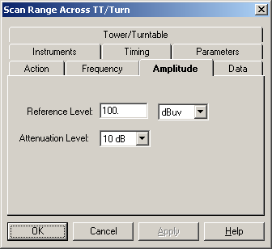
The ‘Reference Level’ for the measurement is set using the text box and units list box. The frequency set is the product of the value in the edit box and the multiplier selected in the units list box. The list of available multipliers can be viewed by clicking on the down arrow to the right of the units list box.

Attenuation Level
Use this field to select the attenuation level to be used for the scans. This allows you to adjust the attenuation to match your environment or EUT. You can choose values from 0 – 60 dB or AUTO. We do not generally recommend AUTO. Some spectrum analyzers change other settings within the analyzer when the attenuation is set to AUTO. If you test this to insure the performance is what you expect it can be a very easy method of controlling the analyzer’s response to high ambient fields.

Quick Scan Data Tab
The Data tab allows the operator to specify the repository data element for the maximum values. There is no tower or turntable position information with this icon. If position information is desired, use the ‘Optimize Measurement’ action.
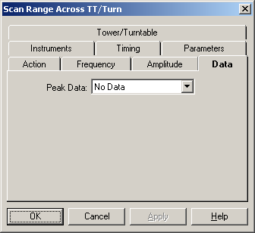

Peak Data
This Data list box is used to identify the data storage element to be used to record the maximum value. When the action is executed, the data element is resized to the product of the number of ranges and the number of measurement points per scan for the instrument connected to this action. If no errors are detected during the execution, the data is marked as valid and the frequency and amplitude data are set for each point measured.
You select the data element by clicking on the down arrow next to this line. This will display all the defined data elements. Select the appropriate data elements.
CAUTION - Picking a data element that is used somewhere else will cause this action to overwrite previous data.

Quick Scan Instruments Tab
The instrument page identifies which instruments will be addressed by this action. At a minimum you must specify the Receiver. Click the drop down button and select the appropriate named instrument.
If you are making QP measurements using a separate QP instrument you will need to specify the QP Detector. If you receiver has this function built-in you do NOT need to identify it here.
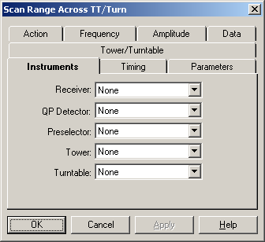
The Preselector is specified if there is a separate instrument performing this function.
Identify Tower and Turntable controllers as needed or when available. This action cannot be used with manual towers or turntables.

Quick Scan Timing Tab

Tower/Turntable Stop Timing
Once a stop command is issued, this value is checked to determine a wait time before any other commands are sent to either the tower or turntable. If your braking system responds slowly, or if it has no braking system, this parameter will let you insure that a command to change direction is not issued before stopping has completed. On some older positioners if you send a stop command and immediately send a change of direction command, the second instruction will be ignored if the positioner is still in motion.
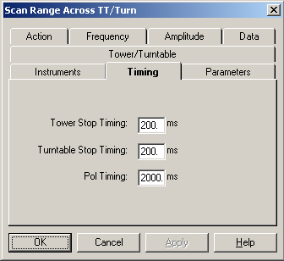

Polarity Timing
This setting determines how long the software will wait after issuing the polarization command (either to go to the vertical or horizontal orientation) before any motion is started. Most towers have no feedback to determine whether polarization has executed, or what polarity they are in, so this command lets the user set a delay time prior to any further motion of the tower.

Quick Scan Parameters Tab
The Parameters tab is used to specify the instrument setup for this measurement.
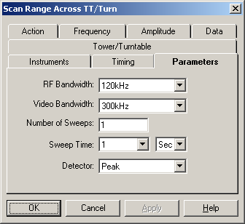

RF Bandwidth
Click on the drop down arrow to display the available RF bandwidth settings. Not all instruments will be able to use each of these settings, but the instrument driver will pick the closest setting that is valid for the specified receiver. For instance, many older EMC Receivers will only do 9 kHz and 120 kHz RF bandwidths. For all bandwidths at or above these settings, the driver will automatically pick the appropriate setting.

Video Bandwidth
Click on the drop down arrow to display the available Video bandwidth settings. Not all instruments will be able to use each of these settings, but the instrument driver will pick the closest setting that is valid for the specified analyzer.
For Receivers, this setting determines the step size for readings. Generally speaking this parameter should be the same or smaller than the RF bandwidth for receivers.

Number of Sweeps
A setting greater than one will cause the analyzer to be put in ‘MaxHold’ and the specified number of sweeps will be made. For EMC Receivers, the software will sweep the receiver the number of specified times and hold the peak value internally.

Sweep Time
The ‘Sweep Time’ setting is how long the receiver/analyzer will take to sweep across the frequency band. This setting will determine the dwell time at each frequency point when using a Receiver. The value is entered by clicking on the drop down arrow for both the text box and the unit’s box. Set these to the required values.
CAUTION - Setting this value greater than 10 seconds can cause the instrumentation to time out. If this happens change the GPIB/Setup/Timeout settings in the instrument definition to a value higher than the sweep time. See page 57, ‘Timeout Settings’ for more detail on sweep times over the GPIB bus.

Detector
Allows selection of the measurement detector desired for this scan. The available options are PEAK, QUASI-PEAK, and AVERAGE. Click on the drop down arrow to select the appropriate type.
CAUTION - Selection of QUASI-PEAK (QP) during a range scan is not recommended. Most analyzers will either not perform the test, or take an excessively long time. QP is only recommended when using a Receiver. For analyzers we recommend using the Measure Peak and Scan Peaks functions.

Quick Scan Tower/Turntable Tab
The ‘Tower/Turntable’ tab controls the settings of the Tower and Turntable during execution of this action.

Tower/Turntable
The Start, Stop and Step settings are relative to the type of instrument selected. The Step size is only appropriate for the Tower. The sequence of this action is to step the tower to the start position and then rotate the turntable from the start position to the stop position with the analyzer in ‘MaxHold’. At the end of the turntable movement, the tower is stepped by the given value and then the turntable is rotated again. The analyzer is in ‘MaxHold’ constantly during this sequence of tests.
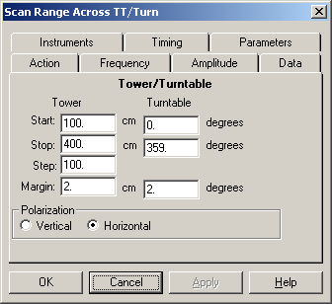

Margin
The margin setting controls when the Tower or Turntable will be commanded to stop before the actual stop position. This setting will be site and test specific because of the differences between positioners and the equipment placed upon them. Some have more slippage than others.

Polarization
When the tower is chosen, these action buttons determine the orientation of the antenna.

Quick Scan Dialog
The Quick Scan dialog box gives the user visual information on the current range that is being performed. The start and stop frequencies for this range are displayed along with the Tower or Turntable current and target position information.
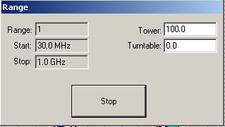
A ‘Stop’ button gives the user the ability to halt execution of the test at this point. When pressed, the system will complete the current sequence of GPIB commands and then halt execution. This is to insure the GPIB is not left in an inoperable condition.

OK, Cancel, Apply and Help
A description of the OK, Cancel, Apply, and Help buttons is found in Common Action Commands on page 77.

Optimize Measurement
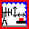
The Optimize Measurement action is used to perform a measurement of a range of frequencies, using either a receiver or a spectrum analyzer, optimized for both tower and turntable maximums. This action optimizes two orientations (both tower and turntable), but either orientation can be ignored. The maximum value is stored along with the angle and height that were determined during execution.

Optimize Measurement Action Tab
The action tab is a common name page. A complete description is found in Common Name Page on page 77.

Optimize Measurement Frequency Tab
The Frequency tab allows the operator to select the range parameters over which measurements will be taken.
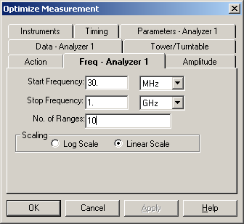

Start Frequency
The start frequency is set using the text box and units list box. The frequency set is the product of the value in the text box and the multiplier selected in the units list box. The list of available multipliers can be viewed by clicking on the down arrow to the right of the units list box. Enter a value in the text box and select the appropriate units. The Tab key will move between these boxes. In the unit’s box, entering the first letter will highlight the appropriate value.

Stop Frequency
The stop frequency is set using the text box and units list box. The frequency set is the product of the value in the text box and the multiplier selected in the units list box. The list of available multipliers can be viewed by clicking on the down arrow to the right of the units list box. Enter a value in the text box and select the appropriate units. The Tab key will move between these boxes. In the units box, entering the first letter will highlight the appropriate value.

Number of Ranges
Entering a value into the text box sets the number of ranges. When this action is executed, the frequency span between the start and stop frequencies is divided into the number of ranges specified. Unique scans are made of each frequency range with the results collected into a single data element. The number of points in the data file is the product of the number of ranges and the number of measurement points per scan for the instrument connected to this action.
In designing the measurement, knowledge of the capabilities of the analyzer/receiver is critical. If your spectrum analyzer has a 401 dot resolution to its display (a common setting), then when you do a scan the instrument will only send 401 points, regardless of the bandwidth you specified in the parameters. If you are making a measurement from 30 MHz to 1000 MHz with a 120 KHz bandwidth, you need 8,083 points. If you analyzer only reports 401 points, you need to break this measurement into 20 ranges to obtain a reasonable accuracy. For this reason, you might want to design a scan with broad bandwidths, calculate the peaks and run a measurement of the peaks only with the narrow bandwidth. Experimentation by the user is strongly recommended.

Scaling
The ‘Log Scale’ and ‘Linear Scale’ radio buttons are used to select the appropriate frequency range scaling. If the range is 30MHz to 3GHz with log scaling selected, the frequency range will be broken into two types of sub-ranges. For each decade, you will have the number of ranges specified. In this example, we would break the 30 MHz – 300 MHz range into 10 separate scans. The range from 300 MHz – 3 GHz would be split into the same 10 ranges, but we would terminate the measurements on the last scan up to 1 GHz. The default is ‘Linear Scale.

Optimize Amplitude Tab

Reference Level
The ‘Reference Level’ is a function of both the noise floor of your instrument and the maximum expected signal. If you are working in an anechoic chamber, you could set this to 60-80 dB and take valid readings. But on an OATS, this would very quickly put your analyzer/receiver in saturation.
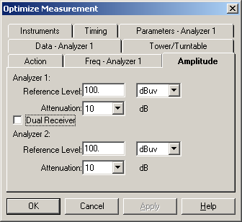
The ‘Reference Level’ for the measurement is set using the text box and units list box. The frequency set is the product of the value in the edit box and the multiplier selected in the units list box. The list of available multipliers can be viewed by clicking on the down arrow to the right of the units list box.

Attenuation Level
Use this field to select the attenuation level to be used for the scans. This allows you to adjust the attenuation to match your environment or EUT. You can choose values from 0 – 60 dB or AUTO. We do not generally recommend AUTO. Some spectrum analyzers change other settings within the analyzer when the attenuation is set to AUTO. If you test this to insure the performance is what you expect it can be a very easy method of controlling the analyzer’s response to high ambient fields.

Dual Receiver
This action has an option to utilize two different analyzers and towers to speed testing. These options are discussed later in this section.

Optimize Measurement Data Tab
This tab allows the user to specify the storage data elements for the maximum value and the related tower and turntable positions for this maximum.
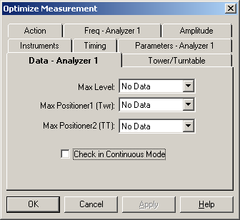

Max Level
This Data list box is used to identify the data storage element to be used to record the maximum value. When the action is executed, the data element is resized to the product of the number of ranges and the number of measurement points per scan for the instrument connected to this action. If no errors are detected during the execution, the data is marked as valid and the frequency and amplitude data are set for each point measured.
You select the data element by clicking on the down arrow next to this line. This will display all the defined data elements. Select the appropriate data elements.

Max Positioner1
This Data list box is used to identify the data storage element to be used to record the height or angle of the maximum value. This is dependent upon whether you are using a tower or turntable controller as Positioner1. If a positioner is identified on the Links tab, a data element is mandatory
You select the data element by clicking on the down arrow next to this line. This will display all the defined data elements. Select the appropriate data elements.

Max Positioner2
This Data list box is used to identify the data storage element to be used to record the height or angle of the maximum value. This is dependent upon whether you are using a tower or turntable controller as Positioner2. If a positioner is identified on the Links tab, a data element is mandatory.
You select the data element by clicking on the down arrow next to this line. This will display all the defined data elements. Select the appropriate data elements.
CAUTION - Picking a data element that is used in another part of the test will cause the previous data to be erased.

Check in Continuous Mode
When this option is selected the turntable (positioner2) will be put into continuous motion instead of stepped motion.

Optimize Measurement Tower/Turntable Tab
This tab determines the range of motion for the two positioners. If a tower is selected for a positioner (either Positioner1 or Positioner2) then all references are in cm. If a turntable is selected, then all references are in degrees.
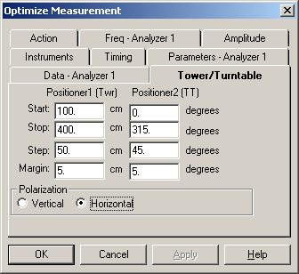

Margin
The margin setting is used to control the slippage of the positioner. The stop command will be sent to the positioner by an amount equal to the stop position – margin. This setting will be site and test specific because of the differences between positioners and the equipment placed upon them.

Polarization
Select the appropriate polarization for this measurement test. If the positioner does not have control of the polarity, no action is performed.

Optimize Measurement Instruments Tab
The Instruments tab is used to identify the instruments from which measurements will be taken. One advantage of the TILE! system is its ability to quickly change test instruments. If you design the parameters and frequency ranges properly, then you can change instruments during a test by simply changing the linkage in the Instrument Window. The names used on the Instrument linkage in each action will automatically adjust to the newly defined instrument.
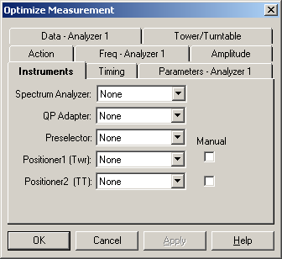
Positoner1 and Positioner2 must be a tower or turntable, but their is no requirement for which instrument occupies which precedence. If the ‘Check in Continuous Mode’ is not set on the ‘Data-1’ tab then the logic of this action is to perform the full range of Positioner1 steps prior to stepping to each position of Positioner2. If ‘Check in Continuous Mode’ is set, then the Positioner2 is rotated completely for each step in Positioner1.

QP Adapter
The ‘QP Adapter’ list box is used to select the a QP Detector only if the there is a completely separate instrument for this function.

Preselector
This drop down box identifies a Preselector only if there is a separate instrument. This needs to be identified also. Press the drop down arrow adjacent to each instrument to display the available instruments.

Positioner1/Positioner2
The choice of positioner determines whether angular and/or height information is captured during the execution of this action. The instrument needs to be identified on the instrument page. Press the drop down arrow adjacent to each instrument to display the available instruments.

Optimize Measurement Timing Tab

Tower/Turntable Start/Stop Timing
Once a stop command is issued, this value is checked to determine a wait time before any other commands are sent to either the tower or turntable. If your braking system responds slowly, or if it has no braking system, this parameter will let you insure that a command to change direction is not issued before stopping has completed. On some older positioners if you send a stop command and immediately send a change of direction command, the second instruction will be ignored if the positioner is still in motion.
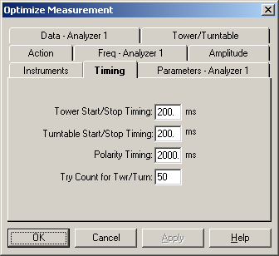
When a start command is sent, some towers and turntables exhibit brush noise during the initial start surge. The start/stop timing value is an amount of delay that will be put between the start command and the next instrument read/motion. This will insure that noise is avoided as much as possible. Some larger turntables take a significant amount of time to start. This delay will insure that a count error will not take place. A count error is when the positioner is read more than the amount specified in ‘Try Count for Twr/Turn” and there has been not motion detected.

Polarity Timing
This setting determines how long the software will wait after issuing the polarization command (either to go to the vertical or horizontal orientation) before any motion is started. Most towers have no feedback to determine whether polarization has executed, or what polarity they are in, so this command lets the user set a delay time prior to any further motion of the tower.

Try Count for Tw/Turn
When a motion command, either up/down or ccw/cw, is sent the software reads the controller looking for the current position. If it does not change in a given number of reads, the tower/turntable is assumed to be non-functioning. This try count value allows the user to control how many times the controller is read before this error is declared.

Optimize Measurement Parameters Tab
The Parameters tab is used to specify the instrument setup for this measurement.
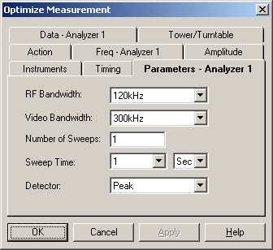

RF Bandwidth
Click on the drop down arrow to display the available RF bandwidth settings. Not all instruments will be able to use each of these settings, but the instrument driver will pick the closest setting that is valid for the specified receiver. For instance, many older EMC Receivers will only do 9 kHz and 120 kHz RF bandwidths. For all bandwidths at or above these settings, the driver will automatically pick the appropriate setting.

Video Bandwidth
Click on the drop down arrow to display the available Video bandwidth settings. Not all instruments will be able to use each of these settings, but the instrument driver will pick the closest setting that is valid for the specified analyzer.
For Receivers, this setting determines the step size for readings. Generally speaking this parameter should be the same or smaller than the RF bandwidth for receivers.

Number of Sweeps
A setting greater than one will cause the analyzer to be put in ‘MaxHold’ and the specified number of sweeps will be made. For EMC Receivers, the software will sweep the receiver the number of specified times and hold the peak value internally.

Sweep Time
The ‘Sweep Time’ setting is how long the receiver/analyzer will take to sweep across the frequency band. This setting will determine the dwell time at each frequency point when using a Receiver. The value is entered by clicking on the drop down arrow for both the text box and the unit’s box. Set these to the required values.
CAUTION - Setting this value greater than 10 seconds can cause the instrumentation to time out. If this happens change the GPIB/Setup/Timeout settings in the instrument definition to a value higher than the sweep time. See page 57, ‘Timeout Settings’ for more detail on sweep times over the GPIB bus.

Detector
Allows selection of the measurement detector desired for this scan. The available options are PEAK, QUASI-PEAK, and AVERAGE. Click on the drop down arrow to select the appropriate type.
CAUTION - Selection of QUASI-PEAK (QP) during a range scan is not recommended. Most analyzers will either not perform the test, or take an excessively long time. QP is only recommended when using a Receiver. For analyzers we recommend using the Measure Peak and Scan Peaks functions.

Optimize Measurement Dialog
The Optimize Measurement dialog box gives the user visual information on the current range that is being performed. The start and stop frequencies for this range are displayed.
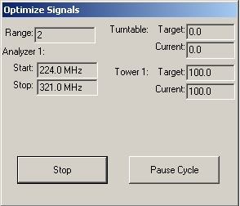
Tower or Turntable ‘Target’ and ‘Current’ position information are displayed in the appropriate boxes.

Stop
A ‘Stop’ button gives the user the ability to halt execution of the test at this point. When pressed, the system will complete the current sequence of GPIB commands and then halt execution. This is to insure the GPIB is not left in an inoperable condition.

Pause
The ‘Pause’ button will pause the test between each movement of the positioner. It will not abort the test, only cause a pause to until the user continues the test.

Two Receiver Option
The Optimize Measurement action has a special feature that allows for simultaneous measurements of two different analyzers/receivers controlling two different towers during a rotation of the turntable. On the ‘Amplitude’ Tab (see page 123) you have a check box called ‘Dual Receiver’. If this is checked there are four additional tabs that appear. ‘Freq-Analyzer 2’, ‘Data-Analyzer 2’, ‘Secondary Instruments’ and ‘Parameters-Analyzer 2’. The settings these four tabs mirror the settings for the related tabs ‘Freq-Analyzer 1’, ‘Data-Analyzer 1’, ‘Instruments’ and ‘Parameters-Analyzer 1’. There are few options are not available, but generally they are the same. When this option is selected the software will setup both analyzers/receivers at the same time. Move the towers to their start positions and then start the turntable in motion. Both analyzers/receivers will be triggered and read. The towers will then be moved to the next step. The towers are synchronized and have the same number of steps
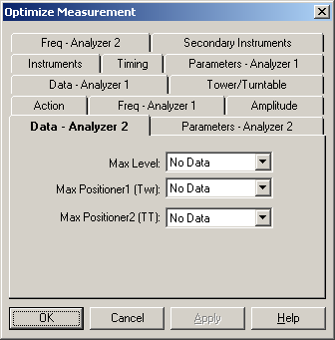

OK, Cancel, Apply and Help
A description of the OK, Cancel, Apply, and Help buttons is found in Common Action Commands on page 77.

Signal Discrimination (OATS)
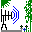
The Open Area Test Site (OATS) Measurement action is a manual capture routine. It can take a set of known frequency points as a starting position or operate only on operator input. The action allows the operator to manually tune to a signal, perform height/rotation optimization and record the information.

Signal Discrimination Measurement Action Tab
The action tab is a common name page. A complete description is found in Common Name Page on page 77.

Signal Discrimination Measurement Input Data Tab
This action presumes that you have a set of points of interest. These may have been generated through a math step or measured using another emissions action. For example, if you have taken readings in a chamber and selected the peaks over the specification limit you will have three data sets; the peak readings, the turntable position of the peak reading and the tower reading of the peak reading. This information can be used as the input data for the discrimination action. When started, the action will tune the analyzer/receiver to the first reading, move the tower and turntable to the related position and wait for the operator input.
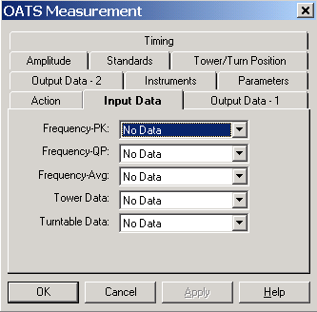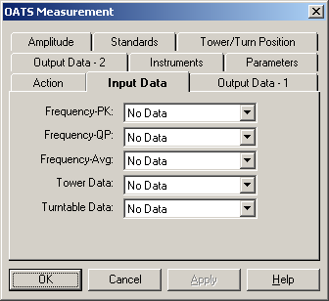

Frequency-PK
Drop down and select the appropriate input data element. You must have either a peak or qp data element or the action will not start.

Frequency-QP
Drop down and select the appropriate input data element. You must have either a peak or qp data element or the action will not start.

Frequency-Avg
Drop down and select the appropriate input data element. You must have either a peak or qp data element or the action will not start.

Tower Data
Drop down and select the appropriate input data element. This data element will represent the position that the tower was in during the measurement that yielded the peak or quasi-peak. This data is used when the ‘Partial Optimization’ option is selected on the ‘Optimize Process’ tab.

Turntable Data
Drop down and select the appropriate input data element. This data element will represent the position that the turntable was in during the measurement that yielded the peak or quasi-peak. This data is used when the ‘Partial Optimization’ option is selected on the ‘Optimize Process’ tab.

Signal Discrimination Measurement Output Data 1 Tab
When performing the signal discrimination we can record Peak, Quasi-Peak and readings. We also can capture information related to these readings, such as antenna used, antenna factor, tower, turntable, polarity and comments.
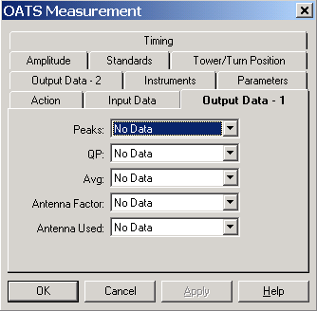

Peaks
Drop down and choose an appropriate data element for storing the Peak values measured. If this is that same data element as the input data, this data will overwrite existing data. If this is a unique data element it will store the output values. Generally if it recommended that you store the output into a unique name. This allows you to compare the input data to the output data for analysis.

QP
Drop down and choose an appropriate data element for storing the Quasi-Peak values measured during this step. If this is that same data element as the input data, this data will overwrite existing data. If this is a unique data element it will store the output values. Generally if it recommended that you store the output into a unique name. This allows you to compare the input data to the output data for analysis.

Avg
Drop down and choose an appropriate data element for storing the Average values measured. If this is that same data element as the input data, this data will overwrite existing data. If this is a unique data element it will store the output values. Generally if it recommended that you store the output into a unique name. This allows you to compare the input data to the output data for analysis.

Antenna Factor
Drop down and choose an appropriate data element for storing the actual Antenna Factor used during each measurement. The signal discrimination action allows the user to specify a different antenna for each frequency measurement. On an OATS, in particular, you might take a reading with a Biconical. Find yourself close to the limit and substitute a Dipole antenna for the final reading. It is important to know which antenna was used at each frequency and to correct the data for the antenna factor.

Antenna Used
Drop down and choose an appropriate data element for storing the Antenna Used during each measurement. This data element must be a ‘Word’ type data element. It will hold a text message with the name of the antenna factor data element used for this measurement. Since these are typically named to identify the antenna, this serves as the name of the antenna used. The signal discrimination action allows the user to specify a different antenna for each frequency measurement. On an OATS, in particular, you might take a reading with a Biconical. Find yourself close to the limit and substitute a Dipole antenna for the final reading. It is important to know which antenna was used at each frequency and to correct the data for the antenna factor.

Signal Discrimination Measurement Output 2 Tab
The Output 2 data elements are for Tower, Turntable, Hor/Vert and Comments. These are continuations of the data available from the Output 1 tab.
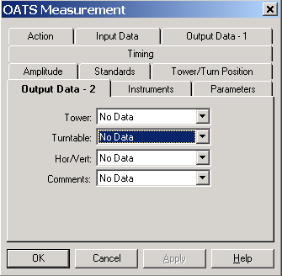

Tower
Drop down and choose an appropriate data element for storing the tower height for each measurement.

Turntable
Drop down and choose an appropriate data element for storing the turntable angle for each measurement.

Hor/Vert
Drop down and choose an appropriate data element for storing the tower polarity for each measurement. This is a ‘Word’ type data element which will hold an ‘H’ or ‘V’ depending upon the polarity measured during the test.
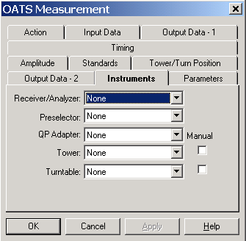

Comments
Drop down and choose an appropriate data element for storing comments entered for each measurement. This is a ‘Word’ type data element.

Signal Discrimination Measurement Instruments Tab
This page specifies the instruments to be used during the execution of this action. You must have an ‘Receiver/Analyzer’ selected. All others are optional.

Receiver/Analyzer
Click on the drop down arrow and select the appropriate instrument. You must have an instrument identified at this position for the action to operate.

Preselector
Click on the drop down arrow and select the appropriate instrument only if you have a separate preselector for the spectrum analyzer. By choosing an instrument here, you change the method of setting attenuation. If a Preselector is present you must consider setting its attenuation using a GPIB direct command. It will NOT be automatically set by TILE!.

QP Adapter
Click on the drop down arrow and select the appropriate instrument only if you have a separate quasi-peak adapter for the spectrum analyzer. By choosing an instrument here, you change the method of setting RF and Video Bandwidth. If a QP Adapter is present, the RF and Video bandwidths chose on the Parameters tab will be set for the QP Adapter. A different set of RF and Video bandwidths will be set on the Spectrum Analyzer. The settings for the analyzer are determined by the manufacturer and set by the TILE! program.

Tower
Click on the drop down arrow and select the instrument. If you are using a manual tower you must set up an instrument in the Instrument Window for the tower. You can either use the ‘Do Not Use Driver’ feature or you can use the ‘Demo.ins’ demonstration instrument driver.

Turntable
Click on the drop down arrow and select the instrument. If you are using a manual turntable you must set up an instrument in the Instrument Window for the tower. You can either use the ‘Do Not Use Driver’ feature or you can use the ‘Demo.ins’ demonstration instrument driver.

Manual
If your tower or turntable does not support GPIB operation, use the ‘Manual’ tower/turntable instrument drivers check boxes to allow operator interruption during the test.

Signal Discrimination Measurement Parameters Tab
The ‘Parameters’ page controls the settings of the spectrum analyzer/receiver during the measurement process.

RF Bandwidth
Click on the drop down arrow to display the available RF bandwidth settings. Not all instruments will be able to use each of these settings, but the instrument driver will pick the closest setting that is valid for the specified receiver. For instance, some older EMC Receivers will only do 9 KHz and 120 KHz RF bandwidths. For all bandwidths at or above these settings, the driver will automatically pick the appropriate setting.
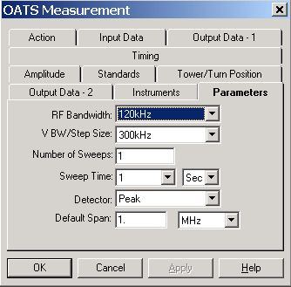

VBW/Step Size
Click on the drop down arrow to display the available Video bandwidth settings. Not all instruments will be able to use each of these settings, but the instrument driver will pick the closest setting that is valid for the specified receiver.
This value is the step size for most EMC Receivers.

Number of Sweeps
A setting greater than one will cause the analyzers to be put in ‘MaxHold’ and the specified number of sweeps will be made. For EMC Receivers, the software will sweep the receiver the number of specified times and hold the peak value internally.

Sweep Time
The ‘Sweep Time’ setting is how long the receiver/analyzer will take to sweep across the frequency band. This setting will determine the dwell time at each frequency point. The value is entered by clicking on the drop down arrow for both the text box and the units box. Set these to the required values.
CAUTION - Setting this value greater than 10 seconds can cause the instrumentation to time out. If this happens change the GPIB/Setup/Timeout settings in the instrument definition to a value higher than the sweep time. See page 57, ‘Timeout Settings’ for more detail on sweep times over the GPIB bus.

Detector
Allows selection of the measurement detector desired for this scan. The available options are PEAK, QUASI-PEAK, and AVERAGE. Since Quasi-Peak is an option on the dialog box for these action, your choices should be between PEAK and AVERAGE. Whichever is selected here will be the default detector type during the action execution. Click on the drop down arrow to select the appropriate type.

Default Span
The default span is the window size for the spectrum analyzer for each frequency. The start frequency for the display will be the current frequency less one-half the span. The stop frequency will be set to the current frequency plus one-half the span.

Signal Discrimination Measurement Amplitude Tab
This tab is used to set the default Reference Level and Attenuation values.
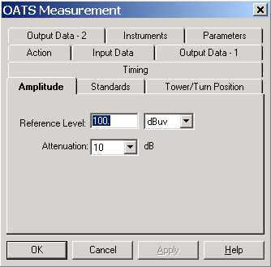

Reference Level
Enter a value and the appropriate units. This value will set the reference level of the Receiver/Analyzer at each frequency step.

Attenuation
Drop down and select an appropriate attenuation value. This will be set on the Receiver/Analyzer at each frequency step.

Signal Discrimination Measurement Standards Tab
These data elements contain the specification limit information as well as antenna correction information appropriate for each frequency being tested.

Limit
Click the drop down arrow and select the data element with your specification limits. The user has complete control of the definition and use of the specification limit. This value will determine the ‘Margin’ on the display. The limit value will be subtracted from the current reading to determine the margin at the current frequency.

Default Ant Factor
In performing signal discrimination the system needs to keep track of the appropriate correction factor for each frequency range in which testing is done. Click on the drop down arrow and select the appropriate data element for the default antenna. This is only used on the first frequency. Thereafter the operator can change the antenna factor data element interactively.
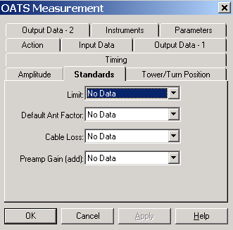

Cable Loss
Select an appropriate data element for the cable loss. This value will be added to the actual instrument reading for calculating the margin. If ‘none’ is selected a default value of 0 dB will be used by the software.

Preamplifier Gain
Select an appropriate data element for the preamplifier gain. This value will be added to the actual instrument reading for calculating the margin. If none is selected a default value of 0 dB will be used by the software.

Signal Discrimination Measurement Tower/Turn Position Tab
This tab determines the range of motion for the positioners. For the tower all references are in cm. For the turntable all references are in degrees.
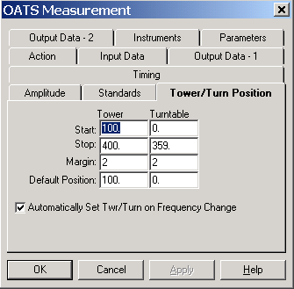

Start
Enter the appropriate minimum position for each positioner. Typically towers start at 100 cm and turntable motions are defined to start at 0 degrees. TILE! does NOT support continuous rotation turntable movements. All movements are swung around a 360 degree arc and then reversed.

Stop
Enter the appropriate maximum position for each positioner. For 3-10 meter emissions measurements, a default height of 400 cm is defined. For 30 meter measurements this would be set to 600 cm. Turntable maximums are set to 359 or 360 degrees.

Margin
The margin setting determines a number or degrees or cm’s prior to the desired position where the positioner will be commanded to stop. This value is the ‘slippage’ of the positioner. Sending the stop command early will allow the positioner to settle to the desired position. This setting will be site and test specific because of the differences between positioners and the equipment placed upon them.

Default Position
Enter a value reflecting the default position for the positioner. When starting the action, this is the position that the tower and turntable will be moved prior to any readings.

Automatically Set Twr/Turntable
When this is checked, the tower and turntable will be set to their position automatically when the user moves to the next frequency. If it is off, the tower and turntable will be left in their current positions.
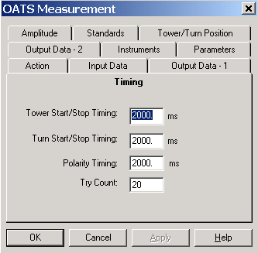

Signal Discrimination Measurement Timing Tab
Certain instruments have timing issues that can be resolved by changing the default values found here.

Tower Start/Stop Timing
Between the start command to the tower and the first read, the system will pause this time to allow the tower to start its motion.

Turn Start/Stop Timing
Between the start command to the turntable and the first read, the system will pause this time period to allow the turntable to start its motion. This is a major concern on very large turntable where the start momentum is large.

Polarity Timing
Most towers with polarity under remote control use an air control to change polarity. The amount of time it takes for the antenna to rotate from horizontal to vertical, or vice versa, is dependent upon the weight of the antenna and the air pressure. We want to insure that the polarity has completed its movement prior to any other movement or measurement. Polarity timing is a value, in milliseconds, that reflects how long it takes the positioner to execute a polarity movement. The software will pause this period before continuing its execution.

Try Count
When either the tower or turntable is in motion (after the start command), the software determines when to send a stop command by reading the positioner and comparing the current position to the desired position. In the event that the current reading the previous reading are the same (but you have not reached the desired position), the software will re-read the instrument as many times as shown in the try count before displaying an error dialog box.

Signal Discrimination OATS Dialog Box
The OATS Signal Discrimination action is basically a manual action. The input table gives the operator a set of known signals to look at, but the operator can always manually scan on his receiver/analyzer and capture new signals.
The dialog box has a table of known signals, as defined in ‘Setup’. The operator then adjusts his receiver/analyzer, searching for new or existing peaks. Once a signal is viewed on the screen, the operator can Add to or Update the table.

Table of Frequencies
The table of frequencies provides a view of the known signals. This table can be added to or subtracted from by the operator through the use of the ‘Set Before, Set After, and Delete Buttons’. To control which items are viewed or their sort order, go to the ‘Set Before’, ‘Set After’, and ‘Delete’ Buttons below. The table of frequencies is only updated with the Set commands.
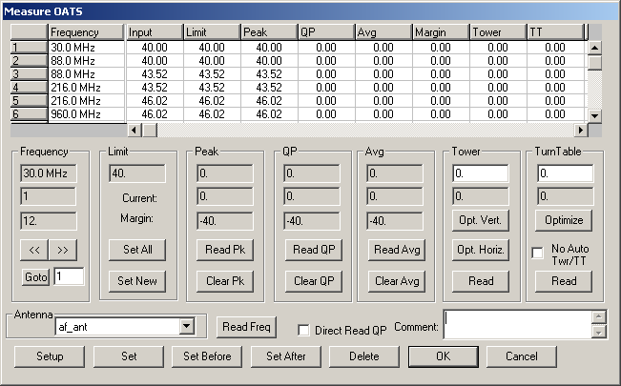

Instrument Read Buttons
Each of the boxes has a related action button, some ‘Read’, others ‘Find’. Since the operator is manually adjusting the instrumentation, these buttons strictly read the current position of the instrument (whether it is a frequency or position).

Frequency
This top box displays the current position in the table of frequencies. The next box lists which step this is in the list (i.e., step 1, 2, etc.). The bottom box displays the antenna factor for the current frequency. If your antenna factor table does not cover the current frequency, a value of zero is shown. The readings in any of the remaining boxes will not be valid if the antenna factor is not valid.
The double arrows move up or down the known list of frequencies. These known points are changed by the ‘Set Before’, ‘Set After’, and ‘Delete’ Buttons’ (see below).

Limit
The ‘Set All’ button does a peak search within the current window of the instrument. The ‘Limit’ displayed is from the Standards ‘Limit’ data element selection.

Peak
The ‘Peak’ box contains the maximum reading at this frequency, the last reading from the instrument and the margin between the maximum reading and the specification limit at this frequency. If you read a number of times, the top box will always reflect the highest reading found at any point. When you ‘Set’, ‘Set Before’ or ‘Set After’ this frequency, the maximum number is the saved number.
The current number reflects the current (last effective) reading from the instrument. Margin is the difference between current reading and the specification limit. No readings in any of the boxes will be valid if the antenna factor is not valid.

QP
The QP box contains the maximum reading at this frequency, the last reading from the instrument and the margin between the maximum reading and the specification limit at this frequency. If you read a number of times, the top box will always reflect the highest reading found at any point. When you ‘Set’, ‘Set Before’ or ‘Set After’ this frequency, the maximum number is the saved number.
The current number reflects the current (last effective) reading from the instrument. Margin is the difference between current reading and the specification limit. No readings in any of the boxes will be valid if the antenna factor is not valid.

AVG
The Avg box contains the maximum reading at this frequency, the last reading from the instrument and the margin between the maximum reading and the specification limit at this frequency. If you read a number of times, the top box will always reflect the highest reading found at any point. When you ‘Set’, ‘Set Before’ or ‘Set After’ this frequency, the maximum number is the saved number.
The current number reflects the current (last effective) reading from the instrument. Margin is the difference between current reading and the specification limit. No readings in any of the boxes will be valid if the antenna factor is not valid.

Tower
There are two boxes in the Tower box. The top box reflects the position of the tower when the maximum recorded signal was taken. The bottom box reflects the current tower position. You can change the antenna from vertical to horizontal by change the ‘H’ and ‘V’ settings and rereading the tower. If a ‘Manual’ tower is used, the display is changed to reflect the current position and a check box for polarity. Enter the position and check the appropriate polarity.

Turntable
There are two boxes in the Turntable box. The top box reflects the position of the turntable when the maximum recorded signal was taken. The bottom box reflects the current turntable position. If a ‘Manual’ turntable is used, the display is changed to reflect the current. Enter a value for the actual position of the turntable, if desired.

Antenna
This drop down box allows the user to change the antenna reference data element for the current frequency. Once a data element is selected, the values will be adjusted to reflect the correct antenna factor. If a data element is selected that does not cover the current frequency, a warning dialog box is displayed. The default antenna correction factor data element is defined on the Standards page.

Read Freq
Clicking this button will read the current frequency and update that information without changing the values for Peak, QP or Avg. This is often used when you want to manual fine tune frequencies of interest prior to executing an automatic measurement using the ‘Scan Peaks’ action.

Direct Read QP
The ‘Direct Read QP’ check box selection will read the spectrum analyzer after it has been manually configured by the user. The reading will take place regardless of whether or not a QP measurement is being performed.

Set Before, Set After, and Delete Frequency Buttons
The ‘Set Before’, ‘Set After’, and ‘Delete’ buttons control recording of information to file.

Setup
Discussed in Table Settings View below.

Set
Changes the current stored information, replacing it with the maximum recorded values from the Peak, QP, Avg, Antenna Used, Antenna Factor, Margin,Tower and Turntable boxes. If you are physically reading a different frequency then the current point in the table, DO NOT USE SET. Set will overwrite the frequency point in the table.

Set Before/Add After
Adds the current frequency and related information into the frequency table on a new line. If you are physically reading the same frequency as the current point in the table, DO NOT USE SET. Add will cause two identical points to exist in the table. This will prevent certain math functions from performing correctly. If an additional data point is added by mistake, select this step then ‘Delete’. See the next section.

Delete
Deletes the currently highlighted frequency point on the table.
Caution - you cannot ‘Undo’ a deletion.

OK
This button saves the current table of frequencies and exits the action.

Cancel
This button aborts the current execution and exits the action without saving any data.

Table Settings View
The user has some control of the items displayed on the table of frequencies. The View of each item can be switched on or off. These items can be changed or updated at anytime by the operator.
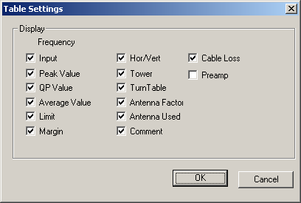

OK, Cancel, Apply and Help
A description of the OK, Cancel, Apply, and Help buttons is found in Common Action Commands on page 77.

Site Attenuation
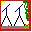
The site attenuation action is designed to assist in performing an Open Area Test Site (OATS) attenuation measurement. These are generally done per ANSI C63.4, but this action can be used for any attenuation measurement.
There are two modes to the action, the cable referencing step and the actual measurement. Generally when performing site attenuation you first lay out your test instrumentation and cables with two, opposed antennas. Prior to taking readings on the antennas, you will connect the cables end-to-end, set your generator level at some standard setting, and read the signal path through the cables. This will give you a reference level that includes any losses in the cables and connectors.
The next step is to hook the cables to the antennas and take readings at the same signal generator output level. The difference between this reading and the cable reference reading is the loss through the antennas and free space. The difference can then be input into the appropriate formula to derive site attenuation. The two different modes are set on the ‘Levels’ page of this action.
This action can be configured to take a cable reference reading (‘Direct Mode’) or take an OATS measurement. It is not necessary to perform a cable reference reading prior to running this action, but if no cable reading is made the user must adjust the final readings to include all appropriate correction factors.

Site Attenuation Action Tab
The action tab is a common name page. A complete description is found in Common Name Page on page 77.

Site Attenuation Frequency Tab
The ‘Frequency’ page of this action sets the frequency range, number of steps and search range of interest for the test. Since we are dealing with radiated signals in free space the search span allows us to limit the effects of ambient signals on our readings. You can either enter Start, Stop and Step frequencies, or you can enter a data element with a set of specific frequencies of interest.
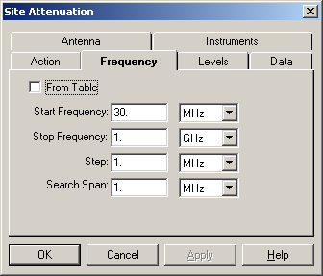

Start Frequency
The starting frequency is set by combining the text box settings and the unit’s settings. Click on the text box and enter an appropriate number. Either use the Tab key or click on the down arrow in the unit’s box to select the appropriate unit. Typing the first letter of the frequency will also select this unit (K-KHz, M-MHz, and G-GHz).

Stop Frequency
The stop frequency is set by combining the text box settings and the unit’s settings. Click on the text box and enter an appropriate number. Either use the Tab key or click on the down arrow in the unit’s box to select the appropriate unit. Typing the first letter of the frequency will also select this unit (K-KHz, M-MHz, and G-GHz).

Step
The ‘Step’ value determines the interval between each reading in the test. Keep in mind when setting this value that each frequency point is scanned for tower height to get the maximum value. The larger this setting the longer the test will take to perform.
Select the step value by setting the text box and units box to the appropriate number. Click on the text box and enter an appropriate number. Either use the Tab key or click on the down arrow in the unit’s box to select the appropriate unit. Typing the first letter of the frequency will also select this unit (K-KHz, M-MHz, and G-GHz).

Search Span
The Site Attenuation action uses a spectrum analyzer/receiver together with a signal generator. Since these two units might have slight differences in absolute frequency accuracy, the ‘Search Span’ determines how wide the window will be on the analyzer during scans. The system will open this window, search for the peak signal and record this level. Since most instrumentation used in an EMC laboratory have been calibrated, this might not appear useful. But the frequency accuracy between different can impact this test.
Set this to an appropriate level by combining the text box settings and the unit’s settings. Click on the text box and enter an appropriate number. Either use the Tab key or click on the down arrow in the unit’s box to select the appropriate unit. Typing the first letter of the frequency will also select this unit (K-KHz, M-MHz, and G-GHz).

Site Attenuation Levels Tab
The ‘Levels’ page sets the base parameters to be applied to the generator and the receiver/analyzer.
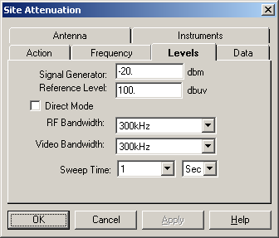

Signal Generator
This field sets the signal generator level in dBm. This action uses a fixed signal level in both direct and indirect mode. The frequency is set on the previous page. If you are using an amplifier, it will be included in the ‘Direct Mode’ readings. Install the amplifier in line with the instrumentation. If you need to use different signal generator levels at each frequency, you should use the Scan Peaks (C_Peaks) action to configure this test.

Reference Level
A reference level for the signal analyzer is set using this value. Using a value to low will cause errors in readings done in an OATS environment because your actual signal will be out of range of the screen parameters. At an OATS, large ambient signals will often saturate the analyzer/receiver. You should set the attenuation for the receiver/spectrum analyzer to prevent this condition

Direct Mode
The ‘Direct Mode’ is used for measuring the cable reference. When this box is checked, the range of frequencies is scanned with no tower movement. These values are stored in the ‘Data’ tab attenuation data element. You then use this data element as the calibration element in a second action configured in a NON-Direct mode. This allows the user to measure only the net attenuation of the transmitted signal during the actual site attenuation readings. When using this mode, all the setting should be identical to those to be used in the final, indirect action.

RF Bandwidth
Sets the RF Bandwidth for the analyzer/receiver. Click on the drop down arrow and choose an appropriate setting. If you select a setting that is not supported by the receiver/analyzer, the instrument will be set to the nearest valid setting.

Video Bandwidth
Sets the Video Bandwidth for the analyzer/receiver. Click on the drop down arrow and choose an appropriate setting. This setting is not appropriate for some receivers but this difference is handled by the instrument driver.

Site Attenuation Data Tab
The ‘Data’ page identifies the data elements that will be used to store the information generated by this action.
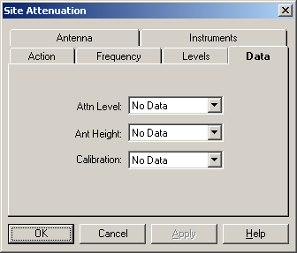

Attn Level
The attenuation level is the net signal level, after correction for the ‘Direct Mode’ cable readings. The system will take the analyzer/receiver level and subtract the ‘Calibration’ level prior to recording this number. If there is no ‘Calibration’ value, then the analyzer/receiver reading is stored without correction.

Ant Height
As part of maximizing the signal, the tower is scanned for the peak signal. The peak is stored in ‘Attn Level’; the actual tower position is stored in ‘Ant Height’.

Calibration
The calibration data element is the direct cable-to-cable readings derived when this action was performed in the ‘Direct Mode’. This data is subtracted from the actual signal readings to derive the net signal stored in ‘Attn Level’.

Site Attenuation Antenna Tab
This page of the Site Attenuation action configures the tower scan and step conditions. All tower readings are in cm.
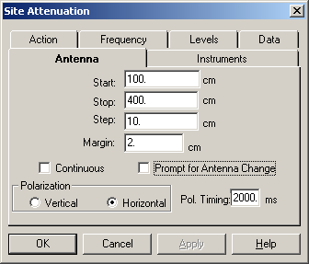

Start
The lowest desired tower height is the start position. In normal C63.4 measurements this will be 1 meter (100 cm). Enter an appropriate value in the text box.

Stop
The maximum tower height desired during the test is the stop position. In Normal C63.4 measurements this will be 4 meters (400 cm) for 3 and 10 meter OATS and 6 meters for 30 meter OATS. Enter an appropriate value in the text box.

Step
The step value determines how many centimeters will separate each height reading on the tower. Enter the appropriate number of cm desired in the text box.

Margin
The margin setting is a value that allows the user to configure the slippage, or stopping error, of the tower. When the tower is in motion the software will check for the current position. Whenever we are within the margin distance of the stop position (not the formal ‘Stop’, but the current move-to position) the stop command will be issued. The presumption is that the tower will then ‘coast’ into a final position as close to our goal as possible. This setting will be site and test specific because of the differences between towers and the weight of the antennas placed upon them.

Continuous
The ‘Continuous’ check box will perform a scan across the designated tower start/stop points recording the maximum value obtained during the scan. The analyzer is put into ‘MaxHold’ and then the tower is moved from Start to Stop. This allows a capture of the highest signal found but records no height information.

Prompt for Antenna Change
The ‘Prompt for Antenna Change’ check box is used when a dipole antenna is in place. For each frequency, the dipole is configured, then the antenna is stepped across the start/stop range, and then the operator is prompted to configure the dipole antenna for the next frequency.

Polarization
This action can be operated with the antenna in either the horizontal or vertical orientation. Check the appropriate box. If you do not have a tower and are manually adjusting the height or using this action for some other purpose, the polarization element is ignored.

Polarization Timing
When executing a polarization change

Site Attenuation Instruments Tab
This section identifies the instruments to be used during this action. Click on the drop down arrow and select an appropriate, named instrument for signal generator, spectrum analyzer and tower. If no tower is available, or it is not GPIB controlled, select the manual tower check box to configure an operator interrupt. This will allow you to manually set the tower position during the test. If you have a separate QP Adapter and Preselector, select these instruments also.
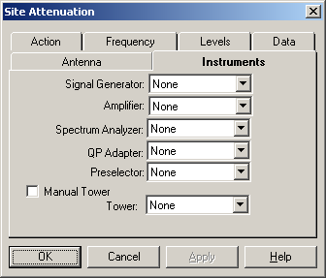

Site Attenuation Dialog
The Site Attenuation dialog box provides visual information to the user as well as the ability to halt execution of the test.
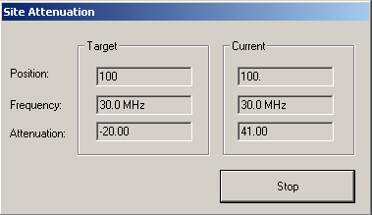
The Target box provides information on the desired (target) position of the tower, the current frequency setting for the receiver/analyzer and the output level for the signal generator.
The Current box provides information updates on the tower position when it is in motion, on the actual frequency setting of the receiver/analyzer, and the corrected reading of the attenuation across the antennas.

OK, Cancel, Apply and Help
A description of the OK, Cancel, Apply, and Help buttons is found in Common Action Commands on page 77.

Immunity Calibration

The Immunity Calibration icon performs a leveling run for immunity purposes to generate a calibration table. The calibration table is then available to perform quick, non-leveled Immunity Tests. Using a calibration table can greatly speed up repetitive testing in a known equipment setup.

Immunity Calibration Action Tab
The action tab is a common name page. A complete description is found in Common Name Page on page 77.

Immunity Calibration Frequency Tab
The Frequency tab is used to set the frequency parameters. The immunity test can be run by selecting the frequency range either by using a Start/Stop/Step mode or by using a data element (Set from Data).

Start Frequency
The Start Frequency text box sets the start frequency for this test. The text box and the units box work together to define the appropriate frequency. After entering data in the text box, the Tab key will move between entry boxes. Click the drop down box to see the available units or type the first letter of the units (K- KHz, M- MHz, G-GHz) to quickly select the units desired. The Start frequency does not have to be less than the Stop Frequency. This action will start at the ‘Start Freq’ and then step towards the ‘Stop Freq’ in the manner instructed, whether this is up or down does not matter.

Stop Frequency
The ‘Stop Frequency’ text box sets the stop frequency for this test. It uses the same conventions as start frequency. The text box and the units box work together to define the frequency. Enter a value into the text box, Tab to the units box and select the appropriate units. Use either the drop down arrow to select units or type the first character of the appropriate unit (K-KHz, M-MHz, G-GHz). This does not have to be higher than the Start Frequency.

# of Steps/Dec/%
This value defines the number of steps to be used in the range of frequencies set by the start and stop frequencies but does change meaning depending upon the ‘Log’ or ‘Percent’ check boxes. If neither ‘Log’ nor ‘Percent’ are selected then the step size is calculated by dividing the range (stop-start) by the number of points.

Log
The ‘Log’ check box defines how the steps will be taken. If checked, the software will split the frequency range into log decades and then split each decade into the number of ranges specified. For instance, if you are testing from 80 MHz to 1 GHz in ‘Log’ steps with the ranges set to 5, the software will split the range 80 MHz – 800 MHz in to 5 sub-ranges. It will then split the 800 MHz – 8 GHz into 5 ranges, but terminate the test on the last range that covers 1 GHz.

Percent
The ‘Percent’ check box is used when performing IEC testing (or other standards) which require a percent stepped frequency progression. When this mode is checked, you can specify any value for percent, including fractions (entered as decimal places). Some of the Mil-Std tests us .25% step sizes. The IEC uses 1%. There are some calibration schemes that use 2% or 5 %. Simply enter the value desired and check ‘Percent’.

Set From Data
The ‘Set From Data’ check box enables a predetermined set of frequencies to be read in from a data set. When this box is selected the data set must be defined using the standard TILE! format of (freq., point). This is explained further in File Elements on page 40.
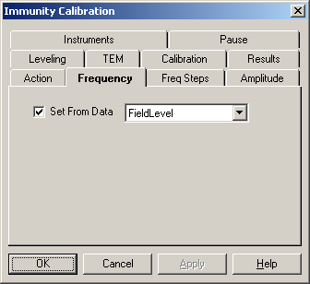
‘Set From Data’ is particularly useful when performing IEC testing (or other standards) which require a percent stepped frequency progression. Creating this progression with standard spreadsheet software is relatively easy. Write this data to file as an ASCII text, Comma, Separated Variable file and define a data element as 'File'-type with this access. This data element will then contain the appropriate information.

Immunity Calibration Freq Steps Tab
This tab lets the user control a number of different functions/methods/algorithms during the immunity test.

Minimum Attenuation between steps
Some signal generators use a relay to set attenuation levels. This relay can wear out over time if used excessively. If you are concerned about this relay, or if the on/off sequence affects your testing, removing the check on this box will prevent the minimum attenuation command from being sent to the signal generator.

No Sig Gen On/Off between steps
Some signal generators use a relay to turn on and off the signal. This relay can wear out over time if used excessively. If you are concerned about this relay, or if the on/off sequence affects your testing, checking this box will prevent the on/off signal command from being sent to the signal generator

Use Previous Amp for Best Guess
When leveling, whether Power Meter or Probe, there are three methods of determining the starting amplitude for the leveling loop. If no other choice is made, the software will calculate a beginning amplitude by taking the desired level, the ‘Offset’ and the gain of the amplifier and ‘guessing’ at a starting amplitude.
The second method is found on the leveling tab (Page 166). You can specify a fixed set of beginning amplitudes (less the ‘Offset’) using the ‘Best Guess’ data element. Generally the fastest method is to use the previous frequencies signal amplitude as a beginning point. If you check this box the previous level will be used.
In this case the choices (Best Guess Data Element and Offset) will be ignored, except at the first frequency.

Power Off at Fail to Level
When the leveling loop fails, a dialog box will be presented to the user giving them the choice to ‘Retry this step, Skip this step or Quit’. While this dialog is present this check box determines whether power is on or off. Generally, for safety sake, RF is turned off when this dialog box is present. This prevents potential damage to your EUT. Turning RF off does have the disadvantage of making it difficult to examine the state of your equipment to understand the failure. Knowing what the last amplitude was or what your power meter was showing can help in correcting or understanding this failure to level. Checking this box will cause the RF to be left on while the failure dialog is present.

Update Sensors at each level
When in the leveling loop, the software normally ignores updating the screen to speed up acquisition. If you want the screen values to update at each step then check this box.

Start Delay
When certain power meters or probes are first exposed to a field, they require additional time to level. This value is an additional delay time that is substituted at the first frequency only.

First Step Tries
The number of tries to check during the leveling for the first step. When using ‘Use Previous Amp for Best Guess’ (see above) the ‘Number of Tries’ from the ‘Leveling’ tab is used to determine the overall number of tries for a leveling loop. On the first step, there is no previous amplitude so the software will start at a much lower level and begin leveling up. This value allows you to let the first step have more tries the the remaining steps. This will allow you to speed the leveling loops of the remaining steps without causing a problem on the first step.

Immunity Calibration Amplitude Tab
The Amplitude tab is used to select the amplitude data.

Data
The ‘Data’ list box allows the operator to select the desired amplitude data to be used in the test. Click on the drop down arrow to view the defined data elements and select the appropriate element. The frequency component of the 'Amplitude' data element must cover the same range as the data element defining the 'Frequency' tab, but they do not have to be the same element. In most tests the same data element will be defined for both Frequency and Amplitude. The units of the 'Amplitude' data element must be in the units desired for leveling purposes. If you are leveling with a power meter, then the units must be dBm. If you are leveling with a probe, the units will be in V/M. For example, if you data element has the following points:
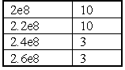
The first frequency, 200 MHz would have a leveling point of 10 V/M if probe leveling were used. If power meter leveling is specified then the system would level to a power meter reading of 10 dBm (the units used by a power meter). Keep this in mind when defining a test. If you are using a power meter and do not have a probe, you must calculate the expected field using the appropriate antenna factors to create this data element. Please contact Quantum Change if you are faced with this task.

Data Units
Check the appropriate data units. This selection will set the display of the dialog box to reflect the correct units.

Delay Time
This value represents a specified delay between each frequency step. It is primarily of value when testing routines that do ‘No Leveling’. This will prevent sending frequency/amplitude data to the signal generator faster then it can react.

Immunity Calibration Leveling Tab
The Leveling tab is used to select the leveling methodology for this run. The TILE! System supports leveling using a probe, a power meter or a pre-calculated field. Pre-Calculated fields are only used with control field transducers, such as TEM Cells or GTEM's. In these cases the field can be predicted (at certain frequencies) very accurately. TILE! Allows you to create a calculated field in these structures and record the probe level, in effect calibrating the probe.

Leveling Source
The Leveling Source radio buttons allow the operator to select which instrument will control the leveling cycle.
A choice of 'No Leveling' makes the remaining choices inactive.
Choosing 'Pwr Meter' or 'Probe' requires careful consideration of the Tolerance, Delay and Max Count fields.

Tolerance
The 'Plus' and 'Minus' list boxes allow the operator to select the desired tolerances for the leveling process. For instance, if you are trying to create a 3 V/M field with a probe then a plus 15, minus 0 would give you a tolerance of 15%, starting at 3 V/M. This equates to a minimum acceptable reading of 3 V/M and a maximum of 3.450 V/M. This is probably too tight a tolerance for most probes to level to but the user should experiment with these settings to obtain the tightest acceptable margin for your instrumentation. A symptom of too tight a tolerance would be a leveling loop that jumps below and above these numbers without ever landing within the zone. You will exceed the 'Max Count' specified without leveling. Raise the margin slightly and retry.

Offset
The ‘Offset’ text box sets the offset in dBm to the expected signal generator levels for the first attempt. This defines a minimum offset to the calculated field for safety purposes. There are often large swings in field strength given different frequencies in the same setups. This number determines how far below your calculated value to place the signal generator on the first reading. The system will step up in maximum steps of 10 dB until it begins to receive valid readings from the probe or power meter. Future leveling will follow an internal algorithm.

Max Lvl Step
The ‘Max Lvl Step’ text box sets the maximum amplitude increment that the signal generator will perform.

Max dBm
This controls the maximum RF level that will be output from the Signal Generator. Use this setting to protect the front-end of your amplifier from overload.

Max Count
The Max Count text box sets the maximum number of tries to establish a level measurement reading before the system reports an error. This field needs to be over 10 in situations where you are seeking a large field or in cases in which your margin is extremely small. For example, if you are trying to create a 3 V/M field with a 500 Watt amplifier, you will find that small ripples in the amplifier cause relatively large changes in the offsets at this level. You will probably need to give the system more tries to level. An indication of this problem would be a failure to level, but levels very quickly if you choose ‘Retry’.

Continue on Fail-to-Level
The ‘Continue on Fail-to-Level’ check box allows the user to continue on with the leveling steps even when a step fails to level.

Best Guess Amp
The ‘Best Guess Amp’ selection is used to set the signal generator to a predetermined level to speed up the leveling process. This is used when approximate signal generator levels are known. The data set must be a defined CSV data element.

Immunity Calibration TEM Tab
The TEM tab is used to configure parameters when using TEM cells or GTEMS. Select the “In Use’ check box if you are using one of these devices.
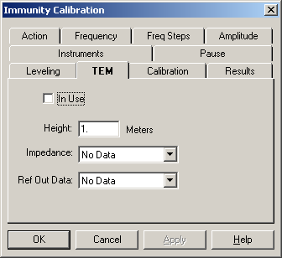

Height
The ‘Height’ text box sets the septum height if you are using a TEM or TEM-type device. The internal algorithm for calculating signal levels is adjusted by this reading. If the septum is less than 1 meter (a value of 1) then the calculated signal generator level will be increased by the inverse. If the septum height is larger than 1 meter, the signal generator level will be reduced by the inverse.

Impedance
The ‘Impedance’ text box allows the operator to select a data set as a defined CSV data element.

Ref Out Data
The reference out data allows the user to store the calculated field strength in a data element

Immunity Calibration Calibration Tab
The Calibration tab is used to select the calibration data sets for the selected instruments. These data elements should contain the appropriate correction factors for this instrumentation.
The Amplifier calibration is MANDATORY. If you are using this action without an amplifier, enter a preset with a value of 1. If you are unsure of your amplifiers gain, enter a preset of at least 40. The calibration table should be the gain of the amplifier in dB, not watts.
Power meter calibration data needs to include cables and couplers. You can calculate this data or set up this action with 'No Leveling', sending a 0 dB signal generator level. Physically hook up the complete system, but install a 50 Ohm load in place of the transducer. The power meter readings taken under these conditions will serve as a calibration file for the power meter during a normal test.
The field probe calibration table should be the correction information from the manufacturer. Probe calibration tables tend to be in the -1 to +2 range.

Immunity Calibration Results Tab
The Results tab is used to select which instruments will be recorded and where the recorded results will be stored. The data elements selected must be defined as 'measurements'.

Record
Check the box for each instruments data you want to record. If not checked the results are not saved. This does not mean the instrument is not read, only that the results are not saved. If you choose to level with a probe and do not record the probe levels, then you will have to assume that the desired amplitude was the actual level. If you record the probe level you can display this later to show the actual field created compared to the standard.
If you are running a “No Leveling” test using calibrated inputs, you might want to record the power meter or probe readings for reference purposes. This will allow you to graphically compare the field established during the calibration run and the field created during the test. If the EUT has an unusually large impact upon the field generation, this will show it.

Data
If the 'Record' box is check, a data element must be selected. If you fail to select a data element, the system will record a failure and not run. Select a data element by clicking the drop down box and selecting from the predefined data elements.

Signal Generator
Choose an appropriate data element if you want to store the amplitude of the signal generator when the leveling loop has completed. This information is useful for duplicating testing or verifying results.

Power Meter1
Choose an appropriate data element if you want to store the amplitude of the forward power during this calibration. Power Meter1 always refers to the forward power if net power is being measured. The forward power value is determining by reading the instrument identified on the ‘Instruments’ tab and adding the calibration value found on the ‘Calibration’ tab. The corrected value is saved.

Power Meter2
Choose an appropriate data element if you want to store the amplitude of the reverse power during this calibration. Power Meter2 always refers to the reverse power if net power is being measured. The forward power value is determining by reading the instrument identified on the ‘Instruments’ tab and adding the calibration value found on the ‘Calibration’ tab. The corrected value is saved.

Net Power
Choose an appropriate data element if you want to store the net power measured during this calibration. You must have both a forward power instrument and a reverse power instrument identified on the ‘Instruments’ tab and you must have checked the ‘Net Power’ box on the same page. The net power value is calculated by the following formula:
P_{f} (Watts) = ((P_{fm}^⁽⁻¹⁰⁾)/10)/100000
P_{r} (Watts) = ((P_{rm}^⁽⁻¹⁰⁾)/10)/100000
P_{net} (dbm) = 10 * Log((P_{f -} P_{r})*100000)

Where
P_{f} = Forward Power (in Watts)
P_{f} = Forward Power (in Watts)
P_{fm} = Forward Power measured in dBm
P_{r} = Reverse Power (in Watts)
P_{fm} = Reverse Power measured in dBm
P_{net} = Net Power (in dBm)

Probe
Choose an appropriate data element if you want to store the amplitude of the probe during this calibration.

Immunity Calibration Instruments Tab
The Instruments tab is used to select the specific instruments that will be used in the immunity calibration. Click the drop down arrow for each instrument in use and select the appropriate instrument. If an instrument is selected (other than the Signal Generator), it must have a calibration entered on the 'Calibration' page. If the instrument is not in use, make sure this field shows 'None'.
For the two Power Meters you can also specify units for their readings. These units are only valid if the instrument supports them. When using a spectrum analyzer for a power meter, you can read in dBuV (for doing leveling to dBuA). Some Power Meters will read in Watts or Volts.

Use Net Power
The ‘Use Net Power’ check box requires the use of two instruments to record the ‘Net’ reading between them. The result is recorded in the data element identified on the ‘Results’ page.

Delay Time
The ‘Delay Time’ text box allows the user to enter a delay time (in ms) before a reading takes place. This is particularly useful due to the long settling time inherent with power meters and probes.

Pause
The pause function allows the user to specify frequencies that will pause the test and prompt the user to take some action.
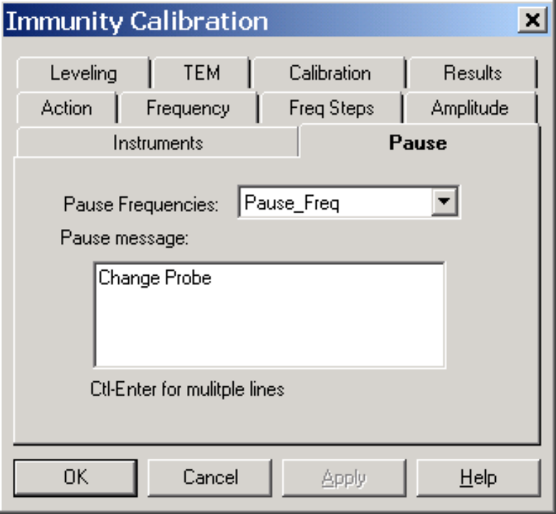

Pause Frequencies
Select and appropriate data element. The data element should have a list (or single) frequency that is the transition point. When the next calibration frequency is equal to or greater then the frequency in the data element, the program will pause and the Pause Message displayed until the operator hits the ‘OK’ button.

Pause Message
Enter an message that will be displayed during the pause. When entering multiple lines, it is necessary to use the ‘Ctl-Enter’ sequence. A normal entry will cause the ‘OK’ button for the Dialog Box to close the box.

Immunity Calibration Dialog
You can execute the Immunity Calibration action either by doubling clicking on the action and selecting ‘Execute’, by executing it as part of the sequence of tests being executed, or by using the ‘Run/Single’ options from the Menu Bar.
When you are executing the Immunity Calibration, you will have a dialog box displayed showing the current frequency, step number amplitude target, current amplitude, leveling try count and delta.
The ‘Delta %’ refers to the amount of change from the previous signal generator level is being accomplished in this try. The final level is saved when it falls within the tolerances defined. Immunity Calibration only saves the information it is configured to save.
The ‘Stop Test RF Off’ button will halt execution of the current action. No information is saved.

OK, Cancel, Apply and Help
A description of the OK, Cancel, Apply, and Help buttons is found in Common Action Commands on page 77.

Immunity Test
The Immunity Test action performs an immunity test using either predetermined field data or real time leveling. Many of the features are identical to the Immunity Calibration in structure, but are used here with slight differences.

Immunity Test Action Tab
The action tab is a common name page. A complete description is found in Common Name Page on page 77.

Immunity Test Frequency Tab
The Frequency tab is used to set the frequency parameters. The immunity test can be run by selecting the frequency range either by using a Start/Stop/Step mode or by using a data element (Set from Data).
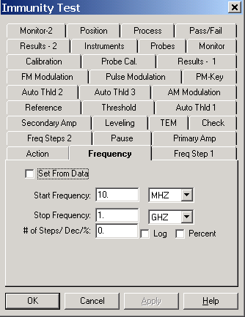

Start Frequency
The Start Frequency text box sets the start frequency for this test. The text box and the units box work together to define the appropriate frequency. After entering data in the text box, the Tab key will move between entry boxes. Click the drop down box to see the available units or type the first letter of the units (K- KHz, M- MHz, G-GHz) to quickly select the units desired. The Start frequency does not have to be less than the Stop Frequency. This action will start at the ‘Start Freq’ and then step towards the ‘Stop Freq’ in the manner instructed, whether this is up or down does not matter.

Stop Frequency
The ‘Stop Frequency’ text box sets the stop frequency for this test. It uses the same conventions as start frequency. The text box and the units box work together to define the frequency. Enter a value into the text box, Tab to the units box and select the appropriate units. Use either the drop down arrow to select units or type the first character of the appropriate unit (K-KHz, M-MHz, G-GHz). This does not have to be higher than the Start Frequency.

# of Steps/Dec/%
This value defines the number of steps to be used in the range of frequencies set by the start and stop frequencies but does change meaning depending upon the ‘Log’ or ‘Percent’ check boxes. If neither ‘Log’ nor ‘Percent’ are selected then the step size is calculated by dividing the range (stop-start) by the number of points.

Log
The ‘Log’ check box defines how the steps will be taken. If checked, the software will split the frequency range into log decades and then split each decade into the number of ranges specified. For instance, if you are testing from 80 MHz to 1 GHz in ‘Log’ steps with the ranges set to 5, the software will split the range 80 MHz – 800 MHz in to 5 sub-ranges. It will then split the 800 MHz – 8 GHz into 5 ranges, but terminate the test on the last range that covers 1 GHz.

Percent
The ‘Percent’ check box is used when performing IEC testing (or other standards) which require a percent stepped frequency progression. When this mode is checked, you can specify any value for percent, including fractions (entered as decimal places). Some of the Mil-Std tests us .25% step sizes. The IEC uses 1%. There are some calibration schemes that use 2% or 5 %. Simply enter the value desired and check ‘Percent’.

Set From Data
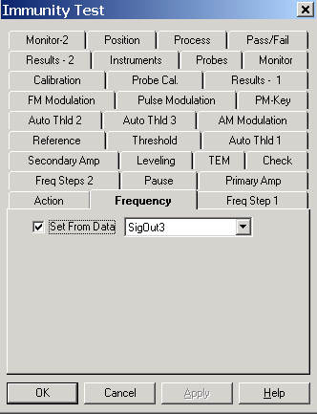
The ‘Set From Data’ check box enables a predetermined set of frequencies to be read in from a data set. This is a good example of the powerful flexibility of the TILE! system.
Set from data is particularly useful when performing IEC testing (or other standards) which require a percent stepped frequency progression but you also have extra frequencies of interest. Merely create a data element of the IEC values and then merge a data element with your additional frequencies of interest. Then use this option and the software will test all the frequencies of interest.

Immunity Test Freq Step 1 Tab
This tab lets the user control a number of different functions/methods/algorithms during the immunity test.

Modulation Always On
There is a specific set of steps that take place during a test. Normally, when the test starts the signal generator will be in a RF OFF state. The attenuation will be set to the lowest number supported by the signal generator (normally –123 dBm). When the action starts, the generator is set to the first frequency, the signal generator is turned to RF ON. The level is set to the first amplitude. Once the field is established the Modulation is turned on. After dwelling, we turn off the Modulation, set the generator to a minimum attenuation, turn the RF Off and step to the next frequency.

No Sig Gen On/Off between steps
Some signal generators use a relay to turn on and off the signal. This relay can wear out over time if used excessively. If you are concerned about this relay, or if the on/off sequence affects your testing, checking this box will prevent the command from being sent to the signal generator.
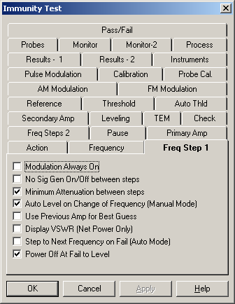

Minimum Attenuation between steps
Some signal generators use a relay to set attenuation levels. This relay can wear out over time if used excessively. If you are concerned about this relay, or if the on/off sequence affects your testing, checking this box will prevent the command from being sent to the signal generator.

Auto Level on Change of Frequency (Manual Mode)
When in manual mode you have the option to step up or down in frequency. When stepping to another frequency, this check box controls whether the software will perform a level cycle or whether the signal generator will be left at the amplitude level from the previous frequency.

Use Previous Amp for Best Guess
When leveling, whether Power Meter or Probe, there are three methods of determining the starting amplitude for the leveling loop. If no other choice is made, the software will calculate a beginning amplitude by taking the desired level, the ‘Offset’ and the gain of the amplifier and ‘guessing’ at a starting amplitude. The second method is found on the leveling tab (Page 166). You can specify a fixed set of beginning amplitudes (less the ‘Offset’) using the ‘Best Guess’ data element. Generally the fastest method is to use the previous frequencies signal amplitude as a beginning point. If you check this box the previous level will be used. In this case the choices (Best Guess Data Element and Offset) will be ignored, except at the first frequency.

Display VSWR (Net Power Only)
When both forward and reverse power is measured the software can calculate the VSWR of the transmitted signal. Checking this box will display this value on the dialog box while it is running. This is very convenient for determining the influence that your EUT has upon the test setup.

Step to Next Frequency on Fail (Auto Mode)
When the ‘Fail’ button is checked, in Auto Mode, the normal behavior is to go to manual mode and pause the test. If you click ‘Auto Run’ at this point it will retest the current frequency. If this check box is checked, the software will automatically step to the next frequency when ‘Fail’ is clicked. This allows you to easily restart the test.

Power Off at Fail to Level
When the leveling loop fails, a dialog box will be presented to the user giving them the choice to ‘Retry this step, Skip this step or Quit’. While this dialog is present this check box determines whether power is on or off. Generally, for safety sake, RF is turned off when this dialog box is present. This prevents potential damage to your EUT. Turning RF off does have the disadvantage of making it difficult to examine the state of your equipment to understand the failure. Knowing what the last amplitude was or what your power meter was showing can help in correcting or understanding this failure to level. Checking this box will cause the RF to be left on while the failure dialog is present.

Immunity Test Freq Step 2 Tab
This tab lets the user control a number of additional functions/methods/algorithms during the immunity test.
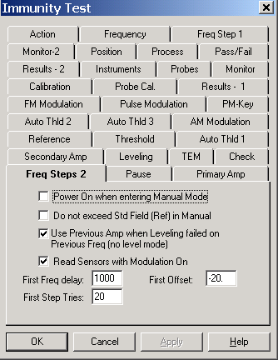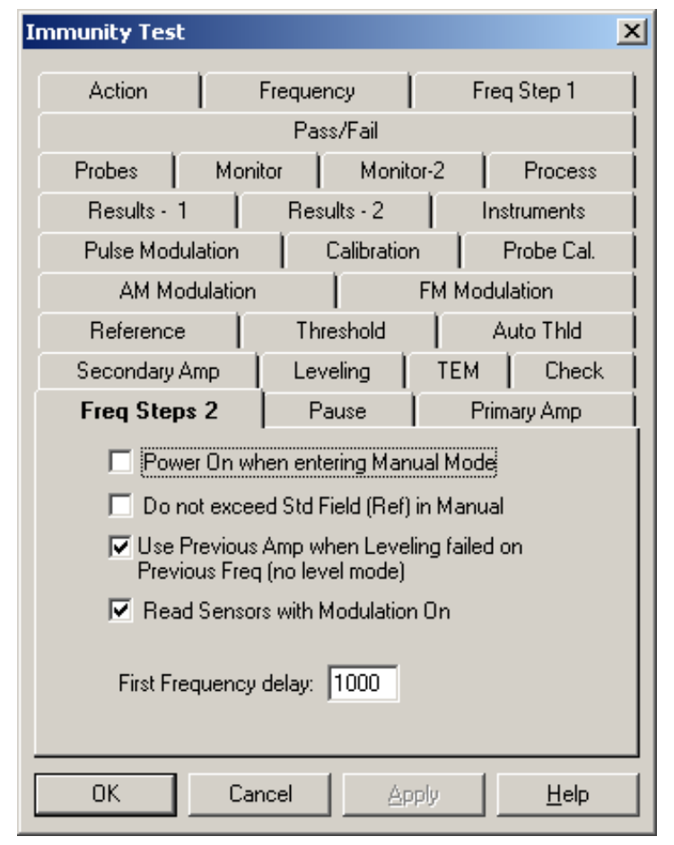

Power on When Entering Manual Mode
When the user clicks the manual button during an automatic immunity test, the default behavior is to pause the test with RF Off. Check this button if you want RF On when entering manual mode.

Do Not Exceed Std Field
When in manual mode the operator can click Up/Down buttons to raise or lower the field level. If this box is check the software will limit the Up button to the standard field. With this checked you CANNOT raise the field level above the limit.

Use Previous Amp when Leveling Failed on Previous Freq
When in ‘No Leveling’ mode with a Secondary Leveling Loop (Secondary Amp Tab), if you failed to level at a frequency the normal behavior for the next frequency would be to start at the signal generator level for the ‘Primary Amp’ field. If you failed to level in the secondary loop, this might make you start too high. Checking this box will cause the secondary loop signal generator level to be used as the first step. The ‘Max Step’ size on the ‘Level’ tab will control the step size for this leveling loop. If you are doing ‘No Leveling’ for the Primary Amp and you have a Secondary Amp defined, it is recommended that the ‘Max Step’ be set to 1 dB.

Read Sensors with Modulation On
When in a leveling loop, sensors are normally read prior to the Modulation being turned ON. Check this box if you want to read sensors with the Modulation On.

First Frequency Delay
Some Power Meters (and Probes) have a very long leveling time when first subjected to power (due to internal averaging methods). This will cause the first readings to be too low. This value controls a leveling delay for the first frequency step that can be different than the values set on the Instrument Tab.

First Offset
When at the first frequency, this is the offset value used as a safety offset prior to turning on the signal generator. The software, unless a ‘Best Guess’ Data element is used on the ‘Leveling’ tab, will take the gain of the amplifier, the desired value and attempt to estimate the drive level required. The offset is a value that is added to this drive level prior to turning on the signal generator output.

First Step Tries
The number of tries which will be attempted for the first step before an error is declared.

Immunity Test Pause Tab
During some tests it is useful to prompt the operator to change hardware, or throw a switch, or change an antenna. If there are no other substantial differences, you can use this tab to define conditions when a pause will be generated. The pause is defined by two conditions: the Frequency at which a pause is requested (and there can be multiple frequencies); and the message to display.
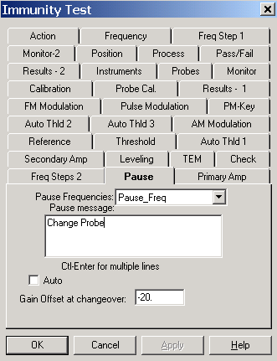

Pause Frequencies
You need to define a data element that has the frequencies, or frequency, at which you want to generate the pause. The software will generate a pause whenever the next frequency is equal to or greater then the pause frequency. You can create this data element with the ‘Direct’ action. See ‘Utility Actions in this chapter.

Pause Message
Enter a text message that will be displayed when a pause is generated.

Immunity Test Primary Amplitude Tab
The Amplitude tab is used to select the amplitude data.
Normally, this data element would match the data element used for Frequency (if that option was set), but does not have to match. If you are using ‘No Leveling’ (on the ‘Leveling’ tab), this data element will indicate signal generator levels. If using ‘Power Meter’ this data element will indicate the power level desired (or specification limit converted to dBm). If using ‘Probe’ this will reflect your specification limit in Volts/Meter. In reality this data element will be interpreted to match the instrument used for leveling. If you use ‘Power Meter’ for leveling and are actually using a Voltmeter or Current Meter, then this data element needs to be the value desired on this instrument (i.e., 1 V - AC or 1 A).

Data
The Data list box allows the operator to select the desired amplitude data to be used in the test. Click on the drop down arrow to view the defined data elements and select the appropriate element. The frequency component of the 'Amplitude' data element must cover the same range as the data element defining the 'Frequency' tab, but they do not have to be the same element. In most tests the same data element will be defined for both Frequency and Amplitude.
For example, if your data element has the following points:

The first frequency, 200 MHz, would have a leveling point of 10 V/M if probe leveling is used. If power meter leveling is specified then the system would level to a power meter reading of 10 dBm (the units used by a power meter). Keep this in mind when defining a test. If you are using a power meter and do not have a probe, you must calculate the expected field strength using the appropriate antenna factors to create this data element. Please contact Quantum Change if you are faced with this task.

Use Apparent Power (CS02)
When performing a Mil-Std 461A Test to Notice 3 you are required to measure ‘Apparent Power’ which is defined as the Voltage + Current/2 – 90 dB.

Immunity Test Secondary Amplitude Tab
The Secondary Amplitude tab is used to define secondary leveling loops, such as BCI (Bulk Current Injection), where there are two standards. The Injected standard and an Induced standard.
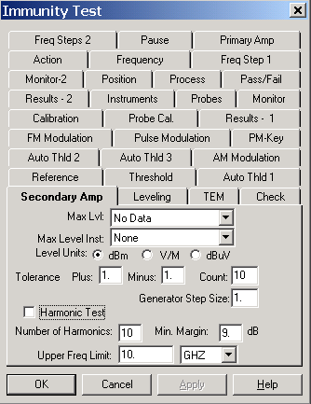

Max Lvl
The ‘Max Lvl’ data element is used in conjunction with the ‘Max Level Inst’ as a means of limiting the RF power which is recorded at a predefined distance away from the EUT.

Max Level Inst
Used to define the instrument that will be used to record the field strength in conjunction with the ‘Max Lvl’ data element.

Level Units
Select this unit to use for display purposes and for instrument control (such as power meters) where units need to be specified.

Tolerance Plus/Minus
You can control the tolerance for the secondary data element. The tolerance is an absolute value.

Count
The number of steps for the secondary loop before an error is declared. The loop will start leveling down by the Generator Step Size. If it cannot achieve the desired pass conditions before the count is reached, then an error message will be displayed for the operator.

Generator Step Size
This parameter controls the step size used when leveling down in the secondary leveling loop. When you exceed the secondary level, the software will enter a loop where it reduces the generator level by the step size shown here. It will then measure the secondary level again. If it is still above the limit it will reduce the level and repeat these steps until the correct level is achieved or the count is exceeded.

Harmonic Test
In automotive testing, the ‘Harmonic Test’ selection is used to monitor up to the 10th harmonic of the fundamental frequency. This, along with the ‘Min Margin’ setting, will limit the field strength accordingly.

Min Margin
The ‘Min Margin’ setting will set the tolerance of the field strength for the ‘Harmonic Test’.

Upper Freq Limit
The upper frequency limit controls a value above which no harmonics will be performed. For instance, if you are doing a GM9112 BCI test up to 400 MHz, but your Spectrum Analyzer does not go above 1 GHz, you can limit harmonic test above 100 MHz (assuming 10 harmonics) to not exceed the analyzers capability.

Immunity Test Leveling Tab
The Leveling tab is used to select the leveling methodology for this run. The TILE! System supports leveling using a probe, a power meter or a pre-calculated field. Pre-Calculated fields are only used with control field transducers, such as TEM Cells or GTEM's. In these cases the field can be predicted (at certain frequencies) very accurately. TILE! allows you to create a calculated field in these structures and record the probe level, in effect calibrating the probe.
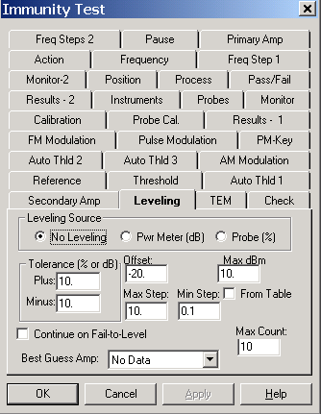

Leveling Source
The Leveling Source radio buttons allow the operator to select which instrument will control the leveling cycle.
A choice of 'No Leveling' changes how many of the remaining choices are used. Some are inactive’Max Step’, ‘Max Count’ have some meaning with regards to ‘Secondary Amp’ and ‘Check’ tab settings. No Leveling’ is the default setting and is preferred when doing a test with calibration input information.
Choosing 'Pwr Meter' or 'Probe' require careful consideration of the Tolerance and Max Count fields. Making either of these selections will negate any calibration runs and cause a new leveled test to be performed.

Tolerance
The 'Plus' and 'Minus' list boxes allow the operator to select the desired tolerances for the leveling process. For instance, if you are trying to create a 3 V/M field with a probe then a plus 15, minus 0 would give you a tolerance of 15% starting at 3 V/M. This equates to a minimum acceptable reading of 3 V/M and a maximum of 3.450 V/M. This is probably too tight a tolerance for most probes to level to but the user should experiment with these settings to obtain the tightest acceptable margin for your instrumentation. A symptom of too tight a tolerance would be a leveling loop which jumped below and above these number without ever landing within the zone. You will exceed the 'Max Count' specified without leveling. Raise the margin slightly and retry.

Offset
The Offset text box sets the offset in dBm to the expected signal generator levels for the first attempt. This defines a minimum offset to the calculated field for safety purposes. This value is subtracted from the expected Signal Generator level, so a negative value will INCREASE the signal generator level. There are often large swings in field strength given different frequencies in the same setups. This number determines how far below your calculated value to place the signal generator on the first reading. The system will step up in maximum steps of 10 dB until it begins to receive valid readings from the probe or power meter. Subsequent leveling will follow in internal algorithm. When using the ‘Best Guess Amp’ data element, the value is reduced by the ‘Offset’.

Max dBm
This controls the maximum RF level that will be output from the Signal Generator. Use this setting to protect the front-end of your amplifier from overload. A typical amplifier cannot handle more then 0 dBm into the input of the amplifier. A value of 0 here will limit the software by halting the leveling if the anticipated signal generator level will exceed 0 dBm.

From Table
You can also use a table of sliding values for the Maximum dBm value. This is done by checking the ‘From Table’ box. This is most common in low frequency (Audio) applications where the maximum capability of the amplifiers is a function of frequency.

Max Step
When in a leveling loop, the ‘Max Step’ controls the largest step allowed to the signal generator. This value might be set quite differently for different types of tests. When the software sets the first signal generator level, if the value returned (either by the power meter or probe) is very low, compared to the limit, the software will take a large step. This value limits the size of the step. When performing some secondary leveling loops (either ‘Secondary Amp’ tab or ‘Check’ tab), this value also determines the step size for these loops.

Min Step
Some signal generators have very poor resolution. This field allows you to control them minimum step size the software will try to send to the signal generator. You might make this value larger to speed up the test, but do not do this if you expect to be near the saturation point of your amplifier, where small steps can do strange things.

Max Count
The Max Count text box sets the maximum number of retries to establish a level measurement reading before the system reports an error. This field needs to be over 10 in situations where you are seeking a large field or in cases in which your margin is extremely small. For example, if you are trying to create a 3 V/M field with a 500 Watt amplifier, you will find that small ripples in the amplifier cause relatively large changes in the offsets at this level. You will probably need to give the system more tries to level. A warning of this problem would be a failure to level which levels very quickly if you choose 'Retry'. This field is also used in the ‘Secondary Amp’ and ‘Check’ loops to determine the number of tries.

Continue on Fail-to-Level
The ‘Continue on Fail-to-Level’ check box allows the user to continue on with the leveling steps even when a step fails to level.

Best Guess Data Element
You can use this data element to control the initial signal generator level for each frequency step. It is mutually exclusive with the check box on the ‘Frequency Step 1’ tab labeled ‘Use Previous Amp for Best Guess’. If that check box is NOT set, then this data element controls the initial signal generator level (less the Offset).

Immunity Test TEM Tab
TEM or GTEM cells, by design, are calibration devices. The field strength in these cells can be accurately calculated if the height of the septum, impedance and net power are accurately known. The general formula is P*I = E^²/H where P is the power in Watts, I is the impedance in Ohms, E is the field strength in V/M and H is the height of the septum.
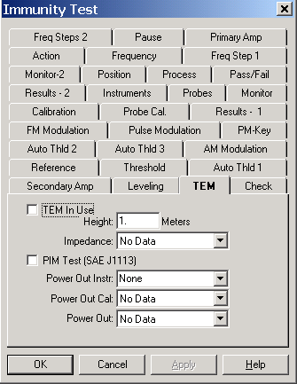

Height
Enter the septum height in meters. This value is used in the above equation to adjust the field strength to an appropriate value.

Impedance
Choose a data element which contains the impedance of the cell. The impedance is the critical in the accuracy of the methodology. You cannot assume a 50 Ohm cell. Measured values are necessary. If you do not have these values it is possible to use TILE to determine closely approximated values. Contact Quantum Change for more information.

Immunity Test Check Tab
This tab is used for two unrelated purposes. First, ‘Power Meter Check’ is a modified leveling method. ‘Door Check Active’ is used as a safety feature.
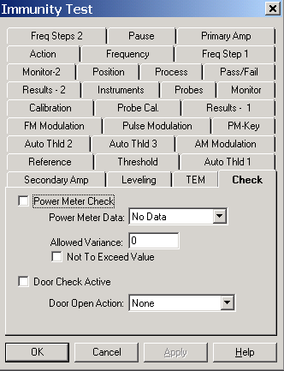

Power Meter Check
‘Power Meter Check’ is a modified form of testing in which you are running ‘No Leveling’ type test, but still want to verify the actual power level present.

Power Meter Data File
Select an appropriate data element which reflects the expected poewr meter level. This value will be referenced against the ‘Power Meter 1’ instrument. If you want to perform any other type of checking, either using another instrument or Net Power, you must configure the ‘Secondary Amplitude’ tab and use that method.

Allowed Variance
This value reflects the +/- tolerance which will be applied to the power meter reading in determine acceptance.

Not to Exceed
If this is checked and the power level is found to be higher then the desired levcl, the software will level down to the desired power meter level.

Door Check Active
When this is selected, the Action specified in the ‘Door Open Action’ will be accessed to determine the switch position. If the switch position indicates and open door, the test will be paused (RF turned off). Then an error message will be displayed for the operator.

Immunity Test Reference Tab
When performing a test sometimes the unit of the standard is different then the actual unit currently being used for the test. For instance, if you have calibrated a field using a field probe (to 3 V/M for instance) and saved the signal generator level (or power meter level). You might then perform a test using these values in either ‘No Level’ or ‘Power Meter’ leveling mode. You will be leveling then in dBm but your standard is still in V/M. The reference field is a field related to the current leveling units which reflects the actual standard being measured. When selected the software changes the display to show the value and units derived from the calibration. If you are feeding back a set of previously calibrated signal generator levels, the display will show 3 V/M, no –15.8 dBm. This is much more useful.
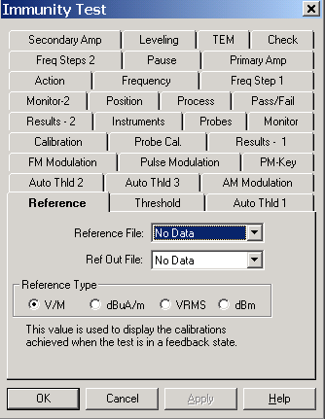
The reference field MUST be related to the data element used in the ‘Primary Amp’ tab. If there is a discrepancy in this relationship, the displayed values will be incorrect.

Reference File
The ‘Reference File’ is used to display the field values achieved during the calibration when the test is in a feedback state.
The most common use of this field would be to display the field probe level achieved during the calibration step referenced to the current leveling method and its related value from the calibration. Assume that you level to 3.03 V/M with a forward power of 23.0 dBm. If you level during the test to 23.2 dBm then the displayed field strength would be:
Estimated field = Reference value * 10^(reference level/actual level)/20
Or
3.03* 10^^{(23.2/20)/20} = 3.40 V/M

Ref Out File
Select an appropriate data element to save the reference value. If you goto manual mode and adjust the signal generator to change the field level, the reference is recalculated to display and adjusted value. This value is stored if you ‘Pass’ or ‘Fail’ this step. This allows you to graph the estimated field actually generated at each step of the test.

Reference Type
Select the appropriate recorded level radio button. These values are for display purposes only. You must have selected appropriate methods of leveling and amplitude/reference data elements to properly level.

Immunity Test Thresholding
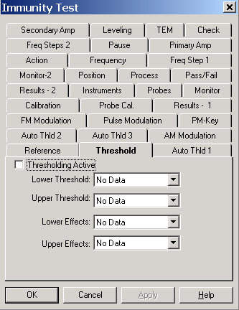
When this function is activated, the software will display the thresholding options during the Immunity Test Dialog. Thresholding assumes the upper and lower threshold’s are identical unless the operator takes manual control and overrides these values. When activated, and in manual mode, the operator can identify a level as being the upper or lower threshold and this value will be save.

Lower/Upper Threshold Data Elements
Selected an appropriate data element to store the thresholding values. There must be a data element selected for both upper and lower or the software will not allow this option to be activated.

Lower/Upper Effects
Select and enter a data element to store an alpha code for effects. There are some standards which allow or require the operator to identify failures by type. Assigning an alphabetic code letter to different failures allows the operator to quickly identify the failure without having to enter the same text repetitively.
These data elements must be defined as ‘Word’ type data to be at this step.

Immunity Test Auto Threshold 1
The software allows the user to configure a threshold value for up to 3 different instruments. As the immunity test runs, each instrument is read to determine the current value. If the value exceeds the value given here, the software wll automatically level down until the EUT passes. If more then one auto threshold is defined, the software will check the ‘Auto Thld 1’, then ‘Auto Thld 2’ and, finally, ‘Auto Thld 3’.

Auto Thresholding
Check this box to activate thresholding.

Tolerance
The tolerance is applied as a plus or minus value to the number found in the ‘Threshold Limit’. If the threshold is a value of 5 with a tolerance of 1 then this feature will assume a pass if the instrument read shows a value between 4 and 6.
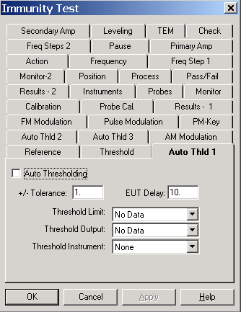

EUT Delay
This delay is put between each read of the instrument to insure proper leveling.

Threshold Limit
Enter a data element that has stored the expected values for this EUT.

Threshold Output
Select a data element to store the results of the instrument read. This allows you to display, either on graphs or tables, the levels the your EUT were outputting during the immunity test.

Threshold Instrument
Select the appropriate instrument to read the EUT.

Immunity Test Auto Threshold 2
The setup and configuration of this tab is identical to the Immunity Test Auto Threshold .

Immunity Test Auto Threshold 3
The setup and configuration of this tab is identical to the Immunity Test Auto Threshold .

Immunity Test AM Modulation Tab
Select the AM Modulation page if you need AM modulation turned on during the immunity test. The action will then turn on AM modulation at the signal generator and turn on the appropriate Internal/External switch (if your generator has this feature). A typical AM modulation envelope would appear as follows:
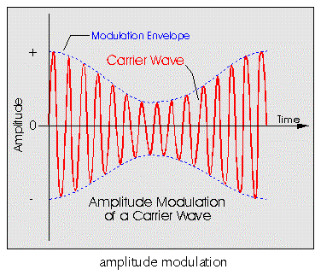

Enable
This box determines whether AM Modulation is turned on (enabled) or not (off). If this box is checked, you must complete the ‘Depth’ and ‘Frequency’ boxes.

Depth
Determines the relative amplitude of the AM modulation. It is stated in percent, as are most standards. A typical standard is the IEC 1000-4-3 which specifies 80% modulation. The amount of modulation is related to the pitch of the ‘voice’ being emulated. The standards are basically trying to duplicate the human voice on a radio transmitter.
Place an appropriate numerical value in the ‘Depth’ text box. If you standard is not stated in percent, you must convert this number to percent before entering.

Frequency
In stating a sound (using Depth), we then specify how often the sound is manufactured. This is stated in Hz (or KHz). Insert an appropriate number in the ‘Frequency’ text box and, using the Tab key or a mouse click, then select the frequency component. You can click the drop down arrow and select a unit, or type the first letter of the appropriate units (H - Hz, K - KHz).

External
Enables the external input of the signal generator, if this feature is available.

Waveform
‘Waveform’ denotes how the carrier wave will be varied in accordance with the characteristics of the modulation signal.

External Gating
If you need the modulation to be controlled by an external gating signal, check this box.

Immunity Test FM Modulation Tab
The page allows for selection and configuration of FM Modulation. Your generator must be capable of this function or these settings will have no effect.

Enable
Select this check box if you want to turn on this function. With this box checked you must complete the ‘Deviation’ and ‘Frequency’ sections of the page.

External
Check this box if you are using an external modulation generator and need to feed this into the signal generator. Control of the external modulation generator is not covered in this action. It can be configured using the GPIB Control action described on page 203.

Deviation
Deviation relates to the relative amplitude of the FM modulation. It is specified in frequency deviation around the primary frequency. If your primary frequency is 100 MHz with a 5 KHz deviation, then the FM Modulation will cycle between 99.95 MHz and 10.05 MHz. This simulates the human voice carried on a FM radio transmitter.
Enter a value in the text box and move to the units box, either by using the Tab key or by clicking with the mouse. Enter the units by typing the first character of the unit (H - Hz, K- KHz) or by clicking on the drop down box and selecting the appropriate unit with the mouse.

Frequency
In stating a sound (using Depth), we then specify how often the sound is manufactured. This is stated in Hz (or KHz). Enter a value in the text box and move to the units box, either by using the Tab key or by clicking with the mouse. Enter the units by typing the first character of the unit (H - Hz, K- KHz) or by clicking on the drop down box and selecting the appropriate unit with the mouse.

Waveform
‘Waveform’ denotes how the carrier wave will be varied in accordance with the characteristics of the modulation signal.

External Gating
If you need the modulation to be controlled by an external gating signal, check this box.
Immunity Test Pulse Modulation
The page allows for selection and configuration of Pulse Modulation. Your generator must be capable of this function or these settings will have no effect.
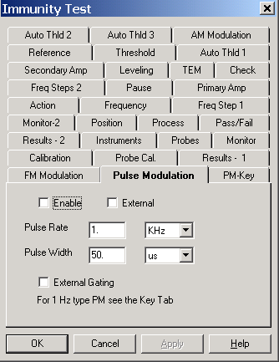

Enable
Select this check box if you want to turn on this function. With this box checked you must complete the ‘Deviation’ and ‘Frequency’ sections of the page.

External
Check this box if you are using an external modulation generator and need to feed this into the signal generator. Control of the external modulation generator is not covered in this action. It can be configured using the GPIB Control action described on page 203.

Pulse Rate
A Pulse Modulation is defined as an on/off width of a certain time over a repetition rate. The repetition rate is measured in frequency units.
Enter a value in the text box and move to the units box, either by using the Tab key or by clicking with the mouse. Enter the units by typing the first character of the unit (H - Hz, K- KHz) or by clicking on the drop down box and selecting the appropriate unit with the mouse.

Pulse Width
The pulse is defined as an on/off width of a certain time over a repetition rate. The parameter is the width of the pulse. The width is defined in time units.
Enter a value in the text box and move to the units box, either by using the Tab key or by clicking with the mouse. Enter the units by typing the first character of the unit (us, ms or sec) or by clicking on the drop down box and selecting the appropriate unit with the mouse.

External Gating
If you need the modulation to be controlled by an external gating signal, check this box.

Immunity Test PM-Key Test

Key Test
The ‘Key Test’, when selected, will command the signal generator to emulate the keying and unkeying of a transmitter at the identified cycle time for the defined number of cycles. The cycle time is defined in the ‘On/Off(ms)’ text box. The number of cycles is defined in the ‘Number’ text box.
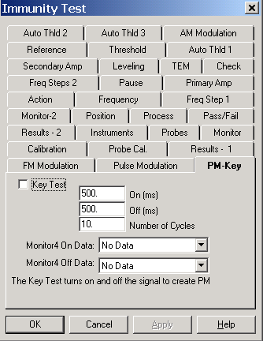

Key On
Defines the number of milliseconds that the RF will be on.

Key Off
Defines the number of milliseconds that the RF will be off

Number of Cycles
The pulse shape of on and off signals is repeated the number of cycles defined here.

Monitor 4 On/Off Data
These data elements are used to record the results of the ‘Key Test’. They must be defined as measurements on the data page.

Immunity Test Calibration Tab
The Calibration tab is used to select the calibration data sets for the selected instruments. These data elements should contain the appropriate correction factors for this instrumentation.
If the Amplifier calibration is not entered, the default value is 0 (a gain of zero). This will cause serious overshoot if you actually have an amplifier present in the system.
If you are unsure of your amplifiers gain, enter a preset of at least 40. The calibration table should be the gain of the amplifier in dB, not watts.
Power meter calibration data needs to include cables and couplers. The default value is 0 if no data element is selected.
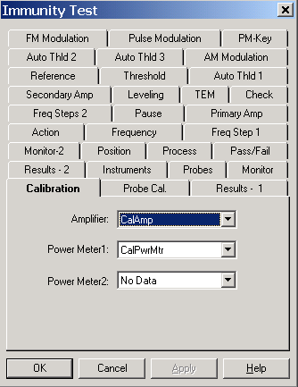
You can use TILE to calculate the calibration data by setting up an action with 'No Leveling' establishing a 0 dB signal generator level. Physically hook up the complete system, but install a 50 Ohm load in place of you transducer. The power meter readings taken under this circumstance represent the system loss from prior to the power meter.

Immunity Test Probe Cal Tab
There can be up to four different probes used during an immunity test. An appropriate calibration data element must be specified for each probe. The probe calibration table should be the correction information from the manufacturer or a preset value of 1. Never use a value of 0 (zero) since probe correction factors are multiplicative. We take the reading from the probe and multiply the probe correction factor. A value of zero would cause all results to be read as zero. Probe calibration tables tend to be in the +.8 to +2 range.

Immunity Test Results 1 Tab
The Results tab is used to select which instruments will be recorded and where the recorded results will be stored. The data elements selected must be defined as 'measurements'.

Record
Check the box for each instruments data you want to record. If not checked the results are not saved. This does not mean the instrument is not read, only that the results are not saved. If you choose to level with a probe and do not record the probe levels, then you will have to assume that the desired amplitude was the actual level. If you record the probe level you can display this later to show the actual field created compared to the standard.
If you are running a “No Leveling” test using calibrated inputs, you might want to record the power meter or probe readings for reference purposes. This will allow you to graphically compare the field established during the calibration run and the field created during the test. If the EUT has an unusually large impact upon the field generation, this will show it.
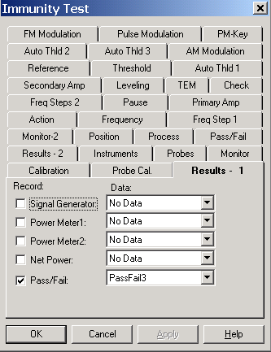

Data
If the 'Record' box is check, a data element must be selected. If you fail to select a data element, the system will record a failure and not run. Select a data element by clicking the drop down box and selecting from the predefined data elements.

Signal Generator
Choose an appropriate data element if you want to store the amplitude of the signal generator when the leveling loop has completed. This information is useful for duplicating testing or verifying results.

Power Meter1
Choose an appropriate data element if you want to store the amplitude of the forward power during this test. Power Meter1 always refers to the forward power if net power is being measured. The forward power value is determining by reading the instrument identified on the ‘Instruments’ tab and adding the calibration value found on the ‘Calibration’ tab. The corrected value is saved.

Power Meter2
Choose an appropriate data element if you want to store the amplitude of the reverse power during this test. Power Meter2 always refers to the reverse power if net power is being measured. The forward power value is determining by reading the instrument identified on the ‘Instruments’ tab and adding the calibration value found on the ‘Calibration’ tab. The corrected value is saved.

Net Power
P_{f} (Watts) = ((P_{fm}^⁽⁻¹⁰⁾)/10)/100000
P_{r} (Watts) = ((P_{rm}^⁽⁻¹⁰⁾)/10)/100000
P_{net} (dbm) = 10 * Log((P_{f -} P_{r})*100000)

Where
P_{f} = Forward Power (in Watts)
P_{f} = Forward Power (in Watts)
P_{fm} = Forward Power measured in dBm
P_{r} = Reverse Power (in Watts)
P_{fm} = Reverse Power measured in dBm
P_{net} = Net Power (in dBm)
Choose an appropriate data element if you want to store the net power measured during this test. You must have both a forward power instrument and a reverse power instrument identified on the ‘Instruments’ tab and you must have checked the ‘Net Power’ box on the same page. The net power value is calculated by the following formula:

Pass Fail
The Pass/Fail data element stores a value that reflects whether the Pass or Fail Buttons were pressed during the test. If the step passed a value of 1 is entered. If the step failed a value of 0 is entered. This allows the user to perform math that easily distinguished the failed frequency. A simple equation – data element < 1 – will identify those frequencies where a failure occurred. Select an appropriate data element to store this value.

Immunity Test Instruments Tab
The Instruments tab is used to select the specific instruments that will be used in the immunity Test. Click the drop down arrow for each instrument in use and select the appropriate instrument. If an instrument is selected (other than the Signal Generator), it must have a calibration entered on the 'Calibration' page. If the instrument is not in use, make sure this field shows 'None'.
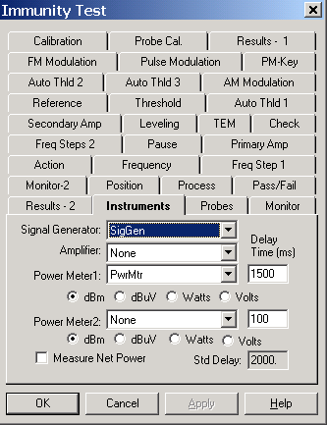
These four categories of test instruments are generic to an immunity test. Certain instruments may have functions that imitate others. For example, many spectrum analyzers can be used as power meters.

Signal Generator
Drop down the selection box and choose the correct instrument. If you select an instrument that does not have the characteristics of a signal generator the action will not work properly. Some spectrum analyzers have built-in tracking generators that can be used for CW type testing using this action. Since a Spectrum Analyzer can also be a Power Meter, you can select the same instrument for both Signal Generator and Power Meter.

Amplifier
Choosing an amplifier is appropriate when the amplifier has a GPIB bus. With this feature TILE! will put the amplifier into Operate mode while running the test, change the bands as needed and put the amplifier back into standby when the test is complete.

Power Meter 1
Within the TILE! system Power Meter 1 is assumed to be the forward power measurement from a Direction Coupler. It does not have to be, but be cautious when using a non-standard configuration.
Select the units for this power meter.

Power Meter 2
Within the TILE! system Power Meter 1 is assumed to be the reverse power measurement from a Direction Coupler. It does not have to be, but be cautious when using a non-standard configuration.
Select the units for this power meter.

Measure Net Power
The ‘Measure Net Power’ check box requires the use of two instruments. When both forward and reverse power are recorded, the software can calculate the ‘Net Power’ reading. See a description in Immunity Test Results 1 Tab. The result is recorded in the data element identified on the ‘Results’ page.

Delay Time
The ‘Delay Time’ text box allows the user to enter a delay time (in ms) before a reading takes place. This is particularly useful due to the long settling time inherent with power meters and probes.
It is important to keep in mind that most power meters and probes are designed as constant output devices. When you have a amplitude or frequency change which requires settling these instruments will continue to respond to requests by sending the LAST valid reading. They do not warn you that they are in the middle of a triggering cycle. For this reason the results can be inconsistent.

Immunity Test Probe Tab
The ‘Probe’ page allows you to identify up to four different probes for measurement. During a test, these probes will be read and the values stored depending upon the choices here, in the ‘Results’ tab and on the ‘Leveling’ tab.
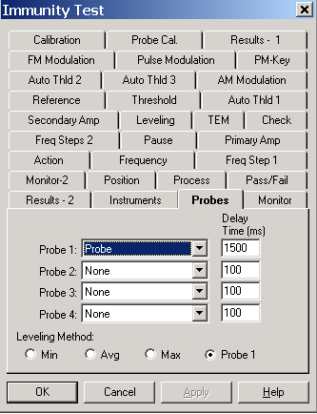

Probe 1-4
Drop down the selection box and choose the correct instrument for each probe. You do NOT have to have all four probes, nor do they need to be identified in order. They are treated independently for reading and saving purposes.

Delay Time
The ‘Delay Time’ text box allows the user to enter a delay time (in ms) before a reading takes place. This is particularly useful due to the long settling time inherent with power meters and probes.
It is important to keep in mind that probes are designed as constant output devices. When you have a amplitude or frequency change which requires settling these instruments will continue to respond to requests by sending the LAST valid reading. They do not warn you that they are in the middle of a triggering cycle. For this reason the results can be inconsistent.

Leveling Method
The ‘Leveling Method’ is a set of four check buttons that determine how the four probes interact. The default is ‘Probe 1’. With this case if leveling is being performed, then the system will level on Probe 1. The remaining probes will be read, if selected, and stored, if selected.

Min
When selected, the software will read all identified probes and level off the lowest value among the probes.

Avg
When selected, the software will read all identified probes and level using the average of the probe readings. This is defined as the value1+...+value4/number of probes.

Max
When selected, the software will read all identified probes and level off the highest value among the probes.

Immunity Test Monitor Tab
The ‘Monitor’ page gives the operator the ability to record the results of the test on instruments which are not part of the leveling loop. The instruments and data elements are selected by selecting the down arrow and selecting the appropriate instruments and data elements.
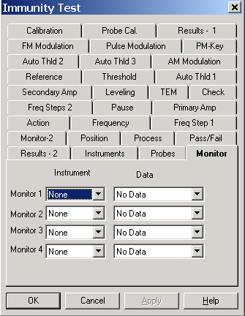
Monitoring allows the user to record values from the EUT while the test is running. The use of the term Monitor is to imply that they are looked at, but are not part of, the leveling loop. One possible use of these fields is to record the state of the EUT while doing automatic testing (in a relatively high speed mode). Then the use of mathematics to determine at what frequencies the EUT was out of band. These frequencies would then be the input frequencies for a manual immunity test with operator intervention.
There are a total of eight monitors that can be configured within a test profile. Chose an instrument and data element for each of the monitors on the Monitor and Monitor-2 Tab.

Immunity Test Process Tab
The process page allows you to control steps during the immunity test. Of particular interest is the ‘Delay’ feature. A more complex, but equally powerful tool, is the ability to perform step tests. A step test involves ‘stepping’ up to the final immunity level, pausing at intermediate stages to determine effects. AutoStart is only obvious once we have discussed the actually running of the test. Refer to Auto Start on page 186 for a detailed description.

Step Test Defined
Usually when we discuss an immunity test we think of a fixed RF level (with or without modulation) at a fixed frequency. But certain standards call for measuring the effects of RF level changes within a frequency point. The IEC 1000-4-3 sets a pass/fail criteria of 3 V/M at most frequencies. This is the only level the standard is concerned with. But some of the automotive standards discuss plateau’s or steps within the frequency point. If our standard is 10 V/M, the standard might call for starting a 1V/M, observing the EUT, stepping to 2 V/M, observing the EUT, and continuing on in 1 V/M steps until we reach 10 V/M. In defining a stepped test, we basically take our final RF level (the specification limit) and apply a ‘Start Delta’ and Step size. These three components will fully define our test requirements.

Start Delta
If you are not performing a stepped test, this box should be set to zero. This will cause an initial offset of zero and the test will begin at the specification limit.
If we are performing a stepped test, the valued needed here is the offset, in specification units, needed for our first point. If we were performing a 10 V/M test with 1 V/M steps starting at 5 V/M, our ‘Start Delta’ would be -5. The system will take the limit and subtract the ‘Start Delta’ yielding the first step level, in this case 10 V/M - 5 would yield 5 V/M.
If you are performing an immunity test from calibrated information, the ‘Start Delta’ needs to be stated in the same units as the signal generator since the signal generator units are the amplitude in this defined action. This will probably require some calculations by the user prior to running this test. Please contact Quantum Change if you are faced with this task and require assistance.
The units are usually stated in a negative number size and we will want to step UP to our specification limit. It is possible to define this action to step down to the specification limit. This is an option to the user in defining the step.
CAUTION - If the ‘Start Delta’ equals the ‘Amplitude Level’ the system will create a starting point of zero - which is not a valid choice.

Step Size
The step size must be stated in specification limit values. If we are leveling to a power meter, which is stated in dBm, then our specification limit will be in dBm. The step size must match these units.

Std Delay
The delay is the period (in milliseconds) that the system should pause once the desired field has been established, and prior to continuing to the next frequency point. Most standards call for 2000 milliseconds (2 seconds), but these do vary. Enter the appropriate value. The ‘Inst Delay’ is shown for reference purposes and is the total delays from the different instrument on the ‘Instrument’ and ‘Probe’ tabs.

Soak Time Off
‘Soak Time Off’ is used to support automotive testing which requires that the transmitter is not to be keyed for a certain amount of time between frequency points. Enter the appropriate value in ms in the text box.

Delay Exceptions
An exception is a frequency that requires a different dwell time than the standard. This page includes the specification dwell time, but some standards call for different dwell times at certain frequencies such as the harmonics of the primary crystal, etc. An exceptions list is a set of frequency points and there required dwell time (in milliseconds). It is critical that the frequency be a point in the frequency data element, or it will be ignored by this step. One way to insure that the primary frequencies are covered is to merge the exceptions list and the frequencies data elements together. This will insure that every point covered by the specification is included.

Auto Start
When running an immunity test with this action you have the option of manually stepping through the frequencies or automatically stepping through them. When first executed the action pulls up a dialog box for communication with the technician/engineer. The ‘Auto Start’ box determines whether the action will immediately begin automatic execution or whether the user must press the ‘Start Auto’ button on the dialog box. This is left at the designer’s option. If desired, check the box.

Immunity Test Pass/Fail Tab
The immunity action has five settings for pass/fail which are standard in the TILE! system. Four of these presume that the user is manually observing the test. The fifth option allows an interface for automatic failure analysis. Please contact Quantum Change for a discussion of these options.
There are four check boxes grouped together. These comprise the manual options within the system. We discussed the concept of steps in Step Test Defined, when the test is running you have the option of forcing the user to respond at each step, at the completion of the current frequency point or at the completion of the complete test. The final (and default) is not to prompt at all.
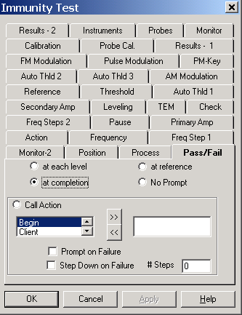
Since the dialog box present during the test will always allow the user to override the automatic mode, the choice of techniques is left to the user. It is suggested that you try running the test each way to better understand the impact on the user that each options will have. In some circumstances, especially with complex EUT’s, it might be necessary to force the user to respond at each step. Again, our recommendation is that you try a short test with each setting to determine that which best fits your requirements.

Call Action
‘Call Action’, when selected, gives the operator the ability to jump to and execute the defined actions. You can select multiple actions to test. Generally these will be switches, instrument commands or the ‘Serial Interface’ action. These icons are setup on the flowchart and configured so that their default behavior is a ‘Pass’ and any deviation is a ‘Fail’. See the manual for descriptions of switches and the ‘Serial’ action.

Prompt on Failure
The default behavior of the call action is to automatically mark a pass or failure. If this is checked, the a specific prompt will be displayed for the operator identifying the failure.

Step Down on Failure
If a failure is detected and this box is checked, the software will automatically level down until the action reports a pass condition.

# of Steps
The number of cycles that the signal generator will be changed and the pass/fail stated reviewed prior to reporting a failure and continuing.

Immunity Test Dialog
You can execute the Immunity Test action either by doubling clicking on the action and selecting ‘Execute’, by executing it as part of the sequence of tests being executed, or by using the ‘Run/Single’ options from the Menu Bar.
When you are executing the Immunity Test, you will have a dialog box showing a wide variety of information about this test. How this dialog box is used is dependent upon your choice of leveling method, pass/fail and process settings. The controls for this dialog box are summarized in the Control Buttons. All the rest of the dialog box is information for the user.

Frequency/Step Information
This part of the dialog box displays current frequency and step number. The step number here refers to the total number of frequency steps to be performed. When in manual mode you can used the ‘Next/Previous’ buttons to move forward or backwards in the frequency table. You cannot enter a new frequency that is not in the current frequency data element.
During automatic testing, the user might be observing the test, notice a failure or questionable reading. Stop the test. Move back to the previous frequency. Test this frequency for sensitivity by adjusting the RF level and overwrite the originally ‘Pass/Fail’ information with updated information.

Leveling Loop Information
If we are using feedback leveling (probe or power meter), then the current status of the leveling loop is displayed. The ‘Substitution’ value displays the current RF level for this leveling step. The ‘Delta’ displays this change in percent. The number in the lower left corner is the count number for the leveling loop. Each time the system changes the RF level in attempting to level, the counter is incremented by one. The ‘Max Level’ value is the ‘Max dBm’ value depicted on the leveling page.

Amplitude Information
The amplitude box displays the estimated field strength, the current amplitude, the target level, the current step and the related step size. If you are using steps within the frequency as part of your leveling process (defined in the ‘Process’ page of the Immunity Test action), the step number displays the current step. Step size, for reference, displays the defined amount by which each step will change. The target level displays your defined specification level. The current level is displayed in the first box and is in the units defined for your immunity test. If you are using ‘No Leveling’ then this will be the signal generator level. If you are using ‘Probe’ this will be in V/M. If you are using ‘Power Meter’ then this reading will be in dBm.

Sensor Information
The sensor section displays the read, or sent, data from the instruments in the test. There are two columns, Current and Saved. The current section displays the information from the last read/write to the instruments. The signal generator displays the last level sent to the generator. The ‘PwrMtr’ and ‘Probe’ are the last read levels from these instruments. A value is displayed only if the instrument is identified in the ‘Instrument’ section of the Immunity Test action.
The ‘Saved’ column displays the last information written to file. This is the last saved frequency point information. If you are in manual mode or you have paused the automatic mode and gone manual, you can display the saved information for previous steps, perform level changes and rerecord the information.

Control Buttons
The control buttons give the operator direct control of the leveling process and recording capability for pass/fail information. The beginning state for this dialog box depends upon the settings in the ‘Process’ section of the Immunity Test. If ‘Start Auto’ was checked the action will start in automatic mode. The button ‘Halt’ will be present. The action will start with the first frequency point and start stepping through the test. If the ‘Start Auto’ was not checked the action will start in the manual mode.

RF On (Manual Operation)
When in manual mode, turning RF On causes the system to level to the first frequency point. Above the ‘RF On’ button will appear the phrase ‘Radiating’. When you have the RF On, you can adjust the level using the Amplitude section and read the sensors. If you click on the ‘Pass’ or the ‘Fail’ buttons the system will record the appropriate value in the data element defined for ‘pass/fail’. You can move up or down in frequency across the defined frequency points. You can vary the amplitude and record.

Start Auto/Halt (Automatic Operation)
When the ‘Start Auto’ button is checked the system will begin an automated sequencing of the frequency points. At each frequency the system will level to the specified RF level. The system will pause if you have marked the either ‘Stop at each step’ or ‘Stop at each frequency’ and request operator input. The operator will indicate whether the unit has pass or failed and the system will record the appropriate value and continue to the next frequency. If you selected ‘Stop at completion of all frequencies’ the system will mark a ‘Pass’ and continue on.
When the ‘Start Auto’ button is pushed, it is replaced by the ‘Halt’ button. At any time during the automatic sequencing, you can halt the test, go to manual mode and make manual adjustments. After completing the manual steps, pushing ‘Start Auto’ will resume the automatic sequence from the current frequency point.

Mod-On/Off
This button will toggle the AM or FM modulation if they are enabled on their respective pages.

Finished
At any time you can press ‘Finished’ to save your test to date and exit the action. Finish aborts the operation, but saves the information.

Cancel
At any time you can press ‘Cancel. This will abort the operation and exit the action. No data is saved.

Help
This button is not active and has no defined purpose.

Pass/Fail
When in both manual and automatic mode, pressing either the ‘Pass’ or ‘Fail’ buttons will cause the appropriate pass/fail information to be saved and the program will step to the next frequency point.

Test
The Test button only works if ‘Call Actions’ have been defined on the ‘Process’ tab. If defined, the Test button will force a read of the call action. The appropriate information will be updated in the current status field.

OK, Cancel, Apply and Help
A description of the OK, Cancel, Apply, and Help buttons is found in Common Action Commands on page 77.

Immunity Field Calibration (16 Point) Test

The Immunity Field Calibration (16 Point) Test action analyzes the 16 point field data to determine if 12 points meet the 0-6 dB criteria for acceptance. If there are 12 points that meet this requirement, then standard field and related probe and power levels are determined. These values are then available for use in performing an immunity test to IEC 61000-4-3.

Immunity Field Calibration Action Tab
The action tab is a common name page. A complete description is found in Common Name Page on page 77.
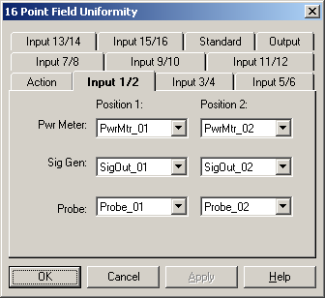

Immunity Field Calibration Input Tab
There are 8 different Input tabs, with information on two different probe positions on each tab. The Power Meter, Signal Generator and Probe data can be specified. You must have, at a minimum, the Signal Generator and Probe levels for Method 1 and the Power Meter and Probe levels for Method 2.
Drop down and select the appropriate data element. It is extremely important care be taken to insure you refer to the correct data element. If you do not specify the correct input values the output will be invalid or, worse, just plain wrong.

Immunity Field Calibration Standard Tab
The choice of method is strictly limited to the IEC-61000-4-3 standard. Amendment 1 is the method specified in the current 1999 revision of the specification. Amendment 2 is based upon a draft that has circulated, but not been published yet. Method 2 is acceptable, but more stringent, then Method 1.
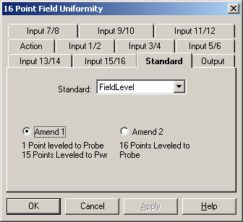
When using Method 1 you must specify the field level to which the chamber was leveled. This value is needed to ‘reference’ the actual readings when calculating adjusted signal generator or power meter levels. Method 1 states that is any of the 12 points (that are in the 0-6 dB band) are less then the desired level, the signal generator level, or power level, is adjusted by calculation to the level needed to achieve the desired field. The adjustment is calculated as follows:
Required field = drive_level - (float)(20.0f*log10(low_probe_value/std_field))
If the lowest probe reading, of the 12 points, was 2.5 V/M when the desired field was 3 V/M with the signal generator set at –23 dBm, the required field would be:
Required power -23 – (-1.58) dBm = -21.42 dBm

Immunity Field Calibration Output Tab
The output tab determines in which data elements the results of the 16 point field calculation will be stored.
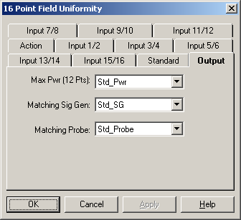

Max Pwr (12 Pts)
Select an appropriate data element to store the required field strength. This can be either signal generator level or power meter level, depending upon which data was stored during the 16 probe positions.

Matching Sig Gen
If you measured power level using a power meter and used these values on each of the Input Tab’s, this action will calculate the forward power required to achieve the field strength. If the signal generator values were also input, the signal generator level for the lowest position of each frequency will be stored in this data element. This output data can then be used as a ‘Best Guess’ starting amplitude. This can substantially shorten the time required to level to the power during the test.

Matching Probe
You were required to have a matching probe input value for each of the 16 points. This output data elements reflects the lowest probe reading included in the 12 points used to calculate the drive level. This data element can then be used for a ‘Reference’ value during the actual test. See

OK, Cancel, Apply and Help
A description of the OK, Cancel, Apply, and Help buttons is found in Common Action Commands on page 77.

Utility Actions

Position Tower
The position tower action provides a control interface to move the tower to various positions as well as change the orientation of the antenna (assuming this function is supported by the tower). This is a stand-alone action that will normally be used for single position movements between different scans or measurements. For tower movement within a measurement action see the Scan Range Measurement action or the Scan Peaks action on pages 99 and 105 respectively.

Position Tower Action Tab
The action tab is a common name page. A complete description is found in Common Name Page on page 77.

Position Tower Position Tab
Three properties are controlled in the Position page of the Tower action, antenna height (in cm), antenna orientation, and margin.

Antenna Height
You can move the antenna height by either clicking on the text box and entering the desired number or by using the sliding box to move the relative position up or down.
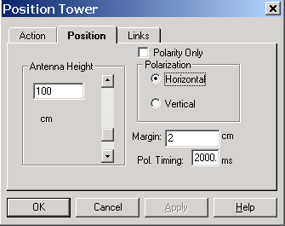

Polarity Only
When you check this box, execution of this action will only a polarity change on the tower. No movement will be performed.

Polarization
To move the antenna orientation simply click on the desired check box. If the antenna tower is already in this position, no change will take place.

Margin
The margin setting is when the positioner will be commanded to stop before the actual stop position. The when movement reaches the desired position less the margin the stop command will be sent to the tower. If the margin is set properly, the tower will settle on the desired position. This setting will be site and test specific because of the differences between positioners and the equipment placed upon them.

Pol. Timing (Polarization Timing)
Most towers with polarity under remote control use an air control to change polarity. The amount of time it takes for the antenna to rotate from horizontal to vertical, or vice versa, is dependent upon the weight of the antenna and the air pressure. We want to insure that the polarity has completed its movement prior to any other movement or measurement. Polarity timing is a value, in milliseconds, that reflects how long it takes the positioner to execute a polarity movement. The software will pause this period before continuing its execution.

Position Tower Links Tab
The Links page selects the instrument to be used for this action. Click on the drop down box to display the available instruments. Select the tower instrument.
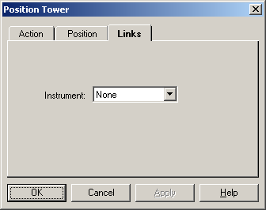

Position Tower Dialog
The Tower dialog box provides visual information to the user as well as the ability to halt execution of the test.
The Target box provides information on the desired position of the tower.
The Current box provides information updates on the tower position when it is in motion.
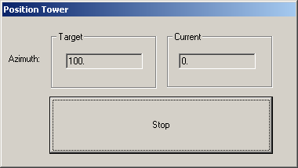

OK, Cancel, Apply and Help
A description of the OK, Cancel, Apply, and Help buttons is found in Common Action Commands on page 77.

Position Turntable
The Position Turntable action provides a control interface to move the turntable to various positions. This is a stand-alone action that will normally be used for single position movements between different scans or measurements. For turntable movement within a measurement action see the Scan Range Measurement action or the Scan Peaks action on pages 99 and 105 respectively.

Position Turntable Action Tab
The action tab is a common name page. A complete description is found in Common Name Page on page 77.
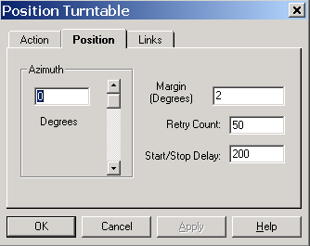

Position Turntable Position Tab
The azimuth property is controlled in the Position page of the Turntable action, Turntable position (in degrees). You can move the turntable position by either clicking on the text box and entering the desired number or by using the sliding box to move the relative position up or down.

Margin
The margin setting is where the positioner will be commanded to stop before the actual stop position. This setting will be site and test specific because of the differences between positioners and the equipment’s placed upon them.

Retry Count
When we first send the start movement command, we begin reading the turntable constantly to determine whether it has reached the target. If we read the same position more then the number of times in the ‘Retry Count’ then an error is displayed. Failure to move is an error condition, but large turntables require a fairly large amount of time to start movement. This parameter, along with ‘Start/Stop Delay’, works together to insure accurate reading of the tower.

Start/Stop Delay
When the start movement command is sent, the software will delay the time shown here , in milliseconds, before sending any other commands to the turntable.

Position Turntable Links Tab
The Links page selects the instrument to be used for this action.
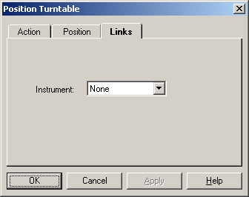
Click on the drop down box to display the available instruments. Select the turntable instrument.

Position Turntable Dialog
The Turntable dialog box provides visual information to the user as well as the ability to halt execution of the test.
The Target box provides information on the desired position of the turntable.
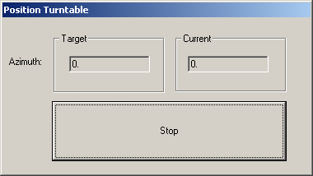
The Current box provides information updates on the turntable position when it is in motion.

OK, Cancel, Apply and Help
A description of the OK, Cancel, Apply, and Help buttons is found in Common Action Commands on page 77.

Position EUT (GTEM Manipulator)

The Position EUT action is used to control an automated GTEM manipulator or X-Y Positioner. The position can be specified within two degrees of accuracy. The position can be selected from a set of predetermined values or specified in degrees.
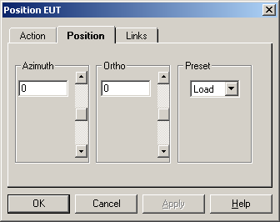

Position EUT Action Tab
The action tab is a common name page. A complete description is found in Common Name Page on page 77.

Position EUT Position Tab
The Position tab is used to move the current position of the manipulator. The position is defined with the Azimuth and Orthogonal controls; or chosen from a set of predetermined values.

Azimuth/X-Axis
The ‘Azimuth’, or ‘X-Axis’ if defined as an X-Y positioner on the ‘Links’ tab, list box specifies the angle or position to which the positioner will be moved when the action is executed. The value is read-only when the value from the preset list box is selected and indicates the value from the selected preset position. When the Custom option is selected in the Preset list box the user can input any desired value from 0 to 360 degrees/cm.

Orthogonal/Y-Axis
The ‘Orthogonal’, or ‘Y-Axis’ if defined as an X-Y positioner on the ‘Links’ tab, text box specifies the angle or position of the second degree of freedom for the positioner. The value is read-only when a value from the preset list box is selected and indicates the value from the selected preset position. When the Custom option is selected in the Preset list box the user can input any desired value from -180 to +180 degrees or 0 to 400 cm.

Preset
The ‘Preset’ list box allows the selection of preset position information. The user can view a list of preset conditions by clicking on the down arrow to the right of the list box. Any value displayed in the list box can be selected by clicking the desired value with the mouse. When a different position is selected, the Azimuth/X-Axis and Orthogonal/Y-Axis Edit boxes are updated with the preset values from the selected position.

Position EUT Links Tab
The Links tab is used to select the instrument that controls the manipulator. The operator can view a list of the instruments by clicking on the drop down arrow to the right of the list box.
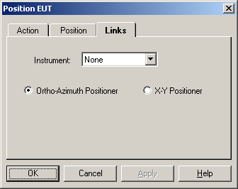

Ortho/X-Y Positioner
This action will control either an Ortho-Azimuth Positioner or an X-Y positioner. Checking either of these affects the default ‘Presets’ on the ‘Position’ tab.

Position EUT Dialog
The Position EUT dialog box provides visual information to the user as well as the ability to halt execution of the test.
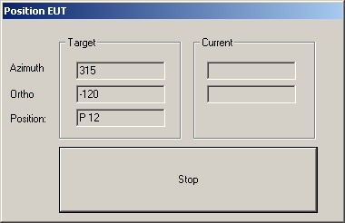
The Target box provides information on the desired Azimuth and Orthogonal Angle of the manipulator.
The Current box provides information updates on the manipulator position when it is in motion.

OK, Cancel, Apply and Help
A description of the OK, Cancel, Apply, and Help buttons is found in Common Action Commands on page 77.

Calibrate Cables/Amplifiers
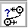
The Calibrate Cables/ Amplifiers action allows the user to perform a calibration of the cables and amplifiers and store the results in measurement data elements. These results can then be used to correct to the results of a measurement.
This action is designed as a simple calibration routine. The ability to control steps size, signal generator levels and instrumentation is limited. For more sophisticated control of a calibration use either the Immunity Calibration (see page 146) or Immunity Test (see page 158).

Calibrate Cables/Amplifiers Action Tab
The action tab is a common name page. A complete description is found in Common Name Page on page 77.

Calibrate Cables/Amplifiers Setup Tab
The Calibrate Cables/Amplifiers setup tab allows the user to identify the parameters of the calibration.

From Table
When the ‘From Table’ is selected the frequencies for this action are determined by a data element selected on this tab. The data element can be of any type, except ‘Word’ types. With this choice you are in complete control of the frequencies and their step sizes.
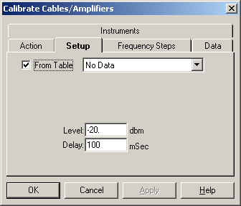
The Level and Delay choices are discussed in the ‘Start Frequency’ tab.

Start Frequency
The starting frequency is set by combining the text box settings and the units settings. Click on the text box and enter an appropriate number. Either use the Tab key or click on the down arrow in the units box to select the appropriate unit. Typing the first letter of the frequency will also select this unit (K-KHz, M-MHz, and G-GHz).

Stop Frequency
The stop frequency is set by combining the text box settings and the units settings. Click on the text box and enter an appropriate number. Either use the Tab key or click on the down arrow in the units box to select the appropriate unit. Typing the first letter of the frequency will also select this unit (K-KHz, M-MHz, and G-GHz).
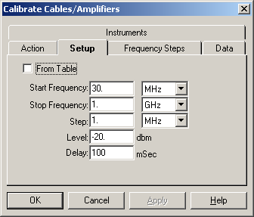

Step
The ‘Step’ value determines the interval between each frequency in a linear fashion.
Select the step value by setting the text box and units box to the appropriate number. Click on the text box and enter an appropriate number. Either use the Tab key or click on the down arrow in the units box to select the appropriate unit. Typing the first letter of the frequency will also select this unit (K-KHz, M-MHz, and G-GHz).

Level
Select the ‘Level’ value by setting the units box to the appropriate number. The ‘Level’ Setting is the signal generator amplitude that will be set at each frequency.

Delay
The ‘Delay’ text box sets the desired delay time (in ms) before reading all measurement. Most probes and power meters have a settling time before their readings can be considered accurate. This field allows you to enter a value to create a delay prior to taking these readings. It is typical for power meters to take well over 1 second (1000 milliseconds) to level accurately. Also, older instrumentation is more susceptible to settling time and will require a large number.

Calibrate Cables/Amplifiers Data Tab
The ‘Data’ tab allows the operator to specify data element links. This is the point of coordination between the data window and the flowchart.
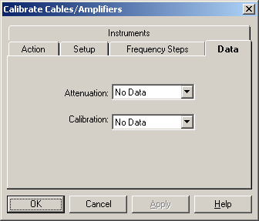

Attenuation
This ‘Attenuation’ list box is used to identify the data storage element to be used to record the measured attenuation value. You select the data element by clicking on the down arrow next to this line. This will display all the defined data elements. Select the appropriate data element. The attenuation value is the measured value less the value of the calibration data element. If no calibration data element is present, then the measured valued is stored.

Calibration
This ‘Calibration’ list box is used to identify the calibration values to be used to correct the ‘Attenuation’ data element during the calibration run.
You select the data element by clicking on the down arrow next to this line. This will display all the defined data elements. Select the appropriate data elements.

Calibrate Cables/Amplifiers Frequency Steps Tab

Reference Level
The ‘Reference Level’ allows the operator to select the reference level for this measurement. This is a function of both the noise floor of your instrument and the maximum expected signal. If you are working in an anechoic chamber, you could set this to 60-80 dB and take valid readings. But on an OATS, this would very quickly put your analyzer/receiver in saturation.

Stop at each Step
The ‘Stop at each step check box will cause the action to pause at each frequency step to change a transducer or other components.

First Frequency Delay
Some power meters have a longer settling time when power is first applied. The value entered in the box is a special delay for the first frequency step only.
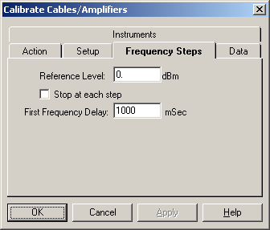

Calibrate Cables/Amplifiers Links Tab
The Links tab allows the operator to specify the instrument links. This is the point of coordination between the instrument window and the flowchart

Signal Generator
Drop down and select the appropriate instrument. The instrument selected can be the same as the Power Meter if you are using a spectrum analyzer with a tracking generator.

Amplifier
Only select an instrument on this tab if your amplifier is GPIB controlled.
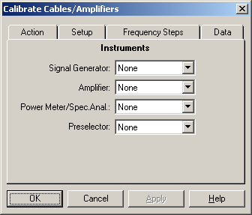

Power Meter/Spec. Anal.
Drop down and select the appropriate instrument. The instrument selected can be the same as the Spectrum Analyzer if this instrument has a tracking generator.

Preselector
Drop down and select the appropriate instrument.

Calibrate Cables/Amplifiers Dialog
You can execute the Calibrate Cables/Amplifier action either by doubling clicking on the action and selecting ‘Execute’, by executing it as part of the sequence of tests being executed, or by using the ‘Run/Single’ options from the Menu Bar.

Step
The ‘Step’ text box displays the current step that is being invoked.

Frequency
The ‘Frequency’ text box displays the present signal generator frequency.
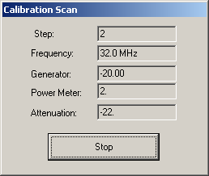

Generator Level
Displays the current signal generator level.

Power Meter Level
Displays the current power level for the designated frequency.

Attenuation
Displays the attenuation level to be recorded to the ‘Attenuation’ data element.

OK, Cancel, Apply and Help
A description of the OK, Cancel, Apply, and Help buttons is found in Common Action Commands on page 77.

Switch
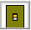
The Switch action allows the user to manipulate GPIB controlled switch devices. This action is also used when performing automatic failure analysis.

Switch Setup Action Tab
The action tab is a common name page. A complete description is found in Common Name Page on page 77.

Switch Setup Switches Tab
The Switch Setup Switches tab allows the user to control the state of up to ten switches, either selectivity controlling an individual switch, or by using the ‘All On’, ‘All Off’, or ‘All N/C’ radio buttons to control the state of all the switches.
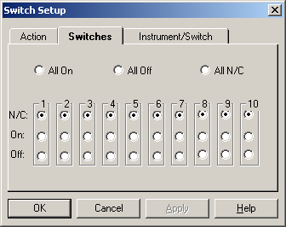

Switch Setup Instrument Tab
This page specifies the instrument to be used during the execution of this action. You must have an ‘Instrument’ selected.
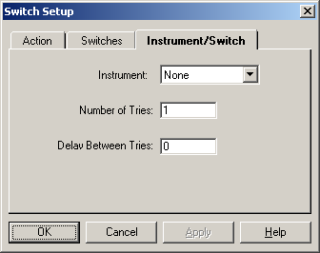

Instrument
For the instrument, click on the drop down arrow and select the appropriate instrument.

Number of Tries
When used for Pass/Fail analysis, this setting determines how many times the switch will be read before returning control to the Immunity Test. If your EUT has a slow response, you might need to set this value to a larger number to trap failures.

Delay between Tries
When used for Pass/Fail analysis, this setting determines the delay time between each try.

OK, Cancel, Apply and Help
A description of the OK, Cancel, Apply, and Help buttons is found in Common Action Commands on page 77.

GPIB Control

The GPIB action allows the user to send a command, or sequence of commands, to any GPIB controlled instrument.

GPIB Control Action Tab
The action tab is a common name page. A complete description is found in Common Name Page on page 77.

GPIB Control Instrument Commands
You need to define the instrument in the Instrument Window. Once the name is defined, you can address it with the GPIB command. If the instrument does not have an instrument driver under the TILE system, define the instrument with 'Do Not Use Driver' set on the driver tab. These commands in this action are sent directly to the bus address specified in the instrument definition (see page 54 for instrument definition).
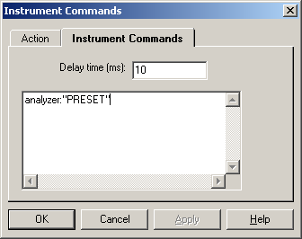

Delay Time
You can sequence multiple commands with this action. The delay time is a delay between execution of each command in the sequence.

Command Format
The format for a direct command is instrument name followed by “:” and then the command in a set of quotes “”. You can embed quotes within the command but must have a set of quotes surrounding the complete string.
You can sequence any number of commands, to more than one instrument, in the same action but do NOT send commands that require an answer. This command is not for two-way communications.

Variable Delay Timing
You can specify a specific delay time at any point by entering a command, using the term ‘delay’, ‘Delay’ or ‘DELAY’ as the instrument name and the number of milliseconds as the command. An example would be the following structure:
analyzer:”command”
delay:”2000”
analyzer::”command”
which would delay for 2000 milliseconds between the two instrument commands.

OK, Cancel, Apply and Help
A description of the OK, Cancel, Apply, and Help buttons is found in Common Action Commands on page 77.

Serial Interface

The Serial Interface action performs a number of related actions when used in conjunction with the Immunity action’s ‘Pass/Fail’ tab ‘Call Action’ selection. There is also an execution function, but this is limited to turning on and off monitoring equipment. The Immunity Action uses this action to pass Frequency, Amplitude and a Date/Time stamp to various types of instruments. This was originally designed to output information to strip chart recorders and VCR’s.

Serial Interface Action Tab
The action tab is a common name page. A complete description is found in Common Name Page on page 77.

Serial Interface Information Tab
When passing information to either a serial instrument or to disk (file), this tab controls what header type information is sent. The two choices are EUT and Customer. When an appropriate action is selected for each of these boxes, the serial action will lookup the EUT and Customer information and append it as header information to the serial output information.
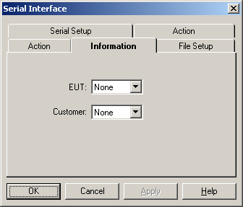

Serial Interface File Setup
The ‘Serial Interface File Setup’ tab sets the file and path information for the data to be stored in a text file. If the data is to be stored to file, select the “Save To File’ check box and enter the appropriate file name and path information in the text boxes. When this action is called from the Immunity action the Frequency, Amplitude and Date/Time stamp are stored in the text file specified.
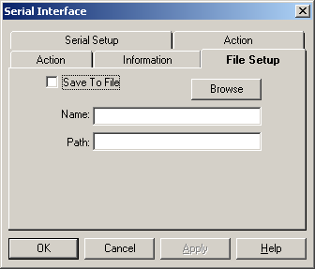

Serial Interface Serial Setup
The ‘Serial Interface Serial Setup’ tab identifies the instruments to be used when this action is called. Also you determine whether the Date/Time stamp is sent in addition to the Frequency and Amplitude.
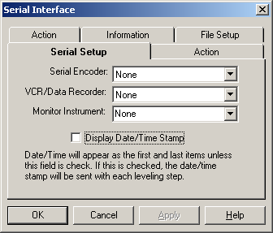

Serial Encoder
Select the appropriate instruments from the drop down list. A serial encoder is a special instrument that formats strings and writes them to the video display of a monitor/VCR.

VCR/Data Recorder
Select the appropriate instruments from the drop down list. Do not enter an instrument if you are writing to the VCR with an encoder. This listing is only if your VCR or Data Recorder accepts direct input.

Monitor Instrument
Select the appropriate instruments from the drop down list.

Display Date/Time Stamp
If this is checked, the Date/Time information will be included in the string written to the instruments. If not check, it will be ignored except for the start up and stop commands, which will include the Date/Time.

Serial Interface Action
The ‘Serial Interface Action’ tab controls the power state of the VCR. When executed, the Serial Action will turn on or off the VCR based upon the settings on this tab.
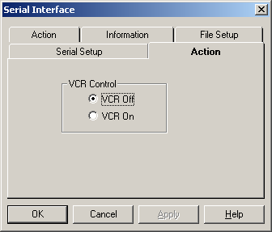

OK, Cancel, Apply and Help
A description of the OK, Cancel, Apply, and Help buttons is found in Common Action Commands on page 77.

Data and File Commands

Math


Math Action Tab
The action tab is a common name page. A complete description is found in Common Name Page on page 77.

Math Data Tab
The Data dialog box controls the data elements that will be executed in this step. It is divided into two columns: Available and Selected. ‘Available’ displays the defined data elements. ‘Selected’ displays the data elements defined as ‘Equations’ which need to be executed at this step in the profile. See Equation Elements on page 41 for further information on equations and creating equation data elements.
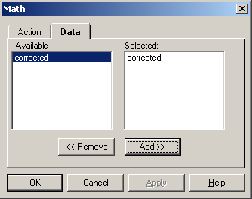
Equations are executed in the sequence ‘Selected’. If the result of one math equation is part of the equation in a second equation, make sure you execute them in sequence.

Add
The Add button will include data elements highlighted in the ‘Available’ list box in the ‘Selected’ list box. If no data elements are highlighted, this button has no effect. You may also add data elements to the ‘Selected’ column by double clicking on the data element in the available window.

Remove
The Remove button will delete highlighted data elements in the ‘Selected’ list box. If no data elements in the Selected list box are highlighted, this button has no effect. You may also delete data elements from the selected column by double clicking on the data element.

Math Dialog
The Math dialog box provides visual information to the user as well as the ability to halt execution of the test.
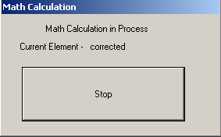

OK, Cancel, Apply and Help
A description of the OK, Cancel, Apply, and Help buttons is found in Common Action Commands on page 77.

Clear Data
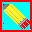
The Clear Data action provides a method of clearing data elements from within the flowchart. This action can be performed between different stages of a test or after a test has been completed. Clear data empties the existing data from a data element. It does not do anything to ‘Preset’ or ‘File’ type data elements since these have different definitions controlling their contents. For ‘Preset’ you need to redefine the data element to change its contents on the ‘Data’ Window. For ‘File’ you can either redefine the data element on the ‘Data’ Window or you can use the ‘Transfer Data’ Action (see page 209) to reload the information from disk.

Clear Data Action Tab
The action tab is a common name page. A complete description is found in Common Name Page on page 77.

Clear Data Tab
The Data page defines the data that will be cleared in this action. It is divided into two columns: ‘Available’ and ‘Selected’. ‘Available’ displays the defined data elements. ‘Selected’ displays those data elements that need to be reset or cleared during execution of this action.

Add
The Add button will include data elements highlighted from the ‘Available’ list box to the ‘Selected’ list box. If no data elements are highlighted, this button has no effect. You may also add data elements to the selected column by double clicking on the data element in the ‘Available’ window.
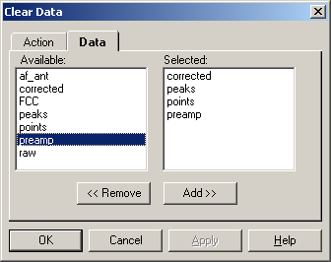

Remove
The Remove button will delete highlighted data elements in the ‘Selected’ list box. If no data elements in the ‘Selected’ list box are highlighted, this button has no effect. You may also delete data elements from the ‘Selected’ column by double clicking on the data element.

OK, Cancel, Apply and Help
A description of the OK, Cancel, Apply, and Help buttons is found in Common Action Commands on page 77.

Transfer Data

The Transfer Data action is used to transfer the contents of a data element to or from a disk file.

Transfer Data Action Tab
The action tab is a common name page. A complete description is found in Common Name Page on page 77.

Transfer Data to File Tab
The Transfer data to File page describes the file from which or to which data will be transferred to when the ‘Data Element’ radio button is selected. When the ‘Table/Graph’ radio button is selected, output to a file is the only option available.
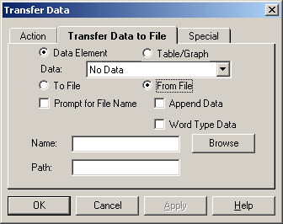

Data
When the ‘Data Element’ is chosen, the Data box is used to select the data element that will be used in this action. Click on the drop down box and select a defined data element.
When ‘Table/Graph’ is chosen, this drop list will list the available tables or graphs. Click on the drop down box and select a defined data element.

To/From File
The ‘To File’ and ‘From File’ radio buttons indicates whether the Transfer Data action will save to file or read from file. If read ‘From File’ the data element defined in the data window will be filled with the input information. This is the exact same procedure as defining a data element as a ‘file’ type and initializing the information, except the data element is already defined and used in the test profile. This procedure is extremely handy in moving information between different test profiles by design.
For example every morning you run a special cable calibration to insure that your cables are hooked up properly and in good condition. The cable calibration information from this test profile is saved to a daily cable file which is then read into every test profile executed to load the cable correction factors.
When, ‘Table/Graph’ is selected, the boxes are not visible.

Prompt for Name
When selected, this will cause a small dialog box to open (during execution) which allows the user to ‘Browse’ and select the file of interest. If you enter a file and path on this tab, they are the defaults when the ‘Prompt for Name’ dialog opens.

Append Data
This determines whether the disk file, if it exists, is overwritten or if information is appended to the existing file. This is especially relevant with tables. When tables are written to disk, it is possible to append multiple tables, representing different executions, into one, single text file.

Word Type
Check this box if the data element being read ‘From Disk’ is expected to control alphanumeric data. If not checked, only numeric values will be loaded. The output data element will be a ‘Word from File’ if this is checked and will be a ‘File’ if not checked.

Name
The Name text box is used to specify the file for this action. The text box will be filled automatically if the operator uses the Windows Browse function to find a file. You must add an appropriate file type (*.dat, *.txt, *.csv. for data elements, *.wmf for bitmaps.) if you want this file to readable by other programs.

Path
The Path text box displays the directory to be used for this file operation. If no path is entered, then the file will be written or read from the root directory. The path should be in standard Windows format - i.e., C:\Tile\.

Browse
The Browse button displays a standard Windows file dialog box that can be used to search directories and disks to locate a desired file. If the OK button is selected the Name and Path text boxes are automatically filled. The Windows Save As dialog box is displayed if the ‘To File’ radio button is selected. The Windows Open dialog box is displayed if the ‘From File’ radio button is selected.

OK, Cancel, Apply and Help
A description of the OK, Cancel, Apply, and Help buttons is found in Common Action Commands on page 77.

Print

The Print action allows the user to print any window in a profile. This is normally used to print graphs and tables, but you can also print the Instrument, Data, Flowchart, Log and Audit Trail Windows. Placing this icon in a flowchart will result in the printing of the selected items at a specific point in the test flow.
You MUST have a default printer defined within Windows or execution of this step will cause a catastrophic failure.

Print Action Tab
The action tab is a common name page. A complete description is found in Common Name Page on page 77.

Print Display Tab
The Display page defines the graphs, tables or other windows that will be printed in this action. It is divided into two columns: ‘Available’ and ‘Selected’. ‘Available’ displays the known graphs, tables and windows. ‘Selected’ displays those items selected for printing in this action.
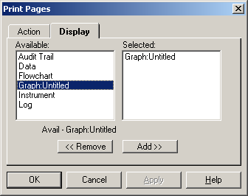

Add
The Add button will include items highlighted in the ‘Available’ list box to the ‘Selected’ list box. If no items are highlighted, this button has no effect. You may also add items to the selected column by double clicking on the names in the ‘Available’ window.

Remove
The Remove button will delete highlighted items in the ‘Selected’ list box. If nothing in the ‘Selected’ list box is highlighted, this button has no effect. You may also delete items from the ‘Selected’ column by double clicking on the name in this column.

OK, Cancel, Apply and Help
A description of the OK, Cancel, Apply, and Help buttons is found in Common Action Commands on page 77.

Launch Application

The Launch Application action allows the user to start another Windows application from within the TILE! test profile. This program will run in an independent window. Certain spreadsheet functions or using a word processor for note taking can be accomplished using this action. You can also, in some cases, launch an application and automatically start a macro running. The macro could then transfer information from the TILE! program into the other application.

Launch Application Action Tab
The action tab is a common name page. A complete description is found in Common Name Page on page 77.

Launch Application Commands Tab
The ‘Commands’ page has three elements. Only the first is mandatory. These elements are ‘Executable’, ‘Parameters’ and ‘Working Directory’. The format for these is the same as the standard Windows OLE launch commands.
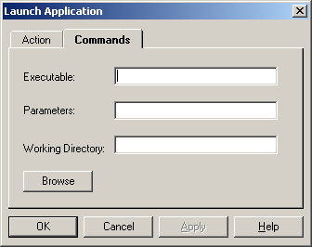

Executable
Enter the program executable, including the appropriate path name. This needs to include proper disk references such as
“c:\msoffice\excel\excel.exe”.
This indicates drive “c:”, directory “\msoffice\excel” and an executable of “excel.exe”. You can select the file by using the ‘Browse’ button that will launch a standard windows file selection window.

Parameters
Certain Windows programs allow starting parameters to be added to the executable line. These parameters can start specific files, set starting switches or override default switches. The user should read the appropriate manual for any program to be launched for the command line command structure.

Working Directory
Enter the working directory for the default setting. If this is left blank, the TILE! default directory will be used.

OK, Cancel, Apply and Help
A description of the OK, Cancel, Apply, and Help buttons is found in Common Action Commands on page 77.

Auto Save
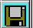
The ‘Auto Save’ action is used to automatically saves the current test profile. The options given are extremely useful for historical recording purposes. This option gives the operator the ability to store the entire test profile which can then be examined at a later date.

Auto Save Action tab
The action tab is a common name page. A complete description is found in Common Name Page on page 77.

Auto Save Save As Tab
The Save As page gives the user the options on how the data is to be saved.
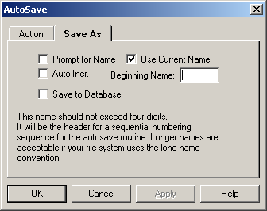

Prompt for Name
When selected will prompt the operator for the file name desired.

Use Current Name
When selected, will automatically save the profile under the current name.

Auto Incr.
‘Auto Incr’, along with ‘Beginning Name’, select and specify the file naming convention/sequence that will be invoked.

Save to Database
If you have the TILE/DB product, then choosing this option will cause the TILE! program to do a save to the database when this step is executed.

OK, Cancel, Apply and Help
A description of the OK, Cancel, Apply, and Help buttons is found in Common Action Commands on page 77.

Direct Entry
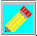
The ‘Direct Entry’ action gives the operator the ability to declare preset values for a data element.

Direct Entry Action tab
The action tab is a common name page. A complete description is found in Common Name Page on page 77.

Direct Entry Data Element Tab
The ‘Direct Entry Data Element’ defines which data element will be used to store the results of this action.
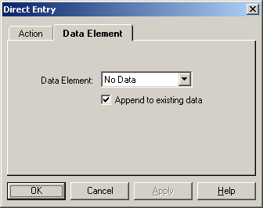

Data Element
Select a data element here using the drop down box. You can also specify a name during execution of this action. Use this choice if you want to predefine a data element and use it through your flowchart, updating it with this action at the start of a test.

Append to Existing Data
If this option is checked, the data you enter will be added to the existing data element contents.

Direct Entry Dialog
The Direct Entry Dialog box is the entry point for the frequency and amplitude data.
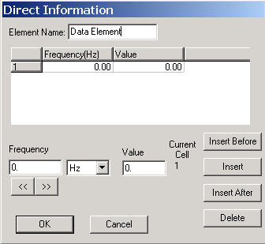

Element Name
The ‘Element Name’ is the data element that will hold the preset information. The ‘Frequency’ and ‘Value’ text boxes are the entry points for the respected data.

Insert Before
Will insert the Frequency/Value combination in the list before the current cell.

Insert
Will insert the Frequency/Value combination in the list at the current cell.

Insert After
Will insert the Frequency/Value combination in the list after the current cell.

Delete
Will delete the current row from the table.

<< >>
Use these buttons to navigate up or down the frequency list.

OK, Cancel, Apply and Help
A description of the OK, Cancel, Apply, and Help buttons is found in Common Action Commands on page 77.

GTEM/OATS 3 Position Correlation

The GTEM Data icon performs a correlation between data generated in the GTEM and the theoretical model for an Open Area Test Site (OATS). The action takes the constants which describe the GTEM cell physical dimensions, the physical dimensions which describe the OATS, and the three readings taken in the GTEM and performs the mathematical transformation which converts three input data sets into the equivalent open field measurement values. The three inputs are measurements made in the GTEM with the equipment under test being rotated so that each data set is made from a unique orthogonal orientation.

GTEM/OATS 3 Position Correlation Action Tab
The action tab is a common name page. A complete description is found in Common Name Page on page 77.

GTEM/OATS 3 Position Correlation Correlation Tab
The GTEM page describes the physical dimensions of the GTEM cell that was used for the input data measurements. As a short explanation of the GTEM physical references, the GTEM is a pyramidal shape in which the x, y and z axis will describe the center point of an EUT in the GTEM. To illustrate this point, consider the following views of the GTEM.
The x-axis in the GTEM (seen in the End View) is parallel to the width of the septum. Since all our measurements are referenced the center septum, we consider the -x and + x to the offsets from the centerline of the septum.
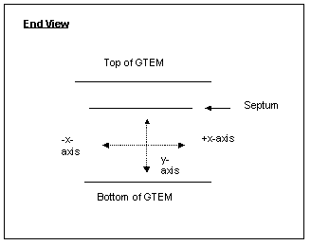
The y-axis is the height of the septum from the floor to the septum. This dimension is a positive number.
The z-axis (seen in the Side View) describes the length of the GTEM. Because of the 90° relationship between the y-axis and z-axis, the length of the z-axis can always be determined by knowing the height of the y-axis.
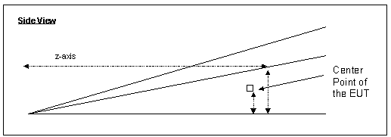

X:
In the text box labeled “X:” enter the offset from the centerline of your EUT. In an optimum setup the EUT would be positioned in the center of the septum width. This is position 0. If your EUT requires a slight offset to either side, enter the offset. As the End View shows above, an offset to the left of the centerline is a negative value. An offset to the right is a positive value. Click on the drop down arrow for the units field, or use the Tab key to move to this field, and select the units. You can enter the first character of the units to quickly select one (m-meters, i-inches, f- feet).
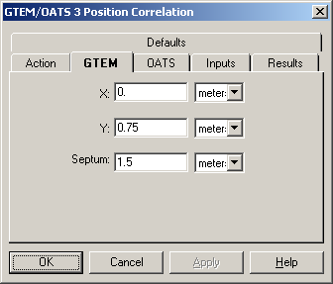

Y:
The y-axis describes the physical height from the floor of the GTEM to the center of the EUT. Enter the appropriate value in the text box. Click on the units drop down arrow, or use the Tab key, and select the units. These can be entered by highlighting them with the mouse (in the drop down box), or by typing the first letter of the unit (m-meters, i-inches or f-feet). If you are not sure, enter a value that represents ½ the height of the septum for the position of the EUT. You can enter the first character of the units to quickly select one (m-meters, i-inches, f- feet).

Septum (Z:)
Since the geometry of the GTEM is precise (see the Side View), it is possible to define both the septum and z-axis lengths by mathematical reference to the y-axis. In this field enter the height from the floor to the septum at the position where the EUT is to be placed. You can enter the first character of the units to quickly select one (m-meters, i-inches, f- feet).

GTEM/OATS 3 Position Correlation OATS Tab
The correlation routine converts GTEM based information to the theoretical field strength that would exist over a ground screen. In calculating this value, the physical dimensions of the OATS are required. This page allows you to specify which OATS configuration is appropriate for the correlation. The scan range and separation are the pertinent elements. The standards specify these numbers. Typical pairs are 1-4 meter scan height with a 3 meter separation, 1-4 meter scan height with a 10 meter separation and 2-6 meter scan height with a 30 meter separation.

Height Min
Enter the minimum antenna height for the scan range on the OATS. This information is specified by the emissions standards. In the text box enter the appropriate number. Click on the drop down arrow for the units field, or use the Tab key to move to the units field. Select the appropriate units with the mouse, or type the first character of the units (m-meters, i-inches and f-feet).
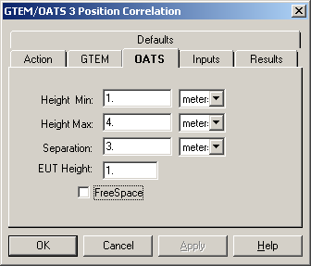

Height Max
Enter the maximum antenna height for the scan range on the OATS. This information is specified by the emissions standards. In the text box enter the appropriate number. Click on the drop down arrow for the units field, or use the Tab key to move to the units field. Select the appropriate units with the mouse, or type the first character of the units (m-meters, i-inches and f-feet).

Separation
Enter the separation distance for the OATS. This information is specified by the emissions standards. In the text box enter the appropriate number. Click on the drop down arrow for the units field, or use the Tab key to move to the units field. Select the appropriate units with the mouse, or type the first character of the units (m-meters, i-inches and f-feet).

EUT Height
Enter the height of the EUT. This information is specified by the emissions standards. In the text box enter the appropriate number.

Free Space
When checked this causes the correlation routine to skip the OATS correction and to only combine the three vectors into a ‘Free Space’ equivalent value.

GTEM/OATS 3 Position Correlation Inputs Tab
The input fields identify the three measurement data elements for the GTEM orthogonal readings. These must be matched, i.e. the EUT was in an identical setup with a 120° orthogonal rotation.
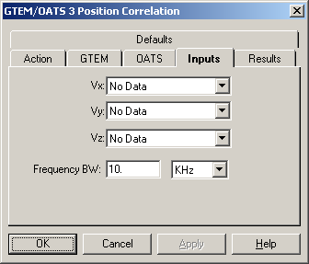
The three readings need to have identical scan ranges, bandwidths, reference levels and sweep times to insure accuracy.
As with any mathematical calculation, if you put garbage in, you get garbage out. It is essential to insure the accuracy of the three readings.

Vx
Drop down and selected the appropriate data element. This element will be the same as was used during the X-orientation measurement on the flowchart.

Vy
Drop down and selected the appropriate data element. This element will be the same as was used during the Y-orientation measurement on the flowchart.

Vz
Drop down and selected the appropriate data element. This element will be the same as was used during the Z-orientation measurement on the flowchart.

Frequency BW
There is a slight possibility, especially when comparing Peak/QP/Avg readings, that the frequencies in the three data elements are not identical. The ‘Frequency BW’ defines how much mismatch there can be before an error will be reported.

GTEM/OATS 3 Position Correlation Results Tab
The correlation analysis yields three data elements. You have the option of recording each element. The basic correlation yields the ‘Maximum’. This value is the straight correlated value between the OATS and the GTEM.
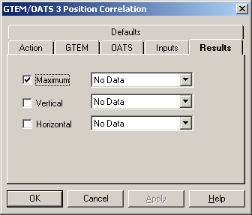
But certain standards require the maximum signal in the horizontal and in the vertical antenna orientation. These values are derived in the mathematics of the correlation algorithm prior to calculating the maximum.

Maximum
Click on the ‘Maximum’ box if the maximum value of the correlation results is desired. Click on the drop down box and select an appropriate data element to store these values. This is the default position and there are few reasons not to use this data.

Vertical
If you would like to keep the maximum signal in the vertical orientation, click on the Vertical box. Click on the drop down box and select an appropriate data element.

Horizontal
If you would like to keep the maximum signal in the horizontal orientation, click on each box for which results are required. Click on the drop down box for each element and select an appropriate data element.

GTEM/OATS 3 Position Correlation Dialog
During execution of the GTEM Correlation, the dialog box provides the user a visual clue as to the current status of the execution as well as a ‘Stop’ button to cancel execution of this action.
The two display boxes are the current step and total number of steps. The current step updates as each calculation is performed and will change very quickly during the execution.
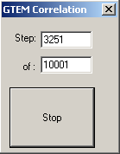

OK, Cancel, Apply and Help
A description of the OK, Cancel, Apply, and Help buttons is found in Common Action Commands on page 77.

GTEM/OATS 9-Position Correlation

The GTEM/OATS 9-Position Correlation Action performs a specialized correlation to determine the magnetic field characteristics for signals measured with a GTEM. This will yield the equivalent field strength as would appear on an Open Area Test Site (OATS). This action requires 9 different readings taken with the GTEM. Using these readings in conjunction with the physical dimensions of the GTEM and the OATS, this action performs a mathematical transformation that converts the 9 input data readings into the equivalent open field measurement values.

GTEM/OATS 9-Position Action Tab
The action tab is a common name page. A complete description is found in Common Name Page on page 77.

GTEM/OATS 9-Position GTEM Tab
The GTEM page describes the physical dimensions of the GTEM cell that was used for the input data measurements. As a short explanation of the GTEM physical references, the GTEM is a pyramidal shape in which the x, y and z axis will describe the center point of an EUT in the GTEM. To illustrate consider the following views of the GTEM.
The x-axis in the GTEM (seen in the End View) is parallel to the width of the septum. Since all our measurements are referenced to the center septum, we consider the -x and +x to the offsets from the centerline of the septum.
The y-axis is the height of the septum from the floor to the septum. This dimension is a positive number.
The z-axis (seen in the Side View) describes the length of the GTEM. Because of the 90° relationship between the y-axis and z-axis, the length of the z-axis can always be determined by knowing the height of the y-axis.

X:
In the text box labeled “X:” enter the offset from the centerline of your EUT. In an optimum setup the EUT would be positioned in the center of the septum width. This is position 0. If your EUT requires a slight offset to either side, enter the offset. As the End View shows above, an offset to the left of the centerline is a negative value. An offset to the right is a positive value. Click on the drop down arrow for the units field, or use the Tab key to move to this field, and select the units. You can enter the first character of the units to quickly select one (m-meters, i-inches, f- feet).
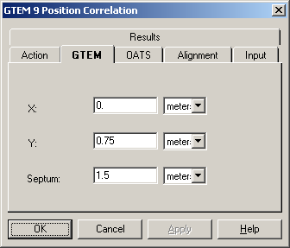

Y:
The y-axis describes the physical height from the floor of the GTEM to the center of the EUT. Enter the appropriate value in the text box. Click on the units drop down arrow, or use the Tab key, and select the units. These can be entered by highlighting them with the mouse (in the drop down box), or typing the first letter of the unit (m-meters, i-inches or f-feet). If you are not sure, enter a value that represents ½ for the height of the septum at the position of the EUT.

Septum (Z:)
Since the geometry of the GTEM is precise (see the Side View), it is possible to define the both the septum and z-axis lengths by mathematical reference to the y-axis. In this field enter the height from the floor to the septum to the position where the EUT is to be placed. . Click on the drop down arrow for the units field, or use the Tab key to move to this field, and select the units. You can enter the first character of the units to quickly select one (m-meters, i-inches, f- feet).

GTEM/OATS 9-Position OATS Tab
The correlation routine converts GTEM based information to the theoretical field strength that would exist over a ground screen. In calculating this value, the physical dimensions of the OATS are required. This page allows you to specify which OATS configuration is appropriate for the correlation. The scan range and separation are the pertinent elements. The standards specify these numbers. Typical pairs are 1-4 meter scan height with a 3 meter separation, 1-4 meter scan height with a 10 meter separation and 2-6 meter scan height with a 30 meter separation.

Height Min
Enter the minimum antenna height for the scan range on the OATS. This information is specified by the emissions standards. In the text box enter the appropriate number. Click on the drop down arrow for the units field, or use the Tab key to move to the units field. Select the appropriate units with the mouse, or type the first character of the units (m-meters, i-inches and f-feet).
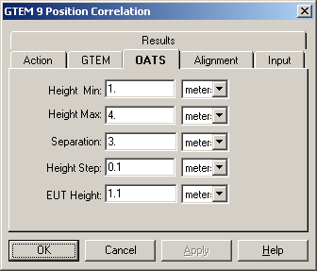

Height Max
Enter the maximum antenna height for the scan range on the OATS. This information is specified by the emissions standards. In the text box enter the appropriate number. Click on the drop down arrow for the units field, or use the Tab key to move to the units field. Select the appropriate units with the mouse, or type the first character of the units (m-meters, i-inches and f-feet).

Separation
Enter the separation distance for the OATS. This information is specified by the emissions standards. In the text box enter the appropriate number. Click on the drop down arrow for the units field, or use the Tab key to move to the units field. Select the appropriate units with the mouse, or type the first character of the units (m-meters, i-inches and f-feet).

Height Step
When performing a height scan on an OATS, the number of steps in height can directly effect the accuracy of your test results. This field is included to allow a closer comparison between the GTEM based data and the OATS readings. Enter the step size for the height scan and the mathematical model will calculate the expected maximums based upon these stated steps. In the text box enter the appropriate number. Click on the drop down arrow for the units field, or use the Tab key to move to the units field. Select the appropriate units with the mouse, or type the first character of the units (m-meters, i-inches and f-feet).

EUT Height
The EUT height is a factor in the calculations. Typical settings are between .8 meters and 2 meters for depending upon the type of EUT and the actual measurement height for the EUT when placed on an OATS. In the text box enter the appropriate number. Click on the drop down arrow for the units field, or use the Tab key to move to the units field. Select the appropriate units with the mouse, or type the first character of the units (m-meters, i-inches and f-feet).

GTEM/OATS 9-Position Alignment Tab
When orienting an EUT in the GTEM it is sometimes difficult to use the exact same geometry as was used on the OATS. The alignment page allows you to specify which physical orientation was used on the OATS. Within the GTEM, when positioning the EUT for proper rotation, it may be necessary to place the EUT in a starting position that is different than the position used when the EUT was tested (or would be tested) on the OATS. The Alignment page allows you to specify the proper ‘home’ position for the EUT. The Z axis is the axis along the length of the septum. The Y axis is the Septum to floor and the X axis is the width of the cell. The EUT +Z face is oriented toward the input of the GTEM. Viewed from the input, the +X face is on the left hand side of the EUT and the +Y face is across the top. The +Y Horizontal, +Z Vertical (i.e., facing the input of the GTEM) is the most common starting position for an EUT in the GTEM. This would duplicate the physical orientation of the EUT facing the antenna on the OATS.
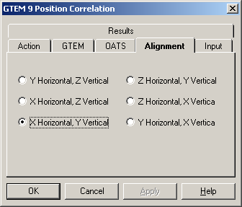

GTEM/OATS 9-Position Input Tab
Performing a 9 position correlation requires that 9 separate readings be taken of the EUT. These are defined as:
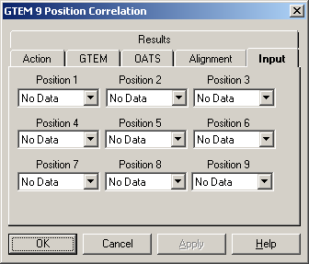
Position 1 - Starting position (SP) referred to as the +X face of the EUT.
Position 2 - SP +45 degrees in the X axis (a counterclockwise movement of the EUT).
Position 3 - SP -45 degrees in the X axis (a clockwise movement of the EUT)
Position 4 - First normal rotation. This is referred to as the +Y face of the EUT. From the SP a 120 degree orthogonal rotation. This is accomplished by rotating the EUT 90 degrees toward the operator and then 90 degrees in a clockwise rotation.
Position 5 - +Y position +45 degrees in the X axis (counterclockwise movement of the EUT).
Position 6 - +Y position -45 degrees in the X axis (a clockwise movement of the EUT).
Position 7 - Second normal rotation. This is referred to as the +Z face of the EUT. From the +Y face position a 120 degree orthogonal rotation. This is accomplished by rotating the EUT 90 degrees toward the operator and then 90 degrees in a clockwise rotation.
Position 8 - +Z position +45 degrees in the X axis (counterclockwise movement of the EUT).
Position 9 - + Z position -45 degrees in the X axis (counterclockwise movement of the EUT).
It is important to not confuse the various uses of X, Y and Z terminology in this section. Using a rotation cube as a reference is very helpful. This can be accomplished by taking a cube and placing +X, +Y, +Z, -X, -Y, and -Z labels on the six faces. The + faces should always maintain the same relative plane as the EUT rotates (i.e., the + faces always occupy the same three faces of the cube during each rotation).
Positions 1, 4 and 7 are the same as those used in the GTEM 3 position correlation analysis.

GTEM/OATS 9-Position Results Tab
The correlation analysis yields two sets of three data elements. You have the option of recording all elements or any choice of each element. The correlation yields a separate set of three values for both the electric field component and the magnetic field component. The basic correlation for each yields the ‘Maximum’. This value is the straight correlated value between the OATS and the GTEM.
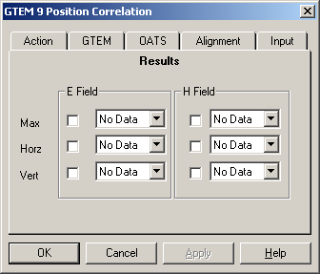
Certain standards require the maximum signal in the horizontal and in the vertical antenna orientation are separate readings. These values are derived in the mathematics of the correlation algorithm prior to calculating the maximum.
Click on each box for which results are required. Click on the drop down box for each element and select an appropriate data element. These data elements need to be defined as ‘measurement’ elements in the data definitions. See Measurement Elements on page 39 for more information.

GTEM/OATS 9-Position Dialog
During execution of the GTEM Correlation, the dialog box provides the user a visual indication as to the current status of the execution as well as a ‘Stop’ button to cancel execution of this action.
The two display boxes are the current step and total number of steps. The current step updates as each calculation is performed and will change very quickly during the execution.
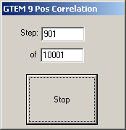

OK, Cancel, Apply and Help
A description of the OK, Cancel, Apply, and Help buttons is found in Common Action Commands on page 77.

TILE! Graphs and Tables
In the TILE! system, graphs and tables are temporary views of the Data. You can have as many graphs or tables defined as you need, each having a unique set of information. The same data element can appear on each graph and table. Each graph and table is literally a separate view of the data. The graphs and tables update constantly. This is both a good and bad. If you define a table with a data element that is being written with 10000 frequency points (each frequency point is a row), the system will practically stop running because of the amount of time spent refreshing the graph.
Graphs and Tables are the primary output of the TILE! program. One of the assumptions in designing TILE! was that we should concentrate on what we do best - instrumentation control. For this reason, the graphs and tables are considered good, solid presentation devices. For very sophisticated reporting, we have designed TILE! to interface easily with Word Processors, Spreadsheets or other Graphing programs.

Graphs
EMC testing can generate thousands of data points. Graphical views of this data can often provide all the information needed to understand a test's results. A graph allows you to superimpose test results, specification limits and other relevant information on one convenient screen. You can use different specification limits on the same graph as well as putting both raw and corrected data on the same graph.
Graphs within the TILE! are static in design. Once designed, though, they update constantly as the data is created or updated.

Creating a Graph
A graph is created from the Window drop down menu of the Menu Bar. Click or select the 'Add' feature to view three choices – Graphs Tables, and Page. You can create as many different graphs or tables as you want. Each new graph is started as a blank graph with no selected data elements. ‘Page’ is not available at this time.
When the new graph is formed, the Windows Menu Bar changes to reveal 'Display'. The 'Display' selection gives you access to the configurations for the graph. There are four choices - Data, Options, Zoom and Copy Graph. Each of these controls a slightly different part of the graph. You can access the ‘Options’ by double-clicking anywhere on the graph.
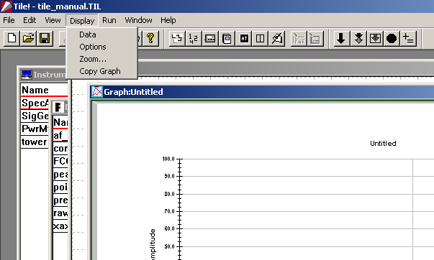
The blank graph defaults to a frequency range of 30MHz - 1GHz, with Log scaling, which equates to 10MHz – 1GHz. The amplitude is set at 0-100. The graph is left untitled.
You can work with the graph in a window or in a full screen. To move to the full screen, click on the maximize box for Windows 95/NT.
When the graph is moved to the clipboard, it is a full screen bitmap that can be scaled to size based upon the capabilities of your receiving program. It is placed on the clipboard in a Windows Metafile Format (wmf) which is one of the most common formats for bitmaps.

Mouse Position
There are two boxes on the lower left corner of the graph. Both boxes display the position of the nearest data point to the mouse cursor. The first box displays the frequency. The second box displays the value.

Data Options
There are two options when selecting data elements: which elements to use and how to display them. Once you have selected a data element, a new tab appears behind the definition page. For every data element selected a tab labeled 'Line' will be generated. The sequence of the tabs is the same sequence as the list on the selection page. The setup of these tabs is identical for both graphs and tables. Certain features have no effect for graphs.

Selecting Data
When ‘Display-Data’ is selected from the Windows Menu Bar, the selection dialog is opened. This is a two-column page with the available, defined data elements in the first column and those selected for this graph in the second column.
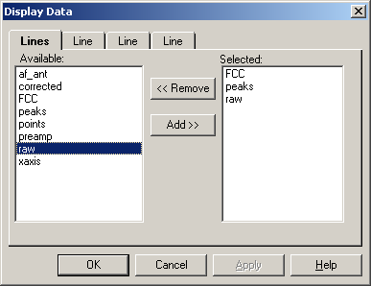

Add
To select a data element you can double click on the available element, automatically adding it to the 'Selected' side. You also can use the Up/Down Arrow keys to highlight the data element and use the Tab key to move to the 'Add' button. Press 'Add' to register the selection.

Remove
To remove a ‘Selected’ data element, double click o the element in the 'Selected' column. This will remove it from the list. You also can use the Up/Down Arrow keys to highlight the data element and use the Tab key to move to the 'Remove' button. Press 'Remove' to register the selection.

Controlling Display Conditions
Once a data element has been 'Selected', a ‘Line’ tab appears which determines the display parameters for this data element on the graph. Line type, color and shape are individually defined for each data element.
If a data element was defined as an interpreted element, i.e. continuous at every point (the default), then the first block labeled 'Line' applies. If the data element was defined as discrete, then the box labeled 'Marker' applies.

Line
Style, Color and Width are the choices for a line. These are only appropriate for data elements that are defined as ‘Continuous’ (either Log or Linear). See page 45 for a discussion of creating data elements. The default settings create a neutral line setting. To highlight the line, choose a different color or shape. This is particularly helpful when displaying the specification limits on the same chart as your readings. By using a dashed line for the specification limit, or a different color, you quickly and visually distinguish this line from the readings.
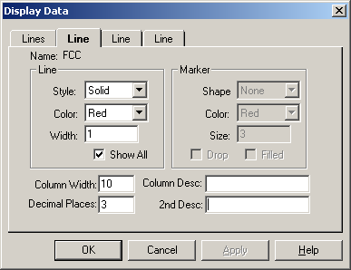

Style
There are five different line styles that can be chosen. The default setting is ‘Solid’. Click on the down arrow to change the selection.

Color
There are 20 different colors that can be selected. The default setting is ‘Red’. Click on the down arrow to change the selection.

Width
The default width is 1. Make this number larger to ‘thicken’ the line. This setting does not work with all line styles.

Show All
When used on a table, the ‘Show All’ check box controls whether all contents of the data element are displayed or only those with matching frequencies to the remaining columns. If you have a specification limit on a table with 10 QP readings the normal setting, with ‘Show All’ checked, would also show the frequencies in the specification limit file. This means the number of lines on the table would be greater then 10. If this is off, only the 10 points of interest would be listed but this data column would show the appropriate matching value for this frequency.

Marker
Shape, Color and Size are the choices for a marker. These are only appropriate for data elements that are defined as ‘Non-Continuous’. See page 45 for a discussion of creating data elements. The default settings is ‘None’. THIS WILL NOT BE VISIBLE ON A GRAPH. To highlight the marker, choose a different color or shape. This is particularly helpful when displaying the points in excess of the specification limits on the same chart as your readings. By using a triangular point for the points over specification limit, or a different color, you quickly and visually distinguish those points from the readings.
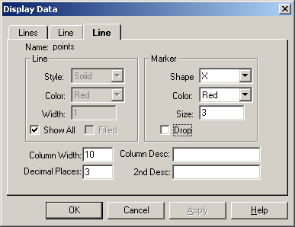

Shape
There are nine different shapes (10 if you count ‘None’) that can be assigned to a ‘non-continuous’ data element. The default shape is ‘None’. It is important to set a shape of nothing will appear on the graph. Click on the down arrow to select or change a shape.

Color
There are 20 possible colors. The default is ‘Red’. Click on the down arrow to select or change a color choice.

Size
This parameter controls the thickness of the marker. The default value of 3 is useable in most cases.

Drop
'Drop' refers to whether the area under marker is filled in (each element drops to the x-axis). This is very helpful in highlighting the specific points of interest. Drop is only appropriate for graphs.

Column Width
When defining a table data element, this field controls the width of the column. The default value is 10.

Decimal Places
When defining a table data element, this field controls the number of decimal places that are visible. This field affects the way tables are copied and pasted. If you export values using the table function, they will be truncated to the value shown in this field.

Column Description
When defining a table or a graph, this field allows this user to control the visible name for this data element. The default is the data element name.

2nd Description
On a table there are two rows of description for each data element. This field controls the second field. You might use this to display units, ‘dBuV/m’, for the reading as a clarifying label.

Display Options
The display option allows you to configure the name, descriptive titling, graph size, axis scaling, and axial labeling. The display option includes the title name for the graph. A unique name is essential when you need to automatically printing or accessing the graph from different applications.
With the graph in the front focus, click 'Display' Options' to access the graph setup dialog box. You can also double-click on the graph to open the ‘Display Options’. The dialog box has thirteen tabs. These control labels, titles, scaling, fonts, legends, default page formats as well as some special features such as additional information, EUT, comment and bitmaps.

Titles Tab
The first text box – ‘Title’ - is for the graph name. As with all TILE! actions and tables, the graphs should have a unique name. Since you can create multiple graphs, unique names help to keep track of the different graphs.
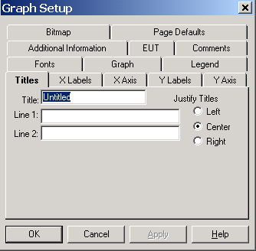
The next two text boxes - Line 1 and Line 2 - are 128 character text boxes that are displayed above the title on the graph. These are used for header type descriptions of the graph, such company name and test descriptions.
If you use the ‘Display/Copy Graph’ function the name will be changed to ‘originalname1’ (where the number will be incremented as additional graphs are created). Make sure you change the name of the graph after copying.

Justify Titles
You can specify left, center or right justification of the titles. All three titles (Line 1, Line 2 and Title) are justified together.

X Labels Tab
The x-axis labels include the title, range (with options), format of the scale, and the position of the label relative to the x-axis.

Title
The x-axis label should be limited to 50 characters. In theory you can put any number of characters, but the scaling of the x axis makes more than 50 difficult to display. The default setting is 'Frequency'. If you wanted to change the title to indicate units, change this field to ‘Frequency (MHz)’, for example.

Frequency Range
The frequency range has different effects depending upon the format setting 'Log'. If the 'Log' function is on, which is the default, the labels will be adjusted to the nearest log scale. In the default setting, the range is 30MHz to 1GHz with log scaling, which equates to a graph display of 10MHz to 1GHz. The frequency range can be overridden by using the ‘Zoom Option’. If ‘Log’ is off, then the actual frequency range shown will be in effect for the graph.
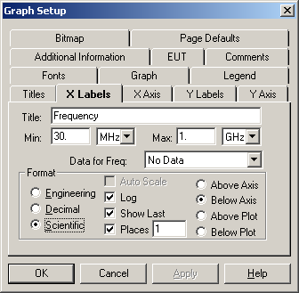

Data for Freq
If a data element is selected, the graph will adjust itself to the starting and ending frequency range of the data element. This is very handy if you are configuring a test where the start and stop frequency will change with each scan.

Format
These are general settings for the scaling of the graph.

Engineering/Decimal/Scientific
There are three different numerical formats, as well as log/linear scaling and position information in this tab.
‘Engineering’, ‘Decimal’ and ‘Scientific’ refer to how the number is displayed. The default is 'Scientific' which displays in KHz, MHz and GHz. One megahertz would display as 1 MHz. Decimal will is raw format in which 1 MHz would display as 1000000. Scientific would display 1 MHz as 1e6.

Log
‘Log’ determines the scaling factor for the x-axis. When in Log mode, the lower range setting will be set to the nearest factor of 10 which encompasses it, i.e. 30 MHz would be 10 MHz, 200 MHz would be 1 GHz. If turned off, then the scaling will be linear starting and stopping at the specified frequencies.

Show Last
‘Show Last’ indicates whether the last data point will be displayed on the chart, regardless of scaling when in a zoom mode.

Places
‘Places’ refers to the number of relevant decimal places to be displayed on the x-axis scale: 1 place - 32.1, 2 places 32.11.

Axis/Plot
‘Above Axis’, ‘Below Axis’, ‘Above Plot’ and ‘Below Plot’ refer to the position of the x-axis label and ticks with regard to the graph and overall plotting area.

X-Axis Tab
The X-Axis tab controls the ticks and grid line colors for the x-axis. These can be configured to suit the zoom range of the x-axis.

Axis Ticks
The ticks are the small marks scratched on the axis lines to designate spacing.
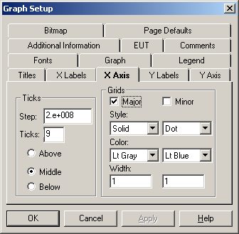

Step
The step scaling determines the position of labels for the x-axis. This is only active when the log mode is turned off. When creating a tick scaling on the x-axis, the range needs to match the desired frequency range. If the ‘log’ scaling is turned off, the default grid ticking will write a tick mark at every 200 MHz step. If your scaling is 'zoomed' to 20 MHz to 200 MHz, changing the tick marking to 2e7 to make them 20 MHz steps.

Ticks
The ‘Ticks’ text box sets the number of tick marks placed across the lower scale between each marker. If you are in the 30 MHz – 1 GHz range, with 200 MHz Steps, a tick spacing of 9 would cause there to be 9 small tick marks on the axis between 30 MHz and 230 MHz, between 230 MHz and 430 MHz, etc.

Grids
The ‘Grids’ settings control the shape, color and size of the x-axis grid lines. Major grids are those at each label position. Minor grids are at each tick mark location.

Major/Minor
Check each of these boxes to turn on or off the appearance of grid lines. If turned off, no grid lines appear for the grid.

Style
You can set the Style to either Solid, Dot, Dashed, alternating Dash-Dot and alternating Dash-Dot-Dot.

Color
The Colors available are the standard Windows 16 colors.

Width
The Width setting configures the size of the line. This will make the grids thicker or thinner, the minimum (and default) is 1.We suggest the user experiment with these settings to better understand how they work.

Y Labels Tab
The y-axis labels include the title, range, format of the scale, and the position of the label relative to the y-axis.

Title
The y-axis label should be limited to 30 characters. In theory you can put any number of characters, but the scaling of the y axis makes more than 30 difficult to display. The default setting is Amplitude. If you wanted to change the title to indicate units, for example, change this field to ‘Amplitude(dBm)’.

Amplitude Range
The amplitude range has different effects depending upon the format setting 'Log'. If the 'Log' function is on, the labels will be adjusted to the nearest log scale. In the default setting, the range is 0 to 100. In log scaling this will be .1 to 100. The amplitude range can be overridden by using the ‘Zoom Option’.
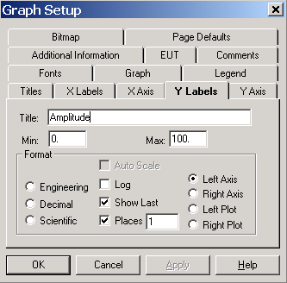

Auto Scale
This is disabled.

Format
These are general settings for the scaling of the graph.

Engineering/Decimal/Scientific
There are three different numerical formats, as well as log/linear scaling and position information in this tab.
‘Engineering’, ‘Decimal’ and ‘Scientific’ refer to how the number is displayed. The default is 'Scientific' which displays in KHz, MHz and GHz. One megahertz would display as 1 MHz. Decimal will is raw format in which 1 MHz would display as 1000000. Scientific would display 1 MHz as 1e6.

Log
‘Log’ determines the scaling factor for the x-axis. When in Log mode, the lower range setting will be set to the nearest factor of 10 which encompasses it, i.e. 30 MHz would be 10 MHz, 200 MHz would be 1 GHz. If turned off, then the scaling will be linear starting and stopping at the specified frequencies.

Show Last
‘Show Last’ indicates whether the last data point will be displayed on the chart, regardless of scaling when in a zoom mode.

Places
‘Places’ refers to the number of relevant decimal places to be displayed on the x-axis scale: 1 place - 32.1, 2 places 32.11.

Axis/Plot
‘Above Axis’, ‘Below Axis’, ‘Above Plot’ and ‘Below Plot’ refer to the position of the x-axis label and ticks with regard to the graph and overall plotting area.

Y-Axis Tab
The Y-Axis tab controls the ticks and grid line colors for the y-axis. These can be configured to suit the zoom range of the y-axis.
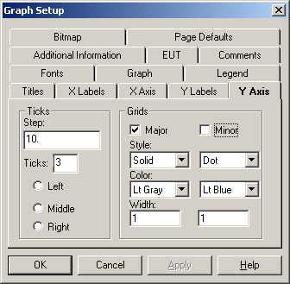

Step
The tick scaling is only active when the log mode is turned off. In creating a tick scaling on the y-axis, the range needs to match the desired amplitude range.

Axis Ticks
The ticks are the small marks scratched on the axis lines to designate spacing.

Step
The step scaling determines the position of labels for the y-axis. This is only active when the log mode is turned off. When creating a tick scaling on the y-axis, the range needs to match the desired frequency range. If the ‘log’ scaling is turned off, the default grid ticking will write a tick mark at every 10 points. If your scaling is 'zoomed' to 1 to 10 (for instance in looking a probe values in a 3 V/M test), changing the tick marking to 1 to make them 1 steps.

Ticks
The ‘Ticks’ text box sets the number of tick marks placed between each marker. If you are in the 0 - 100 range, with 10 Steps, a tick spacing of 3 would cause there to be 3 small tick marks on the axis between 0 and 10, between 10 and 20, etc.

Grids
The ‘Grids’ settings control the shape, color and size of the y-axis grid lines. Major grids are those at each label position. Minor grids are at each tick mark location.

Major/Minor
Check each of these boxes to turn on or off the appearance of grid lines. If turned off, no grid lines appear for the grid.

Style
You can set the Style to either Solid, Dot, Dashed, alternating Dash-Dot and alternating Dash-Dot-Dot.

Color
The Colors available are the standard Windows 16 colors.

Width
The Width setting configures the size of the line. This will make the grids thicker or thinner, the minimum (and default) is 1.We suggest the user experiment with these settings to better understand how they work.

Fonts Tab
This tab allows the user to customize the fonts used for the major components of the graph. The style and size are available for each choice. The five font choices – Arial, Courier New, Script, Times New Roman and Decorative. If these fonts are not installed, Windows will default to a close font.
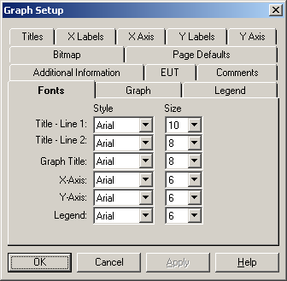

Title-Line 1
This font is only used on the Line 1. The default is an Arial font with a 10 pitch font size. This makes this the largest font on the screen (to emphasize the line).

Title-Line 2
This font is only used on the Line 2. The default is Arial with an 8 pitch font.

Graph Title
This font is used on the Graph Title as well as the X and Y Axis Titles. The default is Arial with an 8 pitch font.

X-Axis
This font is used to set the size of the x-axis labels (and tick indicators). The default is Arial with an 6 pitch font.

Y-Axis
This font is used to set the size of the y-axis labels (and tick indicators). The default is Arial with an 6 pitch font.

Legend
This font is used to set the size of the legend as well as the font size and style for all additional information (see Additional Information tab). The default is Arial with an 6 pitch font.

Graph Tab
The 'Graph' page allows you define the relative size and area of the graph, its plotting area, and the area for text on the graph.
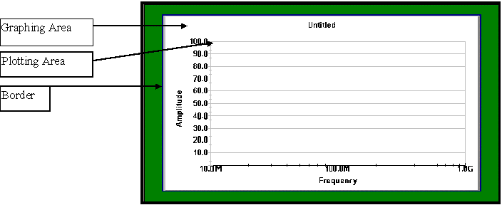

Graph
The overall graphing area is defined by stating how far down from the top of the graph page the graphing area begins. This is stated in percentage of the area. The area of the page outside the graph is defined as the border area. The color of the border can be set, as needed. One common use of this feature is to define a top or side region that is all border. This would be were the 3 hole punch would go to place this graph in a bound document. This way none of the graph is lost to the hole placement.

Left
This value represents starting point for the left side of the graph as a percentage of the page starting from the upper left hand corner. The default value is 0%.
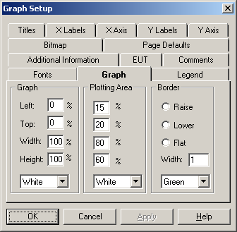

Top
This value represents starting point for the top of the graph as a percentage of the page starting from the upper left hand corner. The default value is 0%.

Width
This value represents width of the graph as a percentage of the page size. The default value is 100%.

Height
This value represents height of the graph as a percentage of the page size. The default value is 100%.

Color
You can change the graph background color by using the drop down box next to the color setting to view the available colors (the 16 default window colors).

Plotting Area
The ‘Plotting Area’ uses the same convention as ‘Graph’ but all percentages are of the graph size, not the page size. It represents the part of the graph area which will include the X-Y presentation of data. All distances are stated in percentages of graph size and thus automatically scale to whatever graph size is used.

Left
The default placement of the left side of the plotting are is 15% of the graph size. This allows room for the Y axis labels and titles to be written outside of the Y-Axis. Choose a size that fits with the data to be displayed.

Top
The default placement of the top of the plotting are is 20% of the graph size. This allows room above the plotting are for the Line 1, Line 2 and Title texts. Choose a size that fits with the data to be displayed.

Width
The default width of the plotting area is a 80% of the graph size. Since there are no default titles or labels on the right side of the graph, the default settings leave 5% of the graph area free along the right side of the graph.

Height
The default height of the plotting area is 60% of the graph size. This leaves room for the Operator, EUT, Client, Data/Time Stamp and File Name information that is set on the ‘Additional Information’ tab. Change this setting if you want a larger graph and no additional information displayed.

Color
You can change the color by using the drop down area next to the color setting to view the available colors (the 16 default window colors).

Border
The 'Raise', 'Lower' and 'Flat' settings are not normally visible unless a high resolution monitor is used. Generally assume they are not active. The Width of the border is stated in percentage terms. You can change the color of the border by using the drop down area next to the color setting to view the available colors (the 16 default window colors).

Legend Tab
The ‘Legend’ is turned off by default. You can place a legend on the graph to illustrate the data elements that are present. The default names in the legend are the data element names. If you want to control the displayed legend name, change the ‘Column Description’ field in the data definition. See Column Description on page 231.
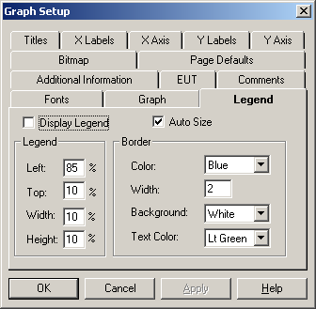

Display Legend
To activate the 'Legend', check this box.

Auto Size
The 'Auto Size' determines whether the legend box expands to encompass the defined elements. If this is turned off, the legend box must be manually sized to include the defined elements.

Legend
The Left, Top, Width and Height of the 'Legend' box are placement percentages. They are referenced to the upper left-hand corner of the Graphing area. These are ONLY used if ‘Auto Size’ is turned off.

Left
The default position of the left side of the legend is set to 85% of the graphing area, referenced to the upper left hand corner of the graph. You can change this to any positive number between 0 and 100.

Top
The default position of the top corner of the legend is set to 10% of the graphing area, referenced to the upper left hand corner of the graph. You can change this to any positive number between 0 and 100.

Width
The default width of the legend is set to 10% of the graphing area, referenced to the upper left hand corner of the graph. You can change this to any positive number between 0 and 100.

Height
The default height of the legend is set to 10% of the graphing area, referenced to the upper left hand corner of the graph. You can change this to any positive number between 0 and 100.

Border
These settings control properties of the legend. The 'Color', 'Width', 'Background' and 'Text Color' text boxes allow you to customize the colors used in the Legend. 'Color' is the border color. 'Width' is the not used at this time. 'Background' refers to the color of the interior area of the legend box. 'Text Color' determines the color of the text on the legend. All the text is the same color; you cannot individualize the colors.

Color (border)
You can set the color of the border to any of the 20 possible color choices in the drop down box. Click on the down arrow to select or change the color. The default color is ‘Blue’.

Width
This setting controls the thickness of the border. The default value is 1. Change this to any numerical value between 1 and 10.

Background (Color)
The default background color is ‘White’. Click on the down arrow to select or change the color to one of the 20 possible colors.

Text Color
The default text color is ‘Lt Green’. Click on the down arrow to select or change the color to one of the 20 possible colors.

Additional Information Tab
Select the ‘Additional Information’ tab to include information on the graph. This information is shown across the bottom margin of the graph. With the exception of EUT (which has a separate tab) the positions are fixed.
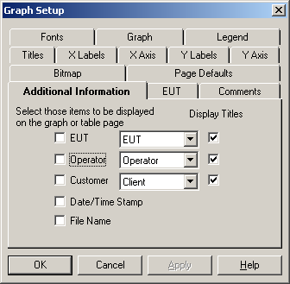

EUT
You can display the EUT model number (string one from the EUT action) across the bottom of the graph. Click the check box in front of the EUT and select the appropriate action from the flowchart. You can have multiple EUT actions on the flowchart, but only one on each graph. They can be different for different graphs. Click on the ‘Display Titles’ check box if you want the title from the EUT action to be displayed.

Operator
You can display the Operator name across the bottom of the graph. Click the check box in front of the Operator and select the appropriate action from the flowchart. You can have multiple Operator actions on the flowchart, but only one on each graph. They can be different for different graphs. Click on the ‘Display Titles’ check box if you want the title ‘Operator:’ to be displayed.

Customer
You can display the Customer contact name and company (strings one and two from the Client action) across the bottom of the graph. Click the check box in front of the Client and select the appropriate action from the flowchart. You can have multiple Client actions on the flowchart, but only one on each graph. They can be different for different graphs. Click on the ‘Display Titles’ check box if you want the title from the Client action to be displayed.

Date/Time Stamp
If checked, the date/time stamp from the newest data element on the graph will be displayed. By using the newest date/time stamp, we allow the graph to reflect the date/time of the last execution that effected the data shown on this graph.

File Name
If checked, the file name will be displayed. This can be a long value depending upon the file name and subdirectory situation.

EUT Tab
Select the ‘EUT’ tab to display a floating text box with all the information from the ‘EUT’ action from the flowchart. This allows significantly more information to be displayed than is shown when the ‘Additional Information/EUT’ option is chosen. This is turned off by default.
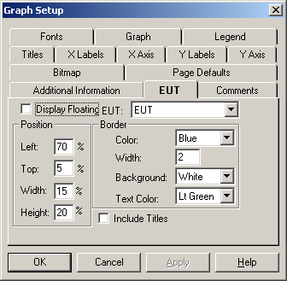

Display
To display the ‘EUT’ information, select this check box.

EUT (Action)
Drop down to show a list of all EUT actions from the flowchart. Select an appropriate comment for inclusion on this graph.

Position
Allows placement of the EUT information text box at any location within the graph. All positions are referenced to the upper left-hand corner of the Graphing area and are in percentages of the graph size.

Left
The default position of 70, places the upper left corner of the EUT box 70% across the graph (measured from the left hand side). Change this to any number between 0 and 100.

Top
The default position of 5, places the upper left corner of the EUT box 5% down from the graphs top. Change this to any number between 0 and 100.

Width
The default width of 15, sizes the width of the EUT box to 15% of the. Change this to any number between 0 and 100.

Height
The default height of 20, sizes the height of the EUT box to 20% of the height of the graph. Change this to any number between 0 and 100.

Border
You can control the shape, color and sizes of the floating text box using these settings.

Color (border)
You can set the color of the border to any of the 20 possible color choices in the drop down box. Click on the down arrow to select or change the color. The default color is ‘Blue’.

Width
This setting controls the thickness of the border. The default value is 1. Change this to any numerical value between 1 and 10.

Background (Color)
The default background color is ‘White’. Click on the down arrow to select or change the color to one of the 20 possible colors.

Text Color
The default text color is ‘Lt Green’. Click on the down arrow to select or change the color to one of the 20 possible colors.

Show Titles
If checked, the EUT titles will also be displayed. The default is to leave these titles out, for space considerations.

Comments Tab
Select the ‘Comments’ tab to allow display of a comment on the graph. Comments are turned off by default. ‘Comments’ are from the ‘Comment’ ‘Information Actions’ action that is defined on the Flowchart.
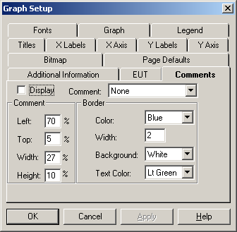

Display
To display the ‘Comments’, select this check box.

Comment (Action)
Drop down to show a list of all comment actions from the flowchart. Select an appropriate comment for inclusion on this graph.

Comment (Position)
Allows placement of the EUT information text box at any location within the graph. All positions are referenced to the upper left-hand corner of the Graphing area and are in percentages of the graph size.

Left
The default position of 70, places the upper left corner of the EUT box 70% across the graph (measured from the left hand side). Change this to any number between 0 and 100.

Top
The default position of 5, places the upper left corner of the EUT box 5% down from the graphs top. Change this to any number between 0 and 100.

Width
The default width of 15, sizes the width of the EUT box to 15% of the. Change this to any number between 0 and 100.

Height
The default height of 20, sizes the height of the EUT box to 20% of the height of the graph. Change this to any number between 0 and 100.

Border
You can control the shape, color and sizes of the floating text box using these settings.

Color (border)
You can set the color of the border to any of the 20 possible color choices in the drop down box. Click on the down arrow to select or change the color. The default color is ‘Blue’.

Width
This setting controls the thickness of the border. The default value is 1. Change this to any numerical value between 1 and 10.

Background (Color)
The default background color is ‘White’. Click on the down arrow to select or change the color to one of the 20 possible colors.

Text Color
The default text color is ‘Lt Green’. Click on the down arrow to select or change the color to one of the 20 possible colors.

Bitmap Tab
Select the ‘Bitmap’ tab to allow display of a bitmap on the graph. The Bitmap are turned off by default. This tab allows the user to place a bitmap, usually a company logo, on the graph for esthetics purposes.
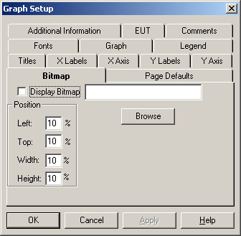

Display
To display the bitmap, select this check box.

Browse (Bitmap)
Click on the ‘Browse’ button to launch a windows browse dialog. This allows you to specify the directory and name for the bitmap. If you know the name you can directly type it in this box. If a profile with a defined bitmap is moved to a computer which does not have the bitmap file in its directory, this will be disabled when loaded.

Position
Allows placement of the Bitmap at any location within the graph. All positions are referenced to the upper left-hand corner of the Graphing area and are in percentages of the graph size.

Left
The default position of 10, places the upper left corner of the Bitmap 10% across the graph (measured from the left hand side). Change this to any number between 0 and 100.

Top
The default position of 10, places the upper left corner of the Bitmap 10% down from the graphs top. Change this to any number between 0 and 100.

Width
The default width of 10, sizes the width of the Bitmap to 10% of the. Change this to any number between 0 and 100.

Height
The default height of 10, sizes the height of the Bitmap to 10% of the height of the graph. Change this to any number between 0 and 100.

Page Default Tab
This tab controls the orientation of the graph to the printed page. They are mutually exclusive.
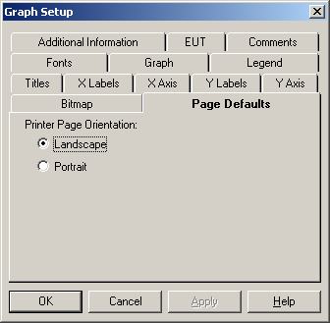

Landscape
This setting will cause the graph to be printed in a landscape orientation to the page, regardless of the printer settings and paper size. It will adjust itself width and height to the available paper size of the printer. Set your default printer to the desired settings prior to printing.

Portrait
This setting will cause the graph to be printed in a portrait orientation to the page, regardless of printer settings and paper size. This will leave a large, unprinted area below the graph on most papers since the graph will adjust itself, in height and width to the width of the paper.

Zoom Graph
The 'Zoom' option allows you to quickly and easily change the X or Y axis ranges without having to define or change any other parameters of the graph. With this option off, you can then adjust the scaling of the x-axis and y-axis to exactly fit your desired scale.
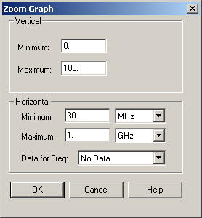

Vertical
The Y axis range can be changed on this page but if 'Log' on the 'Y-Labels' tab is set the final range may not fit your entered values.

Minimum
The default minimum is 0. Set this to a value consistent with your data, or range of interest.

Maximum
The default maximum is 100. Set this value consistent with your data, or range of interest.

Horizontal
The X axis range can be changed on this page but if ‘Log’ is set on the ‘X-Labels’ tab is set the final range may not fit your entered values.

Minimum
The default minimum is 30 MHz. Set this to a value and units to be consistent with your data, or range of interest.

Maximum
The default minimum is 1 GHz. Set this to a value and units to be consistent with your data, or range of interest.

Data for Freq
You can select a data element and the graph will automatically scale the ‘X-Axis’ to the range of values in this data element. If this data element is empty, the default ranges (or last valid range) will be displayed.

Copy Graph
This function will copy an exact copy of the current graph to a new graph. The new graph will be identical except the name will have a numerical appendage (starting at 1) for each time the graph is copied.

Keeping a Graph After Creation
Once a graph has been defined, DO NOT CLOSE THE WINDOW. Closing a graph or table window makes it permanently disappear. To keep the graph, minimize it (the flat line - in Windows 95/NT) in the upper right-hand corner.

Editing an Existing Graph
Once a graph is defined, all the tools used to create the graph are used for editing. See ‘Creating a Graph’ for more details. You can double click anywhere on the graph to bring the ‘Graph/Options’ dialog to the foreground. This allows you to quickly edit an existing graph.

Temporary Zoom
You can zoom in or out of a graph to look at specific details. These are temporary zooms and are never saved. The originally designed graph is always the saved item.

Zoom In
You can zoom in to look at specific data by holding the right mouse button down and dragging the area that you want to expand. The ranges of the X-Y axis will match the zoomed area unless the ‘Log’ option is set on the ‘X-Labels’ or ‘Y-Labels’ tabs.

Zoom Out
Double-right click will return the graph to the original ranges.

Tables
Tables are a tabular method of looking at data elements within the TILE! system. They can be created as often as desired and you can have as many different graphs as desired. Each table can have different combinations of data elements to fit your requirements. These tables can be printed individually or used to clip data to your spreadsheet.
Warning - Tables are generally good for looking a specific, limited sets of data – such as Peaks or QP values. They are NOT normally used for listing raw data. A table is created with the appropriate number of rows to fit the defined data elements. If you place raw data onto a table you might have 8,000 or more rows of data. Since each page only holds 66 lines of data, the table must build and hold in memory hundreds, or thousands, of pages of data. This is extremely memory intensive and can account for significant delays in testing. As you ‘add’ to data the complete tabular data must be reformatted in memory. Again, this can cause a significant delay in system performance.

Creating a Table
A table is created from the Windows drop down menu of the Menu Bar. Click or select the 'Add' feature to view three choices – Graphs Tables, and Page. You can create as many different graphs or tables as you want. Each new table is started as a blank table with no selected data elements.
When the new table is formed, the Windows Menu Bar changes to reveal 'Display'. The 'Display' selection gives you access to the configurations for the table. There are two choices – Data and Options. Each of these controls a slightly different part of the table. You can also double-click on the body of the table to access the ‘Options’.

Data
When ‘Display/Data’ is selected from the Windows Menu Bar, the selection dialog is opened. This is a two-column page with the available, defined data elements in the first column and those selected for inclusion on this table in the second column.
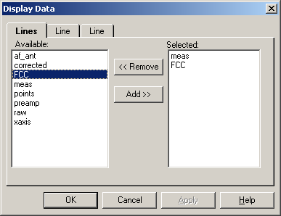

Add
To select a data element you can double click on the available element, automatically adding it to the 'Selected' side. You also can use the Up/Down Arrow keys to highlight the data element and use the Tab key to move to the 'Add' button. Press 'Add' to register the selection.

Remove
To remove a selected data element, double click on the element in the 'Selected' column. This will remove it from the list. You also can use the Up/Down Arrow keys to highlight the data element and use the Tab key to move to the 'Remove' button. Press 'Remove' to register the selection.

Options
The 'Options' dialog has four tabs - 'Titles', “Additional Information’, ‘Comments’ and ‘Page Defaults’. These allow the user to control the appearance of the table and some of the characteristics when the table is cut and pasted into other Windows applications.

Controlling Display Conditions
Once a data element has been 'Selected', a ‘Line’ tab appears which determines the display parameters for this data element on the graph. Line type, color and shape are individually defined for each data element.
If a data element was defined as an interpreted element, i.e. continuous at every point (the default), then the first block labeled 'Line' applies. If the data element was defined as discrete, then the box labeled 'Marker' applies.

Line
Style, Color and Width not active on a table. These are only appropriate for data elements that are defined as ‘Continuous’ (either Log or Linear). See page 45 for a discussion of creating data elements. The default settings create a neutral line setting. To highlight the line, choose a different color or shape. This is particularly helpful when displaying the specification limits on the same chart as your readings. By using a dashed line for the specification limit, or a different color, you quickly and visually distinguish this line from the readings.
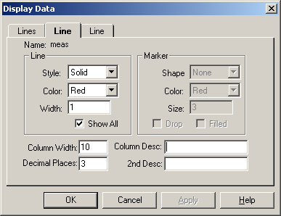

Show All
The ‘Show All’ check box controls whether all contents of the data element are displayed or only those with matching frequencies to the remaining columns. If you have a specification limit on a table with 10 QP readings the normal setting, with ‘Show All’ checked, would also show the frequencies in the specification limit file. This means the number of lines on the table would be greater then 10. If this is off, only the 10 points of interest would be listed but this data column would show the appropriate matching value for this frequency.

Column Width
This field controls the width of the column. The default value is 10.

Decimal Places
This field controls the number of decimal places that are visible. This field affects the way tables are copied and pasted. If you export values using the table function, they will be truncated to the value shown in this field.

Column Description
This field allows this user to control the column header for this data element. The default is the data element name.

2nd Description
There are two rows of description for each data element. This field controls the second description field. You might use this to display units, ‘dBuV/m’, for the reading as a clarifying label.

Display Options
The display option allows you to configure the name, descriptive titling, column headers, the inclusion of additional information, comments and page orientation and cut-and-paste defaults.
The dialog box has four tabs. These allow control of titles, default page formats as well as some special features such as additional information and comment.

Titles Tab
Name the table with a unique name so that it can be 'called' from other programs or quickly opened from the Windows Menu Bar.
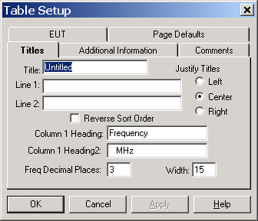

Title
The title name for the table is entered in this box. A unique name is essential to identify this table when automatically printing or accessing the table from different applications.

Line 1
The Line 1 is the top line on the table. It is normally used to enter the company name or other appropriate header information. You can enter up to 128 characters, although this might exceed the width of the page.

Line 2
The Line 2 is the second line of descriptive headers for the table. It is normally used to display information on the test and its general conditions. You can enter up to 128 characters, although this might exceed the width of the page.

Justify Titles
You can specify left, center or right justification of the titles. All three titles (Line 1, Line 2 and Title) are justified together.

Reverse Sort Order
When this is checked, the table will reverse the sequence of the frequencies list. The default, with this unchecked, is to list frequencies from low to high frequencies. When this is checked, the list will be from high to low frequency.

Column 1 Heading
The first column in the table is the frequency. This is not derived from any data element but is calculated by combining all the data elements are listing the consolidated range of values. The default for this is ‘Frequency’.

Column 1 Title
There are two headers for each column in the table. This value is for the second description of the first column. The default value is ‘MHz’. If you want the column header to be blank you must enter a space.

Freq Decimal Places
The user can control the number of decimal places displayed for the frequency. The default is 3 (i.e., 3.755 MHz). This limitation extents to cut and paste operations.

Column Width
This controls the column width of the first column. If you are specifying more then 3 decimal places for frequency, you might need to widen the column.

Additional Information
Select the ‘Additional Information’ tab to include information on the table. This information is shown across the top of the table, immediately below Line 1, Line 2 and the table name.
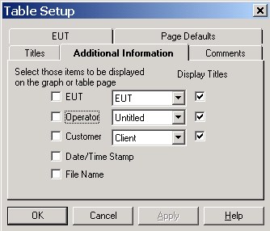

EUT
You can display the EUT model number (string one from the EUT action) on the table. Click the check box in front of the EUT and select the appropriate action from the flowchart. You can have multiple EUT actions on the flowchart, but only one on each table. They can be different for different tables. Click on the ‘Display Titles’ check box if you want the title from the EUT action to be displayed.

Operator
You can display the Operator name across the top of the table. Click the check box in front of the Operator and select the appropriate action from the flowchart. You can have multiple Operator actions on the flowchart, but only one on each table. They can be different for different tables. Click on the ‘Display Titles’ check box if you want the title ‘Operator:’ to be displayed.

Customer
You can display the Customer contact name and company (strings one and two from the Client action) across the top of the table. Click the check box in front of the Client and select the appropriate action from the flowchart. You can have multiple Client actions on the flowchart, but only one on each table. They can be different for different tables. Click on the ‘Display Titles’ check box if you want the title from the Client action to be displayed.

Date/Time Stamp
If checked, the date/time stamp from the newest data element on the table will be displayed. By using the newest date/time stamp, we allow the table to reflect the date/time of the last execution that effected the data shown on this table.

File Name
If checked, the file name will be displayed. This can be a long value depending upon the file name and subdirectory situation.

Comment Tab
Select the ‘Comment’ tab to access the option for a comments to be printed on the table.
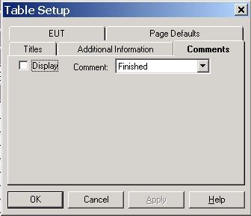

Display
Check this box to add the comment to the bottom of the table. The comment is the last item printed and will print across the bottom of the page.

Comment
Drop down and select the appropriate action from the flowchart

EUT Tab
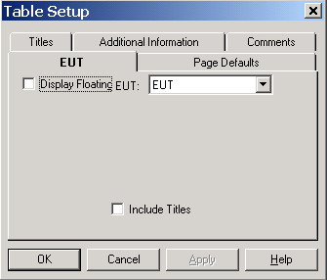
The EUT tab allows selection of an action that contains EUT information. This information is then printed at the bottom of the table.

Display
Check this box to add the comment to the bottom of the table. The comment is the last item printed and will print across the bottom of the page.

Include Titles
When selected, the title for each line of the EUT action is included prior to the information.

Page Defaults
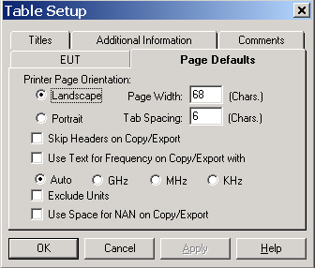
This page allows you to control certain parameters of both printing and cut and paste operations.

Printer Page Orientation
You can select either Landscape or Portrait for printer orientation. This overrides the orientation of the default printer. This is done so that graphs and tables can be printed in different orientations without the user having to change to printer defaults each time.

Page Width
When doing a cut and paste operation, the data is copied to the clipboard in text format. The Page Width parameter formats the information into an expected page size. Information over this width is separated by a line feed.

Tab Spacing
Columns of information in a cut and paste operation are normally separated by a tab (tab delimited). When writing to disk using ‘Copy/Export’, spaces are substituted for tabs to allow more predictable formatting when opened in word processors with different tab settings. For instance the default in Microsoft Word is no tabs, which causes the information to be pushed together. We have chosen to replace the tab with spaces for consistency across different word processors.

Skip Headers on Copy/Export
When copying a table to disk or in a cut and paste operation, it has a WYSIWYG (what you see is what you get) appearance. When checked, the headers will NOT be copied. You will only get the columns of data.

Use Text for Frequency on Copy/Export
When you copy a table, the frequency is normally copied as a value. In this case 1 MHz would be 1,000,000. When this option is checked the frequency is converted to text in engineering format so that 1 MHz would appear as 1 MHz. The Auto, GHz, MHz, and KHz selection lets you specify the format. If Auto is chosen, then the label will be varied to fit the size of the data. 1,000 would be 1 KHz, 1,000,000 would be 1 MHz. If you chose GHz, MHz or KHz then the data is formatted to that size. If KHz is chose 1,000 would be 1 KHz, 1,000,000 would be 1,000 KHz.

Exclude Units
When this option is chosen, the text units is NOT copied. This option is only available is ‘Use Text for Frequeny on Copy/Export’ is selected.

Use Space for NAN on Copy/Export
When copying tables of values there is a technical difference between a zero and no value at all. Since these are normally numbers, the absence of a number shows up as a NAN (not a number) value. This is not very elegant. Choosing this option will substitute a space whenever no value exists so that there is a blank on the copied column, not a NAN.

Keeping a Table after Creation
Once a Table has been defined, DO NOT CLOSE THE WINDOW. Closing a table or graph window makes it permanently disappear. To keep the table, minimize it (the flat line - in Windows 95/NT) in the upper right-hand corner.

Editing an Existing Table
Once a table is defined, all the tools used to create the table are used for editing. See ‘Creating a Table’ for more details.

TILE! Options
The Options available with TILE! give the users extended flexibility and testing capability within the profile with the simple additions incorporated on the Palette.

Voltage Monitoring
The Voltage Monitoring Action is a group of special actions, offered as an option, which allows the user to automate immunity testing for EUT failures. Most of these are versions of the ‘Switch’ action (see page 202) which are created to allow measurement of Voltage rises, Voltage drops, open/close relay states and switch positions.

Database
The TILE! system was designed to interface with a relational database for historical data storage and retrieval. When this option is ordered there is a separate manual which covers its implementation and use. In the data element design and ‘Auto Save’ action you can see options that allow interface to the TILE! Database.

Actions 10-74
Apply 10-75
Auto Save 10-208
Auto Save Action tab 10-208, 10-209
Auto Save Save As Tab 10-208
Calibrate Cables/Amplifiers 10-193, 10-195, 10-196
Calibrate Cables/Amplifiers Action Tab 10-193
Calibrate Cables/Amplifiers Data Tab 10-195
Calibrate Cables/Amplifiers Dialog 10-196
Calibrate Cables/Amplifiers Links Tab 10-196
Calibrate Cables/Amplifiers Setup Tab 10-193
Cancel 10-75
Chapter 2 TILE! Installation Instructions 2-2
Chapter 4 TILE System Overview 4-31
Clear Data 10-203
Clear Data Action Tab 10-203
Clear Data Tab 10-203
Client 10-79
Comment 10-81, 10-82, 10-83
Common Action Commands 10-75
Common Name Page 10-75
Connecting the Actions 3-19
Data and File Commands 10-202
Data Window Structure 5-41
Deleting an Instrument 6-60
Direct Entry 10-209
Direct Entry Data Element Tab 10-209
Direct Entry Dialog 10-209
Driver Page 6-54
Enter Key 10-75
EUT 10-80
File 8-71
File Elements 5-39
Flowchart Window 7-61
GPIB Control 10-198
GTEM/OATS 3 Position Correlation 10-210, 10-212, 10-213, 10-214
Gtem/OATS 3 Position Correlation Action Tab 10-210
GTEM/OATS 3 Position Correlation Correlation Tab 10-210
GTEM/OATS 3 Position Correlation Dialog 10-214
GTEM/OATS 3 Position Correlation Inputs Tab 10-213
GTEM/OATS 3 Position Correlation OATS Tab 10-212
GTEM/OATS 3 Position Correlation Results Tab 10-214
GTEM/OATS 9-Position Action Tab 10-215
GTEM/OATS 9-Position Alignment Tab 10-218
GTEM/OATS 9-Position Correlation 10-215
GTEM/OATS 9-Position Dialog 10-220
GTEM/OATS 9-Position GTEM Tab 10-215
GTEM/OATS 9-Position Input Tab 10-219
GTEM/OATS 9-Position OATS Tab 10-217
GTEM/OATS 9-Position Results Tab 10-220
Help 10-75
How Actions Work 10-74
Immunity Calibration 10-144, 10-145, 10-147, 10-148, 10-150, 10-151, 10-153, 10-154
Immunity Calibration Action Tab 10-144
Immunity Calibration Amplitude Tab 10-147
Immunity Calibration Calibration Tab 10-144
Immunity Calibration Dialog 10-154
Immunity Calibration Frequency Tab 10-145
Immunity Calibration Instruments Tab 10-153
Immunity Calibration Leveling Tab 10-148
Immunity Calibration Results Tab 10-151
Immunity Calibration TEM Tab 10-150
Immunity Test 10-145, 10-154, 10-155, 10-156, 10-160, 10-162, 10-165, 10-169, 10-170, 10-173, 10-174, 10-176, 10-177, 10-179, 10-180, 10-181, 10-183, 10-184, 10-185
Immunity Test Action Tab 10-155, 10-186
Immunity Test AM Modulation Tab 10-169
Immunity Test Amplitude Tab 10-160
Immunity Test Calibration Tab 10-173
Immunity Test Check Tab 10-154, 10-185
Immunity Test Dialog 10-183
Immunity Test FM Modulation Tab 10-170
Immunity Test Frequency Tab 10-155
Immunity Test Instruments Tab 10-176
Immunity Test Leveling Tab 10-162
Immunity Test Monitor Tab 10-154, 10-185
Immunity Test Pass/Fail Tab 10-181
Immunity Test Process Tab 10-179
Immunity Test Results Tab 10-174
Information Actions 10-76
Instrument Actions 10-84
Instrument Initialization 10-84
Instrument Initialization Action Tab 10-84
Instrument Initialization Instruments Tab 10-84
Introduction 1-1
Items Required 2-2
Launch Application 10-207
Launch Application Action Tab 10-207
Launch Application Commands Tab 10-207
Linking Actions 7-62
Log Overview 8-69
Log Window 8-69
Math 10-202, 10-203
Math Action Tab 10-202
Math Data Tab 10-202
Math Dialog 10-203
Measure Peaks 10-91, 10-92, 10-93, 10-94, 10-95, 10-96
Measure Peaks Action Tab 10-91
Measure Peaks Dialog 10-92, 10-96
Measure Peaks Frequency Tab 10-92
Measure Peaks Instruments Tab 10-96
Measure Peaks Output Tab 10-93
Measure Peaks Parameters Tab 10-95
Measure Peaks Search Tab 10-94
Measure Range 10-84, 10-85, 10-87, 10-88, 10-89, 10-91
Measure Range Action Tab 10-85
Measure Range Amplitude Tab 10-87
Measure Range Dialog 10-91
Measure Range Frequency Tab 10-85
Measure Range Links Tab 10-88
Measure Range Parameters Tab 10-89
OATS Dialog Box 10-135
OATS Measurement 10-127, 10-128, 10-129, 10-130, 10-131, 10-132, 10-133, 10-134, 10-135
OATS Measurement Action Tab 10-127
OATS Measurement Input Data Tab 10-128
OATS Measurement Output Data Tab 10-129
OATS Measurement Parameters Tab 10-131
OATS Measurement Standards Tab 10-133
OATS Measurement Tower/Turn Position Tab 10-134
OK 10-75
Operator 10-81
Optimize Measurement 10-120, 10-122, 10-123, 10-125, 10-126
Optimize Measurement Action Tab 10-120
Optimize Measurement Data Tab 10-122
Optimize Measurement Dialog 10-126
Optimize Measurement Frequency Tab 10-120
Optimize Measurement Links Tab 10-123
Optimize Measurement Parameters Tab 10-125
Optimize Measurement Tower/Turntable Tab 10-123
Options 8-71
Palette 10-74
Placing Icons 7-62
Position EUT (GTEM Manipulator) 10-191
Position EUT Action Tab 10-191
Position EUT Dialog 10-193
Position EUT Links Tab 10-192
Position EUT Position Tab 10-192
Position Tower 10-187, 10-188, 10-189
Position Tower Action Tab 10-188
Position Tower Dialog 10-189
Position Tower Links Tab 10-189
Position Tower Position Tab 10-188
Position Turntable 10-189, 10-190, 10-191
Print 10-206
Print Action Tab 10-206
Print Display Tab 10-206
Prompt 10-76, 10-77, 10-78, 10-79
Prompt Action Tab 10-77, 10-79, 10-80, 10-81, 10-82
Prompt Message Tab 10-77
Prompt Sound Tab 10-78
Run Menu 7-68
Scan Peaks 10-103, 10-104, 10-105, 10-106, 10-108, 10-109, 10-111, 10-113
Scan Peaks Action Tab 10-103
Scan Peaks Antenna Polarity Tab 10-111
Scan Peaks Dialog 10-113
Scan Peaks Frequency Tab 10-104
Scan Peaks Instruments Tab 10-105
Scan Peaks Optimization Process Tab 10-109
Scan Peaks Output Tab 10-106
Scan Peaks Parameters Tab 10-108
Scan Peaks Search Tab 10-106
Scan Range Across TT/Turn 10-114, 10-115
Scan Range Across TT/Turn Action Tab 10-114
Scan Range Across TT/Turn Amplitude Tab 10-115
Scan Range Across TT/Turn Data Tab 10-116
Scan Range Across TT/Turn Dialog 10-119
Scan Range Across TT/Turn Frequency Tab 10-114
Scan Range Across TT/Turn Instruments Tab 10-116
Scan Range Across TT/Turn Parameters Tab 10-117
Scan Range Across TT/Turn Tab 10-118
Scan Range Action Tab 10-97
Scan Range Antenna/Turntable Position Tab 10-100
Scan Range Data Tab 10-99
Scan Range Dialog 10-103
Scan Range Frequency Tab 10-97
Scan Range Links Tab 10-101
Scan Range Measurement 10-97, 10-103
Scan Range Parameters Tab 10-101
Serial Interface 10-200, 10-201
Serial Interface Action Tab 10-200
Serial Interface File Setup 10-200
Serial Interface Serial Setup 10-201
Serial Page 6-58
Setup Page 6-56
Site Attenuation 10-139, 10-140, 10-141, 10-142, 10-143, 10-144
Site Attenuation Action Tab 10-139
Site Attenuation Antenna Tab 10-142
Site Attenuation Data Tab 10-142
Site Attenuation Dialog 10-144
Site Attenuation Frequency Tab 10-140
Site Attenuation Links Tab 10-143
Sound 8-71, 8-72
Special Math Functions 5-48
Start 10-76
Step 1 - Checking the Computer Setup 2-2
Step 2 - Installing TILE! 2-3
Step 3 - Ready to Run 2-4
Switch 10-197, 10-198
Switch Setup Action Tab 10-197, 10-198
Switch Setup Links Tab 10-198
Switch Setup Switches Tab 10-197
Tab key 10-75
The Command Bar 4-33
The Status Bar 4-33
The Toolbar 4-32
The Windows Menu Bar 4-34
Transfer Data 10-204, 10-205
Transfer Data Action Tab 10-204
Transfer Data to File Tab 10-204
Working with Icons and the Palette 7-62
Working with the Flowchart 7-63

